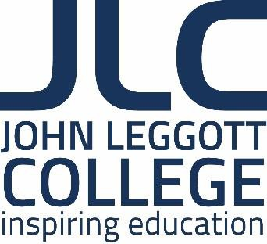
John Leggott College Job Description

JOB TITLE: Head of Biology & Applied Science (1.0 FTE)

REPORTS TO: Assistant Principal
WORK PATTERN: Full Time/Perm
SALARY: Teachers Main Scale (depending on qualifications and experience)

Purpose of the Role

- Lead a team to ensure successful delivery of a range of level 2 and level 3 qualifications in
Biology and Applied Science.
- Ensure successful delivery of biology elements of the Health & Social Care Access to
Higher Education
- Ensure a high quality and relevant learning experience for all students on these courses
- Ensure that all students are given the opportunity to achieve their academic potential

Key Responsibilities

- Employ a range of teaching and learning practices successfully
- Be responsive to innovations and changes in the teaching of Science
- Include numeracy and literacy in all teaching and learning practices
- Promote Equality and Diversity in all teaching and learning practices
- Promote the prevent agenda in all teaching and learning practices
- Work with other leaders to identify and achieve college targets such as those related to student enrolment, retention, achievement and value-added
- Lead a team to coordinate resources for learning, including schemes of work, learning plans and personal learning checklists as appropriate
- Set suitable learning targets and prepare learning programmes that achieve these
- Lead a team to use appropriate assessment techniques to track student progress effectively and make best use of learner data to inform lesson planning and intervention
- Lead a team to employ diagnostic test data in all planning for learning
- Organise and manage the classroom effectively and ensure team members have high standards of classroom management and teaching and learning practice
- Lead and work with team members to ensure outstanding outcomes for learners
- Forge links with feeder secondary schools and be actively involved in the college recruitment and enrolment processes
- Liaise with the advocate team to support the learning of the students
- Liaise with SENCO to ensure all students are fully supported in their learning
- Access training and other CPD opportunities when presented
- Utilise the college’s VLE in order to support teaching and learning
- Be involved in learner support and enrichment activities to provide the best student experience in Science
- Work collaboratively with colleagues across all areas of the college

- Continue to develop his or her own skills in the teaching, learning and assessment of Science
- Be enthusiastic, dynamic, committed and well organised
- Be flexible and prepared to contribute to the delivery of other L2 and L3 Science courses.

In addition to the above mentioned attributes the successful candidate will be expected to:

  - Support effective safeguarding of all young people throughout the college.

  - Attend as necessary, meetings of all Science and college staff.

  - Adhere to college policies and procedures e.g. Equality and Diversity; Health and Safety.
  - Undertake any such other duties as may be required, commensurate with the post, which do not change the character or purpose of the post which are necessary to maintain outstanding standards.

The job description is an outline of the key tasks and responsibilities and is not intended as an exhaustive list. The job may change over time to reflect the changing needs of the college, as well as the personal development needs of the post holder.

We strive for equality throughout the college and positively encourage applications from all sections of the community. The college has a strong commitment to safeguarding and promoting the welfare of young people and vulnerable adults and all appointments are subject to an enhanced DBS clearance.

LEON RILEY

Principal

Employee signature: …………………………………. Date: ……..……………… Line manager signature: ………………………………. Date: ……..………………

