April 2017

Dear Candidate

Thank you for your interest in our vacancy for Teacher of Girls Physical Education and Health and Social Care. On our website you will find an application form, details of the post, a person specification and other relevant details which I hope will be of assistance to you.

You can also find out more information about our school on our website www.st-augustines.worcs.sch.uk

Applications must be received by 12:30pm Tuesday 2nd May 2017. Please mark your application for the attention of Mrs C Evans.

We look forward to hearing from you.

Yours sincerely

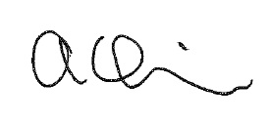

Mr A Quinn
Principal

