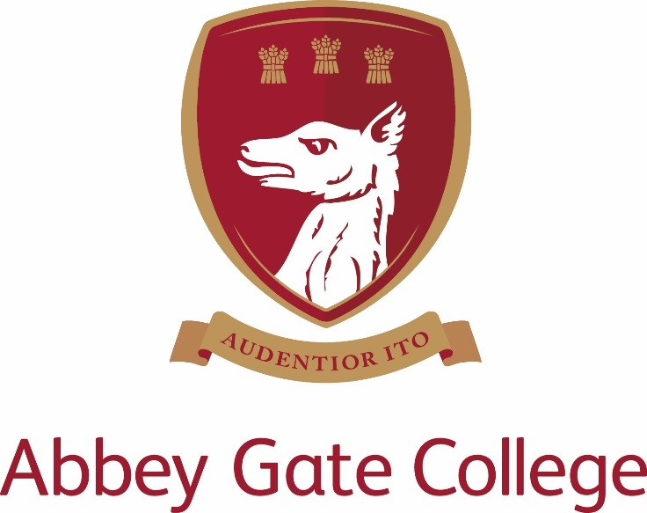
PART TIME (Temporary – 9 months)
TEACHER of French and Spanish

SEPTEMBER 2018 (or ASAP)

Abbey Gate College

The College
Abbey Gate College is the longest-running coeducational independent school in the Chester area, catering for circa 485 pupils aged 4-18 years. Set in the idyllic rural villages of Saighton and Aldford on the outskirts of Chester.
Our pupils are at the heart of everything we do. We believe education is about building self-esteem, a love of learning and igniting a desire in all our students, to ensure they fulfil their academic and personal potential. We strive to guarantee our children leave Abbey Gate College as confident, articulate, respectful and happy young high achievers.
From the youngest in Foundation to our Sixth Formers, we aim to develop skills for life; core values such as respect and compassion within the framework of an excellent education. Developing talents and skills in a wide range of areas are encouraged, success is celebrated and endeavour is recognised.
Abbey Gate College is committed to the safeguarding and promoting the welfare of children and expects all staff and volunteers to share this commitment.

The Post

We are seeking a dynamic and highly motivated French and Spanish teacher to join our innovative department. The successful candidate will teach across the year groups in the Senior School. A willingness to participate in extra-curricular activities, including trips abroad within the MFL framework or beyond is desirable. The role is approx. 0.8FTE however exact hours will be confirmed at interview.

The MFL Department team work together to share outstanding practice and resources, and to develop the curriculum and schemes of work, particularly in light of recent changes to examinations. Valuing our pupils is a top priority and we offer a variety of opportunities and responses in order to tailor our teaching to the individual.

Curriculum

- Year 7 experience an introduction to three languages in carousel format; French, German and Spanish
- Year 8 pupils select two of these languages and continue with at least one language into Year 9.
- All pupils are expected to study one language at GCSE but we offer the opportunity to study two if desired.
- At present we offer all three languages (French, German and Spanish) to A Level dependent on choices.

- The successful candidate will teach a part time timetable. Involvement in departmental planning and supporting extra-curricular activities is expected.

KEY QUALITIES AND PERSON SPECIFICATION:-

The person appointed should demonstrate the following skills and qualities:-
- Have outstanding professional and personal qualities
- Be enthusiastic, innovative and willing to share creativity and positivity in both the classroom and the department
- Be committed to raising standards and monitoring pupil progress
- Be caring, supportive and willing to adapt their teaching to suit the needs of the pupils
- Be proficient with the use of ICT in the classroom
- Be willing to assist with school trips in the UK and abroad

Salary

The salary for this position will depend upon the qualifications and relevant experience of the successful candidate.

Child Protection
Abbey Gate College regards as paramount the welfare and safety of children. Whilst criminal convictions are not necessarily a bar, this safety consideration will be key to all decisions regarding the employment of staff, approval of volunteers and standards of external contractors.

Equal Opportunities
We are committed to treating all employees with dignity and respect regardless of race, ethnic background, nationality, colour, gender, transgender status, pregnancy, age, sexual orientation, religion or belief. We therefore welcome applications from all segments of the community.

Applications
Candidates should complete an Abbey Gate College Application Form and submit this together with a letter explaining their interest in and suitability for the post addressed to Mrs Tracy Pollard, Headmistress, outlining their suitability for the post.

The closing date for applications has been extended to 4pm Friday 1 June 2018; interviews scheduled for the week commencing 11 June 2018.1

The interview process will include; the candidates will meet the Headmistress, Deputy Heads and Head of Modern Foreign Languages and have a tour of the College. Candidates will be asked to prepare and deliver a language lesson (details confirmed before interview).

References will be taken up prior to interview, please inform your referees.

Please mark the envelope:

Rebecca Upton
Human Resouces
Abbey Gate College
Saighton Grange
Saighton
Chester CH3 6EN

Alternatively you can make your application electronically by email to: - rebecca.upton@abbeygatecollege.co.uk

