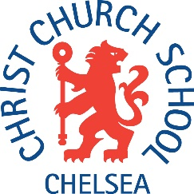
Christ Church CE Primary School
1 Robinson Street
Chelsea
London
SW3 4AA
Salary range: Range A2, Scale 3, point 14,
full time salary £21,189
Mornings 9- 12.30 Term Time Only
Required for November 2018
Christ Church CE Primary School is an extremely happy, welcoming and successful primary school. We have a strong ethos that celebrates the achievements of all pupils and staff alike. Applicants would be expected to be supportive of the school’s Christian values. The school plays a dynamic role at the centre of its community, strongly supported by parents. This is a great opportunity for a teaching assistant to work in a wonderful environment alongside talented and enthusiastic colleagues.
We are looking for a very committed and flexible team member, with energy, enthusiasm and a commitment to their own professional development.

The post is part time, term time only and is to provide support a child with additional needs in Year 4. The role will also include working with small groups of children on focussed activities as well as helping with general classroom activities.
You need to have prior experience of working with children in a learning environment be it at home or in a school.
Visits to the school are encouraged prior to application. Application forms and further details are available from the school. Completed application forms should be returned to the school.
Closing date: 12.00 noon on Tuesday 16th October.
Interviews will be held at the school on Thursday 18th October.

This position requires the post holder to hold an enhanced Criminal Record Bureau Disclosure before an appointment is confirmed.

