Isca Academy
Head of English

Table of Contents

Contextual Information
Copy of advertisement
Job description
Person Specification

To start: September 2018
Closing date: 10am on Thursday 22nd February 2018

Interviews: week commending 12th March 2018

Contextual Information

Welcome to Isca Academy.
Our school has been located on its very impressive and attractive site with a freshly designed campus and entirely new buildings since 2006. This was part of major re-organisation in Exeter with a PFI scheme that re-built all 5 Exeter secondary schools and one primary school. The Academy was built with a capacity for 950 students and the current roll is 750. We expect and need this number to rise and have an ambitious collaborative strategy to improve and strengthen relations with our feeder primary schools.
Students come to the Academy from a large number of primary schools that span the city, though 4 primary schools account for 70% of the intake, these are Wynstream, St Leonards, Countess Wear and Topsham, all within close proximity to the academy. In total the 2017 intake will come from 23 primary schools.
About Our Students
The academy maintains a tradition of being an inclusive community school that serves the variety of family contexts in its immediate neighbourhood. The most distinctive feature of the academy is the very broad range of student abilities and aspirations on entry. Higher ability students have always done extremely well academically, in the activities beyond the formal curriculum and in their progression to further education. We have large numbers participating in the Reach Academy Programme run by Exeter College for able, gifted and talented students. Our intake also presents the challenge of a number of students who join us with low literacy and social skills. At present 32% of students in the academy are ‘disadvantaged students’. 7% of students have English as a foreign language and many of these have their families linked to the University.
Our Curriculum
We keep our curriculum under review and endeavour to construct one which meets the needs of our diverse student body. In Years 7 and 8 there is a traditional curriculum in terms of subjects taught with a good balance of time allocated to each subject to prepare students effectively for Key Stage 4.
At Key Stage 4 we are continually looking to provide the courses and routes necessary and appropriate for all students. There is a blend of core subjects and the EBacc subjects together with a range of options that include vocational courses, sometimes delivered by external providers.
Our latest destination data shows that 80% of leavers go to Further Education (FE), and we are proud that 73% of our disadvantaged students went to FE. Our percentage of those not in education, employment or training has fallen to a figure of 3%. Apprenticeships account for around 2%.
Beyond the Classroom
Whilst important, success at school is not just about examination credentials and we believe in the immeasurable value of activities beyond the classroom to promote self- belief and confidence. Our growing extra-curricular programme offers a huge range of activities. If you look on our web site you will see there is a daily programme of activities offering a Before School Club for those who need a bit of calm and time to organise themselves (staff included!) and then lunchtime and after school activities including a regular After School Study Club, range of sports clubs, choir, samba band, community work and science clubs.
There is also a calendar of Outdoor Education Events, with activities such as Ten Tors, Exmoor Challenge, Exe Valley Challenge and Duke of Edinburgh award scheme led by dedicated and long standing teachers.
We strive to ensure these activities and opportunities are taken up by students from all backgrounds and abilities so they are not exclusive to those fortunate to have very supportive families. Where necessary we will assist students to enable them to participate.
Our Facilities
We are proud of our buildings and even though we all know that buildings alone do not make a good school, they do give a flying start! Wide corridors, spacious classrooms and a welcoming atrium greet our visitors.
As would be expected there are specialist rooms; science laboratories, ICT rooms, technology spaces, music rooms and practice facilities, drama studio, and an impressive hall with moveable seating. There are generous office spaces for support staff, subject staff and middle leaders.
Outside there is a floodlit all weather pitch and extensive grassed areas for sport and recreation (large enough for 2 full sized football pitches ) as well as hard court spaces and plenty of outside seating for students.
The Governing Body
The Local Governing Body operates with full delegated authority from the Ted Wragg Multi Academy Trust and is directly accountable to the Trust. The governors understand well their statutory duties to hold leaders to account as well as setting the strategic direction of the academy and ensuring the academy has a sound financial footing. Their commitment is absolute, believing in social justice, they bring a rich background of experience beyond education. They are led by a chair determined for the academy to be a first choice for parents and where every child is given the opportunity to fulfil their potential.

The Ted Wragg Multi Academy Trust is a values driven, rapidly growing 2 – 16 Trust with a relentless focus on transforming lives through learning by delivering outstanding outcomes for every student, regardless of background.
With a reputation for highly successful school improvement in very challenging circumstances, we are passionate about
driving up standards and raising the aspirations of all our students.

Isca Academy
Head of English
Permanent, Full-Time, Starting September 2018, TLR1a

Do you have a relentless drive to achieve outstanding progress and attainment with children regardless of their background and prior learning?

We are seeking to appoint an outstanding Head of Department and Teacher of English to further strengthen the achievement, progress and experience of students at Isca Academy, and to continue to raise the profile of the department, both within the school and in the wider community. You will be a highly motivated, enthusiastic and capable leader, with a proven commitment to inclusive, innovative and inspiring teaching where each and every child can succeed. The post represents an exciting opportunity to be part of a vibrant and ambitious Academy working within the Ted Wragg Multi-Academy Trust.

Our school is located on a recently designed campus with purpose-built accommodation, offering spacious and excellent teaching and learning facilities. We currently have a roll of 750 students, rapidly growing to a capacity of 950. Isca Academy prides itself on providing high quality comprehensive education. Our students have a broad range of abilities and aspirations on entry, from able, gifted and talented to students needing more support with literacy and social skills. Beyond academic credentials, we firmly believe in the value of a more rounded education which promotes creativity, self-belief and confidence, and as such, offer an exceptional extra-curricular and outdoor education programme. At our last Ofsted inspection, Isca Academy was found to be ‘good’ in all categories and our focus will remain on every student in our school exceeding expectations, whatever their starting point.

The English department at Isca Academy is a friendly, motivated team of specialists who love their subject and who are always looking for creative ways to deliver the curriculum. The team plan together and have a culture of sharing resources and best practice as well as supporting each other and solving problems in collegiate ways. We operate a two year KS3 curriculum which develops students’ skills and knowledge, together with a passion for English, in preparation for the start of their GCSEs in Year 9. The three year KS4, studying both Language and Literature, allows students to fully develop their ideas and consolidate their learning, whilst also making time for fun and creativity.

The Ted Wragg Multi Academy Trust is committed to safeguarding and promoting

the welfare of children and young people and expects all staff and volunteers to share this commitment. All applicants will be subject to a full Disclosure and Barring Service check

before appointment is confirmed.

Application forms and further information are available from our website:
www.iscaexeter.co.uk or by email to bharrad@iscaexeter.co.uk

Closing date for application: 10am on Thursday 22nd February 2018
Interviews will take place: week commencing 12th March 2018

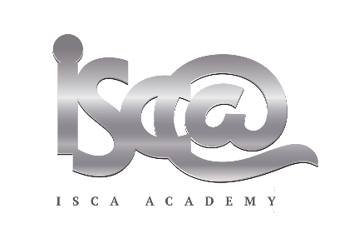

ISCA ACADEMY – JOB DESCRIPTION

Post: Head of English
Line Manager: Assistant Headteacher

CONDITIONS
As defined in the School Teachers Conditions of Service Document and Academy policy documents. The post holder will lead a team of English staff and will be supported by a designated member of the Leadership Group.
KEY PURPOSE
To provide professional and effective leadership and management for the English teachers within the department, in order to secure high student achievement within the context of the Academy overall aims and priorities.

OBJECTIVES

- To promote and provide a clear direction for the English team, within the context of the Academy vision in order to contribute to whole school improvement.
- To promote high standards in English teaching in order to ensure all students achieve their potential in English.
- To promote positive attitudes to learning in English lessons and activities so that students are equipped and able to access all subjects across the Academy.
- To ensure there is a consistency of practice within the English team with regards to Academy policies and procedures, maintaining high expectations of all students in terms of academic success and behaviour.
- To develop English schemes of learning, assessment plans and pedagogy in line with national developments and explore new strategies so that English teaching continues to develop and improve, maximising student outcomes.

MAIN AREAS OF RESPONSIBILITY

      - Improving the quality of teaching and learning
      - Leading and enhancing the teaching practice of others
      - Leading, developing and enhancing a subject or curriculum area

  - Monitoring the standards of teaching and learning and student achievement across all English lessons, and plan for improvement.
  - Working with the Leadership Group (line manager) to undertake regular self-evaluation of the work of the department and the impact on student outcomes, in line with the Academy self-evaluation policy.
  - Setting a clear direction for English within the context of the Academy vision and goals, creating and implementing a subject development plan which involves all subject teachers.
  - Supporting and developing the English staff, providing regular constructive feedback in a way which recognises good practice and supports progress against appraisal objectives.
  - acting as a positive role model for the English team so that staff have a clear understanding of good professional conduct.
  - Maintaining an ethos of high achievement and positive attitudes towards English amongst staff and students, to maximise achievement.
  - Actively engaging the English team in effective planning, development and delivery of the English curriculum.
  - Organisation and provision of resources and allocation of staff to groups, so that resources are used efficiently and effectively.
  - Overseeing and evaluating subject budget allocations to ensure spending is in line with learning priorities and best value principles.
  - Effective communication within the Academy and to key stakeholders with regards to English, to ensure confidence in the Academy and the subject area.
  - Ensuring high standards of health and safety within the department demonstrating an understanding and a commitment to safeguarding students.
  - Promote equality of opportunity and aspiration so that all students achieve their potential.

KEY TASKS

- English teaching across all years.
- Ensure schemes of learning /programmes of study are clear and effective, to ensure progression and to maximise achievement for all students.
- Ensure the quality of teaching across the team meets the needs of all students, and encompasses strategies to engage students in a range of learning styles.
- Monitor the quality and impact of teaching and learning within English through lesson observations, learning walks, work scrutiny and other identified strategies. Plan and implement improvements as appropriate.
- Monitor student progress in English against national and internal targets, planning support as appropriate for both students and staff.
- Plan and implement the developments required in English within the context of the overall Academy improvement plan.
- Ensure a programme of educational enhancement is delivered by the department, as appropriate.
- Ensure effective and timely scheduled meetings with the English staff, both as a group and on a 1:1 basis as required.
- Attend and contribute to Team Leaders’ meetings.
- Order and allocate English resources and manage the English budget.
- Oversee the deployment of staff in English lessons and advise on the recruitment of English staff when required.
- Support the professional development of English staff through Academy Appraisal processes, and other support strategies.
- Ensure efficient management of technical staff support (where required).
- Ensure Academy policies are consistently adhered to by the English team.
- Other general professional duties under the reasonable direction of the Headteacher.

THIS JOB DESCRIPTION IS SUBJECT TO REVIEW BY CONSULTATION

Isca Academy
Head of English: Person Specification

ESSENTIAL | DESIRABLE | HOW  ASSESSED
 |  | App Form | References | Interview
Experience  - Minimum 3 years teaching experience in a state comprehensive school  - Experience in planning and teaching English at KS3 and KS4  - Experience of contributing to and delivering strategies to raise achievement across English, including Assessment for learning and creative pedagogies | - Experience of analysing student data to inform lesson planning
Qualifications  and training  - Qualified teacher status  - Educated to degree level | - Further qualifications relevant to the role
Skills  - Outstanding classroom practitioner (teacher)  - A desire to teach English in an exciting and engaging manner  - Excellent planning skills  - Excellent inter-personal skills  - Ability to sustain positive relationships with staff, students and parents  - Able to analyse data and use this effectively to improve student outcomes  - Excellent ICT skills to support teaching  - Excellent organisation and time management skills  - Meets all relevant national teaching standards  - Good understanding of the National Curriculum and GCSE assessment requirements in English  - Ability to plan high achieving Schemes of Learning to challenge and inspire young people.  - the ability to fulfil all spoken aspects of the role with confidence and fluency in English | - A gifted leader and teacher
Qualities  - Very good communicator and team player  - Energetic and committed  - Ability to work under pressure  - High level of integrity  - Positive role model  - Able to demonstrate commitment to safe school culture | - Keen to develop further by full participation in CPD, often teaching CPD for others
- Must pass relevant  safeguarding of children  checks |  | DBS Checks and interview

Isca Academy
Contacts and information
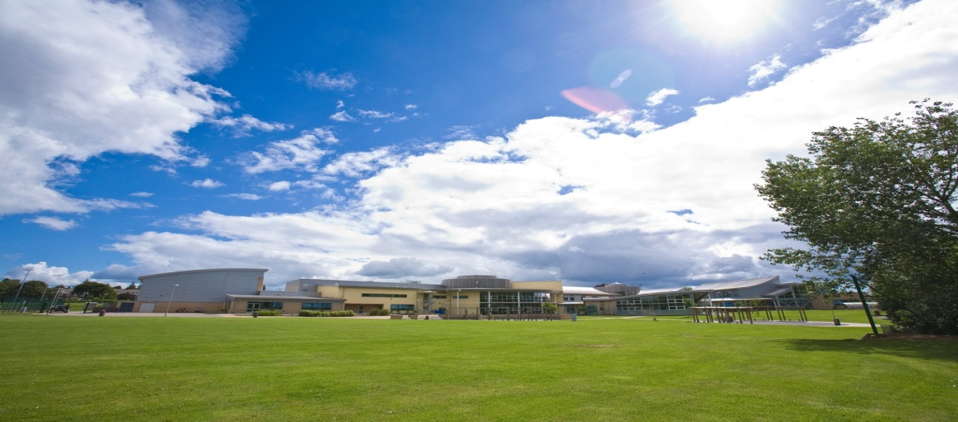
Contact Details: bharrad@iscaexeter.co.uk
Website: www.iscaexeter.co.uk
Isca Academy
Earl Richards Road South
Exeter EX2 6AP
Tel. 01392 204082
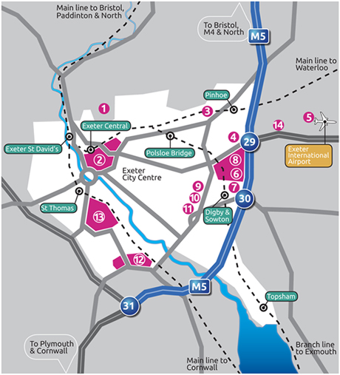
Isca

