Second in English
Information Booklet

A Warm Welcome from Holmfirth High…..

Thank you for considering applying for this key post at Holmfirth High School.

We genuinely believe our school is a wonderful place to work and develop your career. We work hard to ensure that students get the very best quality of learning experience, thus supporting them to achieve the very best outcomes. We are a school community where relationships are positive, respectful and friendly.

We strive to do the best we can for all our students so that they leave here as well-rounded, decent young people who have achieved as highly as possible and have experienced a wide range of opportunities in and out of the classroom.

We strive to provide interesting and valuable developmental opportunities for our staff too so that they know their personal and professional skills are valued and that they are both supported and challenged in their careers.

We are an incredibly busy school community with lots going on all year round. We are fortunate in having an exceptional staff team who enthusiastically provide a wealth of extra-curricular activities and experiences for our students to enjoy.

We have a well-established passion for collaboration; working in partnership with a range of other alliances, schools, colleges and universities to: share best practice; support and train entrants into the profession, and to provide exciting professional development for all our staff.

Should you choose to apply, you will be sure of a warm welcome and will be joining a highly committed, professional and friendly staff group.

Yours sincerely
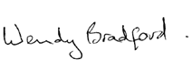

Dr W Bradford Mrs G Howe
Consultant Headteacher Associate Headteacher

Holmfirth High School

This highly successful Leading Edge school has 1300 pupils, a teaching staff of 91 and a support staff of 70.

Originally built in 1959, the school has undergone extensive refurbishment in recent years. Its facilities now include a Modern Foreign Language suite, 6 ICT rooms, a Drama studio, 8 Science laboratories, a Music suite with practice rooms and a brand new SEN department and RE/PSCHE block. The specialist school initiative has also meant the further building work of a new Maths block.

The catchment area comprises Holmfirth and surrounding villages. These provide an intake which is well balanced socially and academically. The school is conveniently situated about seven miles from Huddersfield, surrounding countryside is beautiful, set as we are in the Pennine Hills. Holmfirth is within 30-45 minutes of the centres of Leeds, Manchester and Sheffield and is easily accessible from the M1 and M62 motorways.

The school takes its community responsibilities seriously. It adopts an open policy towards parents, and pupils are encouraged to participate in the life of the school and locality in a positive and helpful manner. The school also manages the sports centre accommodation which is used by local individuals and community groups in the evenings. We became an extended school in April 2006.

As a school, we aim to be sympathetic and understanding while being purposeful and demanding. We encourage all pupils to strive to achieve the highest academic level of which they are capable.

High personal and disciplinary standards are also regarded as important. We are aware of the difficulties that all pupils share as they pass through a large school during adolescence, and we also recognise the special requirements of a small number of boys and girls who have personal or academic problems and provide as much support as we are able. We have a full time pupil counselling service and a pupil health and information service on site.

The school is organised on a year basis, with Heads of Years overseeing the job of Form Tutors. Pupils are taught in their mixed ability tutorial groups in Year 7, although setting is introduced in a number of subjects in Year 8. In Years 10 and 11, all pupils now follow a course which enables them to study English; Mathematics; Science (either combined or three separate subjects); ICT; Religious, Personal and Social Education including Careers, and Physical Education. In addition, pupils take four other choices from a wide programme of vocational and academic options.

The school has an excellent record in public examinations; the great majority of our pupils achieve high standards at education or training beyond the age of sixteen. The average pupil achieves 10 A* - C passes including Maths, English, two Sciences and a Modern Foreign Language, over 50% go on to university and less than 1% become NEET.

We attach great importance to the place of extra-curricular activities in the school programme. A wide variety of cultural, sporting, outdoor pursuits and other activities take place, with outstanding levels of success being achieved. It is hoped that applicants will give a clear indication of areas in which they are able and willing to participate.

We hope that this outline has been useful. If you have any questions please do not hesitate to telephone the school. In normal circumstances, the appointment will be made within one month from the appearance of the advertisement. Unless applicants have been invited for interview within this period, it should be assumed that the post has been filled. It is regretted that expense makes it impossible to write personally to all unsuccessful candidates.

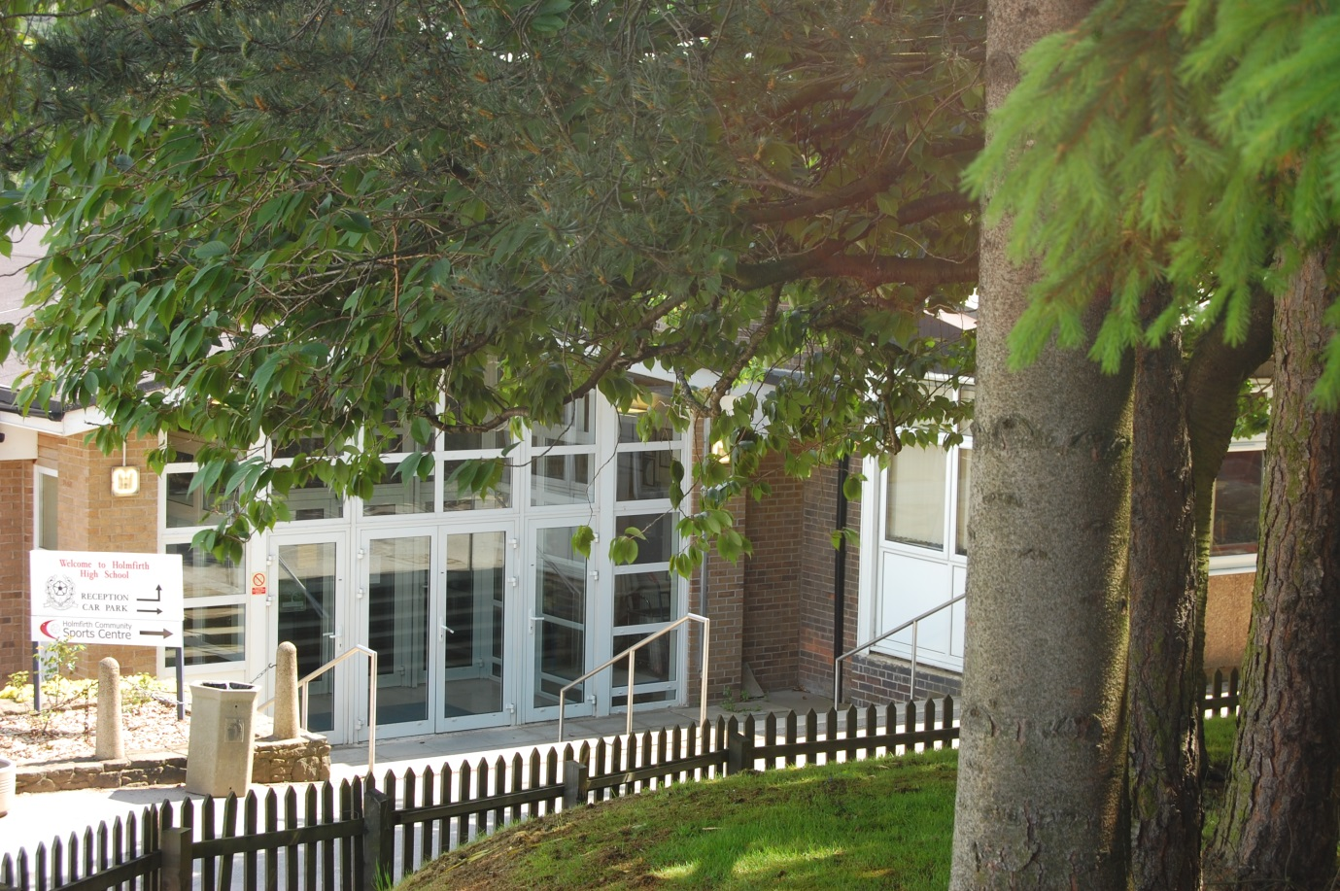

Aims of the School

- Members of the school community are encouraged to achieve their potential – academically, emotionally, socially, physically and spiritually and the school aims for the highest possible standards for all.

- The school aims to ensure that members of the school community feel valued and appreciated.

- The school aims to encourage pupils to enjoy learning through a broad curriculum delivered in a wide variety of ways and thus helps prepare them for later life.

- The school aims to develop qualities of mind, body, and spirit through the encouragement and development of various senses; reasoned thought; the ability to question and discuss rationally, to state a point of view and accept other points of view.

- The school aims to develop self-discipline, self-respect, respect for others and their property, thereby enhancing relationships with others and providing the capacity to live as independent, self-motivated adults with the ability to act as contributing members of society.

- The school aims to encourage that all members of the school community respect religious and moral values, and show tolerance and understanding of other races, religions and ways of life.

- The school aims to provide a wide range of support services for our young people in order to help them manage and cope well with concerns and problems not just with their education, but more generally with their life in and beyond school and as preparation for later life.

- The school seeks to offer a wide variety of learning and activity opportunities through our extra-curricular programme and hope that these will help encourage the development of interests and skills and social interaction.

- The school seeks to work and interact with the wider community to support local efforts to address issues and provide services and to ensure good use of school facilities in out of school hours.

Local Information

Holmfirth – the Heart of the Holme Valley

Located in the heart of the beautiful Holme Valley, Holmfirth is a small town that sits just north of the Peak District in West Yorkshire. The town is better known as the location for the popular BBC TV series ‘Last of the Summer Wine’, with thousands of fans making the journey every year to visit such locations as Sid’s Café and Nora Battye’s Steps.

Whilst ‘Last of the Summer Wine’ is a major visitor attraction, it certainly is not the only reason people visit Holmfirth. With its breathtaking scenery across the Holme Valley, Holmfirth is also popular with walkers and wildlife enthusiasts alike as it is within easy reach of a number of beautiful reservoirs and picturesque surroundings, and if that isn’t enough, there are some wonderful attractions to be seen in the town itself - from the last of the Summer Wine Exhibition, to the Holmfirth Vineyard, to the Postcard Museum or pop into The Nook for a cheeky pint!

Holmfirth is also home to a wide range of eating places, including restaurants, wine bars, pubs and take-aways that cater for a wide variety of tastes. It is one of the most popular and much loved destinations in West Yorkshire, with visitors flocking to the sleepy town all year round, Holmfirth is a wonderful place to visit, with lots of things to see and do.

Holmfirth is within easy reach of the major cities of Manchester, Leeds and Sheffield being accessible from both the M1 and M62 motorways. Our nearest town is Huddersfield which is home to Huddersfield University - winner of the Sunday Times Best University of the Year Award 2014. Huddersfield also has three sixth form colleges – Greenhead College, Kirklees College and New College.

There are many estate agents and letting agents in Holmfirth and Huddersfield, together with numerous high street banks and building societies.

Partner Primary Schools

Hade Edge J & I School  Greave Road  Hade Edge  Holmfirth  HD9 2DF  Tel 222470  Hepworth J & I School  Maingate  Hepworth  Holmfirth  HD9 1TJ  Tel 222472  Hinchliffe Mill J & I School  Waterside Lane  Holmbridge  Holmfirth  HD9 2PF  Tel 222476  Holme J & I School  Meal Hill Road  Holme  Holmfirth  HD9 2QQ  Tel 222477  Holmfirth J I & N School  Cartworth Road  Holmfirth  HD9 2RG  Tel 222481 |  | Netherthong Primary School  School Street  Netherthong  Holmfirth  HD9 3EB  Tel 222487  Scholes J & I School  Wadman Road  Scholes  Holmfirth  HD9 1SZ  Tel 222478  Upperthong J & I School  Burnlee Road  Holmfirth  HD9 2LE  Tel 222488  Wooldale Junior School  Royds Avenue  New Mill  Holmfirth  HD9 1LJ  Tel 222490

The English Department

The successful applicant will help lead a hardworking, experienced and closely-knit team, and will be expected to teach English to all year groups and ability levels.

Staffing

The English department currently comprises eleven English specialists including two NQTs and two part-time teachers. Several members of the department have additional responsibilities and our Associate Head teacher, a Head of Year and the Co-ordinator of the school council all teach in the English department.

Each member of the department has their own teaching base. In addition, the department has its own resource area/office. The department also has its own ICT suite and works closely with our school librarian.

Organisation

In Key Stage 3, pupils are taught in mixed-ability groups, but in Years 10 and 11 groups are set.

Curriculum

Key Stage Three. The curriculum at Key Stage 3 is varied, challenging and engaging. The English department currently use the Assessment Objectives for the new GCSEs in English Language and English Literature to inform teaching, learning and assessment throughout Key Stage 3.

Key Stage Four. At Holmfirth High, we follow the AQA board’s specifications for GCSE English Language and Literature. All students are entered for both GCSEs and creative schemes of work are in place to address the challenges of the new specifications.

GCSE Media Studies is currently taught as an option subject.

A small number of pupils study an entry-level qualification in English during additional literacy support.

The department’s results at Key Stage 4 are consistently above the national average, with 83% of our students achieving a grade 4 or above and 20% of our students gained a 9 – 7 grade in 2017.

The successful candidate will be a highly motivated, imaginative and dedicated teacher, with energy, vision, enthusiasm and a commitment to continuous pupil improvement in English.

POST TITLE: Second in English

SCALE: MPS/UPS + TLR2b
Holmfirth High School
Job Description

BASIC RESPONSIBILITES AND DUTIES
(As detailed in conditions of service and reflecting the Workforce Reform Act)
- STRATEGIC DIRECTION/SCHOOL DEVELOPMENT

- primarily, to support the HoD in promoting high standards of teaching and learning

- to support and promote the ethos of the school

- to actively contribute to the strategic direction and development of the subject area

- to promote high expectations and facilitate the highest standards of achievement by monitoring pupil learning and progress in line with whole school tracking systems

- to liaise with external agencies, parents and governors as appropriate
- KNOWLEDGE/SKILLS/EXPERTISE

- to demonstrate excellent teaching and classroom practice

- to maintain and develop up-to-date knowledge – subject, national, pedagogy, classroom management, research, inspection findings

- to act as a professional role model and lead by example, demonstrating commitment to own professional development

- to examine and utilise data provided (prior, predictive, comparative) to facilitate the highest standards of achievement

- KEY TASKS

- Take minutes at departmental meetings

- Liaise with Year 6 teachers – responsibility for the administration of the school’s ‘transition unit’

- Continued development and administration of Key Stage 3 internal testing. Lead review of systems for recording and using data

- Establish Key Stage 3 teaching groups

- Organise Key Stage 3 theatre trips

- Leading and sharing in the development of the department’s resources and schemes of work

- Monitoring and ordering of consumable items

- Assisting the HoD in the management of the English Resource Centre
4. PERFORMANCE MANAGEMENT

- responsibility for the line management of a number of team members

- responsibility for setting appropriate, challenging objectives and monitoring/reviewing progress towards these objectives

- to formally observe teaching and learning within the department and feedback appropriately

- responsibility for supporting the HoD in evaluating and monitoring the work of the department

- to assist with the professional development of staff within the team, delegating tasks appropriately and identifying/supporting training needs

- to support, guide and motivate team members and support staff

5. ACCOUNTABILITY

- to the HoD and Senior Leadership Team for effective fulfilment of roles and responsibilities outlined above and other duties as appropriate

Responsible to the Head of English

PERSONNEL SPECIFICATION HOLMFIRTH HIGH SCHOOL
Post Title : Second in English

QUALIFICATIONS  AND TRAINING | Qualified teacher status with appropriate honours degree  Evidence of recent, relevant INSET | Application Form  Application Form/Interview | A  A
KNOWLEDGE | Good knowledge of subject  Good knowledge of strategies designed to raise attainment levels  Good knowledge of strategies designed to increase pupils’ motivation to learn | Application Form/Interview  Application Form/Interview  Application Form/Interview | A  A  A
EXPERIENCE | Experience of teaching in the secondary sector,  Ability to use ICT both as a classroom resource and a management tool  Experience of leading teams  Ability to establish good classroom discipline  Ability to demonstrate initiative  Identifiable record of raising standards of pupil attainment in your subject  Proven experience of raising GCSE results  Experience of working with groups of teachers to raise pupil attainment level | Application Form  Application Form/Interview  Application Form  Application Form/Interview  Application Form  Application Form/Interview  Application Form/Interview  Application Form/Interview | A  A  B  A  A  A  A  B
PERSONAL QUALITIES/SKILLS | Ability to communicate effectively with staff and students  Good inter-personal skills  Sound administrator  Ability to motivate, counsel and develop both students and staff  Enthusiasm and enjoyment of teaching  Good health  Appropriate appearance and presence  Sense of humour | Application Form/Interview  Interview  Application Form/Interview  Application Form/Interview  Application Form/Interview  Interview  Application Form  Interview | A  A  A  A  A  B  C  C
Ranking System
Rank A—must have to do the job. These criteria are measured from the application form. In order to be considered for interview you must demonstrate your ability to fulfil all these criteria.
Rank B—Need to have to do the job. These criteria include attributes which are needed to do the job, but could be learnt on the job.
Rank C—Additional bonus to do the job. If we get a large number of applications for the post, the Recruitment and Selection Panel will use the “B” and “C” criteria to draw up a shortlist

Next steps…….

Thank you for taking the time to read this pack. If you wish to apply for the post of Second in English at Holmfirth High School then please complete the standard Kirklees application form which is found on our website and submit it together with a supporting letter of a maximum two sides of A4. Please also indicate in your letter of application whether you wish to be considered for full time or part time employment.

The Headteacher
Holmfirth High School
Heys Road
Thongsbridge
HOLMFIRTH
HD9 7SE

Or via email to vacancies@holmfirthhigh.co.uk or office.holmfirth@holmfirthhigh.co.uk

The closing date for applications is: 12 noon on Monday 5 February

Interviews will take place: w/c 12 February

If we have not contacted you by mid February you will know that on this occasion your application has not been successful. Please accept this as acknowledgement of the time and interest you have shown.

Thank you.

