May 2018

Dear applicant

Thank you for your interest in the post of Head of Maths. In recent years, the maths faculty has achieved GCSE results consistently in line with the national average and I am extremely proud to be the Headteacher of such a successful and rapidly improving school with an innovative and personalised curriculum which provides a stimulating education within a friendly and supportive community.
Worden is a comprehensive Converter Academy that has a proven track record of sustained improvement and growth. In February 2016 the school underwent a successful one day short inspection which highlighted the fact that Pupils leave the school with brighter prospects due to a passionate and driven leadership team working alongside teachers who care and meticulously plan for each unique cohort.

The successful candidate will work closely with the maths team to maintain standards and continue to develop independent learning, thinking and literacy skills whilst maintaining the extremely high standards in order to drive forward further improvements. If you are a committed professional, enjoy a challenge and are passionate about raising standards and making a difference, you are the person we want working with us.

Please take time to read through all the documentation and familiarise yourself with the ethos and aims of Worden and I look forward to receiving your application shortly.

Yours sincerely
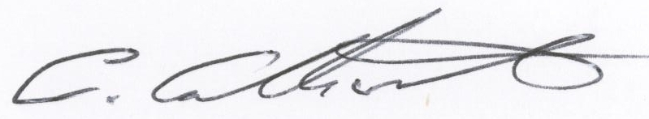

Mr C Catherall
Headteacher

