Information for applicants  Teacher of Co-curricular and Curricular Drama | 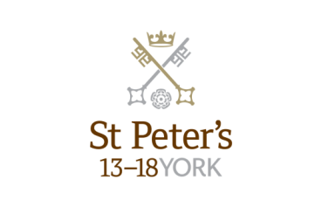

Department: Drama
Hours of work: Part Time - 0.5 - 0.75 FTE

Salary

Competitive salary based on the St Peter’s Teachers’ Salary Scale.

The Post:

The successful applicant will deliver curricular and co-curricular drama across all three schools spanning the ages 3-18. In addition to key responsibilities outlined below there may be an opportunity for appropriately qualified and experienced person also to teach GCSE and A-level drama or prepare pupils for LAMDA qualifications.

Key Responsibilities

- To teach curricular and co-curricular drama across all three schools spanning the ages 3-18.
- To take responsibility for some drama productions jointly and independently as directed by the teachers in charge of drama in each of the three schools (Clifton 3-8, St Olaves’s 8-13, St Peter’s 13-18).
- To follow and show full support for the aims and ethos of St Peter’s School (3-18).
- To create and develop a positive, happy culture where every child feels safe, valued and has fun learning through high quality play experiences.
- To be an energetic, innovative and creative teacher catering for the needs of each child.
- To recognise and meet the individual needs of each child within the class.
- To engage in appropriate continuing professional learning and keep abreast of current educational initiatives.
- To teach within the framework of the school policies (St Peter’s Teaching Standards).
Assessment and Reporting

- To monitor children’s progress and keep meaningful records evaluating progress and performance.
- To communicate fully with parents both verbally and in writing, by means of parents’ meetings and reports.

Pastoral

- To establish and maintain good relationships with children, parents and colleagues in line with the principles of inclusion.
- To share pastoral responsibility for the welfare and safety of all the children in the care of the school.

Other Professional Duties

- To undertake supervisory duties as allocated by the Head.
- To take a full part in all aspects of school life.
- To participate in meetings to discuss curriculum, pastoral and other issues including staff meetings, departmental and whole school meetings as required.
- To undertake any other suitable duties that the Head may require from time to time.
- To attend school events and activities as necessary.
- To work effectively with subject co-ordinators and support staff.

The School is committed to safeguarding and promoting the welfare of children and young people and expects all staff and volunteers to share this commitment. The successful applicant will be required to undergo checks with the Disclosure and Barring Service.
All staff at St Peter’s School are required to observe all relevant Health and Safety, Equality and Data Protection legislation and procedures.
Note: This job description is not a comprehensive definition of the post and the post holder will be expected to undertake any other tasks commensurate with the duties and responsibilities of the post. The job description will be reviewed as part of the cycle of appraisal, and it may be subject to modification or amendment at any time after consultation with the post holder.

Person specification
Criteria | Essential | Desirable | Assessment
Experience | Relevant teaching experience |  | Application  Interview  References
Qualifications | A degree or equivalent qualification in a relevant subject area | Qualified teacher status  Evidence of continuing professional development | Application
Specialist Knowledge | Thorough knowledge of the legal requirements and national guidance on the safeguarding of children  Thorough understanding of  the Drama curriculum and related pedagogy  An awareness of the positive impact that your subject  can make to the whole school | Use of local, national and statistics to evaluate the effectiveness of teaching | Interview  References
Skills / Abilities | Effective teaching skills with the ability to prepare and plan effectively  Ability to prioritise and manage time effectively  Excellent communication skills with the ability to develop and maintain good relationships with colleagues, pupils and parents  Willingness to participate in a range of co-curricular activities |  | Application  Interview  References
Personal Attributes/Competencies | A commitment to safeguarding and protecting children and young people  Passion for teaching with the ability to motivate and inspire students as well as acting as a role model  Commitment to the ethos and values of the School and make a positive contribution to all aspects of school life |  | Application  Interview  References

How to Apply

To apply for this post, submit a school application form, completed in full, with a covering letter. Please do not send CVs, either in place of or as an attachment to the application.

The closing date for applications is Tuesday 26th June 2018 at 10.00am. It is likely interviews will be held sometime w/c 2nd July.

About St Peter’s

Background

St Peter’s School, York comprises three schools: St Peter’s School (pupils aged 13 – 18), St Olave’s School (pupils aged 8 – 13) and Clifton School and Nursery (pupils aged 3 – 8 years). The school is fully co-educational with 1,100 pupils, of whom 158 are full time boarders and 231 are in the Sixth Form. There are over 300 teaching and support staff. It is one of very few schools in the North of England to offer three distinct phases of education, each sharply identified and focused towards the needs of its pupils at each age group and set within an overall context of trust, confidence-building, inspiration and opportunity.

St Peter’s is one of Europe’s oldest schools, founded in 627AD, and is ranked in the top 100 schools in the country for its academic results. The school is located within a short walk of York city centre, with its thriving cultural, educational and commercial life. Many of St Peter’s facilities are modern and spacious, with playing fields adjacent to the main building that stretch down to the River Ouse.

Clifton School and Nursery

Clifton School and Nursery, for day girls and boys aged rising 3 to 8 years, has its own building with use of extensive play areas, sports hall and swimming pool. Under the leadership of the Head, teachers use the attractive buildings and play areas to maximum advantage, teaching a broad and balanced curriculum which gives a wide variety of experiences, and emphasises the importance of basic skills. The curriculum is based on the National Curriculum and Primary Strategy, but goes far beyond this, both within the school day and during the wide range of co-curricular activities and visits outside of School.

Clifton enjoys separateness, a clear identity and its own House system. It allows smooth academic progression and provides tailor-made approaches and facilities for each age group.
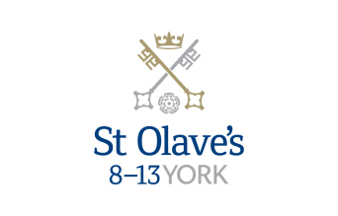

St Olave’s School

St Olave’s School (pronounced ‘olives’), for girls and boys aged 8 to 13 years, is adjacent to the main campus of St Peter’s and introduces boarding as an element of the School. Under the leadership of the Master, the teaching staff provide expertise in the 8 to 13 range, guaranteeing subject specialism to challenge and support every pupil.

The curriculum is wide and challenging with expert teaching from the earliest age. There are many opportunities for recreational and competitive sport with girls’ and boys’ teams enjoying success both regionally and nationally. There are numerous co-curricular activities to choose from on a weekly basis. Music plays a central role in school life, involving the full range of orchestral instruments.

Boarding is an integral element of the School and is accommodated in Wentworth, a boarding house on the main school campus.

St Olave’s has retained its own identity – a school within a school – giving all pupils a sense of pride and identity. It is recognised as a school in its own right, playing a vital role in the success of Clifton and St Peter’s.

St Peter’s School

St Peter’s School, for children aged 13 to 18 years, is underpinned by academic rigour and challenge. Through outstanding teaching, first rate facilities, high expectations and sheer determination on the part of its pupils, St Peter’s achieves considerable success across a broad curriculum.

The four vibrant and successful boarding houses for boys and girls lend vitality to the pastoral life of the School. Inspiration from living in close proximity to a cultured and historic city adds further richness to the pupils’ lives. The Ofsted inspection of Boarding in December 2010 found the School’s provision to be Outstanding.

The School Chapel stands at the centre of the campus and regular services (three mornings a week) give pupils and staff the opportunity to reflect together on the spiritual values of the community and on the meaning and significance of what is happening locally, nationally and globally.

Music, Art and Drama are central to the cultural and academic depth of the School. The Sports programme is extensive, providing a wide range of choice for both girls and boys. Results are excellent, and St Peter’s pupils’ co-curricular achievements are considerable. The excellence of the teaching and facilities allows pupils to thrive.

The school’s website can be visited at www.stpetersyork.org.uk. The most recent inspection report is available on the ISI website.

About York

St Peter’s School is situated five minutes’ walk away from York’s compact city centre. York is one of the oldest and most beautiful cities in Europe, famous for its gothic Minster and winding medieval streets. York has won a number of tourist awards and further details are available on the Visit York website. York is regularly voted as one of the best places to live in the UK. Such is the size and layout of York, walking and cycling are ideal ways to get around, including taking in the famous sights of this historic city; an ancient Roman and Viking capital.

York is a central rail hub between Edinburgh, London and Manchester. The main railway station is only a 15 minute walk from the School. In addition it has a large variety of restaurants, pubs, theatres, cinemas, parks, museums and galleries, and life in York is always interesting, by day or by night.

Finding somewhere to live is also comparatively easy. York’s rental sector is in good health, though demand remains high. If you are trying to buy you will find York prices are around the national average.

York is a family friendly city. Attractions such as the Jorvik Viking Centre, the Barley Hall, the York Dungeons, the National Railway Museum and the York Chocolate Story are immensely popular with people of all ages.

The city lies in the Vale of York, a valley that runs north to south between the heathery North Yorkshire Moors to the east and the famous Yorkshire Dales to the west. Both areas offer an excellent escape for walkers, cyclists, climbers – indeed anyone with a love of fresh air and rolling countryside.

A guide to the City of York can be found at http://www.visityork.org/

Employee benefits

Our vision is to be a happy, thriving 3-18 co-educational day and boarding school community that combines a classical, high quality, all-round education with a forward-looking and exciting approach to learning.

Our staff are the key to our success. It is their expertise, enthusiasm and commitment that is reflected in our high standards and continued success. In return, we offer all our colleagues a competitive total reward package from day one of their employment with us.

Annual Leave

Teaching Staff – Teachers will normally be entitled to take as annual leave all school holidays except for such time as may be reasonably required to carry out additional duties during the school holidays. This includes staff INSET training. Public holidays occurring when the School is in session are working days.

Support Staff - Employees on all-year round contracts are entitled to a basic entitlement of 25 days paid annual leave each year plus public holidays (public holidays occurring when the School is in session are working days). Part-time or term time employees receive a pro-rata allowance of annual leave. This rises to 27 days after 5 years of service.

Childcare Vouchers

Eligible employees can join our Childcare Voucher Scheme that allows tax and National Insurance savings through a salary sacrifice arrangement. This scheme is available for employees with children up to fifteen years old (or sixteen years old for disabled children).
A salary sacrifice arrangement is an agreement between an employer and an employee to change the terms of the employment contract to reduce the employee’s entitlement to cash pay. This sacrifice of cash entitlement is in return for some form of non-cash benefit. Salary sacrifice is financially beneficial for the employee as tax and national insurance contributions are not paid on the non-cash benefit.

Cycle to Work Scheme

Eligible employees can join our Cycle to Work Scheme (also a salary sacrifice arrangement) that allows tax and National Insurance savings on the purchase of a bicycle (and related equipment).

Discounted school fees

A discount on school fees is offered to eligible staff for a maximum of two children at a time, if a place is available and entry requirements are met. The discount is offered for children at St Peter’s and St Olave’s Schools only.

For part-time staff the discount would be pro-rata based on the employee’s working hours.

Enhanced Maternity Pay
After one year’s continuous service with the School by the 11th week before the EWC, you will be entitled to receive enhanced maternity benefits as well as Statutory Maternity Pay (SMP).
You will receive the following benefits for a fixed period of 39 weeks:

First four weeks of absence Full pay

Following two weeks 90% of average weekly earnings

Following 12 weeks Half pay, plus Statutory Maternity Pay (SMP)

Following 21 weeks Statutory Maternity Pay (SMP)

Free School Lunches

Staff can enjoy a free meal during the lunch period in the School Dining Room. Lunch is provided on normal working days during term time. A selection of hot and cold food, beverages and sandwiches are available.

Parking
There is extensive free parking available to staff on the school site.

Pension

For teachers, their employment with the School is pensionable under the Teacher's Pension Scheme. Teachers are automatically enrolled when required by law. Both the teacher and the School will make the appropriate contributions based upon the teacher’s pensionable salary.

Eligible support staff are automatically enrolled into the St Peter’s School Pension Scheme. Those who do not meet the government criteria for eligibility will be given the option to join/opt in. The School pays a contribution of 12% of the monthly salary and the employee is required to pay 6%.

School Chapel

School Chapel is available to former pupils, staff and people connected the school for weddings, christenings and other appropriate events. Extensive grounds and gentle green lawns provide an excellent location for a marquee or champagne reception. The School is licensed for regulated entertainment and the Memorial Hall is ideal for evening functions.
Sick Pay

Where employees are unable to attend work due to sickness, there is a provision for sick pay. The amount of sick pay increases according to the employee’s length of service and current contract.
Sports Facilities

All staff can use the school sports facilities free of charge when they are not in use by the pupils. This includes a modern gym and swimming pool.

Training and Development

Our employees are encouraged to continually develop their skills and knowledge. Training and development opportunities may include gaining a professional qualification and other learning opportunities.

How to find us

You can find St Peter’s School, York, at YO30 6AB. The School is less than fifteen minutes on foot from York Railway Station.

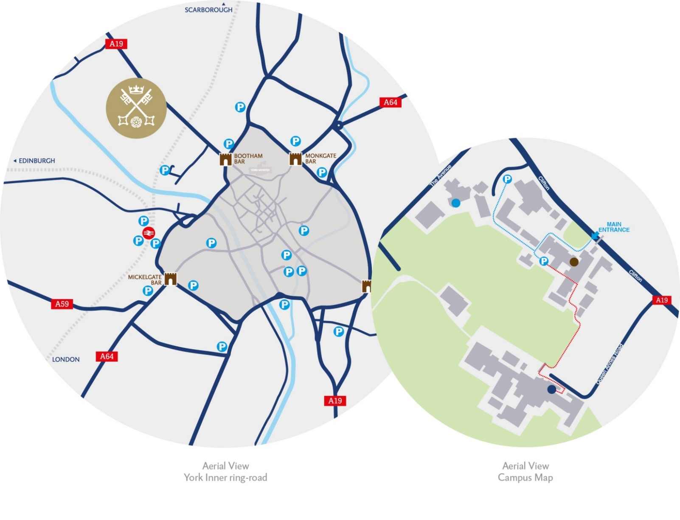
By car:

From York City Centre: Take the Thirsk Road (A19) at the Bootham Bar traffic lights. The school is 700m on the left, immediately after the footbridge.

From the A64: Take the Northern Ring Road (A1237). At the A19 roundabout turn towards the city centre. The school is two miles on the right, 300m after Clifton Green. Turn right into the school immediately before the footbridge that crosses the road.

Parking is available on site.

