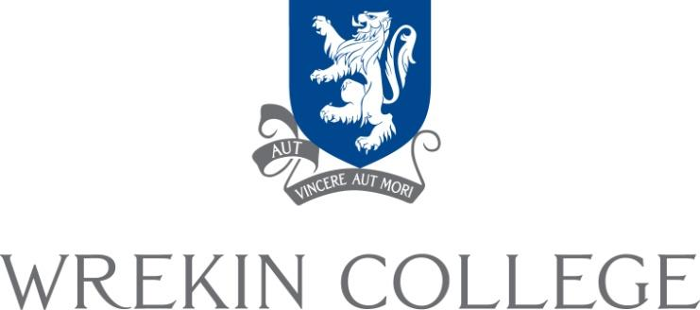

Wrekin College is a flourishing co-educational day and boarding school in a beautiful part of Shropshire. Well served by road and rail links, it combines the benefits of rural and urban living, and is an unusually happy place to work. It provides an outstanding all-round education with a strong academic core. The school community is very strong, with excellent relationships between pupils and staff. Wrekin is moving forwards with enthusiasm and energy, building on its many strengths. This is an exciting time to join the staff, and to contribute to the further development of the school.

WHERE ARE WE?

Wrekin is very fortunate in its location. It occupies a splendid 100-acre site in the leafy outskirts of Wellington, with many mature trees and well-maintained gardens and games fields, but is less than ten minutes from the M54 motorway and the shopping centre of Telford, one of the biggest in England. There is also easy and fast access by rail to Birmingham and beyond from Wellington station, a stone’s throw from the school, and Birmingham airport is less than an hour's drive away. The area is rich in history and cultural interest, including the Ironbridge Gorge, beautiful Shrewsbury, and the Shropshire Hills Area of Outstanding Natural Beauty – which includes Wenlock Edge, the Long Mynd and of course the Wrekin itself. This is Housman country immortalised in ‘A Shropshire Lad’. Telford and South Shropshire are areas of growing inward investment, and the school has good links with the local business community.

THE SCHOOL

Wrekin College was founded in 1880. Over the years it has grown and developed, and now over 400 pupils aged 11-18 are on the roll, of whom about 100 board. The school has been co-educational for forty years, indeed was one of the first schools in England to go co-ed, and relationships between boys and girls – and between all pupils of all ages – are excellent. The school is broadly traditional, operating on the model and maintaining the ethos of a boarding school, with a strong house system and a long school day (from 8.30am until 6pm). Our pastoral care is justifiably famous and much appreciated by parents. Our last ISI Inspection Report commented that “Wrekin College provides warm and special pastoral care, and treats the young as individuals”. They also recognised that the school provides “extensive facilities, well-kept and spacious grounds, which create a civilised environment and play a part in the good behaviour of the pupils”.

The school operates seven days a week, though there are no compulsory academic lessons on a weekend, and offers all pupils the benefits of boarding school life, with many pupils taking up the opportunity for flexi or weekly boarding as they move up the school. There is a wide range of activities within our packed weekly schedule. On Saturday mornings, we offer a broad programme of activities, ranging from archery to zumba dancing and academic revision clinics. Very many pupils attend activities all morning and stay on for sports matches in the afternoon.

Wrekin is a Christian foundation and although our spiritual life is not prescriptive, the chapel plays a very important part in school life. The whole school gathers in chapel four mornings a week, for a service, assembly or congregational singing practice. The way we treat each other beyond Chapel is influenced by what happens in it.

THE PUPILS

Pupils usually enter at 11, 13 and 16, or at other points when spaces are available. We are not strongly academically selective, but our pupils have an impressive range of talents, academic and otherwise. We expect to produce a number of Oxbridge candidates every year, but are equally proud of all pupils who meet or exceed their own ambitions. Our Challenge Grade Review system is designed (and works) to get pupils to aspire for their personal bests academically and in all that they do, and then achieve them. Most of our pupils stay on after (I)GCSEs, and results are very good. Regularly well over half the grades attained at A Level are A* - B grades, and our best pupils at (I)GCSE each year will achieve ten As and A*s. ALPS, a measure of value-added at A level based upon GCSE results, has placed the school consistently in the top 5% of schools nationwide over the last few years.

We have a significant number of elite athletes who compete at regional, national and even international level, including gymnasts, hockey, rugby and netball players, cricketers, cross-country runners and swimmers. Our netball teams are exceptional by national standards. We believe in ‘sport for all’, and there will be a team for each pupil to play in regularly. Music and drama are exceptionally strong and play a major role in school life. About a third of our pupils play an instrument or take part in regular musical activity. House competitions (singing, drama and debating as well as sport) excite tremendous support and a wonderful atmosphere. They are very inclusive affairs. We are proud of our pupils’ courtesy, friendliness and support for each other, their wholeheartedness and lack of cynicism, their vigorous singing in Chapel and their commitment to charitable activity.

Many of our pupils come from the surrounding area – some boarding even though they could travel in each day – but others come from further afield, including a significant minority from overseas. Our international students make a tremendous contribution to school life, in academic, musical, sporting and cultural terms.

SCHOOL STRUCTURE

Lancaster House provides a ‘school within a school’ for pupils in Years 7 and 8, offering a transition between junior school and senior school life and incorporating the best of both. There are separate boys’ and girls’ sections, with their own Housemaster and Housemistress, tutors and prefects, but Lancaster pupils also participate in many aspects of mainstream school life. In Year 9, pupils join one of the five senior houses, three for boys and two for girls. Again, each house has a Housemaster or Housemistress, tutors and prefects, and contains a mixture of day and boarding pupils. Boarding facilities for girls are centralised in Hadden Hall, and boys board in two of the three boys’ houses. Boarding duties are shared amongst the house staff, with the Housemaster or Housemistress taking the main responsibility. Within the same site, and sharing some of our facilities, is The Old Hall School, an IAPS preparatory school catering for pupils from 4-11. The two schools work very closely together, sharing a board of governors, and the vast majority of pupils come on to Wrekin from The Old Hall every year.

THE TEACHERS

Many of the teaching staff live on site, and many have – or have had – children at Wrekin and/or The Old Hall. The staff are highly committed and offer a great deal both inside and beyond the classroom. All staff are expected to contribute to co-curricular activities, including games, music, drama, expeditions, and to support evening and weekend activities of various kinds. Similarly, all teachers are involved in the pastoral care of pupils with a tutor group and are attached to a boarding house. Staff are expected to attend Chapel, including the whole school services on Sundays roughly once a term.

THE REWARDS

Wrekin offers a competitive salary, and requests for accommodation on site are often met because we have good provision. It also offers an extremely pleasant working environment, with excellent relationships between all here, well-motivated pupils, a sense of space and plenty of support from colleagues, governors and parents. The school is in very good shape, and the next stage in its history looks set to be an exciting, productive and fulfilling one.

