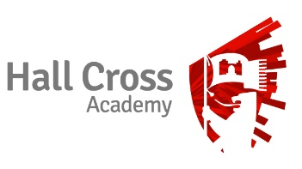

Business and ICT Department

Hall Cross Academy is an 11 – 18, split site school, serving the Hyde Park, Bessacarr and Cantley areas of Doncaster. It has well-resourced and up-to -date facilities for staff and students. The School has two sites: one which is used solely for students at Key Stage 3 and the other for students at Key Stage 4 and Key Stage 5 which is located in the town centre. We provide a friendly, stimulating environment for approximately 2,100 students across these two sites. The sixth form is large and currently has over 500 students. Performance at all Key Stages is currently in line with similar schools.

The Business and ICT department at Hall Cross is a very successful and committed department of eight teachers. The Head of Department is supported by a Second in department and three Co-ordinator posts in ICT, Computer Science and Economics respectively. Collectively the departmental team is well qualified and professional in every sense of the word. New colleagues will certainly find strong support in all aspects of school life from everyone within the department.

In ICT we currently offer OCR Level1/2 Cambridge National Certificate to over 70 students and results are above national averages. At KS5 we offer the Cambridge Technical Diploma in ICT for Y12 and 13 students which has proved increasingly popular, with student numbers rising to over 40 within the department this year. We have recently introduced both A Level and GCSE Computer Science to the curriculum which has attracted growing numbers of students to the department. We currently have two groups of A level learners at KS5 and 3 groups at KS4. At Lower school, the department delivers both an ICT and Computing curriculum to Y9 learners.

In Years 10 and 11, the Business aspect of the department offers a number of courses, which are very well subscribed. We currently have over 180 students following the Edexcel GCSE course in Business Studies, around 40 students following the AQA GCSE course in Business and Communications Systems, WJEC Retail Business and the Vcert in Business Enterprise. KS4 Business results are consistently above national averages. In Years 12 and 13 the department offers very popular courses in A level Business and Economics and the Cambridge Technical Diploma in Business at Level 3. We currently have over 115 students studying Business and over 60 studying Economics within the sixth form. Many of our students progress to study undergraduate degree in Business and ICT.

We are a well-equipped and resourced department whose accommodation includes four dedicated ICT rooms with around 20 PCs on average in each room, as well as three dedicated teaching classrooms.

