**The School**

William Brookes School converted to an Academy on 1 June 2013. We are a mixed comprehensive school with **over 980 students on roll**, including over **160 in the Sixth Form**. Each September sees us oversubscribed in Y7 and the Sixth Form has grown by 50% in the last 2 years. We value the **specialisms** we hold in **Performing Arts** and **Maths & Computing** and continue to support their profile. The school always has an exciting feel to it, with a lot going on every term. We moved into our brand new school in September 2010 and everyone, students, staff and the local community, has embraced the fantastic ICT rich facilities we now have at our disposal. Our school is very much focused on the people who work within the building and we work hard on achieving our motto of “be the best you can be through courtesy, enterprise and endeavour”.

Although situated in beautiful surroundings on the edge of the small rural town of **Much Wenlock**, we are far from being a sleepy rural school. We have **eight partner primary schools**, with whom we work very closely, but we draw from a much broader spectrum of some 25 or more primary schools, including some in Telford, Bridgnorth and Shrewsbury, as well as the **wider rural area of South East Shropshire**.

We are a **comprehensive** school in every sense of the word. Our **ability spread is wide and also well balanced**. The last few years have seen several of our students go on to Oxford and Cambridge but we also cater for students with quite complex special educational needs too. The socio-economic background of our students is equally mixed and we enjoy the same levels of support from parents from all sectors. Some children have moved to us from the independent sector, some students live in isolated communities and many live in our surrounding villages and towns, with some 25% coming from the immediate town of Much Wenlock and surrounding area, approximately 31% from Broseley, which lies to the south of Ironbridge and 17% coming from the neighbouring areas of Telford & Wrekin.

The school's dual specialist status as a performing arts and mathematics and computing college is judged to have contributed extremely well to the school’s success through enabling it to offer an excellent range of cultural opportunities for students in which to participate and also to enable them to make an outstanding contribution to the wider community. The Sixth Form came in for particular praise, as well, with its “lively and purposeful environment”, in which “students develop good social and personal skills and become confident and articulate young people” who are “extremely positive about the education they receive”. The report refers to effective teaching and excellent leadership and management which enable sixth formers to make good progress, with above average attainment.

In order to strengthen our focus on teaching and learning, the whole school has been designed around four **Learning Zones:**

**Enterprise & Technology**: Maths, ICT, Enterprise, Business & Technology

**People**: English, Art, History, Psychology, RE

**Global**: Science, Geography, Government & Politics, Law, PSHE

**Performance**: Dance, Drama, Music, Film Studies, Modern Foreign Languages, PE

Each Learning Zones has common learning environment priorities and provides the base for one of the school’s four Houses (Athens, Beijing, London and Sydney – the host cities of the first four Olympic Games of the 21st Century).

The ‘**Heart’** houses the **Student Support Centre** (incorporating Inclusion, Learning Support and Student Support), Student Services, the Library, the Sixth Form (study centre and social base) along with administrative and clerical services.

**Sports, the Arts and extra-curricular activities** are all features of William Brookes. Our letterhead is indicative of the wide range of success and achievement including the renewal of our Sportsmark Silver accreditation and Artsmark Gold. There is a **joint use Leisure Centre** on the site. As the only **“Coubertin School”** in Britain we enjoy not only a rich cultural tradition that is derived from the life and work of our namesake, Dr William Penny Brookes, but also unique opportunities for Sixth Form students to undertake activities with partner schools from across Europe and beyond. Younger students are participating in student voice and leadership activities related to the Olympics and Olympic values. Our **Arts Centre, “The Edge”**, is located at the heart of our new school and it enhances our Music, Dance and Drama facilities as well as benefiting the wider community of this part of Shropshire and reflecting our great strengths in the performing arts.

Visitors to the school continue to comment very positively on the “**good feel**” and respond very enthusiastically to the school buildings and facilities. Relationships are good and most people - staff and students - are happy here. We pride ourselves on providing a **secure environment within which individuals can flourish** and the **Every Child Matters** agenda is prominent. Values are largely traditional, as are standards of discipline – behaviour and safety is generally outstanding. Our work on **student retention and inclusion** is a strength and a result of us working in partnership with the LA Children & Young People’s Services and other agencies.

We consider ourselves very fortunate to work in a wonderful school with fantastic facilities in a beautiful location. We want William Brookes School to be a great place to learn and a great place to teach and hope that you will want to join us and be part of its exciting future.

**Curriculum**

Our broad and balanced curriculum seeks to maximise the achievement of all our students. It meets the requirements of the revised National Curriculum and is also tailored to the specific needs, interests and aspirations of our students.

Our curriculum contributes to the spiritual, social, moral and cultural development of students. This is achieved through the caught curriculum and through the programme of enrichment activities which help to deliver key aspects of personal, social and health education, as well as citizenship. The curriculum provision is also supported by a strong commitment to impartial careers information, advice and guidance.

**Key Stage 3:**

**Years 7 & 8 Year 9**

|  |  |  |  |  |
| --- | --- | --- | --- | --- |
| **Subject** | **Periods** |  | **Subject** | **Periods** |
| English | 3 |  | English | 3 |
| Maths | 3 |  | Maths | 3 |
| Science | 3 |  | Science | 3 |
| Physical education | 2 |  | Physical education | 2 |
| Design and Technology | 2 |  | Design and Technology | 2 |
| ICT | 1 |  | ICT | 1 |
| Performing Arts | 2 |  | Performing Arts | 1 |
| Art | 1 |  | Art | 1 |
| History | 2 |  | History | 2 |
| Geography | 2 |  | Geography | 2 |
| RE | 1 |  | RE | 1 |
| French | 2 |  | French | 3 |
| PSHE | 1 |  | PSHE | 1 |

In Y7, subjects are mainly taught in half year groupings of 3 classes, set by individual departments. Maths, English, Science, PE and DT teach in four groups.

In Y8 and Y9, subjects are taught in half year groupings of 3 classes, set by individual departments. Maths, English and Science teach across the whole year in 7 groups. PE and DT teach half years in four groups.

**Key Stage 4:**

**Years 10 & 11**

|  |  |
| --- | --- |
| **Subject** | **Hours per week** |
| Maths (8 sets in 2 half years) | 4 |
| English (8 sets in 2 half years) | 4 |
| Physical education (8 sets in 2 half years) | 2 |
| Science (7/8 sets in 2 half years)  We teach triple and combined Science | 6  3 (vocational students) |
| PSHE (7 sets) | 1 |
| **Options (7/8 groups per block):**  Art, Business Studies, Citizenship, Computer Science, Dance, Drama, Food, French, Geography, History, iMedia, Music, PE (BTEC & GCSE), Product Design, RS, Textiles | (4 x 2) = 8 |

**College Provision:**

|  |  |
| --- | --- |
| Motor Vehicle Maintenance | 1 day per week |
| Construction |
| Hair & Beauty |

**Key Stage 5:**

The vast majority of students will study 3 A level courses over a two linear model. This means that students would not be expected to sit AS level exams at the end of Y12. Each subject would also be allocated 5 hours of contact time.

Subjects would be placed into two categories:

* Subjects that we are definitely going to offer based on previous recruitment, retention and results track record: **Maths, Biology, Chemistry, Physics, English, English Literature, History, Geography, Theatre Studies, Government and Politics, French, Further Maths, ICT (or I-Media), RS and Business Studies**, **Dance, Art, Psychology, Law, Computer Science, Design Technology, PE and either Music *or* Music Technology**
* Our Sixth Form is currently 160 in number with many high flying students. Maths numbers continue to be high at both AS and A2, with growing numbers opting for Further Maths at both AS and A2 (9, 5).

**Pastoral Care**

**Student Welfare:**

Student welfare is supported through vertical tutoring and the House system, both of which enable students to develop positive relationships with their peers and with students from other year groups in the school. Tutors monitor academic and pastoral progress, and act as a “Key Worker” - the main point of contact should the student, or their parent, have any concerns. Subject teachers may also be contacted about specific issues. Tutors are supported by House Leaders to whom they may refer issues such as attendance, progress or behaviour if these matters become more serious, or if they affect more than one subject.

**Our House System:**

|  |  |  |
| --- | --- | --- |
|  | **House Name** | **House Leader** |
|  | Athens | Mark Wilson |
| Description: Description: http://www.predock.com/dr2004/TempleofHeaven2.jpg | Beijing | Russell Pugh |
| **London Logo** | London | Steve Tough |
| Description: youtube-symphony-2011 | Sydney | Ruth Bennett |

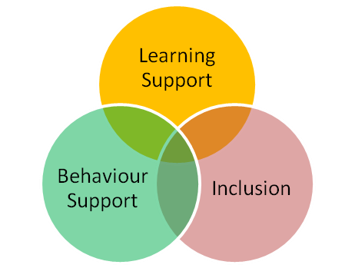**Support for Learning:**

Sometimes a student needs more specialist care and support. The circle diagram to the right illustrates that this is available through a central facility and consists of three specific arms - Learning Support for particular learning difficulties or Special Educational Needs, Inclusion for emotional support and Behaviour Support when withdrawal from lessons is appropriate. These three departments work together to carefully identify individual needs, construct programmes which meet these needs and liaise closely with students, families and the wider school.

**Our Support Partners:**

**West Mercia Police - PC Jane Cowan’s** role as local Police Officer is to improve contact and communication with the local community; this includes involving herself with young people, so being at school is the ideal opportunity. She provides students with advice on the law, and even careers within the police service. She is involved in the anti-bullying programme and recently in the training of the anti-bullying mentors. She is trained in restorative justice, allowing her to participate in mediation sessions when dealing with bullying incidents.

**School Nurse – Karen Kerr** works for the Primary Care Trust and provides a vital link between health and education. She attends school on Wednesday afternoons offering counselling and advice services to students. Karen is also involved in school vaccinations and training programmes related to particular students’ medical needs. Karen also works with CHAT (Confidential Help and Advice for Teenagers), assisting with workshops throughout the year and also contributes to the PSHE programme and the health calendar. CHAT services offer help and advice for teens on a wide range of health and social issues. Young people can access the school based CHAT services for a one to one consultation with an appropriate professional. Open workshops are also held on Wednesday lunchtimes in the London breakout zone offering advice and information on all sorts of issues affecting young people.

**The Link Surgery** is a drop in service run by one of the local GPs and Nurse Practitioners. Available to students on Tuesdays 13.10-14.10, it is a confidential service where students can come and get help and advice on subjects such as weight and food issues, minor injuries and ailments, sexual health, smoking and other

problems that may be worrying them.

**Side By Side Counselling - Sarah Davis** is an independent counsellor who provides counselling to students in school. Sarah can be accessed through a referral made our Head of Inclusion Support. Sarah is a registered member of the MBACP.

**Behaviour for Learning:**

Students are aware of the clear expectations regarding their conduct in and outside of school and we have an established system of rewards and sanctions to support behaviour. With support from parents, we work in partnership to instil the positive values of courtesy, cooperation, respect and equality to that they conduct themselves as excellent ambassadors for the school and the community. Positive praise and rewards are key tools for staff in maintaining motivation for learning and good behaviour at William Brookes School. A reward does not necessarily have a material profit and can be as simple as positive verbal or written praise. Rewards at William Brookes School are linked to the House system and competition between Houses. Students are rewarded with House Points for a range of reasons including:

|  |  |
| --- | --- |
| **Preparedness for Work** | * Being fully equipped for lessons * Arriving on time * Is ready to start work quickly * Homework is completed |
| **Attitude to Learning** | * Active involvement in lesson * Completes all tasks * Involved in group work (willing participant) |
| **Independence** | * Willing to try things on their own first * Asks questions as well as answer them * Is resilient and willing to try again |
| **Desire to Improve** | * Completes all improvement foci (responding to comments) * Seeks support in and out of lessons * Work is completed to a high standard |
| **Literacy** | * Spells subject specific words correctly * Uses punctuation and grammar well in extended written tasks * Active listening so that all instructions can be followed accurately |

House Points are also awarded for participation in or contribution to extra-curricular activities, completing Accelerated Reading tasks or meeting the ideals of Baron de Coubertin. The House Points are recorded electronically on ‘Class Charts’ and link directly to the House competition and the rewards given as part of this.

Other rewards that can be given are:

* Postcards home from the learning zone (with a weekly focus for teachers on specific year groups);
* Heads Commendations (for exceptional work or effort),
* Other subject specific or tutor group rewards.

**Extra-Curricular Opportunities**

At William Brookes School we believe in providing opportunities to nurture the “whole” person and therefore provide our students with opportunities to develop their character through numerous extra-curricular activities.

**Lunchtime & After School Clubs:**

As well as opportunities for students to extend their learning they may also explore other interests. Cheerleading, STEM, ICT and Coding, Photography are just a few of the many clubs available for students to attend. In addition, the Performing Arts team offer Dance, Music and Drama and there are school teams for boys and girls football, rugby, hockey, cricket, basketball, netball, badminton and table tennis.

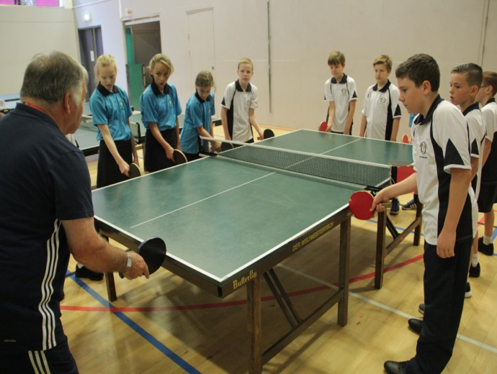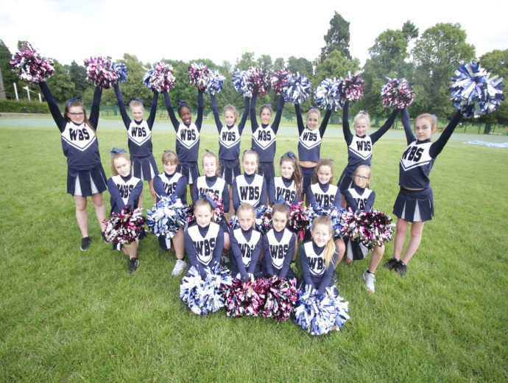

**Inspirational Visits:**

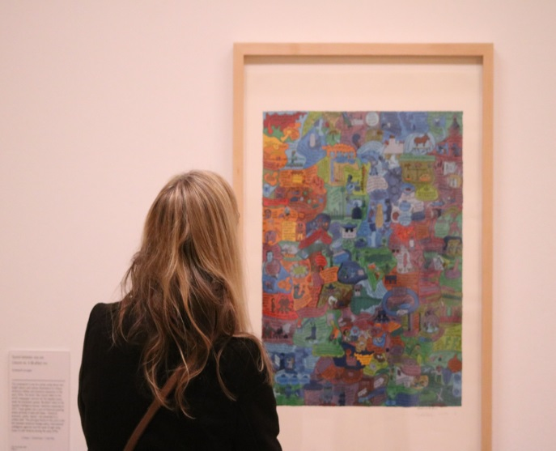Students from all year groups also have the opportunity to watch live sports events. In recent years, students have been to watch England play cricket at Edgbaston, football at Wembley and rugby at Twickenham. Throughout their time with us, students also have many opportunities to go on trips to support their learning such as in KS3 when they take a trip back in time and visit mock WWI trenches and the Worcester Commandery, in KS4 to visit art galleries and museums and in KS5 to visit the law courts to witness real hearings.

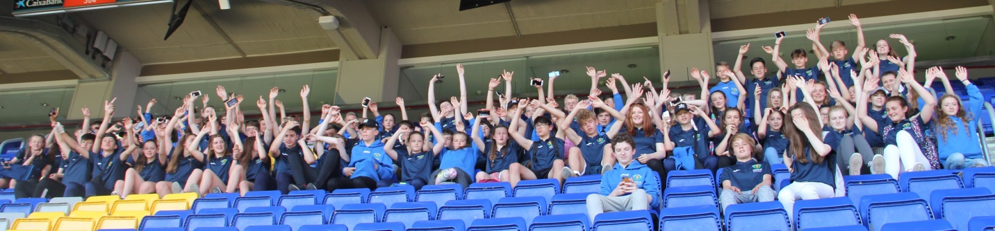

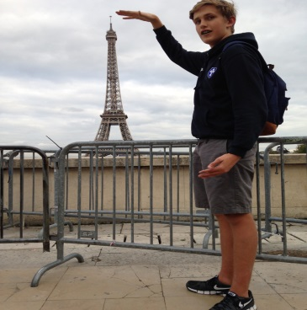**Residential Experiences:**

Students have the opportunity to participate in the following residential visits:

Year 7 Opal Coast, France

Year 8 Arthog Activity Centre

Year 9 French Exchange

Year 10 History/RS visit to Germany

Year 11 History visit to London

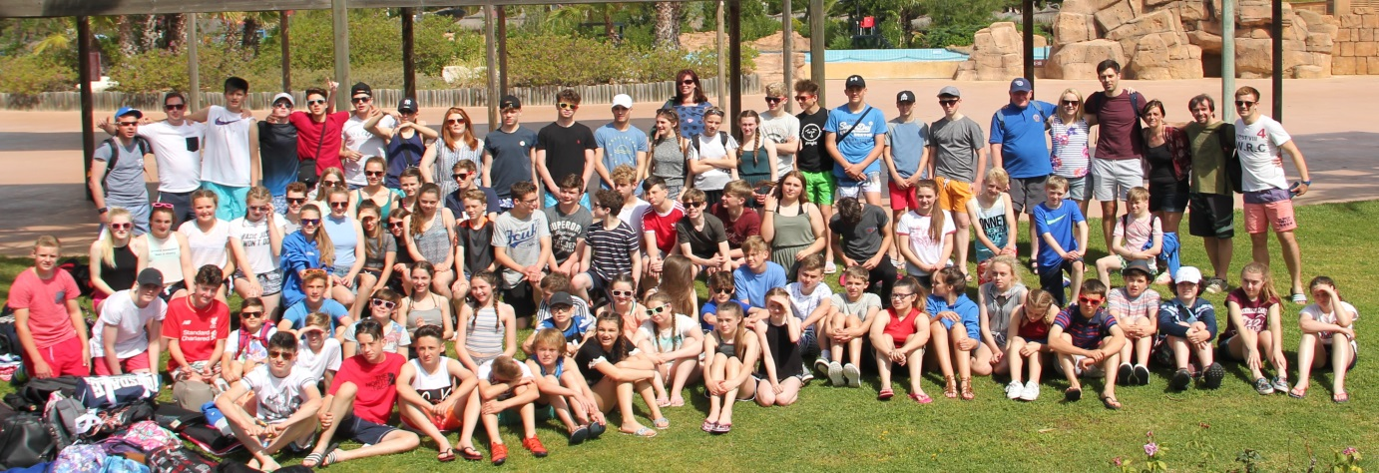

**Duke of Edinburgh Award Scheme**

The prestigious Duke of Edinburgh Award Scheme is recognised by universities and employers for its emphasis on character building. Students from Y10 onwards can start training and preparing for a bronze, silver and ultimately gold award. Planning and organisation are essential skills but resilience and leadership are also developed through the demands of the programme.

**Inspirational Visitors:**

Over the last 6 years, we have hosted visits by a number of sporting stars including Tom Davis (Wrestling), Mel Clarke (Archery) and Heather Fisher (Rugby)