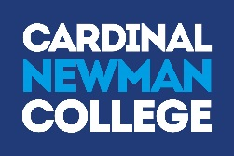
Lark Hill Road
Preston
Lancashire
PR1 4HD

Tel: 01772 460181
Fax: 01772 204671
Email: hr@cardinalnewman.ac.uk
Web: www.cardinalnewman.ac.uk

Dear Applicant

We are delighted that you are considering applying for the post of Teacher of Health, Social Care and Early Years (full or part time- minimum 0.5fte) to take up post from end August 2018.

Cardinal Newman College is a wonderful place to work and we welcome applications from those who are keen to gain a broad experience of working in an outstanding institution. We are a happy and thriving Catholic Sixth Form College and welcome colleagues and students into our community regardless of their religion or belief, ethnicity, gender, disability, sexual orientation, marital or pregnancy status.

At Cardinal Newman, we are committed to the development of the whole person and we value each student as an individual, with a unique mix of skills and talents. Our students achieve outstanding results, which consistently place Cardinal Newman amongst the top four Colleges nationally for Value Added. We were awarded Beacon Status in 2010 and the College was awarded an ‘outstanding’ Inspection in May 2009. However, we are as proud of our students’ social, cultural and spiritual achievements as we are of their outstanding exam results. We have a fabulous team of colleagues who give up an extraordinary amount of time to support their students and their fellow members of staff. The dedication and attention to quality they exhibit is what makes our College so successful.

If you meet the criteria of the post advertised and feel that you would enjoy working here, we hope you will make an application to join us. We welcome applications from suitably experienced and newly qualified teachers for appointment to this teaching post. Please note that we welcome applications from teachers wishing to work full of part time (normally a minimum of 0.5 fte).

Completed application forms should be returned to the Human Resources Department (via email or post) by 8.00am on 19th March 2018. We do ask that you accept, in the interests of economy, that if you have not heard from us by mid-April you have not been selected for interview on this occasion.

We will confirm receipt of all applications by email within one working day of receipt. Please call the HR team if you have not received a confirmation email by the closing date.

Should you have any questions, which are not covered in the enclosed information, please do not hesitate to contact the Human Resources Department.

Yours faithfully
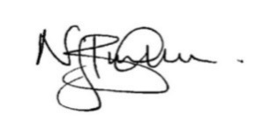
Nick Burnham Principal
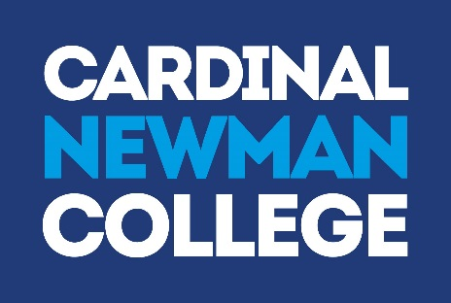

Mission Statement

As a Catholic Sixth Form College, we strive to be a centre of educational excellence for the community built on faith, respect and trust. We celebrate diversity amongst all our students and staff and seek to nurture the gifts of each individual through high quality teaching and learning and dedicated pastoral care.

Values Statement

Cardinal Newman College is a community, which aims to live out the gospel values of service and love. This means that:

- The individual student is central to all our endeavours
- The College values each individual as a unique person irrespective of gender, race, belief or ability and regards each person, made in the image and likeness of God, as worthy of the utmost respect
- The College strives to develop each person intellectually, socially and spiritually through an inclusive programme of study and enrichment
- The College values the spiritual journey of each individual and will offer opportunities for each to engage appropriately in their spiritual search
- The College is committed to creating a culture that is open and welcoming, free from fear and from violence of any kind, in which all individuals feel safe, happy and secure
- The College provides learning environments that are stimulating, enjoyable and challenging to students, fostering their creativity, imagination and search for truth
- The College encourages individuals to contribute positively to the world in which they live, to challenge injustice and to seek out more co-operative, just and peaceful forms of human existence.

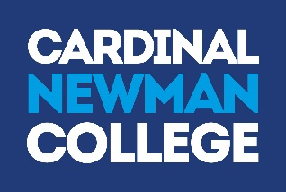

Health and Social Care at Cardinal Newman College

This is a large and vibrant vocational department increasingly popular with students who aspire to work with people in a career relating to health, social care or early years. In recent years there has been a significant increase in student numbers and the range of courses being offered. There are currently over 300 enrolled students in the department, this includes a small cohort of 17 level 2 students and the remainder studying at level 3.

The department is consistently graded outstanding in Self-Assessment, all measures of success are significantly above National and SFC bench marks. All courses adhere to Pearson’s NQF and QCF quality assurance processes and L3 student success and achievement of high grades is outstanding. At L2 there is consistently significant success, with excellent outcomes for students. Supporting work experience opportunities is integral to H&SC teacher role. A culture of high expectations exists within the department, student progression rates onto course related Higher Education, training and employment is high.

The department celebrates diversity of its students and nurtures their gifts and talents through a high quality educational experience. We are committed to placing students at the centre of all our endeavours, we have a proactive student voice strategy and involve students in quality improvement.
The person appointed must embrace the ethos of the College and be willing to share in and promote the gospel values on which the College is founded. They will become part of an extremely hard working, supportive, generous and very positive team who are highly flexible, determined to support all students to achieve their full potential.

Job Description and Person Specification

JOB DESCRIPTION
TEACHER

Responsible to: Head of Health and Social Care

Main Duties and
Responsibilities:

- To contribute fully to the mission and values statement of the College ensuring its effective implementation in all aspects of College life.
- To plan, prepare and deliver high quality lessons in order to achieve excellent student outcomes.
- To set and mark work in accordance with College and department Assessment policy, to record work carried out and assessment of same.
- To develop rapport with individuals and whole groups in order to facilitate the learning process.
- To liaise with the Head of Department in contributing to the administration, necessary to support the teaching and learning within the subject area.
- To attend and contribute to team, full staff and other relevant meetings.
- To communicate and consult with parents, carers, students as appropriate, including attendance at Consultation and Open Evenings.

PERSON SPECIFICATION
TEACHER

Qualifications / Attainments:

The successful candidate should have:

- A relevant degree | Essential
- A teaching qualification (e.g. PGCE, DTLLS or equivalent) | Essential

Experience / Knowledge:

The successful candidate should be:

- An excellent classroom teacher | Essential
- Able to display a high level of skills in the management of learning | Essential
- Competent in IT skills | Essential

Personal / Skills / Attitudes:

The successful candidate should:
- Display the values, attitudes and behaviour consistent with the Catholic Ethos of the College  - Have a commitment to Equality/Diversity and Safeguarding of young people and vulnerable adults  - Have eligibility to work in the UK  - Have Disclosure and Barring Service clearance (following appointment)  - Have a high level of communication and interpersonal skills | Essential  Essential  Essential  Essential  Essential
- Have an ability to enthuse and innovate | Essential
- Have an ability to set and achieve high standards for themselves, colleagues and students | Essential
- Have a high level of organisational and administrative skills | Essential
- Have a commitment to a student-centred approach to the learning process | Essential
- Have the ability to work effectively in a number of different teams | Essential
- Have an awareness and understanding of current developments in subject areas | Essential
- Have the ability to manage student progress and achievement and complete all relevant documentation | Essential

About Cardinal Newman College

Based in the heart of Preston city centre, Cardinal Newman College is a Catholic Sixth Form College. Our core activity is to provide education for students aged 16-18, offering a range of A Level and BTEC courses, at both level 2 and 3. The College also offers a Foundation Learning course for young people with specific learning needs. In addition to the 16-18 provision, Cardinal Newman also offers a range of University courses, including Foundation Degrees in Teaching and Learning Support and Early Years, as well as the School Direct Programme, offering Initial Teacher Training for graduates looking to get into teaching.

Cardinal Newman College is the post-16 provider for the Newman Partnership, a working group consisting of the College and ten Catholic Partner High Schools. The location of these schools demonstrates the wide area from which the College draws a significant proportion of its full time 16–18 learners. Because of its distinctive ethos, its reputation, the levels of achievement, the support the College offers students and its provision of high quality courses, Cardinal Newman College is an attractive option for learners who attend other high schools in Preston and the surrounding area as well. Year-on-year applications from these schools have increased significantly.
An Outstanding College

The latest Ofsted Inspection in the summer of 2009 graded all areas of the College as ‘outstanding’. It confirmed that there is a culture of high expectations and rigorous quality improvement in all areas. Standards, expectations and processes have continued to improve since then. Students achieve well above their (high) target grades and make a positive contribution to the College and its wider community. Student attendance and behaviour are exemplary, illustrating that the Catholic mission and ethos of the College is lived out at all levels.

Every year, the vast majority of the College’s students, progress to Higher Education with almost 40% of those taking up places at Russell Group Universities.

Our Community

Links with the local and Catholic partner high schools are very strong. The Principal meets regularly with Head Teachers and the Newman Partnership Head Teachers meet to discuss and share a wide range of curriculum, pastoral and strategic issues. Relationships with College trustees, and with the Diocese of Lancaster are maintained through the foundation governors.

The College has outstanding links with both the local and wider community. Learners and staff fully contribute to this for example students at the College are continually seeking to engage in volunteer work within the community. Voluntary work is carried out in the local community by the CAFOD Group; Foundation Learning students; Health and Social Care students; the Medical Society and Chaplaincy. The curriculum departments also contribute widely to the links with local community groups, charities and local primary schools.

As a Catholic Sixth Form College we strive to be a centre of educational excellence for the community built on faith, respect and trust. We celebrate diversity amongst all our students and staff and seek to nurture the gifts of each individual through high quality teaching and learning and dedicated pastoral care.

Students study in a purposeful and diverse environment with a strong focus on respect in which every learner genuinely does matter. The team of specialist RE teachers live out the college’s commitment to ‘valuing the spiritual journey of each individual and offering opportunities for each to engage appropriately in their spiritual search’.

College Facilities

At Cardinal Newman College, we are blessed with wonderful surroundings for our students to work, learn and relax in. The College contains Lark Hill House, which was built in 1797 as a private house for Samuel Horrocks, a cotton manufacturer and later Mayor and Member of Parliament for Preston. In 1919 it became Lark Hill Convent Grammar school, which began taking sixth form students in 1967 from other local Catholic Secondary Schools. It finally became Cardinal Newman College in 1978, when it merged with Winckley Square Convent School and Preston Catholic College, taking its name from Cardinal John Henry Newman.

Over the past few years the College has embarked on an extensive redevelopment programme with approximately £16 million worth of investment in state-of-the-art facilities, which perfectly combine the old with the new.

In 2009 we saw the addition of the St Cecilia Building and the St Augustine’s Building in 2010, which was renovated and refurbished to house classrooms, drama/dance studios, as well as the original sports facilities. 2015 saw the addition of yet another new building in the form of St Francis, which is home to new classrooms for Sociology and Maths, as well as Open Learning Centres, Seminar rooms and a Mango Bean Coffee shop.

A further addition to the College’s already outstanding facilities, in the form of a brand new state-of-the-art gym in the St Augustine building, opened in October 2016. This was accompanied by a complete refurbishment of the social space and café area of the St Augustine’s is building. This site also added a new modular building within its grounds, where RE lessons are now delivered from the eight classrooms it has provided.

Staff at Cardinal Newman College

Cardinal Newman College has achieved all of its success through the hard work, skills and commitment of its 260 plus staff. We seek to work with an inclusive and transparent style of management, which is open, consultative and encourages all staff to participate in the leadership and management of the College. The development of staff skills is a priority for the College and teams are encouraged to innovate and continuously improve Cardinal Newman’s curricular and pastoral offer to its students.

What our staff say about working at Cardinal Newman College

Over the last five years staff have been asked to take part in an annual staff survey. The college’s score, as determined by staff, has improved year on year and we are pleased that the scores for all areas (culture, demands, control, relationships, change, role, support, personal wellbeing and work-life balance) places the college at or above the top 10% of employers who take part in the same survey.

What our students say about Cardinal Newman College

Name: David Corr
Previous School: Astley Park
Programme of Study: Foundation Learning
“I wanted to come to Newman because my brother came here and I had heard good things about the course from people I know who were already studying it. I like meeting old friends and making new ones as well as being challenged by my work. I have lots of fun making clubs at lunchtime so that me and my friends can do things that we enjoy like dancing!”

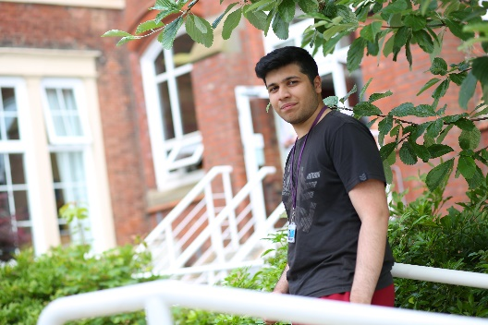
Name: Adil Lakha
Previous School: Archbishop Temple
Programme of Study: A Levels in Biology, Chemistry, Maths and Physics
“There are plenty of excellent enrichment opportunities available at Newman where you can stretch yourself beyond the standard course syllabus. All of my teachers have been enthusiastic and engaging and they are always willing to give me extra help outside of my lessons. I have really enjoyed my subjects and I have met some great friends here at Newman.”

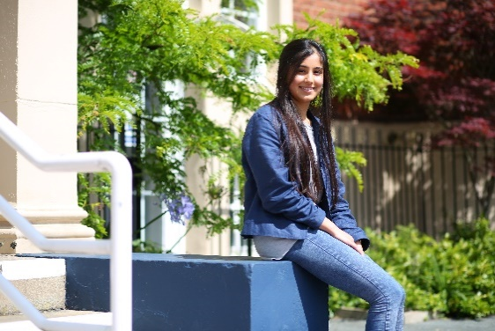
Name: Henna Reddy (main entrance blue jacket)
Previous School: Westholme
Programme of Study: A Levels in Biology, Chemistry and Maths
“Newman has opened my eyes to lots of opportunities and has allowed me to grow so much as a person, both academically and socially. I’ve had the chance to meet so many different people and the teaching here is excellent.”

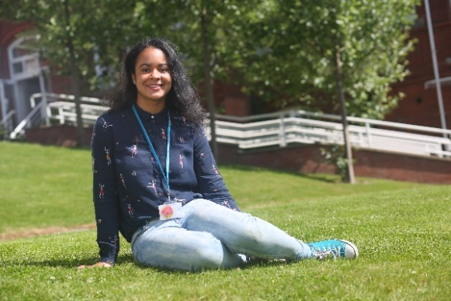

Name: Ella Shaw
Previous School: Leyland St Mary’s
Programme of Study: A Levels in French, Spanish, English Literature
“I have been able to develop my own interests and I have loved the independence that college has given me. Newman is definitely an amazing College and you feel part of something when you’re here. There hasn’t been a day where I have regretted coming to Newman, it’s everything I hoped College would be.”

Name: Abbie Lund
Previous School: Clitheroe Royal Grammar School
Programme of Study: A Levels in Maths, Physics and Further Maths
“I decided to come to Newman because I wanted a change of scene and the chance to meet new people. Throughout my two years here I have always been encouraged to excel. When choosing which college to attend, make sure to go somewhere you feel comfortable and choose subjects you enjoy, success comes a lot more easily when you’re happy!”

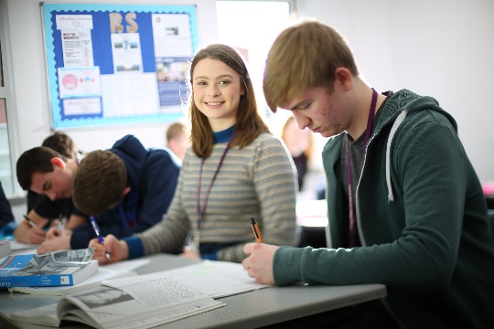
Isabella Raven
Previous School: Broughton
Programme of Study: Religious Studies, Philosophy, English Literature and EPQ
“I felt that coming to Newman would be a big step up from high school but Newman has made the transition much easier. You have a lot more independence when you come to College but the teachers are really supportive and welcoming. They will help you whenever you need it, but also push you to achieve your best. Newman has changed my life!”

Temiloluwa Onilogbo
Previous School: Lancaster Royal Grammar
Programme of Study: A Levels in Maths, Chemistry, Physics and French
“The most important thing is picking courses that interest you and if a College you like has these subjects; go for it! For me, Newman has been a great step up from High School. You can meet people from all over Lancashire, who are actually interested in the subjects that they take, creating a welcoming learning environment.”

Matthew Holden
Previous School: Holy Cross
Programme of Study: A Levels in Economics, Modern World History, English Literature & Business Studies
“After researching local colleges and attending several open days, I was impressed by Newman’s facilities and friendly atmosphere. Their reputation as a brilliant college and their position in Sixth Form College League Tables also helped me decide that Newman was the right college for me.”

 | 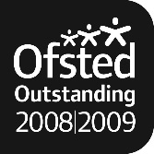 | 