Beaconsfield Drive
Blurton, Stoke-on-Trent
ST3 3JD

Telephone: 01782 882200

Email: info@ossma.co.uk
Website: www.ossma.co.uk

Mark Stanyer
Principal

October 2019

Dear Applicant,

Application Pack – Director of Faculty - Mathematics

Thank you for your interest in the above post for which I have enclosed all the relevant documentation:

- Application Form
- Job Description
- Information about the school
I would like to take this opportunity to enlighten you on our vision and philosophy. I believe passionately in providing a high quality education for the young people of Blurton in order to help the city improve its national profile but, more importantly, ensure our students create a better life for themselves and their families by raising their aspirations and achieving academic success. We are looking for someone with exceptional qualities to be part of our dynamic and innovative community and who has high aspirations and expectations for each and every one of our pupils. Our outstanding personal development, behaviour and welfare as judged by OFSTED is encapsulated in our ethos that “manners maketh man”.

Ormiston Sir Stanley Matthews Academy is one of four Ormiston sponsored academies in the city. We converted from Blurton High School to an academy in September 2010 and have never looked back.

We are a National Support School as designated by the DFE with myself as a National Leader in Education. We are also the lead for School Centered Initial Teacher Training (SCITT) which links with Keele University. We invest heavily in professional development for our staff, and have an outstanding track record of staff moving on to senior posts regionally, nationally and internationally.

We have an open door policy and actively encourage visitors to come and look around our academy.

I look forward to receiving your application.
Yours sincerely,
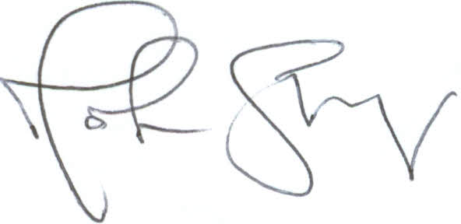
M Stanyer
Principal

