



King Henry VIII School, Abergavenny

Ysgol Brenin Harri’r VIII

Leader of Physical Education

Sports Leadership

Information Pack

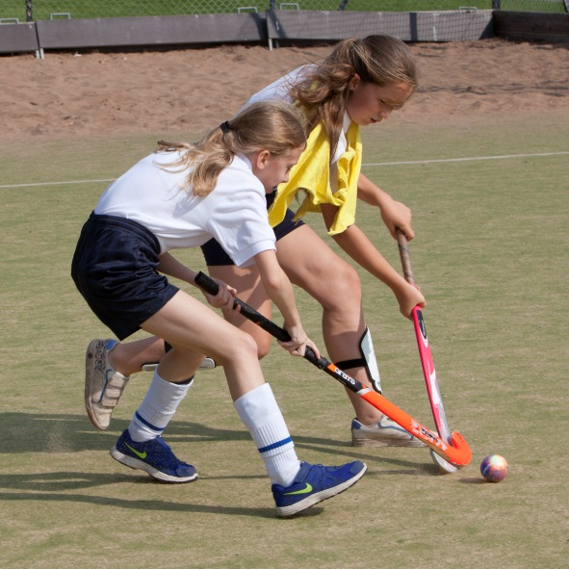 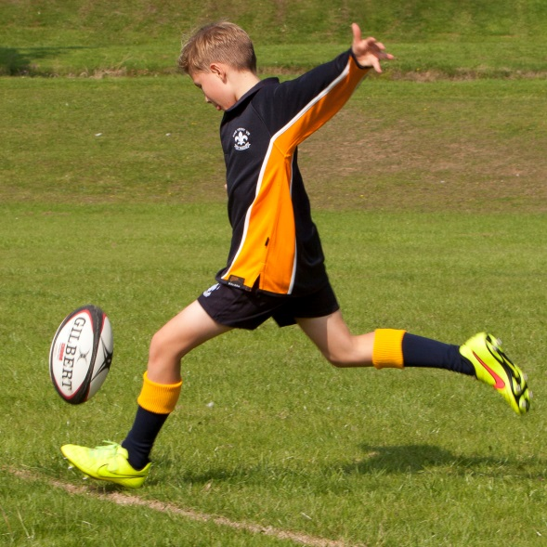

*“Respecting tradition, embracing the future”*

**Introduction**

Dear Candidate

Welcome to King Henry VIII School and thank you for considering applying for the position of Leader of Physical Education and 2nd in Department. To assist you with your application I thought it would be useful if I gave you a brief introduction to our school.

The school is currently going through an exciting school improvement journey and we are seeking a dynamic and inspirational leader to join our school. I have been Headteacher here since September 2014 and was delighted in the positive pupil outcomes last summer. In 2016 our A2 results were our best ever with 60.1% of grades A*-B. At KS4 we also achieved our best ever results, the number of pupils gaining 5 or more GCSE A*-C including English and maths was 71.2%, placing the school in the top 25% when compared to similar schools. These outcomes demonstrate the excellent relationships that exist between our dedicated staff and hardworking pupils. We have laid solid foundations for what will be sustained progress with the aim KHS becomes an outstanding school.

In January 2017 the Welsh Government School Categorisation was published with KHS being graded **1 B Yellow**. Most recently we have secured **Pioneer School status** for ‘Professional Learning’. This aligns to our ongoing focus on further improving the quality of teaching and learning through our Peer Review programme and vibrant in house Professional Learning Communities.

Staff here are extremely friendly and welcoming. They are passionate about our pupils, the school and want to be successful. They have embraced a number of significant changes implemented since my arrival and the level of care they show to pupils is exemplary. The Governors are supportive of the school and contribute greatly to our self-evaluation and improvement processes.

Our pupils have positive attitudes to learning and behave very well around the school and in lessons. We are an inclusive community with a caring ethos that celebrates and rewards success and achievement of every individual pupil. The school is set in well-maintained grounds and our buildings provide a stimulating environment that enhances pupils’ learning.

Although we are pleased with the improvements we recognise there is still work to do to ensure that every pupil attending our school gets the best possible opportunities and education regardless of their ability or background. Our School Development Plan has focussed on key priorities including delivering high quality teaching, learning and assessment leading to outstanding outcomes.

I truly believe that King Henry VIII School has the potential to be excellent in the next few years. If you are ready for the challenge of playing a lead role in helping us achieve this, have a core belief that all pupils no matter their background or ability can achieve, have a passion for and a clear understanding of excellent learning, you are definitely the right person for us.

Please feel free to telephone my PA, Teresa Worthing on 01873 735300 if you would like any more information or if you would like a tour of the school. I hope you will apply because this is an excellent opportunity and a great place to work. I look forward to hearing from you.



Elspeth Lewis

Headteacher

**Physical Education**

The school has a very successful Physical Education Department. Within the department there are five physical education specialists and a number of teachers who volunteer to run sports teams. The department follows GCSE Physical Education at KS4 and BTEC Sports Subsidiary Diploma at KS5. In addition the school is the Monmouthshire hub for the high performance football academy in partnership with TVS Education and Cardiff City Football Club.

Pupil uptake onto examination courses is strong and this reflects their engagement in sport and physical education in lessons and in extra curricular activities. The school has a proud track record of success with many pupils achieving outstanding success at district, county and National level. However the school is also very keen that outstanding physical education teaching and learning is about underpinning pupil wellbeing and the development of self-confidence and healthy lifestyles, very much a ‘sport for all’ approach.

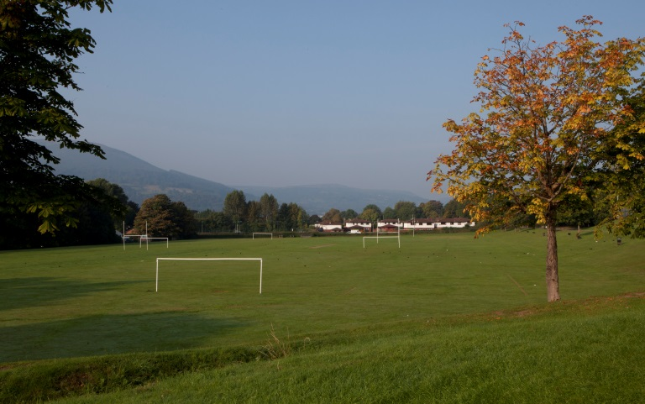Physical education facilities include an all weather floodlit astro turf pitch, a red-gra area, a muga hard court area and extensive grass pitches. The school also has full use of the Leisure Centre facilities, which include sports hall, swimming pool, squash courts, gymnasium and fitness suite.

As well as a wide range of timetabled 5x60 sports activities, lunchtime and after school clubs ensure that enthusiastic pupils receive further coaching. There are plenty of opportunities for competitive sport via inter-house, inter-school competitions and county events.

Links with local sports associations and feeder primaries are extremely good.

The successful candidate for this post will be responsible for teaching boys physical education and have oversight of the Football Performance Course. They will also work closely with the Welsh Baccalaureate Leader in designing and completing the community challenge for all KS4 pupils. It is envisaged physical education lessons will be used to develop ‘Sports Leadership’ skills in preparation for this challenge.

**LOCATION**

King Henry VIII School is an 11-18 comprehensive school with 1000 students serving the town of Abergavenny and the wider rural community.

The School is located on the main Manchester-Cardiff railway link and has convenient links to the Midlands via the M50/M5 and via the M4 to the Severn Bridge and the rest of South Wales.

20 miles – Newport

30 miles – Cardiff

45 miles – Bristol