Challenge I Commitment I Choice

GO/CLL

December 2016

Dear Candidate

Thank you for your interest in the post of Teacher of History. Please download all the information you need to apply for the job.

Contents:
- Application form
- Notes to assist with the completion of the application form
- Job description
- Person specification
- Background of the department

References will be taken up for all short listed applicants. The successful applicant will be required to undertake enhanced DBS clearance.

Completed application forms should be returned to Caroline Collings, at the school, by the closing date Tuesday 13 December 2016 at 5.00 pm. These can be emailed to the school but a signed hard copy will need to be signed if you are shortlisted for interview.

Please make sure you add sufficient postage, we have received applications after the appointment has been made resulting in disappointed applicants.

Interviews of short-listed candidates will take place on Tuesday 20 December 2016.

Applicants who have not been called for interview, within 7 working days following the closing date, should assume that their application has been unsuccessful.

I would urge you to find out more about the school by exploring our website. We are very proud of our achievements and have a committed and talented staff team.

Yours faithfully

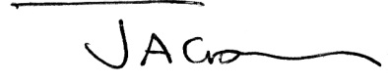

Mrs Julie Goswell
Headteacher

Encl.

