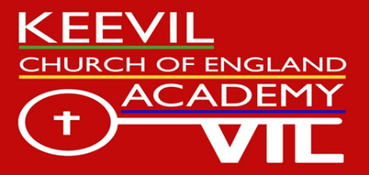
Keevil CofE Academy – Person Specification
Post: YR/Y1 Class Teacher (Temporary Maternity cover for January 2018)
 | Essential | Desirable | How will they be measured in the selection process?
Education/Training /Qualifications | - Qualified Teacher Status  - Degree/PGCE or equivalent qualification | - Other educational/professional qualifications relevant to school priorities, ethos or development | - Application Form
Knowledge and Experience | The candidate must have evidence of:  - Knowledge and understanding of the new National Curriculum  - A personal ambition and passion for every child in your care to make their maximum progress  - Understanding of the importance of Christian values and ethos in achieving the highest standards across all areas of school life, within the context of this school’s own mission statement.  - Clear understanding of Safeguarding procedures including child protection  - Ambition to learn, yourself | - Able to offer ideas and expertise in a particular subject area.  - Experience of mixed age class teaching  - Working with other schools/partners to improve outcomes for children  - Working with other professionals (for instance the Local Authority Special Needs team)  - Able to offer an extra-curricular activity | - Application form  - Interview /Observations  - References
Professional Skills | - Able to lead the team within the classroom and develop strong relationships with support staff  - Ability to take on and implement the school’s curriculum, assessment and intervention (SEN) systems.  - Ability to innovate and continually develop and improve the curriculum in line with best practice and research  - Ability to work effectively with all other members of an aspirational and supportive team for the best outcomes for children  - An understanding of statutory assessment demands  - Ability to interpret and use data so as to have impact on teaching and learning.  - Excellent behaviour management strategies and the highest expectations for all aspects of behaviour in school  - Good communication skills, both written and oral |  | - Application form  - Interview /Observations  - References
Professional Ethos and Commitment | - You see parent’s at the centre of the child’s learning journey  - The highest aspirations for all children’s outcomes, academic, social, moral, spiritual, physical and cultural in line with British values  - Commitment to working in partnership with all stakeholders to ensure best outcomes for children  - Commitment to nurturing positive relationships within the school and with all stakeholders  - Commitment to engage with your own professional development and the wider educational-political landscape. |  | - Application form  - Interview /Observations  - References

