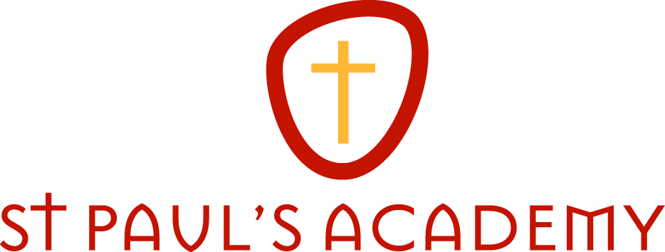
March 2018

Dear Applicant

Subject Leader: Modern Foreign Languages

Thank you for indicating an interest in the above post.

St Paul’s Academy seeks to serve young people from both the Catholic and the local community, welcoming all those who embrace its values and share its quest for excellence:
- To provide opportunities for young people to develop the knowledge, skills and wisdom necessary for effective learning.
- To enable learners to develop their intellectual, social, moral, spiritual and physical potential to the full in order to become proactive members of both the local and wider community.
- To increase aspirations by exploiting educational innovations and opportunities in the best interests of our students and staff.
In 1998 we had just 400 students and in 2014 we reached our full capacity of 1,200 students. Moving to a new campus has allowed us to extend our curriculum to meet the needs of every student, from those who find learning a challenge, to the most academically able. We are delighted that the building allows us to welcome students with physical disabilities and that they can be fully integrated in our community. St Paul’s Academy offers a longer day than most schools and it welcomes students to use the facilities from 7am in the morning to 5pm in the evening. The Academy is an integral part of the local community; we are involved with many primary schools, especially through sport, and we also see ourselves as part of the global community, particularly through our enterprise activities.
Such is the expertise we have developed at St Paul’s, we are now able to share our good practice with other schools. This, of course, hugely benefits schools in a less favourable position than ourselves, but it also greatly benefits our school as many of our staff, particularly the younger ones, gain experience of other institutions whilst our students continue to enjoy their outstanding teaching.
Most importantly, however, our students at St Paul’s become part of a community which focuses on young people and is committed to their individual good. The Catholic Church has a very special concern for education which is fundamental to the nature and dignity of human beings and we endeavour to reflect and foster this mission.
At St. Paul’s, there a strong emphasis on developing and implementing new approaches to learning so that students of all abilities will be continually motivated and challenged to achieve their full potential. For this to happen we require committed staff who are able to deliver the very latest and the very best practice in teaching and learning strategies.

The successful applicant will be working within the English & Communications Learning Zone, which is led by Alice Henderson.

If you would like to take this opportunity for challenge and reward, and if you feel you have the prerequisite skills, experience and qualities, please do not hesitate to apply.

I look forward to meeting you should your application be successful.

With very best wishes,

Patrick Winston
Principal

