Teacher of Economics
& business studies
Salary: £22,709 to £37,984 (Sixth Form Colleges’ pay scale)
Application pack
lowestoft sixth form college

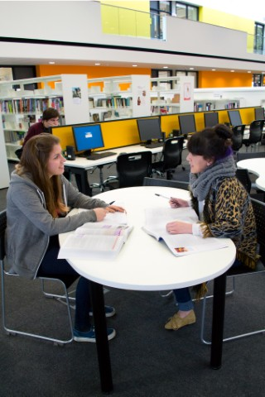

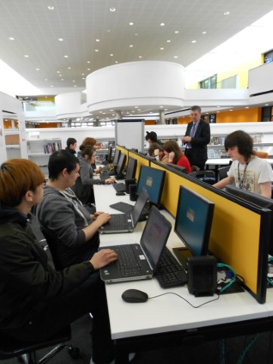
Letter from the principal
Dear Colleague,
Thank you for your interest in Lowestoft Sixth Form College. You have many options when choosing where to start or continue with your career and I would like to share with you why I think Lowestoft Sixth Form College is a very special place to work.
Lowestoft Sixth Form College was created in 2011. We are the only sixth form college in Suffolk and we are here as the result of thoughtful collaboration and partnership between many different groups including Suffolk County Council.
We were given an incredibly rare opportunity to do something that very few have the chance to do: to build a College from its foundations. We have not been hampered by old traditions, we have had a fresh start to create a truly inspirational place to learn and work.

We are passionate about our mission – we believe that our local community needs and deserves the very best education we can provide. Consequently, our standards for our students and for ourselves are high. We know that collectively we can achieve great things and we have done just that!

Our results and significantly our value added, show the real progress made by our students. In 2017 our A level performance was matched only by 10% of providers (an ALPs 2) and by 25% for BTEC learners (an ALPS 3). Our students leave College proud of their contributions and achievements, ready to do more.

As Ofsted noted in 2015 awarding us a GOOD rating across all areas: ‘Well- qualified teachers convey their subject with passion and plan stimulating and well- paced learning activities to spark interest.’ ‘Enthusiastic teachers have high expectations of what students can achieve which motivates students very well.’ At the heart of our collective success is a commitment to learning; a recognition that we can keep developing as teachers, as leaders and in all our activities. We listen to each other and value all contributions from staff and students. We are a community.

So if you are looking for a college where YOU can make a real difference, where you will enjoy your teaching and can innovate and where you will be supported to achieve the very best for your students; then this is the perfect opportunity.
I hope we meet soon.
Best wishes,
Principal
Lowestoft Sixth Form College

“Students enjoy their studies and behave well in a culture of mutual trust
and respect & teachers promote high aspirations and ambition”
OFSTED REPORT 2015
BACKGROUND

Lowestoft Sixth Form College is now six years old.

We are a well-established College offering an excellent student experience. We are delighted that our recent 2015 Ofsted report showed inspectors agreed. We were judged to be GOOD across all categories. Our high expectations and friendly, supportive environment enable students to excel.
We truly value our students and listen to their contributions. Lowestoft Sixth Form College is a special place, we are big enough to provide lots of subject choices and small enough to nurture every student to achieve their goals, whatever they may be. Our students are very successful because our teachers are truly committed subject specialists, because we believe every student is unique and we provide just the right level of support.
Our facilities for learning are exceptional too.

ABOUT US

EQUALITY & DIVERSITY
Lowestoft Sixth Form College is committed to equality, diversity and the promotion of British values in all our activities in our College community. We respect and value differences in age, disability including physical or mental impairment, gender reassignment, marriage and civil partnership, pregnancy and maternity, race, religion or belief, sex, and sexual orientation – the protected characteristics of the equality duty specified in the Equality Act 2010. We believe people are of equal worth and are entitled to be treated fairly and with dignity in all aspects of College life.

OUR VALUES
Learning
Learning is a liberating, inspiring and creative force for examination success and for life.
The unique potential of us all
Our goal is to reveal and help realise the full capabilities of every individual.
Effort
Determination, commitment and tenacity generate success.
Community
We care for, support, respect and listen to each other as we work together to secure our goals. Collectively we can achieve extraordinary things.
Professionalism
We have high standards. We take responsibility for our decisions and work consistently with honesty and integrity to achieve our goals.

Our College values show that as educators we actively champion openness, tolerance and diversity. We promote and facilitate the exchange of opinions and ideas, enabling our students to challenge current orthodoxies and to form their own identities. Our goal is to enable our students to become active, informed citizens, knowledgeable and able to critically evaluate argument. Lowestoft Sixth Form College makes a significant contribution in preparing young people for life in modern Britain and beyond.

WORLD CLASS FACILITIEs

Lowestoft Sixth Form College is unique.

Atkins, one of the world’s largest architectural firms with design studios across the globe, designed Lowestoft Sixth Form College. Our architect, Richard Christmas created a dynamic, innovative place to learn. The atrium space with suspended break out pods creates a dramatic, central meeting area with access to all four floors. The atrium, and indeed the College, have full WIFI coverage and have seen some exciting College productions in its vast space. The Pods provide alternative venues for students to learn individually or collaboratively in an inspiring setting.

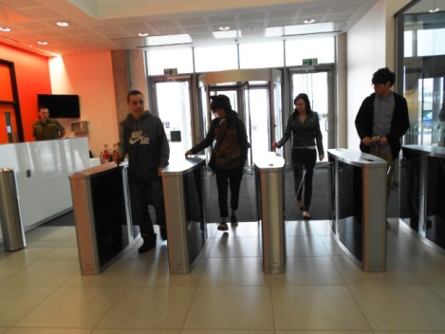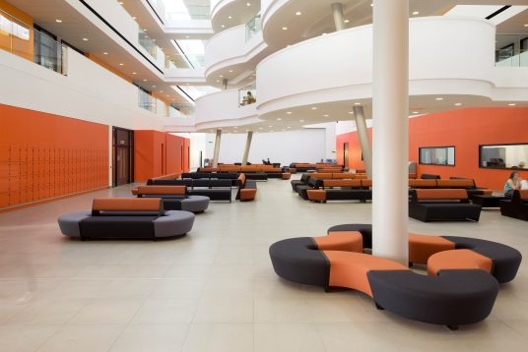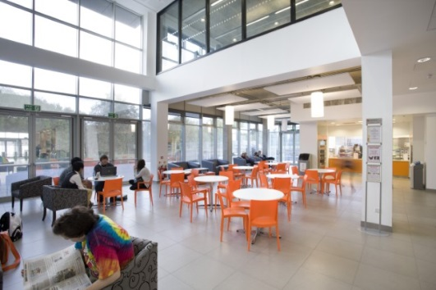

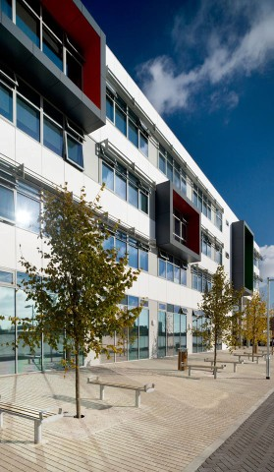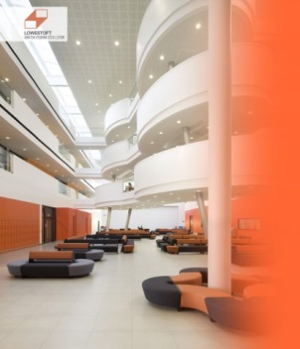

We offer

- State-of-the-art Science laboratories
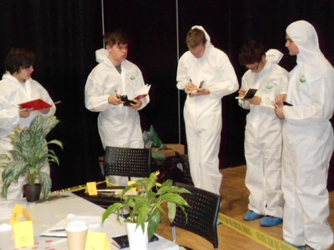

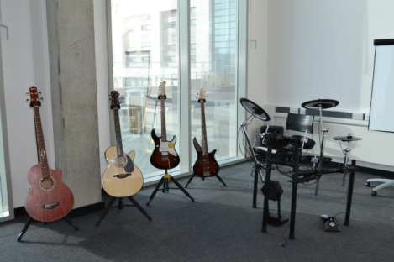
- Music Recording Studios
- Soundproofed rehearsal rooms
- Music Technology editing suite

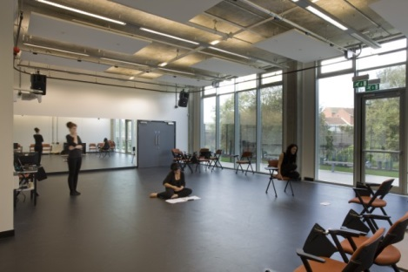

- Contemporary Theatre
- Specialist Dance and Drama studios
- Specialist Art/Design and
Photography Studios

- Teaching classrooms all equipped with the latest technology
- Partnership with Waterlane Leisure Centre, giving free access to all the Centre’s facilities: 25 metre heated swimming pool and fitness suite (allocated times), with the six badminton court Sports Hall, and other facilities used in sports lessons and for clubs. View the facilities at; http://www.waterlaneleisure.co.uk
- Our Barnards Centre Point venue provides state- of-the-art teaching and changing facilities alongside a superb 3G football pitch
- Welcoming cafe with WIFI access.

IT access

Technology is at the heart of Lowestoft Sixth Form College. We have invested over £1.3 million in the infrastructure and latest equipment. High speed internet connection, wireless networking and 24-hour access including the use of College software from home. We offer many ways for students and colleagues to use IT: in lessons with laptops and notebooks, in the Learning Resource Centre, in the Pods, in one of our three Mac suites or in our vast open access IT Centre

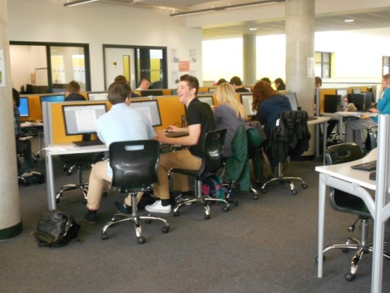

Our RESULTS

Good grades create exciting futures.

Ofsted 2015 judged our outcomes as GOOD across all areas:
Good – Outcomes for learners
Good – Quality of teaching, learning and assessment
Good – Effectiveness of leadership and management
Good – Overall effectiveness.

In 2017 A Level outcomes are judged by ALPs, to be in the top 10% nationally. Our AS outcomes were exceptional too, again placing us in the top 10% nationally and our BTEC in the top 25%.
The Department for Education Performance tables highlight for 2016 results (not yet published for 2017):
Our collective performance for A Levels is above national average for progress –
just 12% of providers achieve this.
For Applied General qualifications we are also above national average –
just 32% of providers achieve this.
https://www.compare-school-performance.service.gov.uk/school/136255
Working at College
COMMUNITY
Our mission is: “to enable our students to excel and progress beyond expectation in an outstanding learning environment in the heart of Lowestoft”.
As a relatively new College we have had a rare opportunity to craft our ethos and community together. We develop our policies and procedures collaboratively. We want colleagues who will participate actively and encourage students to do so too. Professional development is a key priority: time and resources are invested to develop our skills and assist in the challenge of ensuring students exceed expectation. Peer Review partnerships and local support networks contribute significantly; we are members of SFCF (Sixth Form Colleges Forum), AOC (Association of Colleges) and ACER (Association of Colleges Eastern Region).
CURRICULUM
The curriculum is predominantly level three; A Levels and BTEC in nearly 50 different subjects. Additionally, we offer a limited level two, BTEC and GCSE provision. We make extensive use of the virtual learning environment (VLE) and staff and students are supported in making the most of this fantastic resource. Colleagues are given the freedom and respect to take responsibility for their teaching.
We want lessons to be exciting, interesting and stimulating for our students. We want to encourage our students to be part of their learning experience and for them to make a positive contribution to the classroom and the college community.
CARE & GUIDANCE
Students are supported to fulfil their true potential and overcome obstacles by a team of specialist Student Achievement Mentors (SAM’s) who provide one to one support, deliver the pastoral curriculum and closely monitor progress. An online robust academic tracking system is used by everyone across the college and is a key communication tool between students, teachers and parents/carers. Students also have access to Additional Learning Support, counselling and careers advice.

Application & Selection

Application forms and job description are available to download from our website: www.L6FC.org

Completed applications should be sent via email to Diana Archer recruitment@lowestoftsfc.ac.uk

If you have any queries regarding the role or your application, please contact Diana on 01502 537000.

Closing date, Teacher of Economics and Business Studies: 9am Friday 6th October 2017
Shortlisted candidates will be notified, invited for interview and references will be taken up immediately for those candidates.

Interviews: to be held on Thursday 12th October 2017

Shortlisted candidates will be invited to the interview process, comprising of the following:

• A guided tour of the College
• observed lesson
• A case study
• Informal meeting with department members
• Interview with the Principal and senior colleagues

The College is committed to safeguarding and promoting the welfare of children and young people and expects all staff and volunteers to share this commitment. Appointed staff will be subject to Disclosure and Barring Service (DBS) checks. The College is committed to equal opportunities.

Suffolk
A Place to Live and Work
http://www.visitsuffolk.com
Suffolk is a wonderful county in which to live and work. It is one of the safest in the country and one of the most beautiful. Coastal Suffolk has glorious beaches, traditional seaside resorts, and rare opportunities to walk and enjoy wildlife. Rural Suffolk has miles of quiet lanes, beautiful countryside and traditional villages, served by bustling market towns such as Beccles, Halesworth and Bungay. Lowestoft has a wide range of urban facilities and The Norfolk Broads and historic Norwich are just a short car journey away.
Suffolk is a county filled with natural beauty, bordered by 50 miles of glorious coastline and topped with breath-taking skies. Its charming villages and medieval towns draw in artists and writers, while its bounty of great produce and restaurants make it a special spot for foodies. Here in Suffolk you can visit the home of Horseracing, explore Constable Country, experience maritime life in Ipswich, immerse yourself in history in Bury St Edmunds, or simply spend your weekends by the sea.
The housing market is varied in age, style and price depending on where and what you buy. In general house prices are regarded in the Lowestoft area as below national average.
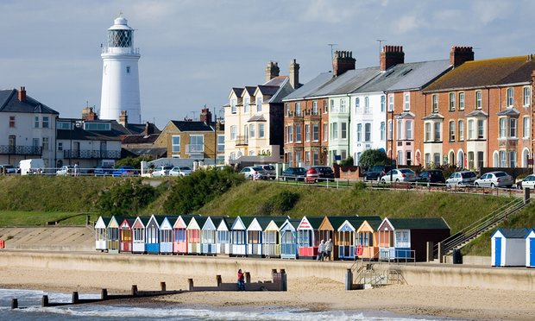
JOB DESCRIPTION

POST: TEACHER
ACCOUNTABLE TO: Director of Faculty
Job Purpose: Maximise student success

Start date: Tuesday 29th August 2017

Lowestoft Sixth Form College’s mission is “to enable our students to excel and progress beyond expectation in an outstanding learning environment in the heart of Lowestoft.”
You will teach to motivate, inspire and encourage students to achieve the best they can. Lowestoft Sixth Form College believes every student has potential. You will contribute to a culture of high expectations, excellent teaching and robust tracking and support.

KEY ACCOUNTABILTIES

You will be responsible for:

TEACHING & LEARNING

- Ensuring teaching & learning strategies recognise and support individual student need
- Ensuring teaching & learning (schemes of learning) are planned effectively to engage students, fulfil examination requirements and maximise achievement
- Maintaining an up to date subject knowledge and seek to communicate the enthusiasm you have for your subject
- Ensuring feedback to students is regular, timely and effective using the principles of formative assessment
- Seeking and responding regularly to student feedback as outlined in the College’s Teaching & Learning Strategy
- Providing information for and support actively the College’s student discipline and rewards systems
- Providing timely subject specific reports as specified to ensure achievement and progression are maximised and students, colleagues and parents/carers are fully aware of current progress and actions required.
- Ensuring excellent punctuality and attendance at lessons and that lateness & absence are pursued rigorously

QUALITY IMPROVEMENT

- Participating in and actively contributing to the College’s quality assurance policy and procedures.
- Participating and contributing actively to the College’s Professional Review & Performance Management systems
- Attending College meetings/staff committees/groups as may be appropriate

COMMUNITY
- Positively promoting equality and diversity in line with the College’ Equality & Diversity Policy.
- Engaging actively in personal professional development and when required, leading Staff Development sessions
- Developing and maintain professional, productive relationships with all members of staff within the college.
- Participating in the shared responsibility of all colleagues for student discipline through collective oversight of the College during the College day

GENERAL
- To comply with all College policies and procedures. This includes those where each member of staff has an individual duty to act and for which the College can be held vicariously responsible for the actions of its employees: equality and diversity, safeguarding the welfare of young people & health and safety.
- If required, serve as a personal tutor with responsibility for groups of students, including their academic and pastoral development
- Participate in the College Duty Rota
- Manage a delegated budgets as appropriate
- Participate in marketing & liaison activities as required
- Undertake any other reasonable duty assigned by the Principal or Vice Principal.
The full duties of a sixth form college teacher are outlined in Appendix 4 of the SFCF Teaching Staff Conditions of Service Handbook.

The department

We are looking to appoint a talented, enthusiastic and committed Economics and Business Studies Teacher to help shape our future.

This is an opportunity to join a successful team – achieving great results.

2017 A Level Economics achieved an Alps 3 – top 25% nationally and BTEC Business achieved a very good Alps 4.

The successful candidate will teach A-Level Economics and BTEC & A-Level Business Studies.

The department have created excellent links with local employers and work in partnership with the Suffolk Chamber of Commerce creating work related learning opportunities for our students. The launch of the L6FC Business Academy programme in September 2017, which provides a structured programme of WRL alongside academic study, ensures our students develop practical skills and theoretical knowledge which enables them to progress to employment or higher education.

