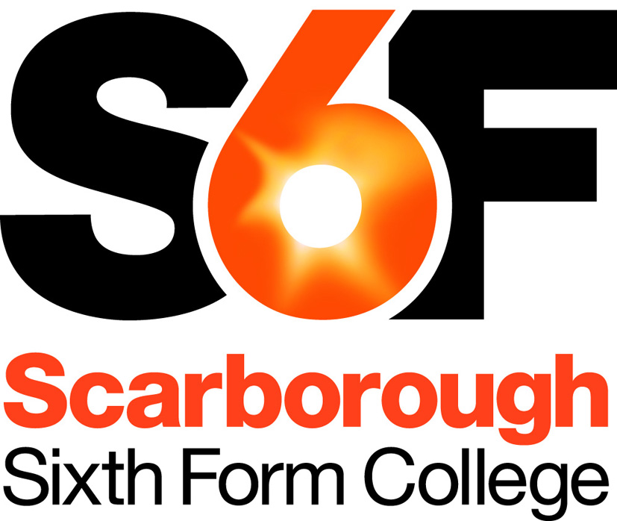
Person Specification
Caretaking (Estates) Assistant

Our aim is to recruit highly talented and competent people, fully committed to the College’s aims and values. Below we have identified the qualifications, skills, experience and attributes ideally required for this post. Applicants need to demonstrate how well they meet this profile and/or their potential to develop to meet the requirements of the post. This will initially be assessed based on quality of application, and then, if shortlisted, based on a combination of relevant task(s) and interview(s).

Qualification
- First Aid at Work Certificate or willingness to pursue once in post, if required

Professional Skills & Experience
- Previous experience in a similar role or environment
- Pro-active and able to work effectively without supervision
- Confident and competent in dealing with emergency situations
- An ability to relate well to staff, students and visitors
- A customer-focussed and flexible approach
- A willingness and ability to carry out manual tasks, such as cleaning and lifting
- Good awareness of health, safety, security and hygiene issues.
- Technical skills to carry out basic repair and maintenance tasks to good standard
- Basic administrative and IT skills
Desirable
- Previous experience in a similar role or environment.

Personal Skills & Attributes
All staff are expected to demonstrate commitment to the college’s aims and values, including:
- Passionate about learning and its importance in life
- Having high expectations of self and others
- Honest, open, reflective and self-critical
- Doing one’s best, adapting well to change and always seeking to do better
- A supportive team worker
- Treating staff and students fairly and with respect, valuing their diverse contributions
- Fully committed to promoting & safeguarding welfare of children & young people.

