Teacher of Science
MPS/UPS
Application Pack

September 2018
Welcome to Rivers Academy West London

Thank you for your interest in the role of Teacher of Science at Rivers Academy West London. We wish to add capacity to our talented team of teachers through appointing an excellent practitioner in Science with ambition to both hone their craft and develop others. Each of our Lead Practitioners plays a key role in driving success for our students.

Each member of staff at Rivers Academy shares a drive to equip students with the qualifications, qualities and skills to reach their personal ambitions working together creatively to overcome any hurdle which might otherwise disadvantage our children.

We all have the highest aspirations for every student and provide exceptional education and pastoral care for each individual. As a result, children perform tremendously well in external examinations. In 2017 a very pleasing 80% of students achieved a 4 or above in English and 63% of students achieved this benchmark or above in Mathematics. 56% of students achieved a grade 5 or above in English and 41% in Mathematics. Across all Year 11 subject entries, we were delighted to see 14% rewarded with the very best grades having achieved a 7 or higher and 40% of students with grades 9-5 or A*-B.

Our March 2015 ‘Outstanding’ Ofsted report was testament to the hard work of our staff, students and families.

“The Outstanding quality of teaching is clearly demonstrated by the rapid progress made by students, in all year groups” Ofsted 2015

We are the one chance of success for our students and we are persistent and resilient in supporting students to overcome any obstacles they may face. We are looking for someone who is passionately interested in teaching and learning who will share our drive to engage and motivate every child to achieve the very best outcomes. The successful candidate is, or will have the ambition to become, an excellent classroom teacher capable of leading others to continually improve their practice.

Andria Singlehurst
Principal

Visits are welcomed and encouraged

To arrange a visit or for more information please contact:

E‐mail: hr@rivers-aspirations.org

To learn more about us visit www.riversacademy.org
or to find out more about the Aspirations Academies visit: www.aspirationsacademies.org

Vision and Ethos
We are passionate about excellence in education, giving students the very best start in life with a firm belief that excellent teaching transforms lives. Our core belief is that for all students to have high aspirations they must believe in themselves, be actively engaged in their learning and see the connection between what they learn today and who they want to become tomorrow.
We teach a highly engaging and challenging curriculum designed to ensure all students develop the knowledge, skills and attributes essential for success in the 21st Century.
We are unapologetically ambitious for every child, no matter what their background, prior attainment or needs. Everything we do at Rivers is driven by this, so that our students can leave us with the best set of qualifications possible and as well rounded young people thereby helping to maximise their life chances.
High Expectations
We expect all students to meet the highest standards, and work with families and the community to ensure that our students meet our high expectations.
Teaching and Learning
Rivers Academy West London teachers provide engaging, challenging and relevant teaching and learning. Our teachers and Lead Practitioners are a key group who drive new initiatives and exciting new pedagogies within Rivers Academy West London and across the Aspirations Academies Trust.
Our Future Ambitions
Our ‘Outstanding’ March 2015 inspection report was testament to the tremendous dedication of our staff, governors, students and parents/carers. This report represents an important milestone on our journey. Our goal is to raise the Aspirations of the young people with whom we work whilst reaching levels of achievement that would place us in the top 5% of schools nationally.

Who are we looking for?
We are looking for an exceptional individual to play an important role in our unique and growing Academy. The successful candidate will be an excellent teacher of Science and will also play an important pastoral role in leading an Academic Mentoring (Tutor) group. They will be capable of delivering consistently excellent lessons in their own classroom and skilled at coaching others to improve their practice and maximise their impact.
It will be an exciting opportunity for someone wishing to further develop their career, with possible opportunities to become a Lead Practitioner and eventually Specialist Leader of Education (SLE). As an Aspirant Lead Practitioner/Lead Practitioner you would play a key role in further developing the curriculum and pedagogy in Science and across the Academy/Teaching School Alliance.
What can we offer you?
With great students, an outstanding and supportive team of staff and an Academy in a well-connected location just 18 minutes on the train from Clapham Junction, Rivers offers an excellent opportunity for an ambitious, talented individual looking to develop their career.

As part of the successful and growing Aspirations Academies Trust we are a part of the newly designated NCTL Teaching School Alliance. You would be joining us at a very exciting time and become part of a vibrant learning community that will offer you fantastic opportunities for CPD, career development, future promotions and for you to be able to make your mark. As a Lead Practitioner / Aspirant Lead Practitioner you would play a key role in this work.
The Science Department
Our experienced and established Science team has a strong track record in developing new entrants to the profession. All students study either Combined or three Single Sciences at GCSE. We also run A-level Chemistry, Biology and Physics in close collaboration with Space Studio West London – an aerospace focused Studio School on the same campus. Teachers often have the opportunity to develop by teaching across both sites and to share facilities. We are looking to grow the science team and develop a truly inspirational curriculum to ensure students leave us to go on to careers in this field.

Job Description Teacher of Science

Department: Science | Accountable to: Subject Coordinator - Science
 | Employment Type: Full time, paid

Principle Accountabilities

- To establish and maintain excellent teaching and learning across the science department.
- To teach consistently excellent lessons acting as a beacon on best practice.

Position Summary

- The Teacher of Science is directly accountable to the Subject Coordinator – Science.
- The purpose of the role is to establish and maintain excellent teaching practice and maximise the progress of all students.

Leading

- Inspire, lead and develop students in science to ensure outstanding learning experiences for every child.
- Support the Coordinator of Science to ensure the provision of an appropriately broad, balanced, relevant and differentiated curriculum for students studying in the subject area, in accordance with the aims and policies of the Academy.
- Contribute to raising standards of student progress and attainment.
- Support the Coordinator in establishing and ensuring high quality teaching in every classroom, every day.

Teaching

- To plan, prepare and teach the curriculum in line with statutory requirements and the academy‛s schemes of work, ensuring teaching of the highest standard.
- To create a stimulating, organised, interactive and informative learning environment that encourages each child to achieve their potential.
- To work co-operatively as part of a teaching team, including planning work for support staff.
- To monitor and assess pupils‛ work, using these assessments to inform planning and set targets that promote continuity and progression.
- To ensure the individual needs of the pupils are met through differentiated work, allowing for the highest standards to be achieved by all.
- To work in partnership with parents and other members of staff to promote the wellbeing and educational progress of each pupil.
- To maintain good order and discipline within the class, in line with the academy‛s behaviour policy.
- To ensure that lessons consistently model best practice and their classroom becomes a beacon of excellence.

Learning and Developing

- To actively take part in professional development, sharing expertise and experiences as required.
- To actively extend own professional learning via collaborative study, attendance at INSET and reading to keep abreast of new developments.
- To lead CPD training both at the department and whole academy level.
- To continue to keep up to date with developments in teaching practice and disseminate these to staff.
- To coach and develop others to maximise their impact on student progress.

Wider Academy Duties

- To contribute to providing a positive and continuous learning culture that promotes achievement, personal well-being and safeguarding among students and academy staff.
- To follow guidance and support from members of the leadership team in relation to utilising opportunities for further career development.
- To work alongside other members of staff to review and innovate the curriculum.
- To develop resources and examples of best practice that can be shared to contribute towards our vision for a seamless transition.
- To follow academy policies under the direction of the Principal and SLT.
To meet the expectations set out in the National Teachers Standards (Sept 12).
- Undertake any other reasonable professional task as directed by the Principal.
- To carry forward the Aspirations Academies Trust vision.
- Ensure the Aspirations framework is embodied in every aspect of Rivers Academy West London.

Person Specification – Teacher of Science

A – Assessed in Application / I – Assessed in Interview / R – Assessed through references

Criteria | Assessed by
Qualifications and Training
Hold a relevant degree or equivalent qualification. | A
Hold a recognised full teaching qualification (including the holding of qualifications of at least Level 2 in Maths and English. | A
Any further relevant training. | A
Experience
At least two years successful teaching experience with demonstrable impact on student progress. | AIR
Experience of raising achievement in present post. | AIR
Professional Knowledge, Understanding & Skills
Knowledge of curriculum developments related to the post. | AI
Ability to use recent developments to inform own and others practice. | I
Proficient in Microsoft Office applications (Word, Excel, PowerPoint, Internet and email) and in using student record information systems | I
Good understanding of how children learn and how to raise standards of achievement. | I
Ability to interpret and act on a wide range of key data. | AIR
Good administrative and organisational skills. | AIR
Personal and Interpersonal
A passion for education and making a difference with demonstrable commitment to achieving the highest possible standards for all learners and a proven record of enabling learners to fulfil their potential. | AIR
Excellent interpersonal skills and the ability to communicate effectively, both orally and in writing, with all stakeholders demonstrating the ability to command respect from students, parents, colleagues governors and other members of the community. | AIR
Demonstrable resilience evidenced by ability to work effectively and reliably under pressure. | AIR
The ability to adapt to varied roles, responsibilities, schedules and contexts. | IR
Effective in taking the initiative and showing a spirit of adventure to explore and expand their own learning independently beyond the basic mastery of skills. | AIR
Effective reflection - Examine and critique the work or performance of themselves and others to make modifications and continuously improve. | AIR
Effective in managing behaviour and in motivating all learners to make a positive contribution to the learning environment and fulfil their potential for learning. | AIR
Effective ability to assess the emotions of others and adapt words, tone and body language to build strong productive relationships and cooperate with others as an effective member of teams. | IR
Excellent attendance and punctuality record. | R
Strong ability to collaborate with demonstrable capacity to be a good team leader. | IR
Demonstrable effectiveness in promoting equality and diversity through teaching, managing the learning environment and challenging discriminatory behaviour and attitudes | AIR
Commitment to the safeguarding of all learners. | AIR

The Aspirations Academies Trust

The Aspirations Academies Trust (AAT) as a sponsor of primary and secondary age academies in England, is committed to raising students' aspirations so that all young people reach their fullest potential and achieve the success they want for themselves.
The Aspirations Academies Trust in England benefits from QISA's (The Quaglia Institute for Student Aspirations) remarkable record of more than 30 years of research and experience working with students, educators, and schools. Aspirations is the ability to dream about the future while being inspired in the present to reach those dreams. The Aspirations Academies Trust was set up in England with the vision to combine the thirty years of educational research by Dr. Russ Quaglia on student aspirations with effective and innovative school improvement techniques in order to create truly outstanding schools that would fully prepare students to succeed in this exciting world. Central to the philosophy of the Aspirations Academies Trust is the innovative Aspirations Framework developed by the Quaglia Institute for Student Aspirations (QISA) which outlines the belief that for all students to have high Aspirations, three Guiding Principles must be present: Self-Worth, Active Engagement, and Purpose. These Guiding Principles direct the development of educational experiences from the individual classroom to the entire school building. The Three Guiding Principles, in turn, are lived out through 8 Conditions that emphasise relationships, active and engaging teaching and learning, and a sense of responsibility over one's own aims and goals. The 8 Conditions are: Belonging, Heroes, Sense of Accomplishment, Fun & Excitement, Curiosity & Creativity, Spirit of Adventure, Leadership & Responsibility & Confidence to Take Action. Students who have high aspirations believe in themselves, are meaningfully engaged in their learning and the life of the school and work with intention toward their goals.
Our Aspirations Academies have a commitment to make certain that all young people achieve their fullest academic potential and become responsible citizens. To achieve this goal we are dedicated to promoting and putting into practice the Three Guiding Principles and 8 Conditions that foster student aspirations. Each Academy strives to ensure that all students have the opportunity to discover and appreciate their endless promise for a successful future.
The Aspirations Academies Trust considers that its beliefs and principles are applicable and effective with students from age 3 to 18. Each stage of a child's education is extremely important pre-school, primary and secondary and should, where possible be coherent across the phases of education in the practice of developing the principles and conditions central to the beliefs and aims of the Aspirations Academies Trust. For this reason, we support primary, secondary and, where possible, all through (Ages 3-18) academies.
At whatever stage a child joins an Aspirations Academy, whether it is at the age of three or sixteen, the aim is to provide each individual child with the best possible life chance. This is done through the achievement of the highest level of qualifications, the development of skills essential to success in an interconnected and highly competitive world, as well as encouraging the highest aspirations, expecting every student to gain a place at university or enter skilled employment.

Continuous Professional Development
We offer unique and bespoke training for staff at all levels. This includes Senior Leadership Training, Aspirations Training - Level 1 & 2, Polishing Pedagogy, Coaching and Mentoring. Staff will be supported to develop a positive orientation to professional learning as reflective practitioners and will be empowered to take ownership and responsibility for their professional learning and development.
We strive to embed the voice of students (for example, through My Voice, iKnow My Class Surveys and student voice and leadership developments) and the active engagement of students in the process of CPD and staff professional learning.

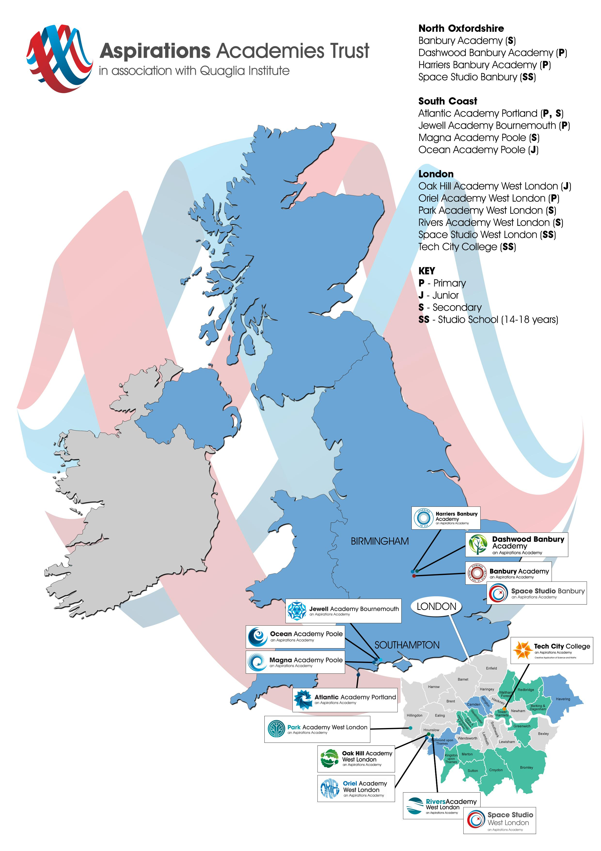

Safer Recruitment Procedure
The AAT is committed to safeguarding and promoting the welfare of children and young people in its academies. In order to meet this responsibility, its academies follow a rigorous selection process to discourage and screen out unsuitable applicants. This process is outlined below, but can be provided in more detail if requested.
Disclosure
This post is classified as one that undertakes regulated activity, and appointment is subject to submission of an enhanced check undertaken by the Disclosure and Barring Service that is considered satisfactory by the Trust. Applicants are required, before appointment, to disclose any conviction, caution or final warnings that are not “protected” as defined by the Rehabilitation of Offenders Act 1974 (Exceptions) Order 1975 (as amended in 2013 by SI 2013 1198). Convictions that are defined in the legislation as “spent convictions” but not “protected” would need to be declared. Non-disclosure may lead to termination of employment. However, disclosure of a criminal background will not necessarily debar individuals from employment – this will depend upon a range of factors including the nature of the offence(s) and when they occurred.
Shortlisting
Only those candidates meeting the relevant criteria indicated in the personal specification will be taken forward from application.
Interview
Longlisted candidates may be subject to a screening interview. Those shortlisted will take part in an interview with questions relating to the job description and person specification and may also have to take part in a selection exercise such as a lesson observation.
Where necessary, candidates will be asked to address any discrepancies, anomalies or gaps in their application form.
Reference checking
At least two references will be requested, normally from the previous and current employers. These may be contacted before the interview and in all case before an offer of appointment is confirmed.

