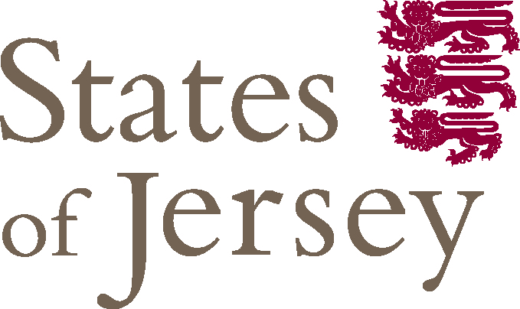

**Welcome**

Dear Applicant

Thank you for your interest in applying for a teaching post at Les Quennevais School.

In addition to providing information about this post, this advert contains information about the Island of Jersey, housing, income tax, health and social security and terms and conditions of employment.

In accordance with the employment policies of the States of Jersey, it is our usual practice to employ people who have been continuously resident in the Island for at least 5 years. However an exception has been made for this post and applications have been invited from outside the Island.

Our employment policy is restricted by the need to limit population growth. This has resulted in legislation which controls both the purchase and occupation of houses by categorising accommodation and specifying requirements for residential status.

If you are successful in your application you will attract “Licenced” status, which means you gain residential status, as an essential employee for the period of your employment with the States of Jersey. After 10 years continuous essentially employed status you will gain residential status in your own right.

We look forward to hearing from you.



Director of Education