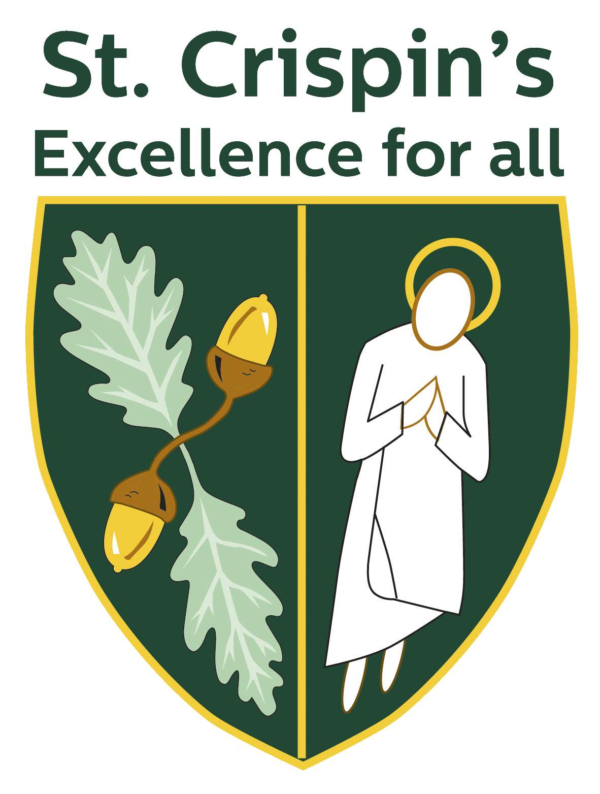
Religious Studies Department Overview

The Religious Studies department is a successful and innovative department, which is committed to raising the achievement of all of our students.

The Department currently consists of three specialist members of staff and a small team of non-specialists. The team is committed to excellent learning and teaching and consistently endeavours to find new ways to engage and inspire our students. Within the department, we place a strong emphasis on collaborative working - sharing ideas and resources. As a new member of staff, you will be made very welcome and given ample opportunity to develop both professionally and personally.

Our vision is that Religious Studies will allow students the opportunity to explore, and engage with, life’s ultimate questions – considering their own opinions towards topics as well as a range of religious perspectives. We aim to provide students with the skills required to become reflective and critical thinkers.

Curriculum overview:

The Religious Studies Department follows the Berkshire Agreed Syllabus for Religious Education. All students study Religious Education in Years 7 – 9 and then, from this September GCSE Religious Studies will now be an option for students in Year 10 and Year 11. Religious Studies (Philosophy and Ethics) is also a popular choice at A level.

In Years 7 and 8 students have one RS lesson per week and study a range of topics including: ‘Big Questions in Christianity’, Ethical Questions, ‘Big Questions in Buddhism’, ‘Pilgrimages Faith in Action’ and ‘Introduction to Islam.’

In Year 9, students begin to look at more GCSE-style topics including Peace and Justice, Good and Evil, and Medical Ethics.

‘Philosophy and Ethics’ is a popular choice at A level – we currently have 2 groups in Year 12 and 2 groups in Year 13. The department follows the OCR Religious Studies: Philosophy of Religion and Religious Ethics course. Students study a range of topics including: Ancient Greek Philosophy, The Problem of Evil, Applied Ethics and Life After Death. Students have eight lessons a fortnight during Year 12 and Year 13.

The Department has three dedicated teaching rooms – all with wall-mounted projectors and two with interactive white boards. The Department has a full and varied collection of textbooks and resources for all Key Stages. The Department shares a working office space with the History and Geography departments.

We run a trip to Salisbury Cathedral and Slough Mosque for Year 7 students.

