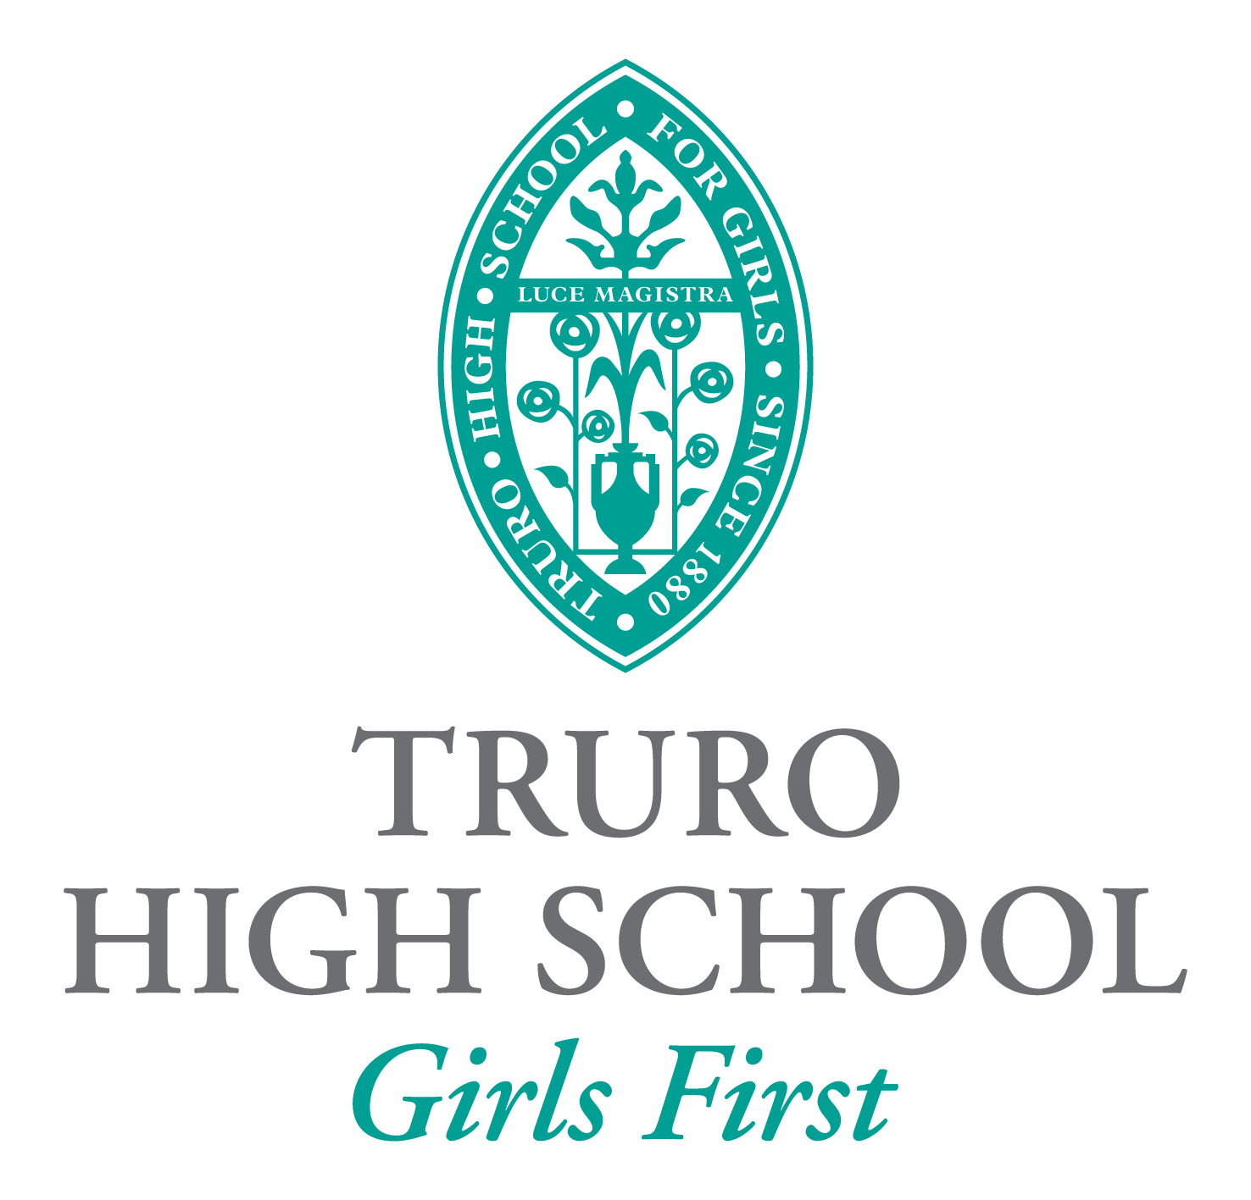

Part-time Latin Teacher (0.64)

September 2018

Information for Candidates

January 2018

Truro High School is seeking to appoint a dynamic and innovative Latin teacher to join our thriving Ancient and Modern Languages Faculty.

The School

Located in the far west of Great Britain with a rugged and spectacular coastline, Cornwall has a unique and special feel. There are lots of things Cornwall is loved for – the beaches, the watersports and surf, the captivating fishing villages, the dynamic arts scene, and of course the Cornish pasty and cream teas.

Truro is Cornwall’s only city and much of the city centre is converted to pedestrian areas. The Cathedral is the city’s most striking building with its green spire and gothic appearance. There is a large indoor market on Lemon Quay and regular farmers’ markets close by. In addition to the major stores, there are still many small individual shops to be found down the narrow streets of Truro.

Truro High School was founded in 1880 by Bishop Benson, who later became Archbishop of Canterbury. The School continues to be regarded as one of the top girls’ private schools in the UK. Situated in the heart of Cornwall, we offer a first-class holistic education in an exceptional setting. There are just around 335 girls at the School, including 45 boarders.

With highly experienced teachers, small class sizes and an ethos that ensures every individual matters, our girls achieve outstanding results – not just academically but in sport, music, drama and the arts too. We aim to provide our pupils with a happy, rewarding start in life which creates aspiration, values individuality and develops self-esteem.

The whole school sits on a single 12-acre site, a short walk from the city centre. The Prep and Senior Schools share facilities, and there is in addition a nursery, run by an outside provider, Naturally Learning.

Truro High School recognises that the staff are one of its most valuable assets. We therefore seek to recruit and retain well-qualified academic and support staff who demonstrate enthusiasm for their areas of expertise and who display interpersonal characteristics which are reflective of the School’s ethos and educational philosophy. There is little doubt that working at Truro High School will reward you personally and professionally.

The School’s Church of England foundation remains central to our ethos and we have strong links with Truro Cathedral. However, in November 2015 we announced that we had joined the Methodist Independent Schools Trust (MIST). We welcome pupils of all faiths and none, but by joining MIST we are now part of a wider collective of schools with similar aims and ethos. This move will also lead to considerable investment in the School’s facilities in the coming years.

The School has recently launched a bold strategic plan to take us through to 2020 – it can be found on our website.

Further information on the School can be found on our website.

Latin at Truro High School

Truro High School is currently the only school in Cornwall where Latin can be studied up to and including A Level.

We believe it is important to teach the Latin language within the context of Roman life and so Latin lessons include both linguistic and historical elements. This allows for discussion and creative work alongside the acquisition of language skills. An introduction to Latin, using the Minimus Primary Latin Course, is given to Year 6. Approximately half of the year group start Latin in Year 8, using the Cambridge Latin Course and continue to the end of Year 9. Those who choose Latin as a GCSE option sit the OCR specification J282, taking the Prose Literature and Literature and Culture options. A Level pupils sit the OCR specification H443. Pupils are prepared for Oxbridge entrance and there have been a number of successful applications in recent years.

The School has run a number of popular trips to Italy and Greece in recent years as well as an annual trip to Bath for Year 9 and visits to the Oxbridge Classics conference and the British Museum. We believe that it is very important to give pupils the opportunity to see real artefacts and sites relating to the classical world.

Latin is part of the Faculty of Ancient and Modern Languages, which is situated in its own building on the site. The successful candidate will be a member of the team and teach all lessons in the well-equipped Helford Building.

The Role

The post involves teaching Latin to Year 6 in the Prep School and across the Senior School from Years 8 to 13. It also brings with it the requirement to promote the subject through trips and through our extra-curricular programme. In addition, the successful candidate will be expected to help prepare pupils for university entrance in Classics and the ability to provide Oxbridge entrance guidance would be strongly desirable.

The successful candidate will be line-managed by the Head of the Ancient and Modern Languages Faculty.

Senior School Classroom Teacher Job Description

Responsible to: Head of Faculty

Purpose of the role:

Teachers should positively contribute to raising standards of attainment and achievement for all pupils at Truro High School through providing high quality teaching and high quality support and guidance to all pupils in their care, through utilising their skills, talents, knowledge and expertise and through setting a positive example in their own professional behaviour.

Teachers are responsible to the Headmaster via the management structure of the School. They are expected to co-operate within curricular, pastoral and management teams to meet the general aims and objectives of the School, in line with the School Development Plan.

Teachers should refer to separate job descriptions for more specific detail on particular responsibilities such as promoted posts.

Duties and Responsibilities:

General

- To be fully supportive of the ethos and culture of the School, which is encapsulated in our Mission Statement, School Development Plan and Strategic Plan.
- To co-operate with colleagues in sharing knowledge and experience.
- To undertake a range of general duties to enable the smooth running of the School.
- To adhere to and support school policies.
- To contribute fully to the programme of extra-curricular activities for pupils.

Academic Teaching

- To know subject matter thoroughly and to plan and prepare courses and lessons appropriate to the individual needs and abilities of all pupils.
- To prepare pupils appropriately for external examinations.
- To teach according to pupil’s educational needs, including the setting and marking of work in accordance with the policies of the faculty
- To demonstrate that on-going planning reflects effective monitoring of the progress of each individual pupil.
- To assess, record and report on the development, progress and attainment of pupils in accordance with the school policy.
- To keep appropriate records in accordance with school policy and practice within the School.
- To provide data and information regarding all aspects of the progress of pupils in order to contribute to pupils’ regular monitoring.
- To work effectively with support staff and the Study Support Department.
- To attend parents’ evenings as a part of monitoring and reporting process of the School.
- To make a full contribution to the work of the faculty team.

Welfare of Pupils

- To provide high quality support, guidance and advice to pupils on educational and social matters and make records and reports in accordance with the school policy and practice.
- To encourage and maintain high standards of behaviour and discipline in order that effective learning can take place and good relationships can be formed within the school community.
- To follow the School’s procedures where pupils fail to co-operate with our expectations.
- To provide high quality support, guidance and advice to pupils on further education and future careers and make records and reports in accordance with school policy and practice.
- To contribute to ensuring the Health and Safety of all pupils through managing and supervising their safety at all times, including travel to and from school, moving between lessons and break and lunch times.
- To communicate and consult with parents in accordance with school policy and practice.

Resources and Administration

- To manage classroom resources effectively and maintain in good quality condition.
- To prepare high quality resources appropriate to raising standards.
- To take part with colleagues in developing the quality of learning areas within the School.
- To maintain the fabric of classroom and subject areas including updating display work.
- To assist the Head of Faculty in managing subject resources.

Professional Development

- To develop subject knowledge and expertise, keeping up to date with national developments, teaching practice and methodology to support pupils in achieving high standards.
- To work in co-operation with colleagues in the sharing of knowledge and experience.
- To participate in the staff induction and appraisal programmes.
- To attend assemblies, staff meetings, INSET training as and when necessary.
- To take responsibility for ongoing development in your role as a teacher at Truro High School.

Tutoring

- To act as a lead tutor or back-up tutor for a form.
- To meet deadlines and perform efficiently any administration role that is associated with the teaching or Form Tutor role.
- To deliver the PSHE curriculum according to the published timetable.
- To ensure an accurate record of attendance is maintained.
- To monitor tutees’ academic progress.
- To proofread reports and chase missing reports for tutees, and to produce tutor reports.
- To support tutees in academic and pastoral matters and to follow up on concerns, including liaising with the Deputy Head Academic and Deputy Head Pastoral as required.
- To act as a referee for tutees.
- To encourage tutees to participate fully in the life of the School.

Additional Duties

- To externally market and promote the School through the subject area by contributing to the local community or contributing to the school newsletter.
- To supervise lunch in the dining room or other areas of the School during lunchtime on a rota with other members of the teaching staff.
- To supervise Homework Club on a rota with other members of teaching staff.
- To perform other reasonable duties as required from time to time by the Headmaster (including attendance at Open Day, School Carol Service, Founder’s Day and Speech Day).

The postholder has a responsibility for promoting and safeguarding the welfare of children and young persons for whom he/she is responsible, or with whom he/she comes into contact. He/she must comply with the School’s Child Protection and Safeguarding Policy at all times. If, in the course of carrying out the duties of the post, the postholder becomes aware of any actual or potential risks to the safety or welfare of children in the School he/she must report any concerns to the Designated Safeguarding Lead or the Headteacher. Protecting children from the risk of radicalisation is part of the School’s safeguarding duties (under the Prevent Duty).

Senior School Classroom Teacher Person Specification

 | Essential | Desirable | How identified
Qualifications | - Graduate | - Teaching qualification  - Relevant degree  - Evidence of CPD | Application
Relevant Experience | - Recent successful experience in teaching the appropriate age range, with proven pupil success  - Experience of teaching a range of abilities  - Experience of working as part of a team | - Evidence of leading high quality extra-curricular activities  - Experience of teaching at A Level | Application  References  Interview

Skills and Knowledge | - Ability to teach a specialism to A Level  - Ability to prepare candidates for Oxbridge interviews  - ICT competence  - To be a capable teacher  - To have good time management skills  - To be discreet and adhere to confidentiality  - To possess excellent interpersonal skills | - Evidence of innovation in a recent role  - Knowledge of how to use and adapt a range of teaching, learning and behaviour management strategies, including how to personalise learning, to provide opportunities for all learners to achieve their potential | Application  References  Interview
Personal Qualities | - Motivation to work with young people  - Ability to form and maintain appropriate relationships and personal boundaries with young people  - Emotional resilience  - A positive attitude  - Commitment to raising achievement  - A commitment to continue own personal development  - Imaginative/keen to try out new ideas in the classroom  - Able to take initiative and lead/seek advice as appropriate  - To be self-motivated and able to work independently  - Willingness to take on delegated responsibility |  | Application  References  Interview

Applications

Candidates should complete an application form (available on our website or via the TES portal) and send this, together with a covering letter explaining how you meet the person specification and reasons for applying for the post, to:

Mrs Harriet Andrew
Deputy Bursar
Truro High School for Girls
Falmouth Road
Truro
TR1 2HU

or by email to handrew@trurohigh.co.uk

Closing date: Applications should reach the School by midday on Monday 29 January 2018.

Interviews: Interviews will take place at the School on Monday 5 February 2018.

Salary: The salary will be commensurate with the qualifications and experience of the successful candidate.

