Belvedere Infant & Nursery School 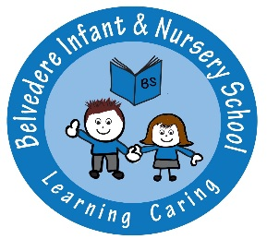
Person Specification
Teacher - MPS

Experience: | - A successful and experienced teacher or highly motivated NQT  - Have experience of monitoring and evaluating at least one area of the curriculum (experienced teacher)  - Provide a successful learning environment
Qualifications or  Training: | - QTS
Professional Skills & Abilities: | - To provide a positive learning environment and set appropriate learning tasks for children of all abilities  - To deal with children with warmth, care and understanding, setting clear and appropriate boundaries and standards of behaviour  - To communicate orally and in writing at a level of skill necessary for the job  - To effectively organise and manage classroom resources  - To be a successful team member who contributes effectively to the team and supports colleagues  - Be an outstanding classroom practitioner who is a good role model for the children  - Use ICT competently for teaching and personal purposes
Knowledge: | - Thorough knowledge of EYFS framework and early childhood development/KS1 National Curriculum  - Knowledge of the requirements of good primary school teaching and learning  - Knowledge and understanding of stages of children’s development; strategies to motivate development in all areas and issues of equal opportunities
Commitments: | - To implementing the aims and values of the school  - To raising achievement  - To his/her own professional development as a teacher  - Towards protecting children and ensuring that they are safe at all times.

