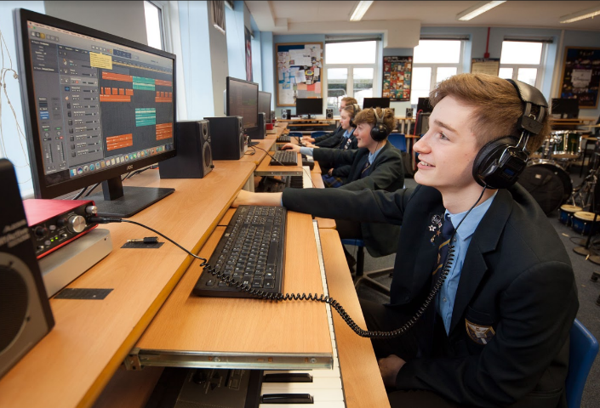

Information for Prospective Candidates

For the post of
MATERNITY COVER ENGLISH TEACHER
(February 2019)

Dear Potential Candidates October 2018

Thank you for your interest in this teaching vacancy and I hope that the information contained in this pack helps answer your questions about the post and the academy, and that this leads to an application from you.

The most important thing you need to know is that Warden Park Secondary Academy is a fantastic school to work in! The academy is very well respected in the local community and has a long tradition for excellence and our students’ outcomes are very strong. Our students are excellent - generally above average ability on intake they have an excellent work ethic, standards of behaviour are very high and they are enthusiastic in their support of the academy evidenced, for example, by the very high numbers who engage in extra-curricular activities. You will therefore not be surprised to hear that the academy is significantly over-subscribed for the 300 places on offer in Year 7 each year. Places in our excellent SSC which caters for 18 students with Education Health and Care Plans are equally sought after.

I have been in post since September 2017 as Headteacher of the academy which, along with two local primary schools, Warden Park Primary Academy and Northlands Wood Primary, make up the Sussex Learning Trust. The three Headteachers work closely and opportunities for partnership work across the curriculum are evolving as the Trust develops.

There is a strong focus in the academy on developing teacher practice. It is our stated intention to become a research driven learning institution and our professional development is focused on reviewing best practice and carrying out our own research in order to improve the quality of teaching in our classrooms. There is excellent pastoral care in the school coordinated by a very experienced team of Heads of Year and Pastoral Support Officers who contribute to ensuring that, even in a large academy such as ours, every student is known and well-cared for.

Ensuring students leave Year 11 with the best possible GCSE results is a priority for all who work in the academy. In 2018, 57% achieved Grade 5 or above in both English and Maths making Warden Park Secondary Academy one of the highest attaining schools in the county. However, it is also a priority that students leave well-equipped to be successful in the next phase of their learning and, beyond that, to be confident and empowered with the skills and capabilities to go on to be successful employees, citizens, partners and parents. These are equally important outcomes.

The English Department

The English department at Warden Park has been transformed in recent years to be our highest performing core subject. Having achieved the best results the department had seen within the last 10 years in the summer of 2016, and maintaining this high performance in the first round of the new GCSEs in 2017 and again in 2018, we firmly believe we have a team that has the potential to reach beyond outstanding.

The department currently has 14 staff. We have high aspirations for our students as well as our staff, and firmly believe that the school’s maxim, ‘The Best From All’, should be present in all that we do.

The department is well-resourced, being accommodated in eleven classrooms, of which all of the main rooms contain promethean whiteboards. The department has a designated resource room, where staff may work, and socialise during breaks, and which forms a central base for the English teachers. All our students and staff have mini iPads, and wi-fi access is available in all English teaching rooms.

We are developing working links with our partner primary academies, and are working towards more cross-phase work being undertaken on a regular basis.

There is plenty of support available to new staff, both from colleagues and in the form of resources. We believe CPD is invaluable, and are building links with schools in the locality to further develop this. We also ensure Teaching and Learning is at the heart of all we do in the English department, therefore ensuring we offer CPD within our department meetings wherever possible. A generous capitation allowance has also permitted the acquisition of new texts and apps designed to stimulate and enhance students’ experience of English across the board.

The Department follows the AQA syllabus for English Language and English Literature. All students take both English Language and English Literature.

English nationally has been undergoing a period of significant change. However, Warden Park’s English Department is fully committed to embracing these changes, whatsoever they may be, and adapting to them in the interests of ensuring that all students fulfil their potential in this crucially important subject.

Job Description – the following is indicative rather than exhaustive

This post is subject to the current conditions of employment for Class Teachers contained in the School Teachers' Pay and Conditions Document, the 1998 School Standards and Framework Act, the required standards for Qualified Teacher Status and Class Teachers and other current legislation.

This job description may be amended at any time following discussion between the head teacher and member of staff, and will be reviewed annually.

Job Purpose

- To ensure effective learning for each student taught
- To plan and deliver effective lessons
- To be accountable for high standards of student achievement and behaviour

Responsibilities:

- Responsible to the Curriculum Leader
- Responsible for students’ learning, development and progress

Main duties:
- To individually and with colleagues, plan inspiring lessons and teach with a focus on ensuring that all students make better than expected progress;
- To have a secure knowledge of students’ prior attainment, individual learning needs and any barriers they may have to learning;
- To use a broad range of assessment strategies to identify gaps in students’ knowledge, understanding and capabilities and modify and/or plan learning to address these;
- To record student progress information as required and provide data as necessary for reporting to parents;
- To effective utilise the classroom and department environment to support students’ learning;
- To utilise and develop the opportunities that iPads and other technologies provide to enhance, deepen and accelerate students’ learning;
- To engage in the professional development structured by the academy and to work independently and with colleagues to develop own practice through research, collaboration and peer observation;
- To maintain and develop positive professional relationships with colleagues, students and parents;
- To undertake required student supervision duties;
- To act as a positive role model and set and uphold high expectations in relation to students’ conduct;
- To act as a Form Tutor.

Whilst every effort has been made to explain the main duties and responsibilities of the post, each individual task undertaken may not be identified.

Employees will be expected to comply with any reasonable request from a line manager to undertake work of a similar level that is not specified in this job description.

Person Specification

Teachers should have the following qualities, qualifications, skills and experience.
- Qualified Teacher status;
- A passion for teaching their subject and a vision of how to engage students in that subject;
- Knowledge of current developments in their subject, an understanding of effective assessment strategies and an awareness of wider educational issues;
- Experience of being a successful classroom teacher and tutor;
- The determination and drive to continue learning and enjoy a successful career in education;
- A positive attitude, flexible approach and excellent communication skills;
- A high level of interpersonal and organisational skills and a commitment to working in teams;
- An understanding of the importance of forming excellent relationships with stakeholders across the school community especially parents;
- A good working knowledge of ICT and a commitment to use this in both managing their work and enhancing learning;
- A willingness to embrace the opportunities offered by academy status and to support our partner schools as appropriate;
- A commitment to safeguarding and promoting the welfare of children and a satisfactory DBS disclosure.

In Conclusion:

Securing the best possible outcomes for the young people in our care is the absolute priority for me and in applying for this vacancy you will be seeking to join a highly professional and supportive team of colleagues committed to achieving exactly this. As an individual you will possess a growth mindset, be relentlessly optimistic, enthusiastic and determined with an unwavering energy and determination to make a significant contribution to the on-going success of the academy.

Visits from prospective candidates are very much encouraged. We look forward to meeting you!

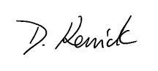

Dom Kenrick
Headteacher

Candidate information

Individual visits:

We would be delighted to organise individual visits with any potential candidate who wishes to visit or find out more detail about a particular area of the Academy. Please contact our Reception staff on 01444 457881 to arrange a tour.

Submitting your application:

If you would like to apply for this post:
- Please complete an application form, available on the Warden Park website
- Also submit a letter of application, no longer than two sides of A4. In your letter please focus on the following:

  - How will you ensure that all students in your classes make outstanding progress?

Your completed application should be emailed to jobs@wardenpark.co.uk by 10am on Wednesday 14th November 2018. Please note that we will be considering applications as they are submitted up until the closing date. Our HR Manager, Shirley Batchelor (sbatchelor@wardenpark.co.uk) will be happy to answer any questions you may have about this process or vacancy (01444 476556).

Safer Recruitment:

Warden Park Academy is committed to safeguarding and promoting the welfare of children and young people and expects all staff and volunteers to share this commitment. We will ensure that all our recruitment and selection practices reflect this commitment. All successful candidates will be subject to DBS checks along with other relevant employment checks

Short listing:

The selection panel with undertake short listing wherever possible on the same day as the vacancy closing date, however if there is no closing date we will contact successfully shortlisted candidates as soon as possible. Shortlisted candidates will be notified by telephone and/or email giving them as much notice of the date of interview as possible. If shortlisted, please bring with you your passport, driving licence (both parts) and a recent bill or statement less than 3 months old along with your degree/educational certificates when you attend for interview. This is for DBS purposes and will save time later should you be appointed.

Local information

Location:

The school is ideally situated in the lovely Sussex village of Cuckfield, in a rural location, yet within easy reach of excellent facilities and communications. There are a good range of local amenities, including restaurants, boutiques and pubs found in Cuckfield and the nearby town of Haywards Heath. Haywards Heath lies in the centre of the Mid Sussex District of West Sussex, surrounded on all sides by stunning countryside, which is less than a five-minute drive in any direction from the town centre.

The vibrant seaside city of Brighton (15 miles) offers first-rate shopping, restaurants and cultural facilities.

Transport:

There are regular trains from Haywards Heath to London and the South East (London Bridge/Victoria from 42 minutes). Gatwick airport (14 miles) has a fast rail connection to London (Victoria 30 minutes).

www.southernrailway.com

There is very easy access to the A23/M23 and in turn the M25 and national motorway network.

Schools:

There are a number of highly regarded primary schools in the area:

www.wardenparkprimary.co.uk

www.northlandswood.co.uk

www.harlandsprimaryschool.org

www.holytrinity-cuckfield.w-sussex.sch.uk

www.bolnorevillage.w-sussex.sch.uk

