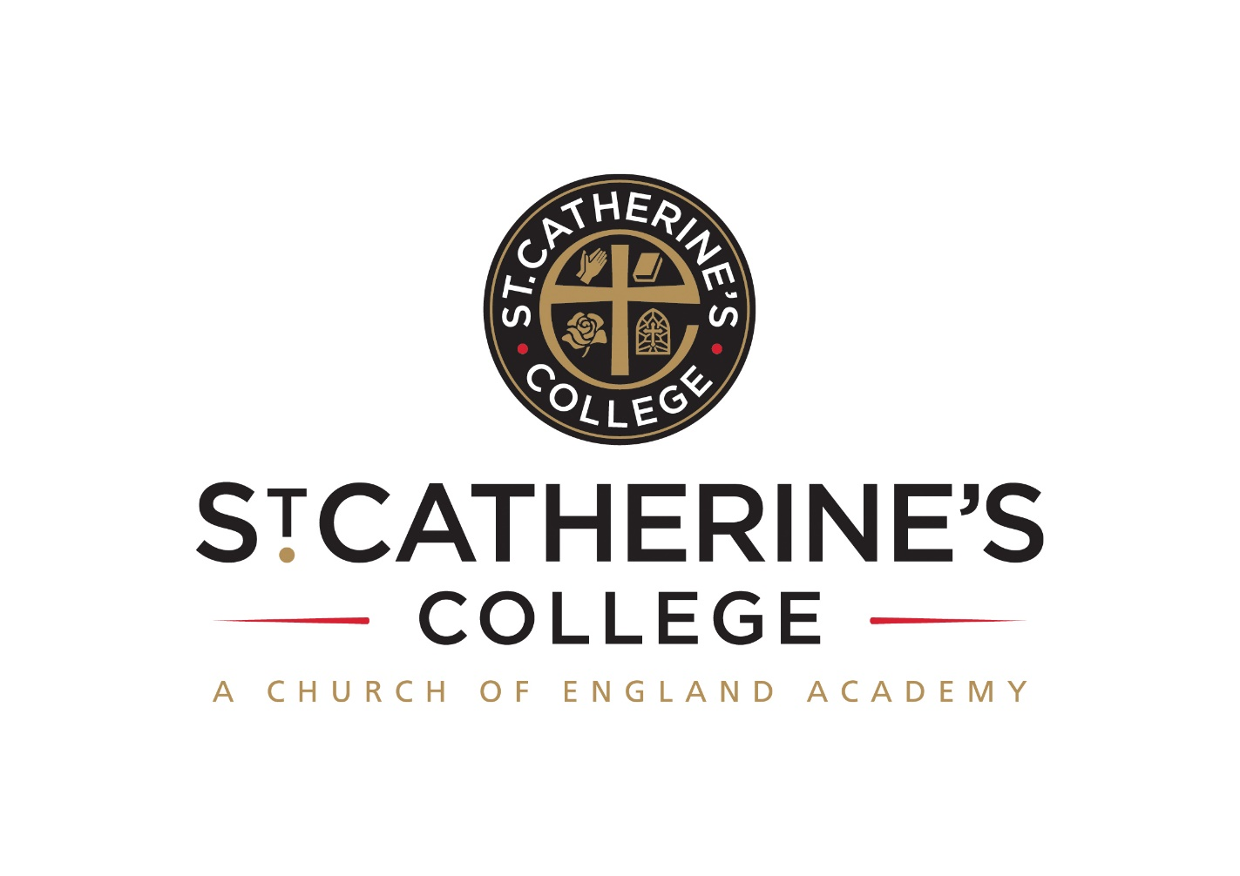 **TEACHER OF MATHEMATICS**

**Salary: TMS / UPS / Leadership Pay Scale**

Required Easter / September 2018

**INFORMATION FOR APPLICANTS**

**CONTENTS**

1. Letter from Principal
2. Job Description
3. Person Specification

January 2018

Dear Applicant

**Teacher of Mathematics**

Thank you for your interest in this post.

We are proud of our college, our talented and highly motivated staff and pupils. Our staff team work tirelessly to ensure that teaching is the best it can be and everyone has a role to play in this. We support each other and there is an open, friendly and collegiate atmosphere where new members of the team are welcomed and supported.

We are:

* An Investors in People Gold Award School, which means that we invest heavily and value the development of all our staff
* An inclusive Church of England School with the benefits of links with The Diocese of Chichester and the opportunity to promote strong lasting values based on the Christian faith
* Recognised by Ofsted as a strong ‘good’ and are working towards outstanding. We are also rated as ‘outstanding’ for leadership and our Christian distinctiveness as a Church School.

Understandably this letter and our website only gives a flavour of the college. We therefore encourage visits for prospective candidates to see our college in action. We do understand however that visits are not always possible or practical and you would not be at a disadvantage if you are unable to visit the college.

**The Post**

We are looking to recruit to our existing strong team a committed Teacher of Mathematics who is passionate about their subject area.

There is an opportunity of a Lead Practitioner role, paid on the Leadership pay scale, for an exceptional candidate. This would require the successful candidate to share their subject expertise and be prepared to lead projects within their specialism.

Additionally at St Catherine’s College we are part of a growing trust called DCAT (Diocese of Chichester Academy Trust) currently part of six academies this offers the opportunity of career development, potentially working in different settings and leading cross trust projects in Mathematics.

Mathematics staff teach across the full age and ability range and are encouraged to be creative and inspiring to meet the needs and challenges of all pupils. This reflects in the success amongst mathematics staff in developing modern positive approaches in their teaching practice.

The Maths team currently consists of ten highly qualified staff (of which one is presently part of the Senior Leadership Team), who together create an extremely positive learning culture based upon high expectations and a huge enthusiasm for the subject! We aim to do this through encouraging pupils to enjoy mathematics and to give all pupils an opportunity to progress and reach their full potential.

**Meet the Mathematics Department**

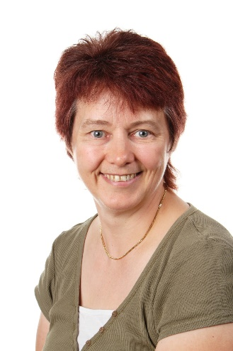   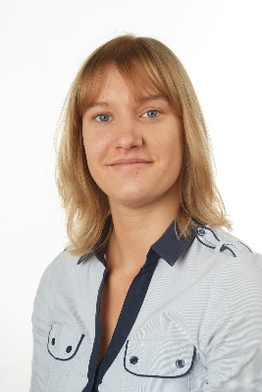

Chris Akister Nicky Baker Emma Brooker Nikki Butcher

Teacher of Maths Teacher of Maths Teacher of Maths 3rd in Dept. Maths

  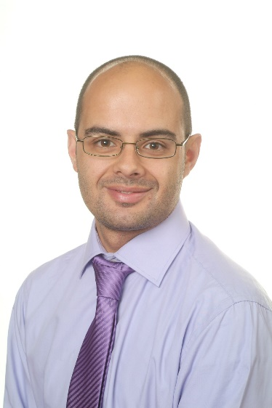 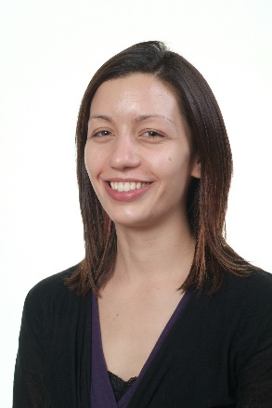

Jason Clarke Martyna Dalecka Ric De Sousa Cat Loveland

Teacher of Maths Teacher of Maths Head of Maths Teacher of Maths

 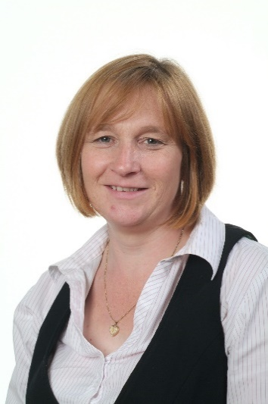 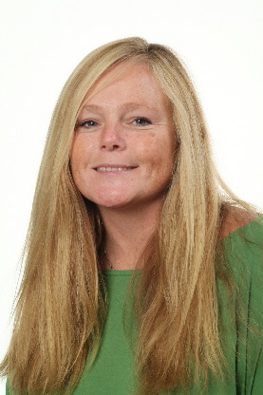

Siobhan Tinkl Jenny Inch Maja Poulsen

Lead Practitioner Maths Assistant Principal HLTA

The Department is looking to build further success through innovative, imaginative lessons which incorporate both challenges, functional skills and investigative problem solving; and thereby encompassing progress for all learners.

At Key Stage 4 all pupils follow the Edexcel linear examination depending upon their ability. As a department we offer extra-curricular activities which are well attended by the pupils and the local community, for example master class for the local feeder primary schools. This shows the commitment and dedication to the subject of not only the staff but that of our pupils.

Ongoing improvement in the teaching and learning of mathematics at St Catherine’s College is of the utmost importance. We are seeking to employ a member of staff whose passion for maths and enthusiasm for teaching reflects our ethos.

**We offer you**

* Excellent career development opportunities



* A geographical location, being situated near Sovereign Harbour, Eastbourne’s award winning Marina. It is part of several miles of beautiful coastline, including the South Downs National Park, the white cliffs of Beachy Head and 1066 country
* A friendly, supportive and caring staff team
* A fabulous staff room with complimentary tea and coffee
* A café that serves at breakfast, break and lunch using freshly sourced ingredients
* Plentiful staff car parking in two on site car parks
* Did you know that buying a house in East Sussex can be cheaper than in many other counties in the UK.

**Your Application**

Completed application forms and letters of application should be sent directly to the college addressed to Mrs S Windsor, Head of Personnel, swindsor@stcatherines.college and arrive by no later than **noon on Thursday 25 January 2018**.

Please use the standard application form, accompanied by a letter of application, which must be no more than two sides of A4. We are unable to consider CVs in place of application forms unless you are a person with a disability and a CV is the most convenient method of applying. In your letter of application you should clearly address the relevant sections of the Person Specification for this post and may find it helpful to use headings. We are committed to safeguarding and promoting the welfare of children and young people, successful applicants will need to undertake a DBS enhanced clearance.

I am conscious of the time and effort it takes to submit an application and am grateful for your interest. Shortlisted candidates should hear from us shortly after the closing date. St Catherine’s is a thriving college with a bright future and a vibrant and collegiate atmosphere within which to work. I am keen that we appoint quality candidates to join what is, I believe, one of the best staff teams. If I can be of any assistance or provide any further information, please do not hesitate to contact me.

Yours faithfully



Mark Talbot

Principal

**PERSON SPECIFICATION: TEACHER OF MATHEMATICS**

|  |  |  |  |
| --- | --- | --- | --- |
| **Attributes** | **Essential** | Desirable | |
| Qualifications and training | * Qualified teacher status recognised by the DfES * Graduate with a degree in Mathematics or a related subject |  | |
| Experience | 🖹 The post would suit a newly qualified teacher or someone with experience |  | |
| Skills and Abilities | * Be a talented classroom practitioner, with potential to develop further * 🗣Able to teach Mathematics to GCSE * Enthuse pupils * Will teach a vibrant and varied culture of Mathematics * 🗣Possess good ICT skills and be able to use them in their own teaching * 🗣 Able to communicate well, both in writing and orally   ✍🗣 Set goals that stretch and challenge students of all backgrounds and abilities  ✍🗣 Ensure your planning identifies and caters for students of different backgrounds and needs, specifically pupil premium students, those with special educational needs and the more able  ✍ Ensure the effective and efficient deployment of classroom support  ✍Ensure your planning provides appropriate and timely coverage of all aspects of the curriculum and that students acquire and consolidate the knowledge, skills and understanding expected  ✍Use relevant data to establish high expectations, monitor progress and plan sequences of lessons that respond to students learning and ongoing progress  ✍Provide regular formative feedback to students, both written and oral, that encourages them to respond and enables them to understand how to progress  ✍ Able to manage time effectively and work to deadlines |  | |
| Knowledge and Understanding | * 🗣Understanding of the principles, processes and strategies underpinning outstanding teaching and learning * 🗣 Outstanding knowledge of current educational developments/issues in Mathematics teaching   ✍ A passion for Mathematics |  | |
| Values | * 🗣 Be broadly in sympathy with the aims and ethos of the School * A commitment to comprehensive education, equal opportunities and inclusion * A passionate commitment to achieving the highest standards for all learners * A commitment to teaching approaches which make learning interesting, challenging, relevant and effective * An enthusiasm for running and involvement in, extra-curricular activities | * 🗣 A practising Christian |
| Personal Qualities | * Shows warmth, care and a sensitivity to the needs of others * Is self-motivated and hard working * Possesses a sense of humour and the humility to admit mistakes * Shows imagination, vision and proactivity * Possesses an infectious enthusiasm, stamina and considerable energy * Ability to work under pressure to achieve, to have high expectations, lead by example and meet deadlines | 🖹 Has a good health and attendance record |

**Criterion assessed by:** 🖹 = application form; ✍ = letter of application; 🗣 = interview