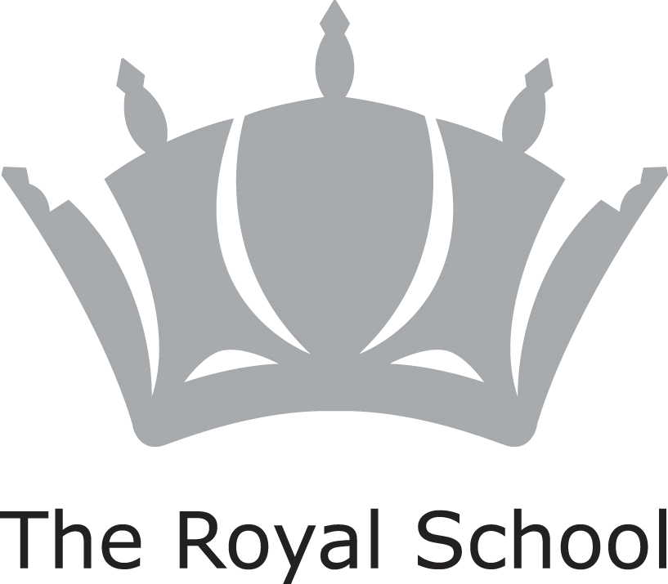

JOB TITLE

Classroom Assistant

JOB CONTEXT
In 2011 The Royal School adopted a diamond model of education which enables children to benefit academically from single-sex classes at key points in their education.
Pupils are educated together up to 7 years old and again at Sixth Form. From 7 years old to 16 years old they are taught in single-sex classes; the principal advantage of this teaching model is that boys and girls can be taught in different ways that maximise their learning in the classroom but still allows them to benefit from a co-educational social environment.
At the Junior School, boys and girls are housed on the same site and the Pre-prep department is fully co-educational. Boys and girls are taught separately for core subjects from Prep 3.

The ethos of the school is rooted in the Christian values of its founders. Service to the school community and to the wider world and personal, social and intellectual development outside the classroom are integral to school life.

JOB PURPOSE

To provide support to class teachers and specialist teachers as required.

ACCOUNTABLE TO

The Governing Body of the School & the Principal.

RESPONSIBLE TO

The Head of the Junior School.

RESPONSIBLE FOR

Children from 4-11 years.

KEY RESPONSIBILITIES

To promote good working practices within School and model ‘best practice’ behaviours.

To help the class teachers and specialist teachers fulfil their roles and responsibilities.

Responsibilities may include (but are not limited to):

- Working with an individual child or a group of children as they access the curriculum;

- Listening to children read;

- Supporting children in the completion of classwork or a curriculum activity;

- Assisting the class teacher in the completion of administrative tasks within the classroom.

General Responsibilities:

To take part in the School’s performance management process.

To attend INSET appropriate to the Junior School and the whole school and to keep necessary skills up to date.

To maintain a ‘whole school’ ethos working collaboratively with colleagues, especially the class teachers.

To actively follow all School policies, including Safeguarding, ICT Conduct, Equal Opportunities and Health and Safety in all working areas.

To support and develop the Christian ethos of the School.

To assist at special functions which may occur outside of normal agreed working hours and to attend meetings as required.

To maintain good relationships and communication with members of the School’s administrative and support staff and to ensure confidentiality.

To carry out any other duties that are within the scope, spirit and purpose of the job and its title as requested by the Principal or the Head of the Junior School.

This job description reflects the present requirements of the post. As duties and responsibilities change and develop, the job description will be reviewed and be subject to amendment in consultation with the post holder.

Personal Qualities:

- Honesty
- Trustworthiness
- Cheerful disposition
- Clean and tidy appearance
- Polite, patient and prepared to help
- Caring towards pupils and fellow workers
- Flexibility
- Good organisational skills

