CANDIDATE PACK

Dear Candidate,

Thank you for expressing an interest in becoming a member of our dynamic and forward thinking team at Swanbourne House.

This presents an incredibly exciting opportunity to become part of something special. Swanbourne House provides a unique balance between tradition and the best of modern teaching practice, a beautiful setting in 55 acres of Buckinghamshire countryside and a passion for the delivery of excellence in education. The school is thriving with more than 380 pupils from 3 to 13 and a flourishing Boarding House with upwards of 80 regular boarders.

We give teachers the chance to be creative, collaborative, and by bringing teaching alive to develop the skills, passions and innate attributes of all the children.

Simon Hitchings,
Headmaster

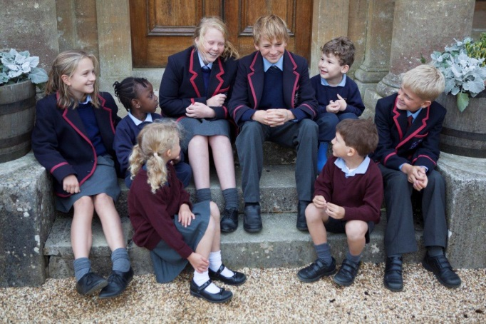
Contents – the aim of this pack is to give you sufficient background information to support your application.

1. Letter from the Headmaster

2. School History

3. Ours values and beliefs

4. School Organisation

5. Important Features of the
School

6. The local area

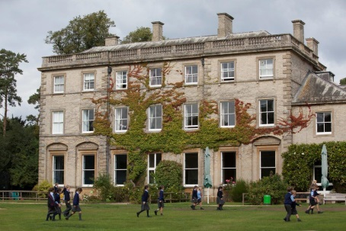
School History. The school started as a boys’ boarding school at St Andrew’s College, Bradfield in 1915 and moved with just 43 boys to Swanbourne House in 1920. The Prep school remains situated in and around the main house, which was built in 1860 as the residence of Lord Cottesloe. The school became co-educational in the 1970s and a Pre-Prep was opened in the 1980s. The school remains true to its boarding roots, and day pupils benefit from the ethos of a boarding school in which the range of activities and the wrap-around care extend into the evening. Flexi-boarding is strong and complements the life of the weekly and full boarders. A majority of pupils move on from Swanbourne House to board at senior schools.

Coat of Arms. The heraldic tinctures provide the School livery colours still in use today. The swan’s heads are an allusion of the School’s name and a reference to the County of Buckinghamshire. The swan in the crest is shown holding a pomegranate, which, with its many seeds is an allusion to learning with the seeds representing the seeds of wisdom.

Motto. ‘Discendo Crescimus Vera Quaerentes’ - ‘We grow by learning, seeking after the truth’

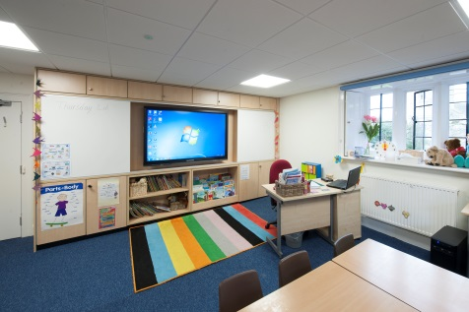
Swanbourne House has progressively expanded since the early days and now boasts a modern range of buildings housing a number of departments. The Pre-Prep department is situated in a late 16th century house, known as The Manor House; the Nursery was opened soon afterwards and is now housed in the Coach House extension built in 1997. Three classroom blocks with dedicated Science Labs, DT Lab, and IT rooms supplement the classrooms built in the old stable block, known now as The Cloisters. Sporting facilities have been expanded with an indoor swimming pool built in 2001 and two large Astros, the latest added in 2010, and a golf course. The Bridget More Hall provides a spacious indoor sports facility as well as the venue for the frequent musical and dramatic performances which are a central part of education at Swanbourne House.

Recent projects have included refurbishment of the school Chapel, a Performing Arts Studio, and an ongoing programme of classroom and Boarding House upgrade with Clevertouch screens providing the technological base to support the most effective teaching.

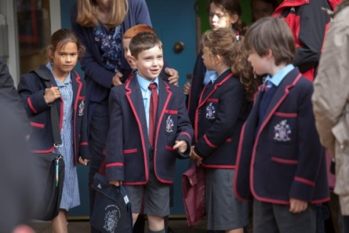
Our Values and Beliefs
Swanbourne House is a family-centred school which aims to provide a broad education. We recognise each child to be unique with individual needs and talents. We cater for pupils’ social, emotional, moral and spiritual well-being in a stimulating and creative academic environment. Day pupils and boarders are well prepared within the context of a Christian pastoral ethos for their next school and for their future lives in a fast moving and challenging globalised world.

School Organisation

Important Features of the School

The majority of our pupils move on to boarding at public schools and the school is run with a strong boarding ethos which benefits both day and boarding pupils. The school day is long with a full academic curriculum and a sport for Prep children every day. From Year 4 Saturday morning lessons are a compulsory part of the week with matches on Saturday afternoons as well as during the week. Many children stay after school to do their homework, to have tea and to take part in activities.
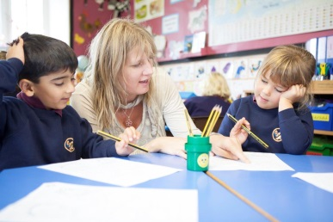
Mathematical Skills are emphasised from the Early Years upwards. A strong focus on learning number bonds and multiplication and division facts provides a strong foundation for pupils’ development. We aim to teach ahead of National Curriculum expectations and the focus on independent school exams takes our curriculum beyond national age expectations.

English Language is at the heart of everything we do, with pupils having the chance to develop their reading and writing skills every day. All teachers are expected to develop reading, writing and speaking skills in lessons.

Integration of New Technology is becoming a central plank of the pupil’s learning experience. Whether iPads, laptops, IT suites, language laboratories or usage of the Swanbourne Digital Learning platform, pupils are constantly challenged and stretched to achieve their potential. All staff are expected, with training, to develop this practice further.

Throughout the school we take pride in a broad curriculum. From Year 5 Science and the humanities are usually taught by specialist teachers. Preparation of children for Common Entrance or academic scholarship entry to a range of senior schools is the aim of our own schemes of work.

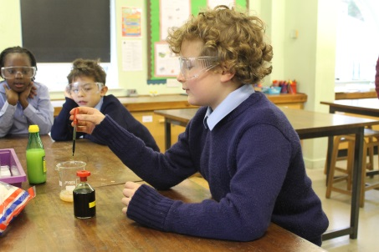
Science is seen as a core subject within the curriculum with a generous lesson of allocation which increases to five 40 minute lessons in the final two years. The scheme of work is structured towards preparing girls and boys for entry to public schools at 13+ via Common Entrance or Academic Scholarship exams. A practical approach to Science is encouraged throughout in the belief that the children will learn best though experimental Science. The school is currently undertaking a significant refurbishment of the Fremantle Science and Technology Building which will result in two fully reequipped and extended Science labs in September. This is therefore a very exciting time to join a very well-resourced department which is able to plan its future in these new learning spaces.

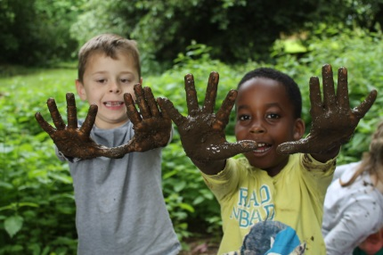
The Pre-Prep is fully integrated into the life of the school, but has its own classroom buildings, kitchen and play areas. The Pre-Prep runs from the Nursery (which takes children from the term they turn 3) to Year 2. Class teachers provide the bulk of the teaching across the curriculum. Our high academic standards mean that we accelerate most children beyond the requirements of the National Curriculum. We keep abreast of developments in the National Curriculum, but plan beyond it. Alongside the core skills of reading, writing and Maths, we seek to broaden the children’s horizons as they explore topics in Science and the humanities. Games, PE, swimming and ICT are taught in the facilities shared by the whole school. The curriculum is planned in order to provide a smooth transfer to the Prep and all pupils use the wider school facilities. Forest School is taught in Reception and Year 1 and dedicated areas of the woods by staff who are fully accredited to deliver this part of the curriculum.

The Boarding House provides a home during term-time for full and weekly boarders (currently 30) who are joined each evening by flexi-boarders who are committed to from one to four nights each week. The capacity of the House is 80 and the House is full on several nights each week.

Class Sizes are small and rarely 16 exceed pupils. Setting by small groups within classes and by creating separate classes is gradually increased as children move through the school to further stretch those who have been identified as academically capable and to support those who are progressing more slowly.

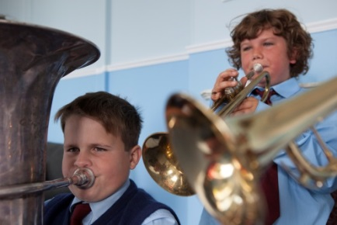
The Music Department has been built up to a position of great strength within the school. The department consists of a part-time Assistant Director of Music who shares the administrative and teaching load, a Pre-Prep Music Coordinator and a dozen peripatetic instrumental and singing teachers. There are five choirs, a wind band, string orchestra and other occasional instrumental groups. Around 80% of the children in the Prep part of the school have one-to-one lessons. Termly informal concerts, a Gala Concert in the summer, a biennial House Music Competition, the annual school musical and services such as Remembrance, Christmas and Easter are public occasions when the Music Department is on show. Each year the main school drama production is a large scale musical which the Music Department supports; other year group drama performances will have a musical element. The successful candidate will have the opportunity to lead an exciting and dynamic team, to liaise with Music Departments at the top public schools and to develop the instrumental and choral opportunities for Swanbourne House pupils. The nurturing of our top musicians for Music Scholarship entry to senior schools is a key development objective for the department

The school owns a day nursery, Home Farm Day Nursery, which functions as a separate part of the business. The Head of Pre-Prep acts as line manager to the Manager at Home Farm Nursery.

We want all our teachers to teach excellent and innovative lessons consistently and be able to coach others to do the same. Successful candidates will be excited at working collaboratively across disciplines to deliver rich learning experiences and be keen to develop different pedagogies. We believe that the combined power of flexible teaching styles, adaptable learning spaces and different group sizes to meet different curriculum needs is a potent way to improve learning.

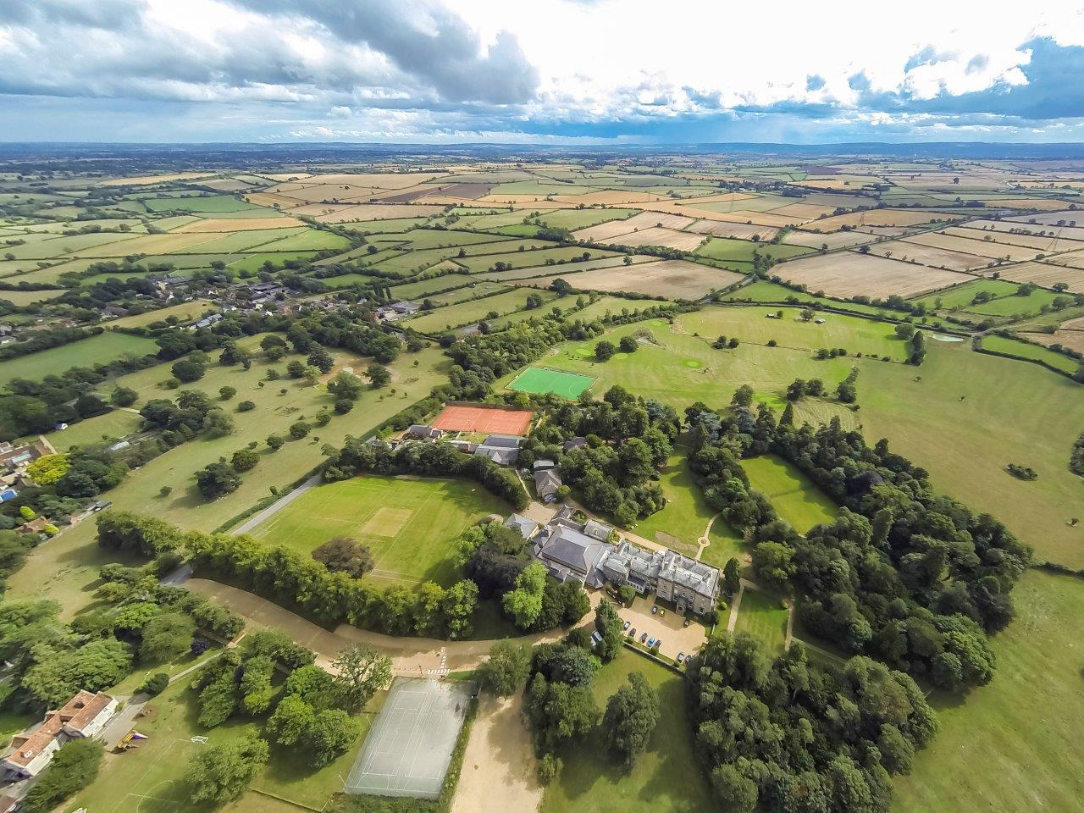
The Local Area

Swanbourne is a thriving community, nestled in the heart of the Buckinghamshire countryside, close to Milton Keynes, Buckingham, Aylesbury and Leighton Buzzard. The village boasts a general store, sub-post office and its own pub, the acclaimed Betsy Wynne, which is in easy walking distance of the School.

