

**Candidate Information Pack**

Hockey Coach

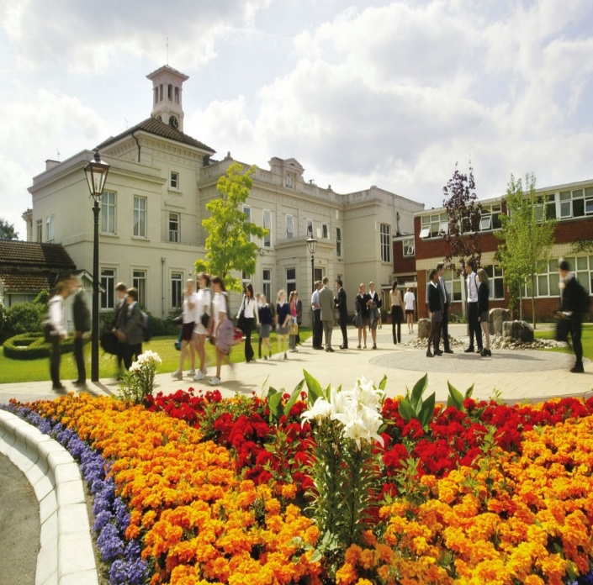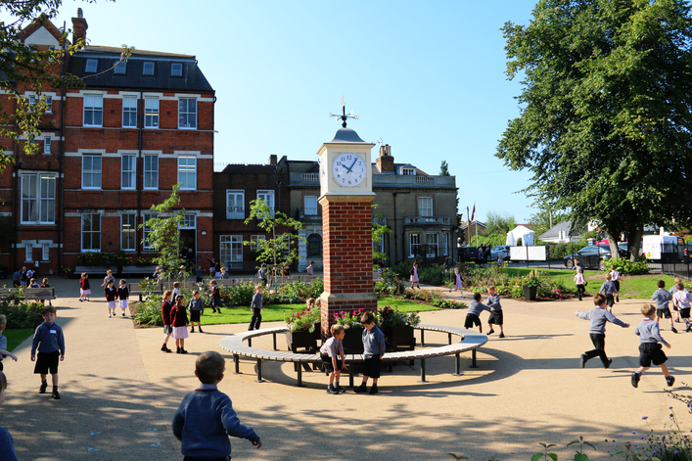

[**www.stgeorgesweybridge.com**](http://www.stgeorgesweybridge.com)

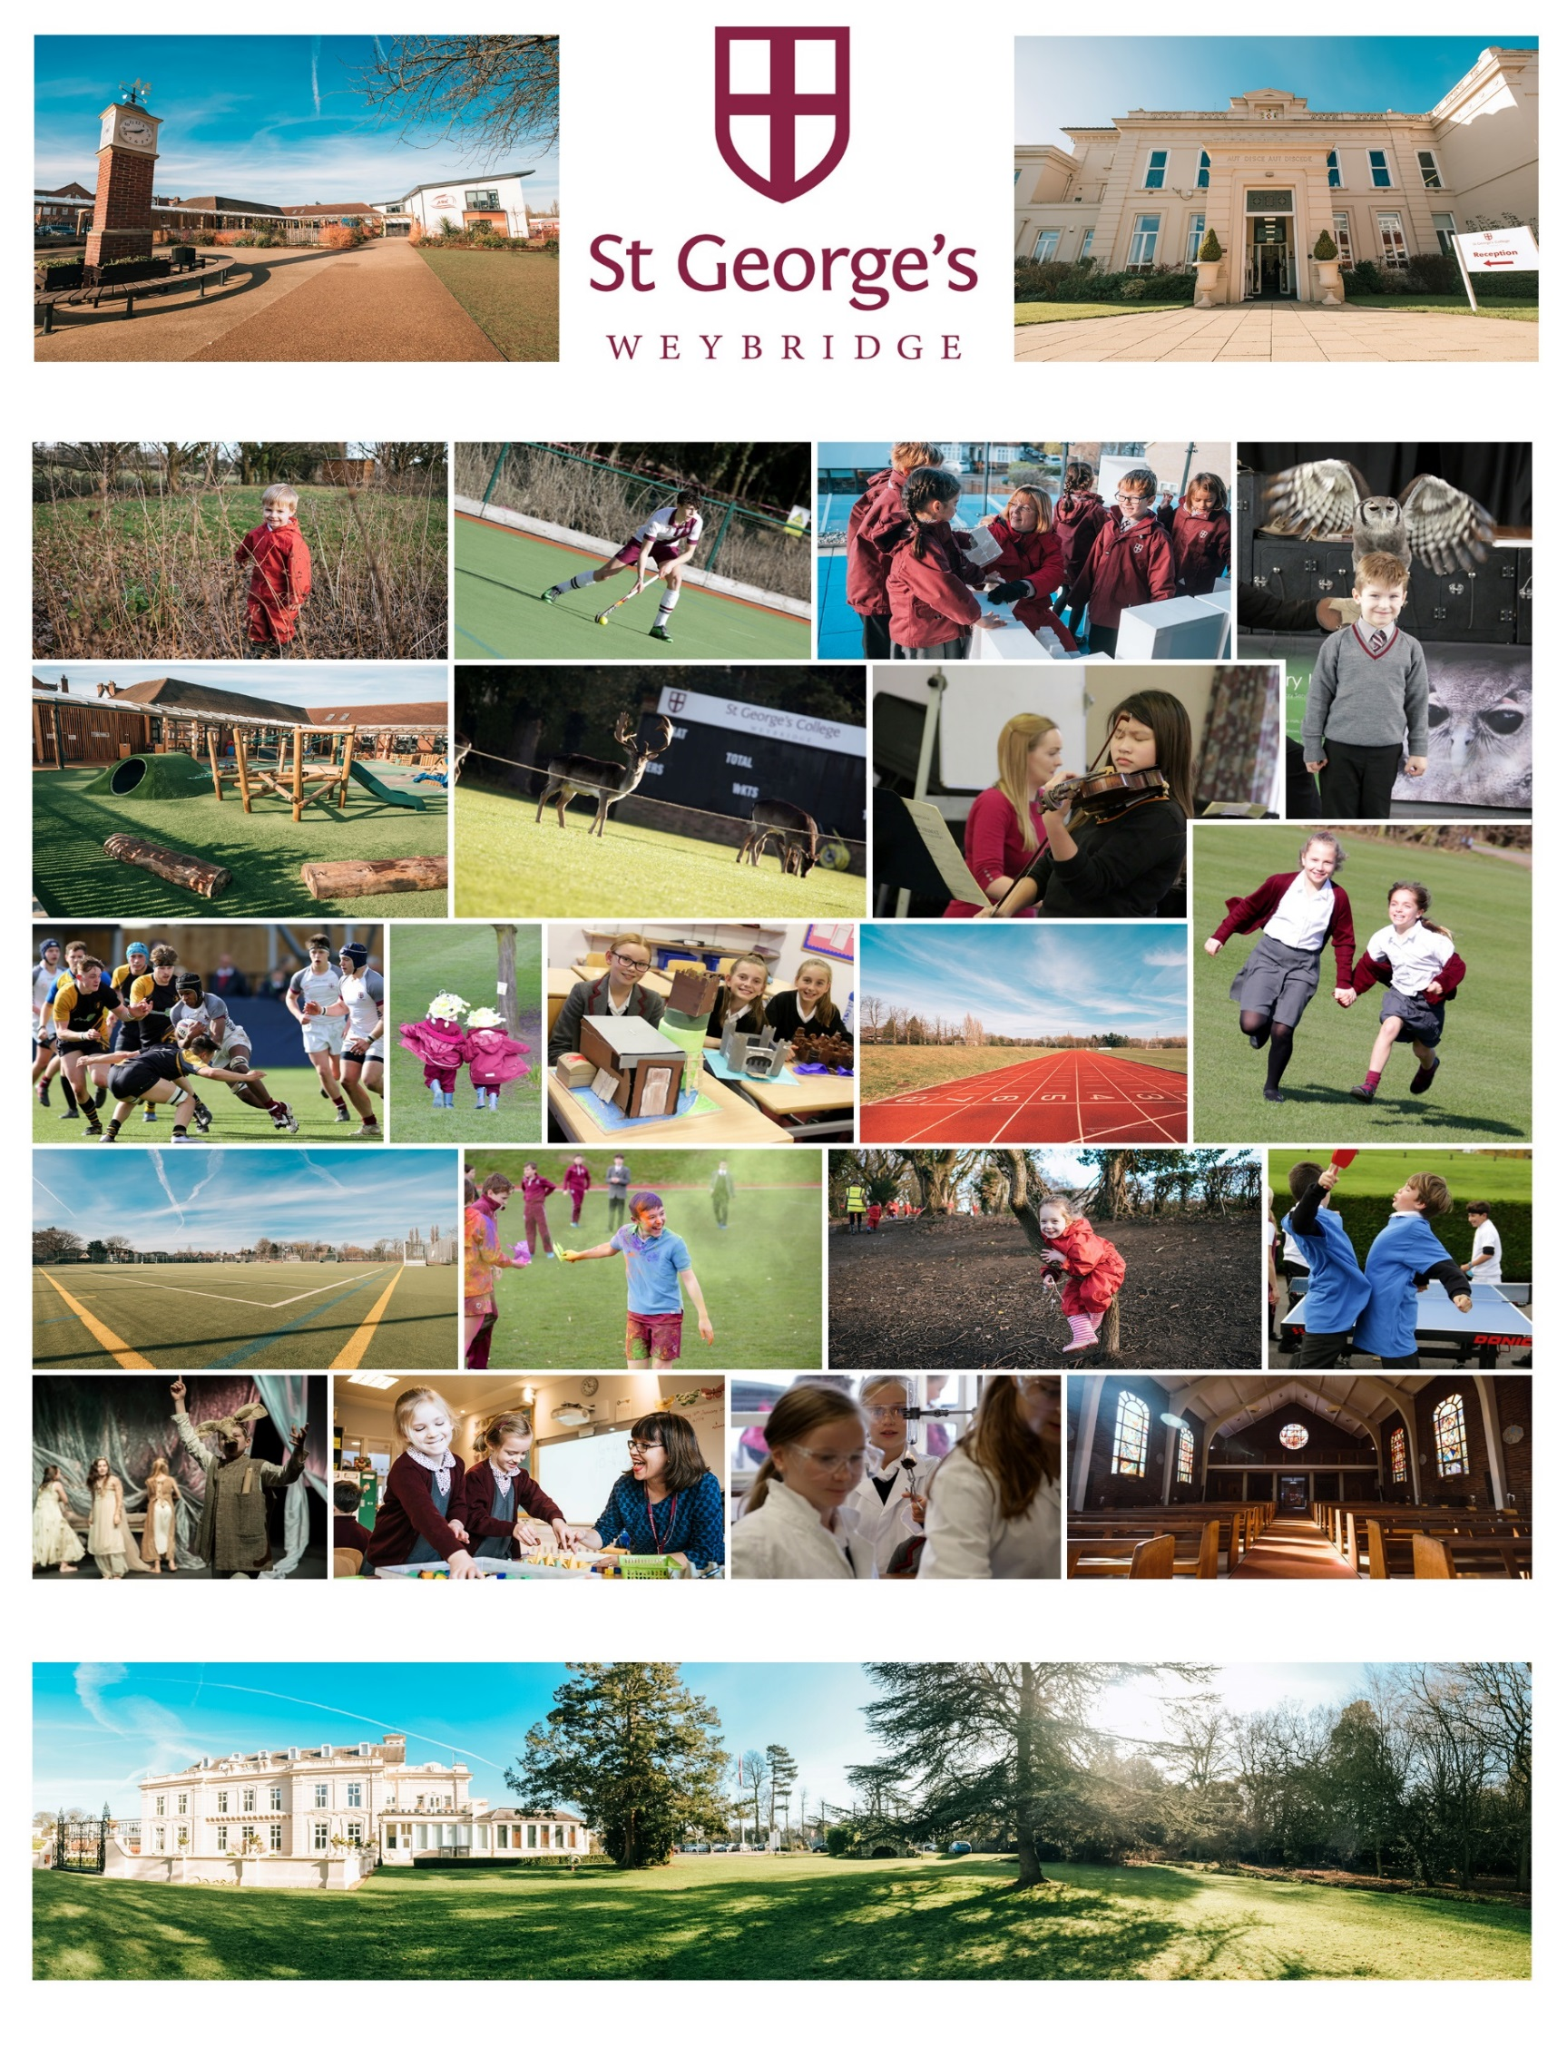

St George’s Weybridge

Thank you for your interest in joining the staff at St George’s Weybridge. We are delighted that you are considering our School and we hope that you will wish to apply for this position once you have found out more about us.

Founded in 1869 by the Catholic order of Josephites, St George’s Weybridge has become the largest independent Catholic school in the country. Academically autonomous, the College and Junior School work together to a ‘one-school’ principle, educating in excess of 1,600 students across the two school sites.

At St George’s we seek to inspire a love of learning in our students and to encourage all to fulfil their aspiration and potential within an atmosphere of mutual respect and compassion. We acknowledge that each child is an individual with unique talents and abilities. Our role is to identify and develop these talents by providing them with every opportunity to achieve in the classroom, on the sports field and on the stage.

It has been an exciting time here at St George’s Weybridge, with Rachel Owens joining us as Headmistress at the College, bringing her vision and enthusiasm as she leads the College in the next stage of its development. And to mark our forthcoming 150 year anniversary, work is commencing later this year on an exciting new architectural development for the College that will transform our current activity facilities. The Junior School, led by Antony Hudson, goes from strength to strength and last year saw the opening of “The Ark” with its’ state of the art classrooms, resource areas, IT suite and outdoor learning areas.

Our Schools are supported by a strong Business Team made up of passionate and dedicated individuals working across a broad spectrum of departments, all pulling together to provide professional business services enabling the delivery of an outstanding Georgian education. The heads of each of the nine business departments form the Business Management Team which complements the activities of the College and Junior School Senior Management Teams.

We hope this pack provides you with useful information about both St George’s Weybridge and this pivotal role. We recognise that a great deal of thought and time goes into preparing such an application and we assure you that we will, in turn, give your application serious consideration.



The distinctive Josephite traditions upheld by St George’s College and St George’s Junior School encourage a strong sense of family where all students are valued and encouraged to fulfil their potential in an atmosphere of mutual respect and compassion.

Our Georgian Family Ethos

This atmosphere aims to reach out to all families, our alumni known as 'Old Georgians', the local community and the wider world.

St George's College and St George’s Junior School are proud to have a reputation for being friendly schools, where all students are individually known and valued equally whatever their strengths and weaknesses. Great care is taken by the teaching staff to ensure that all of those in their care develop into quietly confident, compassionate and perfectly balanced individuals, which will prepare them to play a responsible role in the shaping of society.

Christian values have always permeated every aspect of School life. St George’s College and St George’s Junior School are Roman Catholic schools which welcome students from all Christian denominations. It is our wish that during their time at St George's, our boys and girls will grow up within a community where Christian beliefs and principles are a guide for all that we do. This is evident in the liturgical life of our Schools and in the many ways we have of reaching out beyond our community. St George’s Weybridge has clear policies about equal opportunities and does not tolerate any form of harassment or bullying.



At St George’s Weybridge, we employ a number of full and part time staff in a wide range of teaching and business posts. Our salaries are competitive and we offer a range of excellent employee benefits. Staff will undertake a full induction programme on joining St George’s and continuous professional development is actively encouraged and supported.

Working at St George’s Weybridge

Conveniently situated, both schools are supported by great road and public transport links. The grounds of St George’s Weybridge are stunning with the College sitting in 100 acres of park land and the Junior School on a 52 acre site. The facilities offered at both schools are exceptional with many more exciting developments underway.

St George’s prides itself on offering a harmonious and supportive environment for all staff and the Josephite ethos of “Coming home to school” is experienced not only by our pupils but extended also to our staff.

What Our Staff Say

“From the moment I drove into St George’s College, I felt a great sense of welcome and belonging. The recruitment process was effortless and accommodating. The general attitude and friendliness of staff at St George’s has enabled me to settle in very quickly and comfortably into the Georgian Family. Students at both the College and Junior School are really lovely, along with the grounds that are a joy to walk around. I feel very proud working for such a wonderful place, which clearly values and appreciates its staff.” ***Oliver***

“I can honestly say I love working at St George’s and enjoy coming into work every day. The people at St George’s make the school what it is today and I feel extremely lucky to be part of this community.” ***Laura***

“St George’s Weybridge is a fabulous place to work, set in beautiful grounds and with an ethos where everyone shares and embraces each other’s skills and knowledge. From day one, I have found everyone to be warm and welcoming and there is culture that evokes mutual respect amongst staff and students alike. I definitely feel part of the ‘Georgian family’!” ***Angela***

“Since day one the staff and students have been extremely friendly and helpful to me, there is a lot of respect between staff and students and this combined creates the perfect learning environment for everyone at the college, staff included.” ***Toby***

The Role

|  |  |
| --- | --- |
| **Job title:** | Hockey Coach |
| **Line Manager:** | Head of Boys and Girls Hockey |
| **Responsible to:** | Director of Sport |
| **Salary:** | £25.00 per hour, inclusive of holiday pay |
| **Hours:** | Hours per week to be agreed with the Heads of Hockey  Fixed term contract, September 2018-April 2019 |
| **Overall summary of role:** | |
| St George’s provides opportunities in Hockey for all of the students within the College, whether they are of an elite standard or play as a recreational activity within the Games curriculum. The College has a successful reputation for Hockey with both boys and girls teams throughout the school frequently reaching regional and national finals. There is a competitive fixture list including surrey and south qualification competitions and indoor hockey competitions for senior teams in the school.    ***Personnel and Facilities***  Presently the staff involved in Hockey include the Head of Girls’ Hockey, Head of Boys Hockey, PE staff and additional academic staff.    The College has two superbly maintained Hockey Pitches and a multi-million pound sports hall under construction that will be used for Indoor Hockey from 2019.  Each year group has timetabled games and an after school practice every week, with matches traditionally on Saturdays. The U12, U13, U14, U16 and 1st XI boys and girls will enter surrey qualifying competitions with U13, U14, U16 and 1st XI having a chance of competing at nationals if they progress U15 boys and girls enter the Independent schools cup. In addition, the College holds its own Sixes tournament. | |
| **Main duties & responsibilities:** | |
| * Work with the Heads of Hockey to promote and develop Hockey within the College, at both the elite and ‘sport for all’ levels. * Assist in the coaching of Hockey within the College. * Responsibility for a team(s) including weekend fixtures. * Be aware of the students’ needs across the whole ability range. * Organise practices, fixtures, and competitions where appropriate. * Provide inset and training opportunities for students and staff to develop. * Work with the Heads of Hockey to strengthen links with the Junior School, external clubs and agencies. * Any other duty as required by the line manager commensurate with the post.   This job description is indicative of the nature and level of responsibilities associated with this post. It is not intended to be exhaustive. Other tasks and responsibilities may be allocated as necessary from time to time. | |

Person Specification

* Experience of coaching or playing Hockey to a high standard
* Level 1, 2 or 3 Hockey Coaching qualification, or equivalent
* Proficient match umpire
* A team player able to work collaboratively and motivate colleagues
* Excellent interpersonal and organization skills
* Reliable with the ability to provide flexibility with working patterns
* To promote and adhere to the Josephite values of politesse, douceur, mercy, honesty, zeal, happiness, inclusiveness, collaboration, pastoral care and hospitality

**Meals:**

Benefits

Staff are provided with lunch in the dining room, as part of the Student Supervisory Policy.

**Employee Assistance Programme:**

Marsh DAS provides a free confidential counselling helpline available 24 hours per day.

**Holiday Camps & Local Retailer Discounts:**

Discounts are available to all permanent staff on holiday camps and activities hosted at St George’s Weybridge. In addition a number of local shops and retailers offer discounts to staff at St George’s.

Conditions of Employment

**Initial Period of Employment**:

One Month

During the Initial Period of Employment, sick pay will be paid in accordance with current legislation.

**Notice Period:**

One week on either side during the Initial Period of Employment, thereafter:

One Month

**Pre-Employment Vetting Checks:**

It is a condition of employment at St George’s Weybridge that every applicant who accepts the offer of a job will be subject to criminal background checks through the DBS and will be required to provide documentary evidence to confirm their identity and right to work in the UK. The checks will be carried out at the School’s expense. References will be taken up, including those from previous employers.

**Safeguarding Children:**

The post-holders responsibility for promoting and safe-guarding the welfare of children and young persons for whom he/she is responsible or with whom he/she comes into contact will be to adhere to and ensure compliance with the Safeguarding Policy Statement at all times. If, in the course of carrying out the duties of the post the post holder becomes aware of any actual or potential risks to the safety or welfare of children in the school he/she must report any concerns to the Head and/or Designated Safeguarding Lead.

**Dress Code:**

The Hockey Coach is expected to conform to the St George’s dress Code as set out in the Staff Procedures Book.

**Place of Work:**

The Hockey Coach is normally based at the College, but may be required to work at the Junior School or elsewhere as directed by the line manager.

**No Smoking Policy:**

St George’s College and St George’s Junior School operate a no smoking policy.

To find out more about the post or the school, in the first instance please contact Andy Cornick, Director of Sport, for a confidential discussion:

Your Application

Tel: 01932 839300 ext 3562

Email: [ACornick@StGeorgesWeybridge.com](mailto:ACornick@StGeorgesWeybridge.com)

Applications are encouraged as early as possible on the enclosed form and emailed together with a covering letter to [humanresources@stgeorgesweybridge.com](mailto:humanresources@stgeorgesweybridge.com).

**Closing date for applications: 18 May 2018**

Interview date: w/c 21 May 2018

Before making an application, please familiarise yourself with our [**Safeguarding Policies**](http://www.stgeorgesweybridge.com/further-information/school-policies-)**,**[**Recruitment Policy**](http://www.stgeorgesweybridge.com/uploads/redactor_rails/document/data/2953/Recruitment__Selection_and_Disclosure_Policy_and_Procedure_January_2016.pdf), [**DBS Code of Practice and Associated Policies**](http://www.stgeorgesweybridge.com/uploads/redactor_rails/document/data/2737/DBS_Code_Of_Practice___Associated_Policies_Final.pdf) which are available at:

[http://www.stgeorgesweybridge.com/further-information/employment-opportunities](http://www.stgeorgesweybridge.com/further-information/employment-opportunities-)

St George’s Weybridge is committed to safeguarding and promoting the welfare of children and applicants must be willing to undergo screening appropriate to the post, including checks with past employers and the Disclosure and Barring Service.

St George’s Weybridge is an Equal Opportunities Employer and a registered Educational Charity. 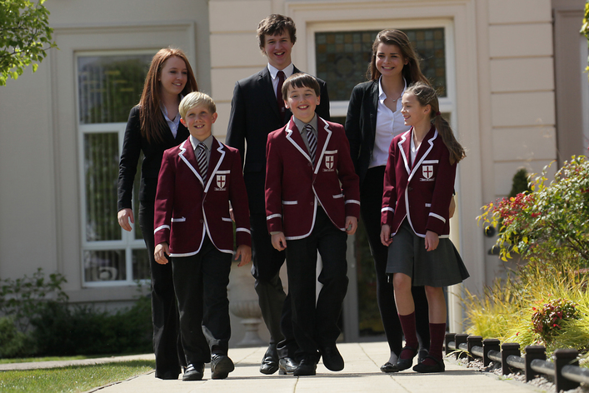We look forward to receiving your application.