Information for applicants | 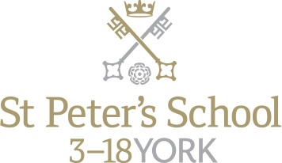

Full Time Teacher of Mathematics

September 2018

A well-qualified mathematician is required for September 2018 to teach in the school’s large and highly successful Mathematics Department. At present the Department has six full-time members of staff and two part-time staff. The position would suit either an NQT or an experienced teacher.

In Year 11 students sit the Edexcel International GCSE and there is opportunity for the most able to be entered for a further mathematics qualification. In 2017 all pupils achieved grade C or above at IGCSE, with 89% achieving A/A* grades. Approximately 70 boys and girls take ‘A’ Level Mathematics each year, with a significant proportion studying Further Mathematics. In 2017 68% of ‘A’ Level pupils gained A/A* grades. The new Edexcel specifications will be followed for both qualifications.

A new Mathematics Teaching Block is currently under construction and this exciting project will be ready for September 2018. The new purpose built area will comprise 8 large teaching classrooms, each fitted with new furniture, a digital projector and large whiteboard space. There will also be a shared office, a meeting room and a Sixth Form study area.

It is expected that the successful candidate will make a positive contribution to the department and to the continuing development of the subject. Each year pupils are entered for the individual UKMT Intermediate and Senior Challenges and the school enters a team for the Year 10 Maths Feast and the UKMT Junior and Senior Team Challenges. Students have the opportunity to take part in the Cipher Challenge run by the University of Southampton and there is an annual trip to the Maths Inspiration Lectures in Leeds.

Ideally the successful candidate should have:
- A thorough knowledge of the (13-18) subject curriculum
- Excellent classroom management skills and be capable of delivering inspirational and informative lessons

Salary

The starting salary will be at a point on the St Peter’s salary scale, related to, but currently significantly above, the old National Scale.

Other Opportunities

The school works a busy six day week and the person appointed will be expected to play an active part in the school’s tutorial system and in its co-curricular life. The guideline teaching load is 28 forty minute lessons in a 40 period week. The School’s co-curricular programme is broad and is well-supported by the teaching staff. An overview of the current range of activities is attached. The standards of both girls’ and boys’ sport at the School are high, and all sports have a number of competitive teams and so an ability to coach sports would be an added recommendation. Opportunities exist to choose to become involved with the School’s active Music Department, the Community Action programme and the various dramatic productions staged annually. Because of the breadth of activity on offer, there is scope for the interests and expertise of the successful candidate within the framework of co-curricular activity provision. There is also a broad range of school trips each year, from expeditions to Ecuador and India, major sports tours, choir tours to Europe, numerous cultural visits as well as ski trips. The School runs an active and well-supported CCF and a large number of children complete Duke of Edinburgh awards each year.

All full time teachers at St Peter’s take on pastoral roles as tutors in either a day house or a boarding house. This gives some responsibility given guidance from a Housemaster or Housemistress for the personal, social and academic development of around twelve children. In many houses it is the normal practice to follow a group of tutees through the school and so see them fulfil their potential. Tutors are an important point of contact with parents who value the overview which the tutor can take on their child’s progress.

How to Apply

To apply for this post, submit a school application form, completed in full, with a covering letter.

Mr Leo Winkley, Head Master, St Peter’s School, York, YO30 6AB

Tel: 01904 527408
Fax: 01904 527302

Or by email to j.warner@stpetersyork.org.uk

The closing date for applications is 10.00 Monday 29 January 2018

Interviews will be held during the w/c Monday 5 February 2018

About St Peter’s
Background

St Peter’s School, York comprises three schools: St Peter’s School (pupils aged 13 – 18), St Olave’s School (pupils aged 8 – 13) and Clifton School and Nursery (pupils aged 3 – 8 years). The school is fully co-educational with 1,100 pupils, of whom 158 are full time boarders and 231 are in the Sixth Form. There are over 300 teaching and support staff. It is one of very few schools in the North of England to offer three distinct phases of education, each sharply identified and focused towards the needs of its pupils at each age group and set within an overall context of trust, confidence-building, inspiration and opportunity.

St Peter’s is one of Europe’s oldest schools, founded in 627AD, and is ranked in the top 100 schools in the country for its academic results. The school is located within a short walk of York city centre, with its thriving cultural, educational and commercial life. Many of St Peter’s facilities are modern and spacious, with playing fields adjacent to the main building that stretch down to the River Ouse.
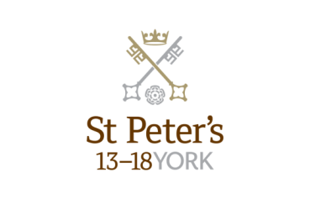

St Peter’s School

St Peter’s School, for children aged 13 to 18 years, is underpinned by academic rigour and challenge. Through outstanding teaching, first rate facilities, high expectations and sheer determination on the part of its pupils, St Peter’s achieves considerable success across a broad curriculum.

The four vibrant and successful boarding houses for boys and girls lend vitality to the pastoral life of the School. Inspiration from living in close proximity to a cultured and historic city adds further richness to the pupils’ lives.

The School Chapel stands at the centre of the campus and regular services (three mornings a week) give pupils and staff the opportunity to reflect together on the spiritual values of the community and on the meaning and significance of what is happening locally, nationally and globally.

Music, Art and Drama are central to the cultural and academic depth of the School. The Sports programme is extensive, providing a wide range of choice for both girls and boys. Results are excellent, and St Peter’s pupils’ co-curricular achievements are considerable. The excellence of the teaching and facilities allows pupils to thrive.

The school’s website can be visited at www.stpetersyork.org.uk. The most recent inspection report is available on the ISI website.
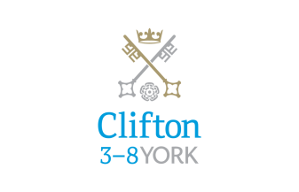

Clifton School and Nursery

Clifton School and Nursery, for day girls and boys aged rising 3 to 8 years, has its own building with use of extensive play areas, sports hall and swimming pool. Under the leadership of the Head, teachers use the attractive buildings and play areas to maximum advantage, teaching a broad and balanced curriculum which gives a wide variety of experiences, and emphasises the importance of basic skills. The curriculum is based on the National Curriculum and Primary Strategy, but goes far beyond this, both within the school day and during the wide range of co-curricular activities and visits outside of School.

Clifton enjoys separateness, a clear identity and its own House system. It allows smooth academic progression and provides tailor-made approaches and facilities for each age group.
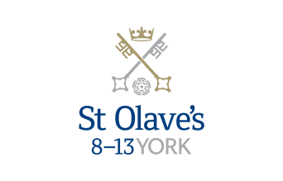

St Olave’s School

St Olave’s School (pronounced ‘olives’), for girls and boys aged 8 to 13 years, is adjacent to the main campus of St Peter’s and introduces boarding as an element of the School. Under the leadership of the Master, the teaching staff provide expertise in the 8 to 13 range, guaranteeing subject specialism to challenge and support every pupil.

The curriculum is wide and challenging with expert teaching from the earliest age. There are many opportunities for recreational and competitive sport with girls’ and boys’ teams enjoying success both regionally and nationally. There are numerous co-curricular activities to choose from on a weekly basis. Music plays a central role in school life, involving the full range of orchestral instruments.

Boarding is an integral element of the School and is accommodated in Wentworth, a boarding house on the main school campus.

St Olave’s has retained its own identity – a school within a school – giving all pupils a sense of pride and identity. It is recognised as a school in its own right, playing a vital role in the success of Clifton and St Peter’s.

About York

St Peter’s School is situated five minutes’ walk away from York’s compact city centre. York is one of the oldest and most beautiful cities in Europe, famous for its gothic Minster and winding medieval streets. York has won a number of tourist awards and further details are available on the Visit York website. York is regularly voted as one of the best places to live in the UK. Such is the size and layout of York, walking and cycling are ideal ways to get around, including taking in the famous sights of this historic city; an ancient Roman and Viking capital.

York is a central rail hub between Edinburgh, London and Manchester. The main railway station is only a 15 minute walk from the School. In addition it has a large variety of restaurants, pubs, theatres, cinemas, parks, museums and galleries, and life in York is always interesting, by day or by night.

Finding somewhere to live is also comparatively easy. York’s rental sector is in good health, though demand remains high. If you are trying to buy you will find York prices are around the national average.

York is a family friendly city. Attractions such as the Jorvik Viking Centre, the Barley Hall, the York Dungeons, the National Railway Museum and the York Chocolate Story are immensely popular with people of all ages.

The city lies in the Vale of York, a valley that runs north to south between the heathery North Yorkshire Moors to the east and the famous Yorkshire Dales to the west. Both areas offer an excellent escape for walkers, cyclists, climbers – indeed anyone with a love of fresh air and rolling countryside.

A guide to the City of York can be found at http://www.visityork.org/

How to find us

You can find St Peter’s School, York, at YO30 6AB.
The School (point B) is less than fifteen minutes on foot from York Railway Station (point A).

By car:

From York City Centre: Take the Thirsk Road (A19) at the Bootham Bar traffic lights. The school is 700m on the left, immediately after the footbridge.

From the A64: Take the Northern Ring Road (A1237). At the A19 roundabout turn towards the city centre. The school is two miles on the right, 300m after Clifton Green. Turn right into the school immediately before the footbridge that crosses the road.

Parking is available on site.

