Bourne Grammar School

Atmosphere

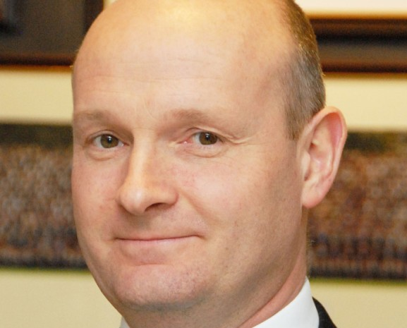
The best schools do everything well - academic, pastoral, sport, music, drama, Duke of Edinburgh’s Award, trips and visits. By virtue of a committed staff working with willing students and an appreciative Leadership Team, we have all these in abundance and to a high standard.

Support

We have no ‘mission statement’ - merely a very short purpose statement: Best Atmosphere, Best Support, Best Results. The order is deliberate; we believe that if we get the first two right then, given our able students and a committed staff, good results will follow. The atmosphere is
special and is cherished by us all.

I write as a fellow teacher. It is important to me that I am a teacher for a significant part of my time. I do not run other schools. I am not always out at meetings and conferences.

I am entirely committed to ensuring that Bourne Grammar offers the best experience to its students and, importantly for those who read this, a pleasant and rewarding
experience to its teaching staff.

Jonathan Maddox
Headteacher
Results

We are a large and busy school, educating the top 25% by academic ability. That means that we do have a range of ability here. Some do very well indeed; practically all achieve at least pass grades in all their GCSE subjects.
The students want to be here and their parents/carers want them to be here. Most of the students, most of the time, want to learn and enjoy lessons which are well- planned, well-taught and are engaging.

We have expanded considerably because of demand for our places. A full, expanded school means that our income allows us to run a financial surplus. There have been no redundancies and departments are well funded. We pay salary increments. Our estate and IT systems are in good order. A new, £4m Science Block enhances an estate which is modern and well maintained. We are adding not losing subjects in our large and expanding Sixth Form which will soon have 27 A-level subjects; there is no minimum set-size.

I didn’t go to a grammar school

Neither did I. There are only 164 selective schools in the country so it is not surprising that only a handful of our staff were educated at grammar schools. We recruit teachers who were educated and may now work in comprehensive, selective or independent schools.

I don’t have a degree from a top-class university

We don’t demand that. Colleagues here come from across the entire range of higher education. What matters to me is that you want to teach here.

Behaviour?

Behaviour will be a revelation if you have not worked in a school such as ours. Students want to be here, they want to learn, they do not want to make your life a misery. If you engage well with the students and keep them interested, you can expect calm lessons which leave you feeling positive, fulfilled and worthwhile. You will not drive home feeling shattered.

Please get in touch

We always welcome visits by prospective applicants, although, I understand that it isn’t always easy or possible to come here before you apply. In any event, Stella Chamberlain is at the end of the phone, and she responds quickly to email. Please do contact her. She can put you through if you wish to discuss the role.
The best atmosphere, the best support, the best results

The Post
We are looking to recruit a teacher of Law for September 2018 to teach A Level Law.

Application process
Please contact Stella Chamberlain on 01778 391648 or emailing recruitment@bourne-grammar.lincs.sch.uk

Go to our website for more information about the School: www.bourne-grammar.lincs.sch.uk

Closing date for application is Tuesday 22 May 2018

