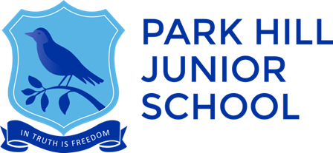

Information Pack for Candidates
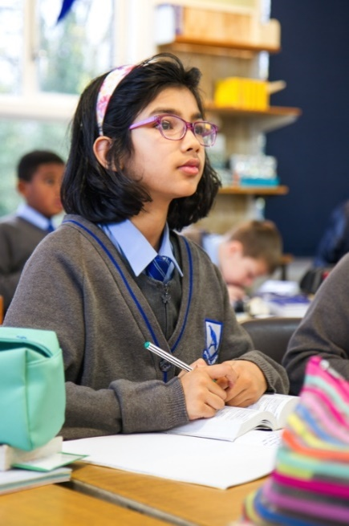

Class Teacher
Start Date: September 2018

Stanhope Road, Croydon, CR0 5NS Tel: 020 8686 8623

www.phjs.co.uk

This document is a prospectus designed specifically for you as a candidate, the aim being to summarise the relevant information you require to reach your decision on whether to apply for a position at our School. We hope you find this useful. Please access the School website www.phjs.co.uk for further information.

Welcome from the Head Teacher

Park Hill Junior School is an amazing place to be so I am delighted that you are considering taking a role at our school.
Park Hill is a diverse and rich multicultural community and our children bring a wide range of experiences to enrich their learning. The children are kind and respectful, and show resilience as they aim to be the best they can be. They understand the concept of a growth mindset and understand the power of the word ‘yet’ especially when inserted into the statement: ‘I can’t do it’!
The staff have worked hard to establish systems that have secured our Ofsted judgement as a GOOD school in October 2014, and we continue to work together as a team to ensure that we are moving towards outstanding.
Please make time to visit us to see around our school and see this for yourself prior to making your application. I look forward to welcoming you to our school.
Mrs. Cathy Daniels
Head Teacher

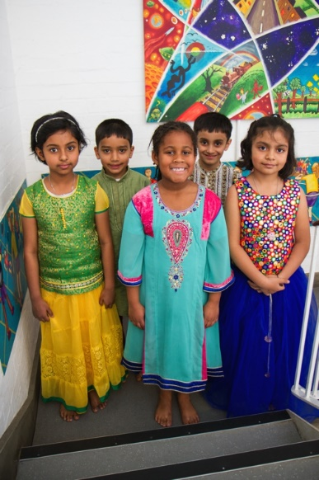

Our Children

The children of Park Hill Junior School are simply wonderful!

We have a vibrant school community and our children make us smile every day with their joyous outlook on life and their enthusiasm and love of learning. We call ourselves ‘The Park Hill Family’ and we really do look after each other. We embrace the diversity of our children and our wonderful mix of different cultures, ensuring that we learn from each other and respect all races and religions.

At Park Hill each child belongs to one of our four house groups – Coleridge-Taylor, Latham, Johnson and Flower. Two House Captains represent each house and there are opportunities throughout the year for the children to represent their houses in the inter-house sports competitions and sports day. There is a sense of pride in belonging to a group with children of all ages in the school and great excitement at the end of the summer term when the winning house is announced for the year!

We encourage our children to be respectful, kind, resilient, rigorous and aspirational and these qualities pervade our teaching and ethos. We want our children to be the best they can be and we strive to give them the tools through which this can be achieved. We truly believe in them and we want them to believe in themselves, to know that they can do anything if they try their best and set their sights high.

We are very extremely proud of all of the children at Park Hill!

Our goal is to attract teachers who can inspire and excite the minds of our children and embrace their different cultures and backgrounds to bring out the best in everyone.

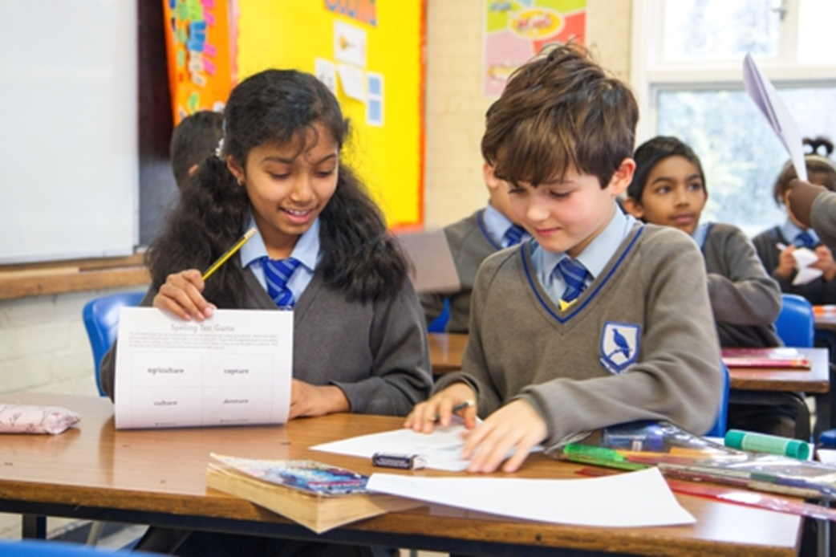

Background and Ethos of our School
Park Hill Junior School is located in the centre of Croydon Town Centre in Greater London. Croydon is the second most populated borough in London with an estimated population of 381,000. There are 93,194 young people under the age of 17 in Croydon, the largest number of any other borough. Croydon is a major economic centre in London with 81.8% of the population economically active. The borough is at the heart of a range of investments among them the £1.4bn regeneration of the Whitgift shopping centre, further bolstered by the arrival of Westfield and the recently opened Boxpark pop-up mall all delivering 5,000 new jobs as well as acting as a catalyst for the wider regeneration of Croydon. However, deprivation is increasing in Croydon. 21% of Croydon children are living in poverty (18,000 children) and 30% of Croydon children live in working families who receive tax credits.

Park Hill is a three form entry Junior School with 366 children on roll aged 7-11. In April 2017 the school joined the Folio Multi-Academy Trust which comprises Wallington Boys Secondary Grammar School, Coombe Wood Secondary Free School and St Peter’s Primary School. The majority of children joining year 3 come from Park Hill Infants School which is located on the same site, but operates entirely separately. Year 6 pupils leaving Park Hill Junior School go to on average 32 different Secondary schools, including selective and non-selective schools.

Of the 363 children on roll 67 are in receipt of Pupil Premium Funding, 44 have Special Educational needs, including 3 with EHCPs. 55% of children speak English as an additional language, 6 of whom are in the early stages of acquiring English. There are 39 different languages spoken throughout the school.

The School has a full-time Head Teacher, 2 part-time Co-Deputy Head Teachers, a full-time Assistant Head, a full-time SENCO and 4 Year Group Leaders who are all non-class based. There are 12 class teachers, including one NQT and one School Centred Initial Teacher Trainee. All PPA cover and staff absence is covered internally by the Year Group Leaders. Each Year Group is supported by one Year Group Learning Support Assistant and there are currently 3 Individual Support Assistants working with named children. Other support staff include a School Business Manager, two administration/finance assistants and a premises manager.

Wrap around care is provided before and after school (8am-6pm) for children from the Junior and neighbouring Infant school. This is managed in-house by the school’s full time Extended Day Manager and her team. Provision is also provided during school holidays and INSET days.
Our facilities include a large sports field, all weather multi-surface games area, adventurous play equipment (trim trail, climbing wall and tyre parks). There is also a 31 station ICT suite, 4 year group library areas and a learning support hub called the iHub. Each year group also has its own individual learning support room.

Peripatetic music tuition is available for all pupils in a range of instruments. We also have 18 extra-curricular clubs which run weekly either at lunchtime or after school. Many of these are led by members of staff, others are run by outside providers.

We aim to meet the needs of all of the children at the school through providing structured extension and enrichment activities, specific activities for our gifted and talented pupils as well as targeted support for children with specific learning difficulties or individual needs.
Park Hill Junior School provides child care and education opportunities beyond the normal school hours for 51 weeks of the year. The ‘Breakfast Club,’ ‘After School Club’ and ‘Holiday Play Schemes’ are organised and managed by the school directly. The provision is led by a dedicated Extended Day Manager who is also a trained first aider and deputy designated safeguarding lead.

- Breakfast Club – This operates from 8:00am until the buzzer/bell for both Infant and Junior schools to signal the start of the school day. Children who attend the Infant school are accompanied by Breakfast Club staff to the school just before the bell rings. The children are able to use the facilities of the Junior School including the Atrium for games including table tennis, chess and four-in-a-row.

- After School Club – This operates from 3:30pm until 6pm every weekday. The club provides a happy, caring, environment for the children to relax, do their homework or take part in activities such as arts and crafts, sports, reading, and trips to the park etc.

- Long Holiday Play Scheme – This operates during all school holiday periods (except for Christmas week) between 8am and 6pm. This scheme operates on a similar basis to the After School Club. However, the day is split into session of ‘Free Play’, ‘Structured Activities’ such as arts and crafts and sports sessions. Children who attend are required to bring a packed lunch. However, children who remain after 4pm are offered a light snack. The Play Scheme is also open to children who attend other schools. However, places are limited and allocated on a first-come-first-serve basis.

- During the October, February and May half terms the extended day team run a series of day trips. Locations they visit include: castles, farms, museums, cinemas, parks and the beach. They can cater for up to 45 children (3 minibuses).

- On Trust training days when the Junior School is closed to children, but the Infant school is open we run ‘Play Days.’ On these days breakfast and after school club run as normal and Junior School children can stay for the day to enjoy a variety of indoor and outdoor activities.

Pay
We pay staff on the Outer London Pay Spine and have a performance related pay policy which aims to reward commitment to, and excellence in, our practice.

Results and Progress

 | Park Hill SATs 2017 | National Average 2017 | Park Hill SATs 2016 | National Average 2016
GPV | 79% | 77% | 83% | 72%
Reading | 81% | 71% | 78% | 66%
Writing | 73% (TA only) | 76% | 78% (TA only) | 74%
Maths | 80% | 75% | 81% | 70%
RWM Combined | 71% | 61% | 74% | 53%

We are very pleased with the attainment of our children as shown above and this year Park Hill Junior School rank 2nd in Croydon for attainment at Greater Depth. This is a great achievement and a testament to the hard work of the whole staff and the pupils.

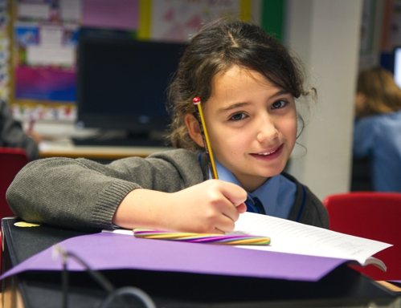
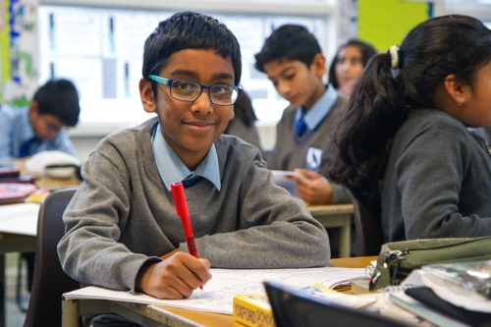
All children have different starting points, however, and it is our aim that each child makes the maximum progress possible in order to be secondary ready. Great care is taken to assess and address barriers to learning and pupil progress meetings are held termly to discuss the progress of every child. The needs of every child are equally important and we want every single child to fulfil their potential.

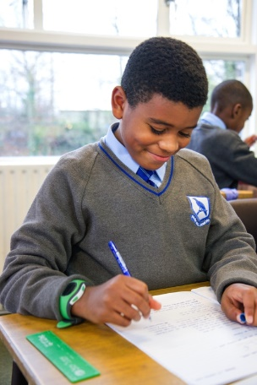
Our Curriculum
At Park Hill Junior School, pupils across the whole of Key Stage 2 study both core and foundation subjects, to meet the challenging demands of the National Curriculum. Our aim is to teach the foundation subjects in an engaging, interesting and stimulating way primarily through a thematic approach, often linking with our Power of Reading English topics. Many subjects are taught through cross-year topics and some topics involve the whole of a key stage.
Here is overview of our curriculum for the current academic year:
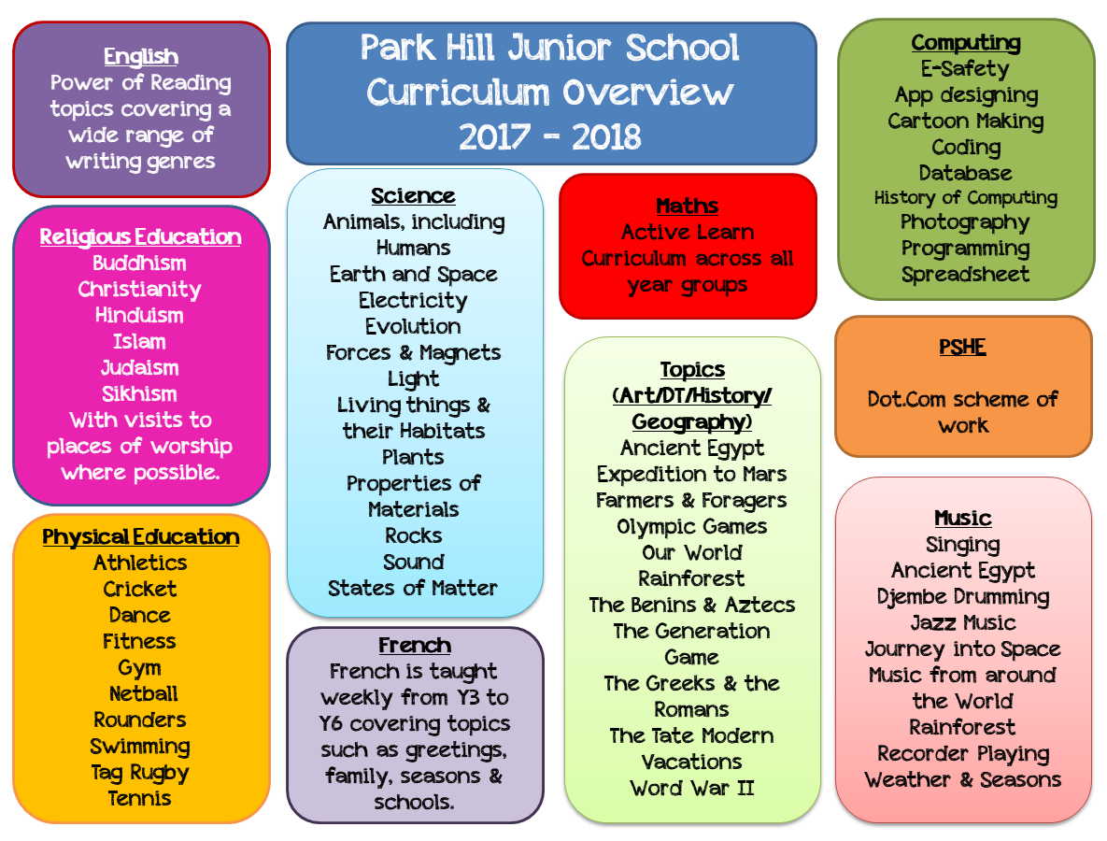
The majority of teachers at Park Hill Junior School are responsible for a subject area(s) and have the opportunity to develop the topics as the demands of the curriculum change.
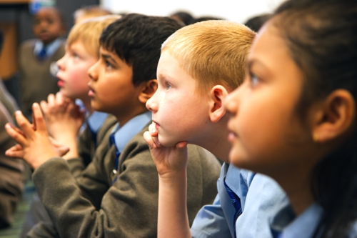

Extra-curricular Activities & Opportunities
At Park Hill Junior School we provide a range of opportunities, outside of the classroom, for the children to participate in; this includes clubs, productions, trips and residentials.
The school runs a wide range of extra-curricular clubs which are run by members of staff or external coaches. Without the generous support from the staff, we would not be able to offer the current club list which includes:
- Be the Best You Can Be!  - Chess  - Coding  - Cricket  - Fitness  - Football | - Gardening  - Grub Club  - Hakuna Matata  - Knitting  - Netball  - Musical Theatre
The School maintains a healthy list of sports fixtures with competitive teams in football, netball and cricket. We are also part of the Croydon School Sports Partnership therefore value the opportunities offered to participate in inter-school sports.

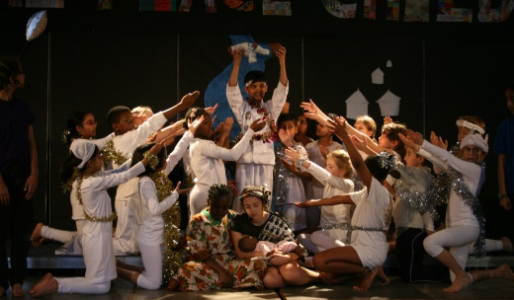
We are proud to have a reputation for our high level of musical productions which take place at Christmas (involving all pupils from Y3-Y6) and the Summer Y6 show. Children are offered peripatetic music lessons in a range of instruments, in addition to learning the recorder and djembe drumming as part of the curriculum.

Park Hill Junior School offers a variety of off-site activities which encompasses residential activities, environmental studies, sports, physical and cultural activities, and adventurous activities. We are keen to offer as many activities as possible as participating in off-site visits has shown to have wide ranging personal development benefits. Currently, Year 4 attend a three-day residential to Downe Activity Centre for a multi-activity outwards bounds weekend. Year 5 are offered the opportunity to attend a five-day residential to Belchamps Activity Centre for a multi-activity trip. In Year 6, children have the chance to finish the Summer Term with a Watersports trip.
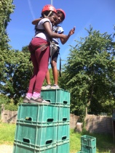
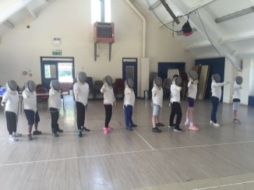
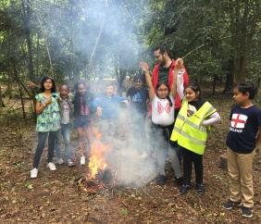
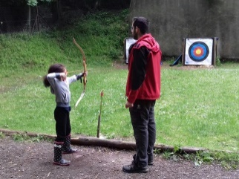

Folio Education Trust
Park Hill Junior School became part of the Folio Education Trust in April 2017, joining a small family of schools with a shared ethos and drive for excellent education for our children.
What do we believe?
That we are outstanding: not because we say it, but because we work hard at it. We are dedicated, committed and focused. We believe that every person will reach their personal best and overcome any challenge through a shared culture and ethos. We are dedicated to developing as successful individuals, creating a positive environment where all of us will learn. We never fail because we never give up. We believe in ourselves. We believe in each other.
Core Values – The system which helps guide our existence:
Our ‘values system’ is shared by all academies within the Trust and is the cornerstone of our existence. It ensures that everything we do is with the young people in mind and promotes a culture and ethos which allows all to BELIEVE.
Believe in ourselves and those around us encouraging ability and creativity.
Endeavour at all times and never give up.
Love what we do and the end result will be a logical consequence.
Inclusion will help us ensure we are one community without isolation.
Emotional intelligence will guide our decision making.
Value our community and develop a sense of social responsibility.
Excellence will be achieved with a growth mind-set.
Folio vision for the future
Folio Education Trust aims to support academies that are the first choice of local families because of the ‘gold standard’ education that is provided. All academies within the Trust are pupil centred and this drives our decision making. Smiling faces are common place for pupils and staff as they are happy being part of the academy and part of a wider Trust community. Being educated as part of this Trust will mean something to not only the individual but also those who provide the next step of a young person’s education, training or employment.
The service provision which helps drive the individual organisations within the Trust is focused on quality –listening, understanding and adjusting to meet the needs of those it is designed to serve. A main objective is to provide a system of self-challenge, self-improvement and collaboration with a shared passion to raise standards and allow all pupils to reach their personal best. No pupil or member of staff is neglected but inspired to develop improved life chances and live long and happy lives. As part of the collaboration between academies there is a desire to research pedagogy and influence social change to remove the barriers which limit well-being and opportunities for recognising and reaching personal best. Every person deserves the best and the Trust will do what it takes to deliver this while ensuring efficiencies and economies of scale which deliver outcomes beyond outstanding on a global scale.

Profile for Vacant Post
Job Title: KS2 Class Teacher
Position type: Permanent
Contract type: Full Time
Salary: MPS plus Outer London Allowance
Experience: KS2 Class Teacher

Park Hill Junior School is committed to safeguarding and promoting the welfare of children and young people and expects all staff to share this commitment. Please note this post is subject to an enhanced disclosure and barring service check (DBS) and references.

We can offer you:
Excellent professional development opportunities
An ambitious, successful and vibrant place to work
Children who are bright, confident and eager to learn
A supportive working culture that focuses on positive learning behaviour and high expectations for all children

We would like someone who is:
An excellent classroom practitioner with a creative approach, who will support school improvement
Committed to achieving the best outcomes for all pupils
An experienced teacher with high expectations of all pupil
A hard worker whose planning and marking is thorough
An excellent communicator and team player

The school is an equal opportunities employer and welcomes applications from all sections of the community. Any offer of employment will also be subject to satisfactory references being received in addition to documentation and qualifications being checked.

Becoming part of the team at Park Hill Junior School you have the advantage of joining a pioneering group of schools where your career can progress and you will benefit from professional development opportunities within Folio Education Trust: http://www.folio-education.co.uk/. This is local collaboration of schools offering access to high calibre CPD which contributes to the recognised quality of learning within our schools.

Please send your completed application form by post to: Mrs Claire Gillick, School Business Manager at Park Hill Junior School, Stanhope Road, Croydon, Surrey, CR0 5NS or email: hr@parkhill-jun.croydon.sch.uk. Visits to the school are most welcome.

Closing date for applications: Monday 30th April 2018 at noon
Shortlisting: Tuesday 1st May 2018
Interviews: Thursday 3rd May 2018
Starting Date: 1st September 2018

Please ensure you enclose a Personal Statement with your application form. If you have an existing DBS please also enclose a copy.

Contact Information, How to Apply
Designated contact for this vacancy:

Name Claire Gillick – School Business Manager 020 8686 8623
Email: cgillick.306@lgflmail.org

Application packs are available from the School website at www.phjs.co.uk or by emailing a request to hr@parkhill-jun.croydon.sch.uk

Please return your completed Application Form to Mrs Claire Gillick at hr@parkhill-jun.croydon.sch.uk Please be aware that part of the application form requires a statement which will act as a letter of application to the Head Teacher. Please note CVs will not be considered.

Closing date: Monday 30th April 2018 at noon

We reserve the right to interview and appoint before the closing date should there be a suitable candidate and therefore advise that applications should be submitted as soon as possible.

Shortlisted candidates will be contacted with details of the interview process. If you have not heard from us within two weeks of the closing date please assume your application has been unsuccessful.

Safer Recruitment

Park Hill Junior School is an equal opportunities employer and welcomes applications from all sectors of the community. We are committed to protecting our students and staff and therefore have a rigorous recruitment process which includes assessing candidates’ suitability to work with children. All staff will be required to hold an enhanced DBS Disclosure.

Equal Opportunities

At Park Hill Junior School, we believe that all individuals are of equal value and we are committed to equal opportunities for all. All people who work and study in the school have the right to be respected and valued within a safe and secure environment and not to be discriminated against on the grounds of age, class, sex, race, disability, sexual orientation and religion or belief.

Park Hill Junior School is committed to safeguarding and promoting the welfare of children and young people and expects all staff and volunteers to share this commitment.
