Mathematics at Royds Hall Community School
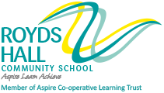
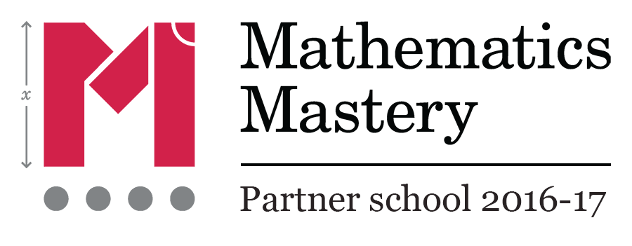
Overview
In 2016, 56% of students achieved an A*-C grade in GCSE Mathematics. We were pleased that 57% of our students made at least expected levels of progress during their time in Royds Hall. We aspire to even greater success for our students this year and we are working hard with all year groups to give them the best possible grounding we can in mathematics.
We are firmly committed to helping our students to master mathematical skills and, to this end, we are working as a partner school to the Mathematics Mastery programme to deliver interesting and effective lessons to all our students. This is having a marked impact on levels of student engagement and has led to even greater cooperation and collaboration within an already close-knit team of teachers. We have a weekly workshop in which we often sit and do some mathematics then use our experiences to plan together in preparation for upcoming issues in the curriculum. We are also determined to encourage a growth mind-set in all our students and the mathematics team is at the heart of the developments that Royds Hall is undertaking in this area.
Who makes it happen and where?
The Mathematics and Computing Faculty is one of the largest in the school, comprising eleven teachers in total and mathematics is taught by an enthusiastic, determined and supportive team of eight people. The Director of Faculty is currently supported by a Leader of Learning in Computer Science, an Assistant Leader of Learning in Mathematics and one of the maths team is a Lead Practitioner. The subject is taught in a well-appointed suite of neighbouring classrooms with all full time staff in their own room. These are equipped with Promethean ACTIVboards and there is access to sets of laptop computers and iPads.
The structure of the mathematics curriculum
Our students first come to Royds Hall at the end of the summer term in Year 6 for a two week period to experience life in a secondary school and meet their new classmates. Students love this time and it ensures they make a really good start when September comes around. Our Year 7 and 8 classes are organised in mixed-attainment groups and this principle continues as students move through the school. We do begin to let classes settle into two broad bands in the older years so that we can focus the more confident learners on the rigours of taking a Higher tier examination by the end of Year 11. Throughout, there is significant overlap between the sets in all year groups allowing us to move students as we get to know them better and as they develop their understanding.
GCSE Mathematics is taught using the Edexcel linear specification, with about 50% currently studying towards the Higher tier examinations.
Mathematics option
For many years the school has taught option subjects in vertical classes of Year 9, 10 and 11 students and the Mathematics Department is no exception. This year we are using Edexcel’s GCSE Statistics as our option course while we have previously had students taking OCR’s Additional Mathematics FSMQ.
Enrichment and student mentoring
All students follow a mixed programme of regular homework tasks and occasional extended tasks that cover a range of research projects, investigational tasks and opportunities to work in teams to plan and deliver lessons.
We are always looking for interesting activities to enrich the curriculum: students in Year 7 have competed in a solar-powered model car challenge while members of Year 8 have designed, built and raced leaf-blower hovercraft. Our latest project is bringing together many areas of the school with a sizeable group of students exploring how they can build their own flight simulator. There have also been many projects on other STEM themes in which our staff worked closely with our feeder primary schools.
As a school we encourage our students to help each other pastorally and academically. We have had confident Year 9 students working with Year 7 students to build their fluency with number skills and we regularly utilise a large number of volunteers from Year 10 to help Year 6 students in our partner schools to get ready for their SATs. There is also a student team of STEM Leaders who work with staff to offer a regular STEM Club to younger students.

