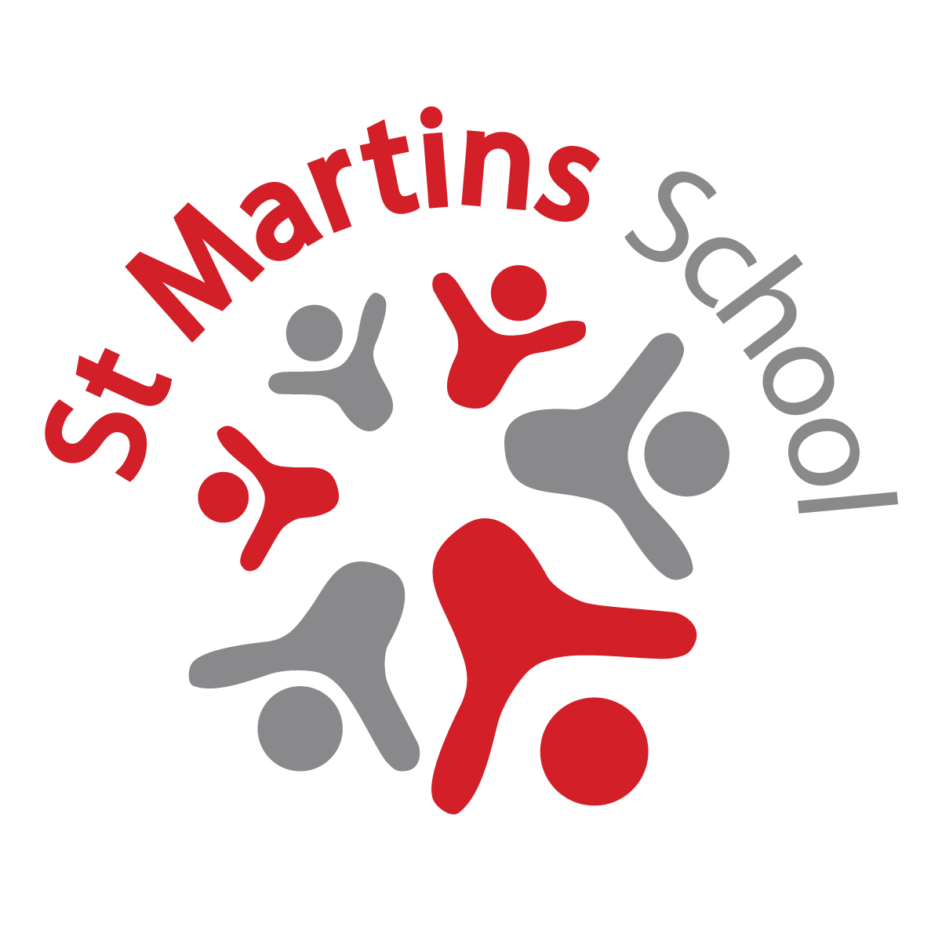Deputy Headteacher: St Martins School

Job Description

Duties and responsibilities:

To support the Headteacher and Leadership Teams in providing strong professional leadership for our highly motivated staff, who constantly strive to secure continued success and improvement commensurate with our Ofsted Outstanding grade. Whoever is appointed will be an outstanding and experienced practitioner who will have the necessary skills and personal qualities to ensure high quality educational experiences, progress, achievement and attainment for all students. The successful candidate will also work closely with the Headteacher and Assistant Headteachers to develop the CPD, coaching skills, job satisfaction and well-being of all staff and stakeholders working within, and supporting the school.

Professional duties:

The Deputy Headteacher has the same professional duties as a classroom teacher as set out in School Teachers Pay and Conditions as well as those designated for Deputy Headteachers in the same document. In addition, he/she is required to do the following: to play a major role in implementing the aims and objectives for the School Improvement Plan as well as undertaking major leadership responsibilities and duties which have been reasonably delegated by the headteacher. The Deputy Headteacher will also undertake, as necessary, the full range of professional duties of the Headteacher in the event of the latter’s absence from school.
In addition, the deputy headteacher will:

- lead by example, and reinforce the educational vision and direction of the school to secure the commitment of staff, students and their parents/carer, Governors and wider stakeholders.

- participate in the selection and appointment of the teaching and non-teaching staff of the school.

- deploy and manage all teaching and non- teaching staff of the school, allocating particular duties to them, as agreed with the Headteacher

- undertake professional leadership qualifications commensurate with the levels of responsibility for the Deputy Headteacher’s position.

- have a clear overview of local, regional, and national educational developments that impact on the students and staff in school, and be able to communicate this to staff to enable them to carry out their professional duties more effectively.

- advise and support staff with student disciplinary procedures and consequences.

- liaise with parents and carers to engender more support for their children and strengthen the home-school link.

- In collaboration with the Headteacher, ensure that all staff are familiar with relevant administrative procedures, memoranda, school policies and procedures.

Specific areas of responsibility:

- To lead on keeping up to date and improving teaching and learning across all phases, towards outstanding student progress.

- To oversee and co-ordinate the school’s curriculum development across all phases - KS3, KS4, KS5- and to ensure it is fit for purpose in meeting the needs of all students.

- To actively promote our SHAPE curriculum concept throughout the school with students and staff and more widely with parents/carers, Governors and other stakeholders as appropriate.

- To be conversant with appropriate formative and summative assessment processes and procedures for students, including appropriate accreditations – Personal Progress, Entry Level, Level 1 and GCSE.

- To lead the teaching team in setting aspirational targets for all students across all learning.

- To take full responsibility for the collection of data (3 assessment rounds per year), analysis of data and subsequent intervention plans for any student off trajectory to meet aspirational targets set.

- To analyse and interrogate data, presenting a concise, clear overall picture of progress and achievement that all stakeholders can understand.

- To lead and manage the school timetabling system and to make appropriate adjustments in relation to staff cover in consultation with the Assistant Headteacher and HLTA team.

- To update the timetabling and duties information on staffroom information boards, Learning Platform, website and the shared folders.

- To be responsible for improving and strengthening staff communication through briefings, meetings, visual displays and shared folder information.

- To lead and run the Key Stage leaders group in school, building on the exciting offer for students that prevails, alongside ensuring the smooth organisational running of the school.

- To teach a subject as part of the learning pathways and KS4 accreditation offer, for a maximum total of a day per week.

- To advise and support staff with career progression, from a position of personal qualifications and experience, and act as a registered coach for staff on leadership courses.

- To actively build upon the existing network of school partnerships and agencies to enhance provision and opportunities at St Martins School.

- To represent school on influential leadership groups across the city, region, and nationally as personally identified or delegated by the Headteacher.

General

- To be familiar with the Children and Young Peoples Services and policies, with particular reference to safeguarding procedures and the law.

- To promote the school as part of an Integrated Children and Young Peoples Service and to take a full and active part in the life of the school.

- To undertake any other reasonable duties as may be from time to time determined by the Head Teacher.

NOTES

- The above responsibilities are subject to the general duties and responsibilities contained in the statement of conditions of service which apply to all teachers.

- This job description will be reviewed regularly and it may be subject to modification or amendment at any time after consultation with the post holder.

Signed ………………………………………………………… Date …….…………….

Signed ……………………………………………. Headteacher, Date ……………..

