St. Joseph’s Catholic High School

*Business & Enterprise College*

*Living, Loving & Learning Through Christ*

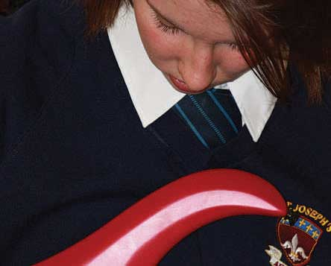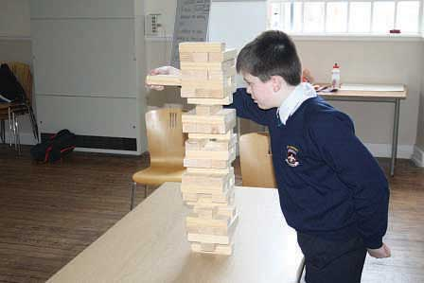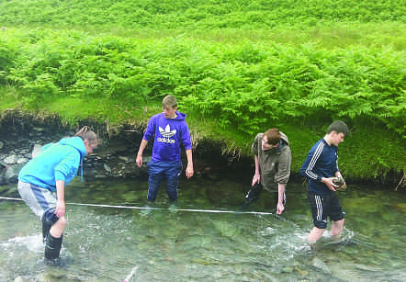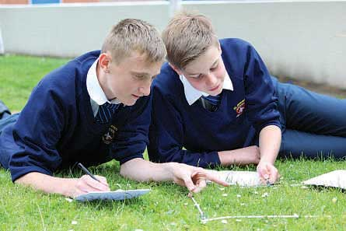

Teacher

of

Science

St Joseph’s Catholic High School - serving the community

• Judged ‘Good’ in their recent Ofsted

• Improved GCSE results

• Improved A* As

• Excellent Pastoral Care

Harrington Road, Workington CA14 3EE. 01900 873290

www.st-josephs.cumbria.sch.u



**St Joseph’s Catholic High School**

**Business & Enterprise College**

**Harrington Road, Workington, Cumbria CA144 EE**

**NOR 697 11-16 school**

**Full time Teacher of Science for September 2018**

**M1- UPS3**

We are seeking a suitably qualified and experienced teacher of Science, (preferably a Biology or Physics specialist) to teach across the full age and ability range and become actively involved in a team already producing results above national but who want to improve further. The successful applicant will be joining a strong hardworking team which is committed to achieving excellence and in which a creative approach to teaching and learning in science is strongly encouraged.

St Joseph’s Catholic High School is a ‘Good’ school (Ofsted April 2016). All at the school are committed to achieving the highest academic and social standards for students and to the well- being and continuous professional developments of all staff.

There are many reasons to come and work in St Joseph’s, the staff are supportive and fully focussed on the best outcomes for our students. We have an excellent team of Science Technicians who support the Teachers. We have five modern, well equipped science labs with demonstration areas, practical areas and seating areas. There is a dedicated computer suite with 25 computers that supports the learning at both key stages.

Our standards and expectations are high and we expect our new staff to lead our continuous drive for excellence in the classrooms. Student voice tells us that Science is an area that students enjoy. The dynamic Science department has continued to contribute to record breaking student results at KS4 with 31%of year 11’s achieving 3 GCSEs A*-C* in science and 82% of students achieving 5A*-C (4 + grades).

In KS3, year 7 and 8 follow the ‘Activate’ scheme of work, with a focus on investigative skills and science in context. All KS3 students are taught in sets for four 50 minute lessons per week.

KS4 begins in Year 9 and students follow either: AQA Biology, Chemistry and Physics or AQA GCSE Combined Science: Trilogy.

There will be a teaching timetable that covers years 7-11 but this will be tailored to the expertise and experience of the successful candidate. We have a structured programme that will help you deliver good lessons and results for all your students.

We ensure that there is dedicated planning and preparation time by allocating above the 10% normally afforded to staff.

The post is suitable for teachers at all stages of their careers and the school is fully committed to support staff with CPD including NQT an RQT programmes. We welcome applications from candidates who are returning to teaching after a career break.

**The person appointed will have**

* A commitment to the Catholic ethos of the school
* High standards and expectations
* Highly developed inter personal skills
* A commitment to teamwork
* A positive outlook

If you do not live in this area then this is a fantastic opportunity to live within, or close to an area of outstanding beauty where there is a lot to offer, especially for families and those who like the outdoors and getting away from City life. There are good schools in the area and the price of housing is reasonable. A large proportion of our staff who have come to work in Cumbria have made it their home. A contribution to relocation expenses may be made under the right circumstances. The school offer a Cycle to work scheme.

The school is committed to safer recruitment procedures and all applicants will be subject to an enhanced DBS.

This is not an equal opportunities school.

Interviews will be held on Wednesday 21st February 2018

Application form and further details can be found on the TES website.

We welcome prospective candidates to visit the school or have a conversation with the Head teacher Jacky Kennedy. Please telephone Julie Gaffney on 01900 873290 ext 205

Closing date 9th February 12.00 noon interviews will be held on 21st February 2018.

**Please complete the application pack and return to Julie Gaffney by 01900 873290 email jw@st-josephs.cumbria.sch.uk.** [**www.st-josephs.cumbria.sch.uk**](http://www.st-josephs.cumbria.sch.uk) **Closing date, noon on the 9th February 2018**

The school is committed to safer recruitment procedures.

Applicants are subject to an enhanced DBS. This is not an equal opportunities school but we subscribe to the North West Diocese Equal Opportunities policy.

January 2018

Dear Candidates,

Thank you for expressing an interest in our school. We hope you find the information that we have provided useful.

We would be very pleased to arrange visits from prospective candidates or respond to calls if you require more information.

We look forward to hearing from you in due course.

Best wishes,

Jacky Kennedy

Headteacher

# ST. JOSEPH’S CATHOLIC HIGH SCHOOL - SCIENCE

Our Science department has five well equipped and modern science laboratories, with demonstration areas, practical areas and seating areas. In addition, the department houses an ICT suite of 25 computers to support learning at both Key Stages.

In KS3, year 7 and 8 follow the ‘Activate’ scheme of work, with a focus on investigative skills and science in context. All KS3 students are taught in sets for four 50 minute lessons per week.

KS4 begins in Year 9 and students follow either: AQA Biology, Chemistry and Physics or AQA GCSE Combined Science: Trilogy.

Students are currently taught four 50 minute lessons in Year 9 and, dependent on GCSE course, six or seven 50 minute lessons per week in Year 10 & 11. Each class studies two topics at a time, shared between two science teachers.

The 2017 GCSE Science results were roughly in line with the national average:

GCSE Science A*- C 50%

GCSE Additional Science A* - C 60%

We have a good Science department that is intent on continuing to improve standards and raise attainment in the process. The ethos which permeates our work is one where high aspiration and expectations flourish. Teamwork in the department is strong and the entire department is very supportive of each other. Teachers and technicians regularly share best practice in order to ensure they are always developing new ideas to raise standards.

|  |  |  |
| --- | --- | --- |
| **Person Specification** | | |
|  | **Essential** | **Desirable** |
| **Qualifications/ training/ competencies** | Qualified teacher status | Evidence of participation in professional development or further study |
| Relevant qualification in subject area (degree) | Practising Catholic |
| Teaching qualification (PGCE/Cert Ed) |  |
| **Relevant experience** | Outstanding teaching ability | Experience of dealing with a wide range of students and responding to their needs |
| Experience of effective team working and promoting effective relationships | Understanding and experience of exam board procedures and administration |
| Ability to use IT in teaching and administrative duties | Experience of teaching to A level |
| Ability to teach across the ability range in Key Stage 3 and 4 |  |
| **Knowledge** | Knowledge and understanding of equality and diversity issues |  |
| Knowledge and understanding of different teaching strategies and ability to apply these appropriately |
| **Skills** | Excellent communication skills |  |
| Student focused |
| Flexible approach |
| Ability to manage time effectively and meet deadlines |
| Ability to demonstrate patience and understanding with learners |
| **Personal Qualities** | Commitment to actively supporting the school’s distinctive ethos |  |
| Ability to work as part of a team |
| Ambition and the capacity for hard work |
| Energy and imagination |
| A talent for motivating students across a range of abilities |
| Good organisational skills |
| Determination to achieve the very best result for every student |

**GCSE Results:**

Ours GCSE Results for the last 3 years are:

|  |  |  |  |  |
| --- | --- | --- | --- | --- |
|  | 2013/14 | 2014/15 | 2015/16 | 2016/17 |
| 5 A*-C (EM) | 57% | 45% | 56% | 58.7% |
| Progress 8 | n/a | n/a | -0.51 | -0.25 |

**Staff development/ Career development**

We are part of the Western Lakes Teaching Schools Alliance and are continuing to build on the already strong links with other schools in the area. We have dedicated time after school on a Thursday for CPD/Department meetings. This time is used for whole school training, sharing best practice and work in departments.

The development of our staff is of the highest importance and it is a strong feature of our school and many staff have benefitted from internal promotions over the years. Career development is one of our school’s priorities in the school improvement plan 2017/2018 and we will be working with each member of staff to identify where they want to be in their stage of their careers and finding opportunities to gain experience receive mentoring and training to help the individual achieve their goals.

**Business and Enterprise:**

The school became a Business and Enterprise College in 2003 and we were re- designated as high performing as part of our Ofsted inspection in March 2009. We were awarded the ‘Centre for Excellence in Enterprise Education’ by the University of Warwick in May 2011. We were one of the first schools to receive this award in Cumbria.

Our Business and Enterprise is delivered through the curriculum where possible; as part of our Pupil Personal Development Days and as one-off Enterprise activity days. We celebrate National Enterprise week in November through form activities; Careers talks at breakfast and lunch time; extra-curricular events after school.

We have developed many partnerships with local business and commerce that help us out with events and in curriculum areas throughout the year. We hold a work ready day with mock interviews for Year 10 pupils.

A member of the Senior Team has taken a lead role in working with the Cumbria Enterprise Learning Partnership covering Enterprise Education from 4-19. This involved working with business commerce, Secondary, Primary School and FE Colleges. We delivered training programmes and shared best throughout to schools and Colleges throughout Cumbria. This work is on-going but in a slightly different format.

Students take part in a number of external competitions throughout the year.

# Conditions of Service

The above responsibilities are subject to the general duties and responsibilities contained in the statement of Conditions of Employment.

These duties may be amended as necessary at the discretion of the Headteacher in light of the future development of the school.

The creation of a truly Christian environment in which the Gospel is lived and experienced by all members of its community, is the central aim of St Joseph’s. All applicants are expected to be supportive of this central aim.

# Features of West Cumbria

The School is situated at the western fringe of the Lake District National Park.

Many staff choose to live locally and enjoy a rural lifestyle in towns such as Cockermouth, Keswick and the villages in West Cumbria.

Housing and rented accommodation are generally readily available at prices which are lower than urban and city locations.

The school exhibits all the advantages of a smaller comprehensive school. Children are known by name by all, standards of discipline and the quality of staff pupil relationships is excellent.

Closing date for applications is Noon on Friday 9th February 2018.

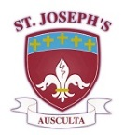Our School Mission Statement

AT ST. JOSEPH’S CATHOLIC HIGH SCHOOL

WE WILL CHALLENGE YOU TO AIM HIGH, WE EXPECT YOU TO SUCCEED

LIVING LOVING LEARNING

All members of the school community – pupils, staff, governors and parents – will be united in sharing a common purpose: to achieve their personal best, to pursue lifelong learning, to develop and model respect for themselves and others and lay a significant role in the life of the local community; and they will be able to articulate this common purpose and support each other to achieve these goals.

LIVING LOVING LEARNING

Our School will be characterised by positive, appropriate, productive and warm relationships all of which are at the heart of our faith. We will encourage all members of the community to reflect on and develop their relationships with each other to promote tolerance and understanding.

LIVING LOVING LEARNING

All members of the school community will strive to achieve excellence – their personal best in all areas of school life; academically, in extra-curricular activities and through their embodiment of positive attitudes and qualities.

*Living, Loving and Learning through Christ*