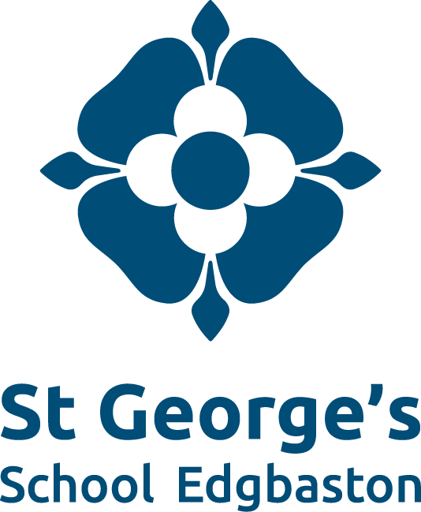

SHMIS Co-educational
400 pupils aged 4 –18yrs
Teacher of English (Upper School)
We are seeking to appoint an energetic and committed English teacher to join our successful and dedicated Faculty.
As a subject specialist and excellent teacher, the successful candidate should be able to demonstrate the skills and attributes they are able to bring to the role. Applicants will have the opportunity to teach and potentially lead both GCSE and A Level.
For further details of the post and application form, please contact the Headmaster’s PA.

Tel: 0121 625 0398
e-mail: admin@sgse.co.uk
Website www.sgse.co.uk
Registered Charity No: 529052
St George’s school is an equal opportunities employer committed to safeguarding its pupils.
The English Department
The English Department aims to develop and cultivate an environment where students are able to flourish in the study of our subject. We boast some of the best results in the school; in 2017 95% of students achieved Grade 4 or above and GCSE.
We cater for all students from Year 7 - 13 and offer a number of pathways to ensure that students are able to meet their full potential; this could be through different specifications at GCSE or through setting and appropriate text choices at Key Stage Three. We work closely with the Inclusion Department to ensure that the additional needs of our students are met fully and that they are able to enjoy the subject in a way that builds their confidence, challenges them in a supportive manner and enables them to progress well.
Staffing
The English Department consists of 3 dedicated specialists, as well as being supplemented by other experienced teachers who have additional school wide responsibilities. We are an enthusiastic and creative department who are all passionate about our subject and have varying areas of expertise which allows us to teach to our strengths. We are also very supportive and enjoy collaborating on various projects such as team teaching, planning and intervention. The Department is very forward thinking and is proactive about the challenges associated with such an important subject.
Accommodation
All English rooms are situated on the same corridor and are in the heart of the school. Having been recently refurbished, we are proud of our vibrant classrooms.
Curriculum
In Years 7-9 we study a range of different texts that cover the key areas of English; prose, poetry, drama (including Shakespeare) and non-fiction. We also supplement this with other projects that are relevant to the curriculum as we want to ensure that students experience a wide range of texts and concepts before embarking on GCSEs. At Key Stage Four, we use the AQA exam board to complete GCSEs in English Language and Literature as well as offering the opportunity to take an iGCSE in English. At A Level, we follow the AQA A Specification in English Literature - a well established course at St. George’s which both staff and students enjoy very much. We are a forward thinking department who are always looking to create the best opportunities for our students.

