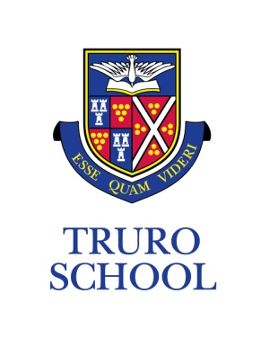

JOB DESCRIPTION

JOB TITLE: Teacher of Design and Technology

GRADE: Teachers’ Pay Scale

REPORTING TO: Head of Department
______________________________________________________________________________

KEY FUNCTIONS

- teach and manage the students in their classes in co-ordination with their Head of Department and department colleagues
- maintain and contribute to the safety of pupils and efficient operational environment of the workshops
- be aware of, contribute to, and implement the department’s schemes of work
- to attend, contribute to and participate in departmental and planning meetings as required by the Head of Department

The general responsibilities of all teachers at Truro School are to:

- undertake form tutor responsibilities
- actively participate in the co-curricular life of the school
- plan and prepare for the short, medium and long term
- teach according to the educational needs of the students
- provide a stimulating environment for learning to take place
- assess, record and report on the development, progress, behaviour and attainment of students and maintain effective records
- participate in all necessary arrangements and procedures for assessment
- maintain good order and discipline among students
- undertake supervision duties as required by the Senior Leadership Team
- provide pastoral care and guidance to students as appropriate
- participate in staff meetings and discussions as required by the Senior Leadership Team
- undertake INSET as part of the school’s development plan
- participate in the school’s monitoring and evaluation annual cycle
- adhere to the school’s policies and procedures regarding reporting to parents
- act at all times as a professional member of staff

PERSON SPECIFICATION

Essential Criteria

- excellent classroom practitioner who can recruit and inspire future designers through excellent subject knowledge, positivity and energy.
- recent and appropriate experience of working with Key Stage 3 to 5 students
- demonstrable successful experience of teaching GCSE and A Level
- demonstrable experience, understanding and use of CAD software and CNC manufacturing
- proven high level manufacturing skills and continued personal interest in design
- an appropriate teaching qualification/experience
- a proven desire and ability to manage assigned curricular responsibility
- inspired by the school’s mission and aim, and a commitment to vigorously promote and model the behaviours and values expected of others
- ability to manage change and work under the pressure of changing circumstances
- excellent organisation skills with the proven ability to implement and see things through to completion
- excellent communication skills, both written and verbal
- a clear enhanced DBS disclosure
- an empathy and understanding of expectations within Independent Schools education
- an understanding of the school’s Methodist tradition

Desirable Criteria

- the ability to work with a variety of materials and machinery, both CNC and manual
- experience in collaboration with external businesses, exhibitions, competitions

ADDITIONAL

- Truro School is committed to safeguarding and promoting the welfare of children and young people and expects all staff and volunteers to share this commitment and behave accordingly.
- This job description sets out current duties of the post that may vary from time to time without changing the general character of the post or the level of responsibility entailed.

Date prepared: March 2018

Prepared by: Head of Department

