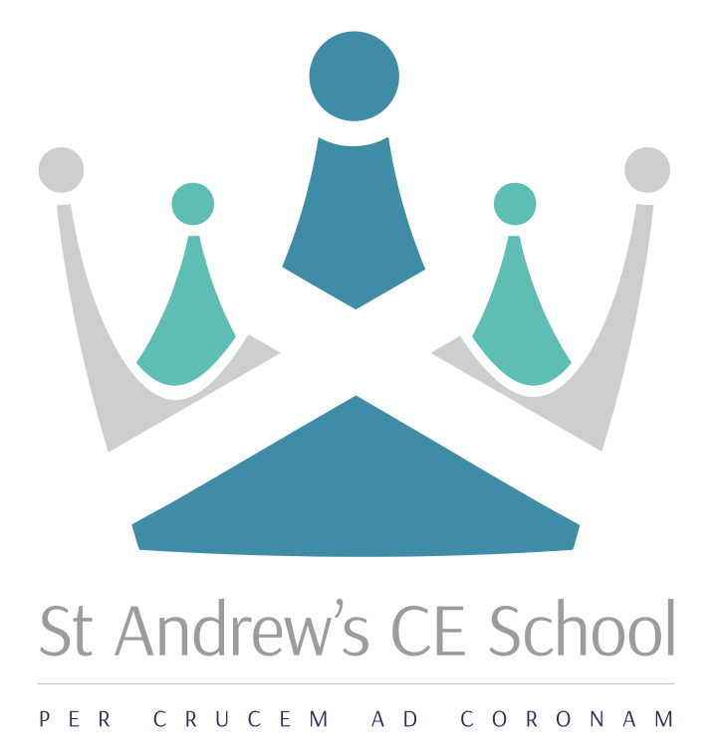

Information for Applicants

2nd i/c of Humanities
St Augustine Faculty
Main Scale + TLR 1C
Required for September 2018

Application to be submitted by 9.00am on Monday 21 May 2018
Interviews will take place on 24/25 May 2018

Mission  ‘In God, Through Grace and Guidance,  to Grow and Give’ | Vision  We will ‘StAnd’ together in God’s Grace, to Guide and Grow young people who are motivated, curious and academically successful; who are ready to inspire and aspire to be the very best they can be. Who are ready to give back to their community, work hard and are equipped to embrace life’s many journeys.

Dear Applicant

Thank you for showing an interest in the post of 2nd i/c of Humanities. Enclosed in this pack is information about St Andrew’s CE School and the job that you have enquired about. I hope that you will find this useful in helping you to decide if we would be a school you are interested in joining and becoming part of the team.

St Andrew’s CE School is a five form entry, Church of England Voluntary Aided School for boys and girls aged 11 to 16. It is a Christian school, within the Diocese of Southwark, serving the Archdeaconry of Croydon. We welcome all students, whether or not they have an affiliation to Christianity or any other Faith. We have a fully comprehensive intake, with good numbers of ‘high achievers’, as well as those who require more support; however the intake has changed significantly over the past 5 years or so with an increase number of students who are in receipt of free school meals and / or who are disadvantaged. We have also taken a larger number of EAL students, many of whom are Unaccompanied Minors. Many of our students have complex home situations and challenges in their personal lives; school is therefore, for many, the stability and the opportunity to change these factors.

The school itself has faced a few challenging years and has seen new staff and a new leadership team in place. This has supported rapid progress and the raising of standards across the school as we have been working hard to move the school from RI to Good. The Governing Board is strong and supportive, providing the necessary challenge to keep us focussed on our journey. Our major challenge has been our falling roll, with only 40 students currently in Year 7. Whilst we take measures to improve this it has given us the opportunity to strengthen our curriculum at KS3 and provide a much more personalised education to this year group. One key and very exciting change being proposed to address this is a merger with The Minster Junior and Infant School to create an all through Reception to Year 11 campus. Whilst still in discussion, it is hoped that this will be in place for September 2019.

Key Information about the school:
Number of students: 493
Number of teaching staff: 37
Number of support staff: 29
P8: -0.67
No. students achieving 9-4 EM: 43%

https://www.compare-school-performance.service.gov.uk/school/101813

Though there have been many challenges to overcome there is a great set of dedicated staff who have embraced the changes and improvements to ensure that students receive the best education possible. Students want to learn and have been reported by internal and external reviews to demonstrate great attitudes to learning in the classroom. There is a desire from the students to be involved in active lessons with opportunities to be creative and engage in meaningful discussions. Our latest monitoring visit which took place in June 2017 indicated that we were taking ‘prompt and effective action to raise standards…’

https://reports.ofsted.gov.uk/inspection-reports/find-inspection-report/provider/ELS/101813

Our own improvement as a school is of course our priority and we are currently working with St Cecilia’s School in Wandsworth. They are supporting the Senior and Middle Leaders in their work and helping us to quality assure our standards in teaching and learning.

We value personal development and leadership at all levels and expect staff to be ambitious in their own development; our commitment to staff is to encourage attendance at PiXL events and recognised conferences, to study for an MA / recognised leadership qualifications and to collaborate with schools in the local area.

My students here at St Andrew’s, need teachers who have a passion for their subject, great drive and determination; someone who is not afraid of a challenge and who teaches because they want to make a difference to the lives of the young people they are commissioned to teach.

I am happy to talk further about my school or show you around so you can really get a feel for us a school community. Please do not hesitate to contact me for any information at all. head@standhigh.net

Kind Regards
Kerry Targett
Headteacher

“In God, through Grace and Guidance, to Grow and Give”

Job profile
Title
2nd i/c of Humanities

Purpose of the post:
To be responsible for the quality of Teaching & Learning and Outcomes for RS & PSHE, within the Humanities Faculty and to be the lead on the SIAMS agenda.

Reporting to:
Director of Humanities

Responsible for:
- Supporting the Director of Faculty in leading the attainment, progress and achievement of students across the Humanities Faculty
- GCSE attainment, progress and achievement
- Leading enrichment and engagement of RS and PSHE across the key stages

Principal Accountabilities:
- To lead RS and PSHE; line managing the Subject lead for PSHE.
- To assist in leading, managing and co-ordinating the strategic development of Humanities within the school to lead to good/outstanding achievement in the faculty
- To oversee disadvantaged (PPG) students within the Faculty and work with the Learning and Welfare Team to ensure that students can access the curriculum and have the same opportunities as their peers.
- To mentor ITT students in the Faculty
- To develop an understanding of the SIAMS agenda and see how this is implemented across the school to ensure that we are at least good if not better over the next few years
- To engage with stakeholders and promote the work that we are doing within the Faculty and SIAMS agenda
- To report termly to governors and regularly through the newsletter and News of the Week.
- To sit on the SLT and undertake whole school responsibilities in the day to day running of the school.
- To undertake mentoring and SIAMS training as necessary to support the role
- A commitment to enrichment to provide planning opportunities for the students will also be necessary.

Teaching:
- To teach consistently high quality lessons
- To act as a role model through an open door policy to lessons and modelling best practice in lessons
- To track and monitor students effectively so they make good progress
- To lead the development of appropriate syllabuses, resources, schemes of work, marking policies and teaching strategies for RS and PSHE.
- Updating professional knowledge and expertise as appropriate to keep up to date with developments in teaching practice and methodology, in general, and in the subject areas within the Faculty
- Contribute towards ensuring a high quality learning environment within the Faculty by managing and improving:
  - the fabric of the classrooms
  - displays and exhibitions of students’ work, including references to key stage grades on display work
  - classroom behaviour by ensuring that faculty policies on sanctions are consistent with the agreed school Behaviour Policy and systems

Assessment, Feedback and Tracking:
- To help lead, monitor and evaluate the assessment and feedback to students in line with whole school and faculty policy
- To help lead the innovation and development of assessment and feedback strategies within the faculty to shape and further improve whole school policy
- To help lead the faculty monitoring and tracking systems relating to students attainment, progress and achievement
- Mark, grade and give written/verbal and diagnostic feedback as required
- Undertake assessment of students as requested by external examination bodies, curriculum areas and school procedures
- Assess, record and report on the attendance, progress, development and attainment of students and to keep such records as are required
- Complete the relevant documentation to assist in the tracking of students
- Organise faculty tracking of student progress and use information to inform learning and teaching
- Managing, setting and co-ordinating assessment arrangements in RS / Humanities and in all areas as required by school policies, including standardising those assessments
- Meet with students over whom there are concerns and contact home where necessary in conjunction with student support team and faculty heads

Contribute as an effective and collaborative member of the School
The post-holder will:
- attend relevant meetings as required
- participate in training to be able to demonstrate competence
- participate in first-aid training as required
- participate in the on-going development, implementation and monitoring of the School Priorities
- be expected to understand and have sympathy with the school’s Christian ethos and the active expression of this, within the Anglican tradition.

Safeguarding
The school is committed to safeguarding and promoting the welfare of children and young people and therefore expects all staff to share this commitment. All appointments are subject to a satisfactory, enhanced DBS check.

Equalities
The post-holder will:
- be expected, with all employees, to understand, comply with and to promote the school’s policies (having a strong commitment to achieving equality of opportunity in its services to the community and in the employment of people) in their own work, to undertake any appropriate training and to challenge racism, prejudice and discrimination.

Person Specification

Subject Teacher Method of Assessment
 | Application | Interview | Task
Essential Knowledge and Experience
The post-holder will:
- have a second-class or higher honours degree, or equivalent qualification
- have a teaching qualification
- be committed to and understand how to safeguard and promote the welfare of children and young people
- have knowledge of teaching one’s subject to at least GCSE level or the equivalent
- understand how teaching and learning is modified to stretch all students of differing abilities
- understand what constitutes an effectively differentiated curriculum at KS3 and KS4
- understand what constitutes efficient feedback and assessment, and translate these into practical classroom strategies to support progress
- understand how this post and others each contributes to the realisation of a school’s development plan
- understand how a child’s experiences at school and well-being underpin their future opportunities
Essential Skills and Abilities
The post holder needs to demonstrate the ability to:
- manage his or her time effectively, reconciling conflicting priorities
- effect positive relationships with students and colleagues at all levels, exercising a high degree of emotional intelligence
- reward and motivate students, as appropriate, ensuring that due recognition is given to positive behaviour
- discipline students authoritatively, as appropriate, ensuring that sanctions are followed through
- plan and deliver effective lessons within a given time-frame and in accordance with agreed specifications
- ensure accurate records are maintained and data analysed to inform effective teaching and learning
- communicate effectively in different contexts
- take different roles within different teams
- evaluate one’s own learning needs and actively seek learning opportunities for personal and professional development
- be sympathetic to the school’s Christian ethos

Job profile - Tutor
Title
Tutor

Dimensions
This post operates with regard to:
- a tutor group with up to 30 students across the full ability range
- a team of 5 tutors within the same house
- colleagues holding similar posts as tutors throughout the school

Reporting Line
The holder of this post:
- reports to the KS3 or KS4 Coordinator to support the learning and spiritual, moral, cultural and social development of the students in the tutor group
- liaises closely with fellow tutors, teachers and other colleagues
- manages tutor group prefects or monitors

Primary Purpose
To support the academic progress and spiritual, moral, cultural and social development of the students in the tutor group:
- establishing a positive relationship with the members of the tutor group, fostering a cohesive unit
- guiding members of the tutor group through their school career
- celebrating individual students’ achievements
- monitoring and intervening, when appropriate, in matters of discipline
- communicating with parents and carers
- generating reports and references to a high standard and to an agreed format, when and as appropriate

Key Accountabilities
The post-holder is required to:
- manage tutor-time efficiently, as directed by the KS3 or KS4 Coordinator, so that a proper balance is achieved between administrative tasks and activities focussing on the students’ spiritual, moral, cultural and social development
- monitor and guide students in their approach to learning, within and beyond the academic curriculum, so that each achieves his or her full potential
- engage constructively with the rewarding and disciplining of students so that they develop the capacity to make appropriate decisions
- manage the tutor group prefects and monitors so that they develop their own capacity to lead and manage initiatives
- ensure that a Christian Act of Worship occurs during tutor periods, when no other assembly is scheduled, to maintain the school’s distinctive ethos
- communicate effectively with parents, guardians and other professionals to provide full, appropriate support and coherent support and direction for individual students
- contribute to the House’s pastoral agenda to ensure the House runs efficiently on a daily basis, develops effective strategies to address the demands of the present, and anticipate the demands of the future

Safeguarding
The school is committed to safeguarding and promoting the welfare of children and young people and therefore expects all staff to share this commitment. All appointments are subject to a satisfactory, enhanced DBS check.

The post-holder will be expected to understand and have sympathy with the school’s Christian ethos and the active expression of this, with in the Anglican tradition.

2nd i/c of Humanities
Main Scale + TLR 1C
Required September 2018

St Andrew’s is a successful and highly supportive 11 - 16 Church of England school. St Andrew’s is a friendly school which fosters positive relationships between students of all ages and the staff. It is on a journey of rapid progress and high expectations and all staff are required to play a positive role in developing this focus with the students. The school has a strong Christian ethos which underpins the day to day work of students and staff.

We are seeking to appoint an outstanding teacher who:
- has the ability to inspire and engage across KS3 and KS4
- has an absolute commitment to inclusive education
- has high standards and the drive to see these realised
- excellent inter-personal skills

In return we can offer:
- the opportunity to work with energetic, supportive and enthusiastic colleagues
- well-behaved students committed to their community
- scope to make a significant contribution to a school with ambition and vision
- opportunities for professional development

The school runs an established induction programme. St Andrew’s is committed to safeguarding and promoting the welfare of children and young people and therefore expects all staff to share this commitment. All appointments are subject to a satisfactory DBS check.

The application details are available via the school website: www.standhigh.net

Applications to be submitted by 9.00am on Monday 21 May 2018
Interviews will be held on 24/25 May 2018

St Andrew’s CE School, Warrington Road, Croydon, CR0 4BH, www.standhigh.net

General Information

Contact Details:

St Andrew’s CE School
Warrington Road
Croydon
CR0 4BH
t. 020 8686 8306
f: 020 8681 6320
e: office@standhigh.net
w: www.standhigh.net

Location Map:

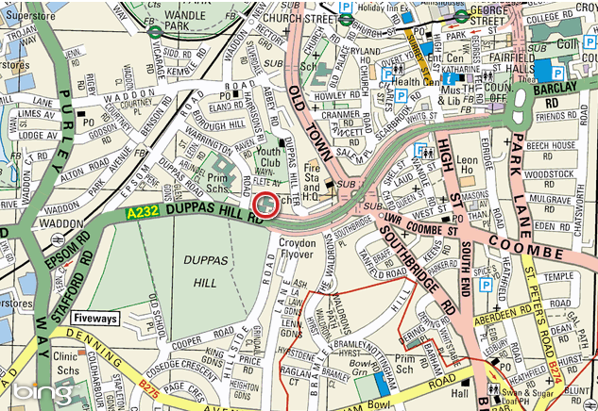

Nearest transport link:

Tube: Morden
Railway: Waddon
Tram: Wandle Park/Church Street

