February 2018

Dear Colleague

Thank you for your interest in the Headship of Ivingswood Academy.

Ivingswood is a member of White Hill Schools Trust, a Multi Academy Trust established in September 2015. There are currently two schools in the MAT, the other being Chesham Grammar School, an outstanding secondary school which converted to Academy status in 2011.

This is an exciting time to join WHST. A third school, Waterside, which is also a primary school, is joining the Trust on 1st April 2018. Over the next year, the Trust is expected to further expand, realising our vision of providing an excellent educational experience for local children.

Ivingswood is a single-form entry primary school which has made significant progress in the last two years. It is not without its challenges and we are looking for someone with the necessary passion, drive and enthusiasm to lead the Academy to good as quickly as possible. Working under the Executive Headteacher and with support from White Hill Schools Trust, the Headteacher will lead the school on a daily basis, with a core focus on teaching and learning and pupil outcomes.

If you believe that you have the expertise, skills and commitment to lead Ivingswood Academy at this important and exciting time, we look forward to hearing from you. If you wish to apply, please complete an application form and also explain in no more than two sides of A4 how your experience to date has prepared you for this role and what action you would take as the Headteacher to lead Ivingswood Academy to good.

With warm wishes
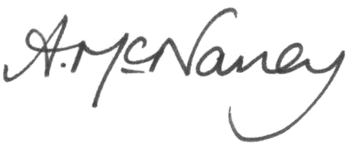

Annmarie McNaney Sue Walton
Executive Headteacher Chair of Trustees

