Teacher of Mathematics
Are you passionate about getting children to understand Maths?
Do you enjoy breaking down learning barriers in subject often perceived as challenging?
Would you like to work in a forward thinking, vibrant Academy with a dynamic principal and SLT?
If you have answered yes to these questions, The Chalk Hills Academy would love to hear from you!

Due to maternity leave, The Chalk Hills Academy have a great opportunity for a self-motivated Teacher of Mathematics to join our wonderful Department. Maths is often a subject perceived as challenging, but studying abstract concepts like Algebra forces students to think in new ways, build new connections and understand problems in a way that may not have seen before. Therefore, we are looking for a passionate teacher that will break down those learning barriers and make Maths understandable for all students. We also have the opportunity to offer additional responsibilities for candidates wishing to develop and are willing to pay a recruitment and retention allowance for the right person who will drive attainment forward.
The successful candidate will:
- Be able to develop, plan and deliver effective and high quality learning experiences to all students
- Be an aspirational professional who is enthusiastic, influential and committed to working in pursuit of success for the academy and its learners.
Job specifics:
- Start date: February half term ideally but will consider other start dates
- Salary: MPS/UPS + Additional allowance
- Job Role: Full time, Fixed Term Contract
Why work for Chalk Hills Academy?
- £30 million state of the art building with well-equipped classrooms in an Ofsted rated ‘Good’ school
- You’ll be working alongside a collaborative, forward thinking Principal and Senior Leadership Team who are here to support and develop you
- Great support for NQT’s including your own dedicated mentor, reduced teaching timetable and ‘Outstanding’ teacher programmes available
- Unparalleled CPD opportunities with free courses every Thursday catered to your developmental needs
- We recruit for attitude and train for skills with excellent opportunities for career progression in a successful and expanding Academy
- All teaching staff receive a laptop to use whilst in employment
- Freshly brewed coffee for staff on arrival to the academy every morning
- Employee of the month scheme winning shopping vouchers
- Fantastic staff benefits that make a difference to your work life balance
Here’s what Ofsted have to say: “The purposeful and caring leadership of the Principal and SLT have created a strong academy identity and a positive ethos shared by all members of the community. The strength of leadership is recognised without exception by the academy’s staff. Students’ behaviour is good, the atmosphere in lessons is calm and studious and attitudes to learning are routinely positive as students want to learn. Students are hugely proud of their academy, they wear their blazers and ties smartly, do not drop litter and look after the modern, purpose-built site impeccably. They stand without instruction when any adult enters a classroom.”

Teacher Testimonial: “Moving from Industry to Teaching was a daunting yet exciting experience; I joined Stockwood Park Academy (known as South Luton High School at the time) as an instructor to see if teaching was for me, and have never looked back! The seamless transition into education was exciting, demanding, and the best decision I made. Like many teachers, my role has evolved and I have been fortunate enough to work across the Trust in different positions. The Trust has provided me with multiple opportunities to grow and develop. I now work as an Assistant Principal at The Chalk Hills Academy, with a focus on The Teaching Trust, Admissions and Science. I feel extremely privileged to be working for an organisation that inspires learning, growth, confidence and creativity, and challenges students to rise to their full potential in a warm and caring environment.”

Meet the lovely Maths Department:

Visits to the Academy are warmly welcomed, please contact Gayle Elliott, PA to the Principal on 01582 601 221.
‘We believe in the safeguarding and welfare of children and expect all staff to share this view’.
The Academy is committed to safeguarding and promoting the welfare of children and expects all staff to share this commitment. Applicants must be willing to undergo child protection screening appropriate to the post including checks with past employers and the Disclosure and Barring Service. We are an equal opportunities employer.

HOW TO APPLY

Closing Date: Wednesday 15th November at 12pm Interviews: As soon as possible
Please read the information in this pack. If you decide to apply, please apply online via our career site on www.thesharedlearningtrust.careers.eteach.com

INFORMATION FOR APPLICANTS:
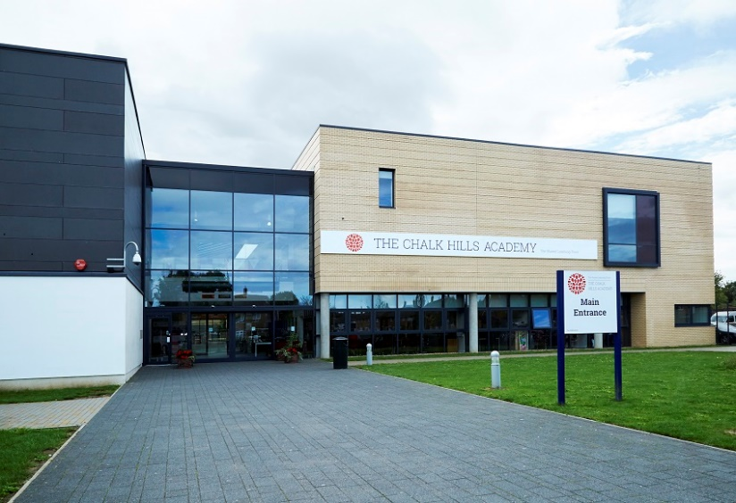
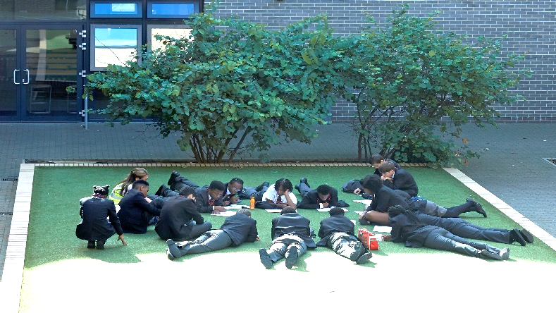
Teacher of Mathematics

WELCOME TO THE SHARED LEARNING TRUST FROM THE CHIEF EXECUTIVE, CATHY BARR
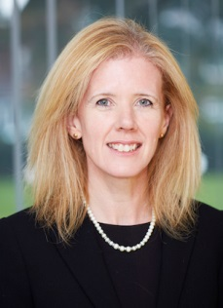
The Shared Learning Trust has appointed Cathy Barr as its new Chief Executive Officer. Cathy is already part of the Shared Learning Trust's family of schools, having been Principal of the Stockwood Park Academy in Luton for the last five years. The Shared Learning Trust is a stand-alone multi academy trust, which runs a family of four schools based in Bedfordshire: Stockwood Park Academy, the Chalk Hills Academy, the Linden Academy and the Vale Academy. Cathy grew up locally, in Harpenden, and went to school in St Albans. She has almost 25 years' teaching experience under her belt, qualifying in 1993 and joining the team at Stockwood Park (then the Barnfield South Academy) in 2009.
Cathy said of her appointment: "I am thrilled to have been appointed CEO of the Shared Learning Trust. I care passionately about the students we teach and will do all I can to ensure each and every child, from the age of two to 18, gets the best possible care and education in our academies."

I am conscious that this may be your first contact with our Academy Trust and first impressions are very important. I hope what you read; coupled with anything else you discover about us, inspires you to apply for this post.
- We recruit people for attitude and train for skills
We aim to recruit outstanding people who have the right attitude. If you have a love for teaching and are passionate about seeing children succeed, we would love to hear from you!
Recruiting the right teachers and staff help us to achieve the goals we set for our children. We are always keen to hear from educators who are passionate about working for the schools and communities we serve. We would rather make no appointment than appoint someone who does not share the same positive ethos that runs through our Academies. For this reason, we try to articulate clearly our vision, values and expectations when putting together information for applicants.
We aim to recruit staff who:
- are excited by their role and by the prospect of working with young people, even those who are less well motivated;
- love the processes of learning and teaching and are keen to continually develop their own skills;
- recognise that teaching can be a demanding job but react positively to those demands rather than complaining;
- will subscribe to the ethos of the Trust and ‘go the extra mile’ in terms of time and commitment to get the very best from our young people;
- see break duty as an opportunity to talk to children;
- are quick to praise and slow to criticise; and are not afraid to admit to seeing themselves as potential leaders of the future.

WELCOME TO THE CHALK HILLS ACADEMY FROM THE PRINCIPAL, LOUISE LEE
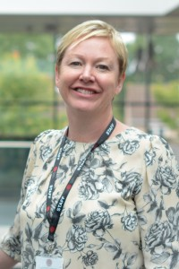
Dear Applicant,
It is a privilege and an honour to lead Chalk Hills Academy.
Our students are extremely motivated, and have an exceptional desire to achieve and behave impeccably.
Our staff are highly qualified and work tirelessly in the pursuit of world class progress for all of our students.
The facilities at Chalk Hills Academy are state of the art, providing students with the opportunity to develop their interests and skills in a wide range of areas.
In 2016 our students achieved 60% A*-C English & mathematics, which was a fantastic achievement for our young people.

As an Academy within the Shared Learning Trust, we believe our key aim is to give every child the best possible opportunity to flourish and develop into decent, disciplined, well-educated and employable adults.
Learning is clearly at the heart of all we do.
‘It is the supreme art of the teacher to awaken joy in creative expression and knowledge.’ - Albert Einstein
I am delighted to extend a warm welcome to you.
Best wishes,
Louise Lee

THE TRUST

The Shared Learning Trust is a stand-alone multi academy trust, which runs a family of four schools based in Bedfordshire:

- The Chalk Hills Academy, Luton, age 11-18, judged 'Good' by Ofsted
- The Stockwood Park Academy, Luton, ages 11-18, judged 'Good' by Ofsted
- The Sixth Form, Luton, age 16-19, judged 'Good' by Ofsted (A part of both Chalk Hills and Stockwood)
- The Linden Academy, Luton, age 4-11, judged 'Good' by Ofsted
- The Vale Academy, Dunstable, age 4-13, judged 'Good' by Ofsted

Our Academies are supported in their work by our Teaching School, based at The Chalk Hills Academy. The structure of our family of schools means that we can be with a child every step of the way, from teaching them to tie their shoe laces right through to congratulating them on their university place or their first job.

Our Trust is vibrant and friendly, supported by 3 state-of-the-art buildings. It is a learning environment where all students have the opportunity to be high achievers, make good friends, contribute to their community and take part in a wide range of extra-curricular activities.

VISION & VALUES – ‘Strive, Achieve, Believe’

At The Shared Learning Trust, we provide opportunities for all our students and adults to be aspirational and develop a passion and excitement for learning. Working with our communities, we ensure all students are able to achieve beyond their targets to reach the success they deserve. Our students develop a strong self-belief so that they flourish and develop into well-rounded, self-respecting young people.
Our commitment to our vision can be seen through:
- Our academies working together to provide more opportunities for all students and staff
- A focus on the development of our staff with opportunities for clear and dynamic career progression and high quality recruitment and retention.
- Strong Trust approaches to our key issues, for example; teaching, assessment, attendance and curriculum development.
- Partnerships with schools outside of our Trust to maximise opportunities for all.
- Close working and communication with our families and local community.
- Care for our families beyond the school day.
- Excellent lessons and learning incorporating effective use of new technologies.
- An interesting yet challenging curriculum.
- 16-19 provision, which ensures progression, routes for all.
- A Cross-Trust focus on high achievement and high standards.
- Ensuring that every child in our Trust reaches their full potential by providing exciting opportunities both inside and outside of the classroom.
- Exemplary behaviour and conduct at all times.
- A can-do attitude across the Trust that fosters belief and high expectation.
- Ensuring no opportunities are missed.

ABOUT THE CHALK HILLS ACADEMY

Providing the very best education for all our students is the simple goal for The Chalk Hills Academy. Whilst firmly rooted in traditional values, we have made our Academy a vibrant and exciting place with a positive ethos that runs throughout the Academy. We want our children to flourish and develop into decent, disciplined, well-educated and employable adults.

We have an innovative curriculum, which makes the transition from primary to secondary education an enriching and enjoyable experience and enables students to follow a personalised route to success. Our students are achieving the highest standards in the classroom, on the sports field and among the community.

Our state of the art building which we moved into in February 2011 offers cutting edge facilities that are benefiting students even further. Our hardworking and motivated staff are providing outstanding lessons and are given the best possible support. We work closely with parents and carers, encouraging their children to achieve and ensuring that excellent progress is made.

With the rigorous use of data, constant assessment of student progress and quality assurance methods, together, we are achieving more than we ever thought possible. We instantly respond if students experience difficulties. Dialogue with teachers is encouraged as a framework for students to develop ideas, ask questions think about their learning.

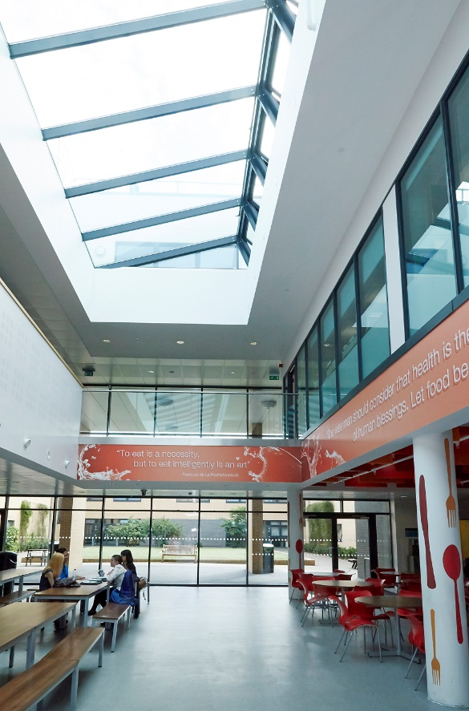

OFSTED at The Chalk Hills Academy

Leadership and Management: ‘GOOD’
- The purposeful and caring leadership of the Principal and the senior team have created a strong academy identity and a positive ethos shared by all members of the community. The strength of leadership is recognised without exception by the academy’s staff. The atmosphere created allows teachers to teach effectively and students to learn well.

Behaviour and Safety of Students: ‘GOOD’
- The behaviour of the students is good. Students are calm and orderly when moving between lessons and at breaks and lunchtimes. They are unfailingly polite and courteous to staff and each other. The atmosphere in lessons is calm and studious, attitude to learning are routinely positive as students want to learn and these characteristics have a strong impact on their progress.

Quality of Teaching: ‘GOOD’
- Teachers help create positive learning environments in their classrooms. Constructive, trusting relationships have been developed throughout the academy and teachers and students share an expectation that learning will begin as soon as each lesson starts. Students are confident to engage actively in lessons and feel safe to venture answers to questions and make mistakes. Teachers are committed to improving their own skills and they regularly take advantage of the high quality professional development opportunities available at the academy. This has enabled continuous improvement in the quality of teaching.

Achievement of Pupils: ‘GOOD’
- The proportion of students that attain five or more good GCSE passes including English and mathematics is higher than the national level. When compared to other schools nationally the progress made between Key Stage 2 and Key Stage 4 at the academy overall is extremely high. Most ability groups make very strong progress and finish Key Stage 4 with standards of attainment which are above average.

CPD and Training: Our Teaching Trust (We invest in you!)

All four Academies at The Shared Learning Trust are a part of our Teaching Trust, which is held at The Chalk Hills Academy. We aim to offer exceptional teacher training and high quality professional development programmes to new and experienced staff to support them in excelling in their career.

Our programmes are facilitated by experienced school leaders, who have exemplary records in leadership and improving outcomes for their students. We are able to cater for specific requests and can offer custom-made support packages that focus on the quality of teaching and learning, curriculum development and aspects of Leadership and Management.

We currently offer 'The National Award for Middle Leaders', 'The Outstanding Teacher Programme', 'The Improving Teacher Programme' and 'The National Professional Qualification for Senior Leadership'. As Chalk Hills Academy is part of a Multi-Academy Trust, there are fantastic opportunities to climb the career ladder. The Shared Learning Trust are a firm believer in helping all staff reach their full potential and developing their career within our Academies. If you are willing and wanting, we will do all we can to put you on the relevant courses and give you the right opportunities so you can keep achieving more in your career. If there isn't a current opportunity at The Chalk Hills Academy for promotion, there will be opportunities to move to one of our partner Academies.

Teacher Testimonial

“Having worked in London schools for over 12 years and overseas for a couple of years, I hadn’t really considered a move to Luton. There is something about the diversity of London schools, both culturally and socially that I love and I genuinely didn’t think that this would be replicated unless I working in another big city. The opportunity to work at Chalk Hills Academy came up and after looking at the website and Ofsted report, I decided to apply and have been here since January 2017. Chalk Hills Academy and The Shared Learning Trust (this is my first time working in a small academy trust) has certainly exceeded my expectations. Everything that I loved about working in London - diversity, atmosphere, forward thinking and generally wanting the best for all students is at Chalk Hills. In addition, working in a school that is part of a small multi-academy trust means that there are regular opportunities for collaborative working and partnerships. As well as the working environment, salary is always a consideration and I have been pleasantly surprised to find that there isn’t a great deal of difference between The Shared Learning Trust and an Inner London salary. I would unreservedly recommend Chalk Hills Academy, The Shared Learning Trust and Luton; have a look I am sure you will too will be pleasantly surprised!”

RECRUITMENT TIMETABLE

Wednesday 1st November 2017 | Advertisement appears on the Trust Website, Indeed, TES, The Guardian
Wednesday 17th November at 12pm | Closing date for applications  References will be requested at this stage
As soon as possible* | Interviews commence  *The Academy reserves the right to interview suitable candidates before the deadline*

Job Description

Job Title: Class Teacher - Maths
Responsible to: Curriculum Leader
SECTION 1 - GENERAL TEACHING DUTIES
To maintain and build upon the standards achieved in the award for QTS (Secondary) as set out by the Secretary of State.
Teaching & Learning
1. To manage pupil learning through effective teaching in accordance with the Department’s schemes of work and policies.
2. To ensure continuity, progression and cohesiveness in all teaching.
3. To use a variety of methods and approaches (including differentiation) to match curricular objectives and the range of pupil needs, and ensure equal opportunity for all pupils.
4. To set homework regularly, (in accordance with the School homework policy), to consolidate and extend learning and to encourage pupils to take responsibility for their own learning.
5. To work with SEN staff and support staff (including prior discussion and joint planning) in order to benefit from their specialist knowledge and to maximise their effectiveness within lessons.
6. To work effectively as a member of the Department team to improve the quality of teaching and learning.
7. To set high expectations for all pupils, to deepen their knowledge and understanding and to maximise their achievement.
8. To use positive management of behaviour in an environment of mutual respect which allows pupils to feel safe and secure and promotes their self-esteem.
Monitoring, Assessment, Recording, Reporting, and Accountability
1. To be immediately responsible for the processes of identification, assessment, recording and reporting for the pupils in their charge.
2. To contribute towards the implementation of IEPs as detailed in the current Code Of Practice particularly the planning and recording of appropriate actions and outcomes related to set targets.
3. To assess pupils’ work systematically and use the results to inform future planning, teaching and curricular development.
4. To be familiar with statutory assessment and reporting procedures and to prepare and present informative, helpful and accurate reports to parents.
5. Keep an accurate register of pupils for each lesson. Unexplained absences or patterns of absence should be reported immediately in accordance with the School policy.

Subject Knowledge & Understanding
1. To have a thorough and up-to-date knowledge and understanding of the National Curriculum programmes of study, level descriptors and specifications for examination courses.
2. To keep up to date with research and developments in pedagogy and the subject area.
Professional Standards & Development
1. To be a role model to pupils through personal presentation and professional conduct.
2. To arrive in class, on or before the start of the lesson, and to begin and end lessons on time.
3. To cover for absent colleagues as is reasonable, fair and equitable.
4. To co-operate with the employer in all matters concerning Health and Safety and specifically to take reasonable care of their own Health & Safety, and that of any other persons who may be affected by their acts or omissions at work.
5. To be familiar with the School and Department handbooks and support all the School’s policies, e.g. those on Health and Safety, Citizenship, Literacy, Numeracy and ICT.
6. To establish effective working relationships with professional colleagues and associate staff.
7. To strive for personal and professional development through active involvement in the School’s appraisal system and performance management procedures.
8. To be involved in extra-curricular activities such as making a contribution to after-school clubs and visits.
9. To maintain a working knowledge and understanding of teachers’ professional duties as set out in the current School Teachers’ Pay and Conditions document, and teachers’ legal liabilities and responsibilities relating to all current legislation, including the role of the education service in protecting children.
10. To liaise effectively with parent/carers and with other agencies with responsibility for pupils’ education and welfare.
11. To undertake any reasonable task as directed by the Head of Department.
12. To be aware of the role of the Governing Body of the School and to support it in performing its duties.
13. To train in basic first aid.
14. To be familiar with and implement the relevant requirements of the current SEN Code of Practice.
15. To consider the needs of all pupils within lessons (and to implement specialist advice) especially those who:
- have SEN;
- are gifted and talented;
- are not yet fluent in English.

N.B: Every subject teacher will be expected to have pastoral responsibilities - detailed separately.

SECTION 2 - ADDITIONAL DUTIES FOR THIS POST
The following tasks will be negotiated and agreed at the time of appointment and at annual review. These additional tasks are seen as an important part of the School's professional development programme:
This job description will be reviewed annually and may be subject to amendment or modification at any time after consultation with the post holder. It is not a comprehensive statement of procedures and tasks but sets out the main expectations of the School in relation to the post holder’s professional responsibilities and duties.

Person Specification - Class teacher

This acts as selection criteria and gives an outline of the types of person and the characteristics required to do the job.
__________________________________________________________________________
Essential (E) :- without which candidate would be rejected
Desirable (D):- useful for choosing between two good candidates.

Please make sure, when completing your application form, you give clear examples
of how you meet the essential and desirable criteria.
Attributes | Essential | How Measured | Desirable | How Measured
Experience | Teaching in the relevant subject area.  Using data to inform target setting and planning. | 1,2  1,2 | Working with children with English as an Additional Language. | 1,2
Skills/Abilities | Able to communicate with a variety of stakeholders (eg colleagues, parents, external agencies).  Able to use IT to support both the curriculum and work organisation.  Able to work as part of, and contribute to, a whole-school, multi-disciplinary team.  Able to monitor and evaluate teaching and learning.  Able to identify the necessary resources which ensure high quality teaching and learning.  Able to assess the needs of individuals to inform lesson planning.  Able to deliver high quality lessons, evaluate the impact of these and develop future planning accordingly. | 1,2  1,2  1,2  1,2  1,2  1,2,5  5 | Able to coach and mentor others. | 1,2
Equality Issues | Demonstrable commitment to inclusive teaching and learning.  Awareness of the effects of discrimination on pupils, parents, colleagues and policy. | 2,5  1,2
Competencies | Able to demonstrate the appropriate motivation to work with young people  Able to form appropriate relationships with young people  Emotional resilience in working with challenging behaviours  Appropriate attitudes to the use of authority and maintaining discipline | 1,2  1,2  1,2  1,2
Specialist Knowledge | Subject/KS, curriculum knowledge | 1,2,5
Education and Training | Qualified Teacher Status  Evidence of ongoing cpd. | 4  1.2 | Evidence of meeting the threshold standards.  Sustained and substantial performance in the threshold standards. | 1,2  1,2

( 1 = Application Form 2 = Interview 3 = Test 4 = Proof of Qualification 5 = Practical Exercise )

We will consider any reasonable adjustments under the terms of the Disability Discrimination Act (1995), to enable an applicant with a disability (as defined under the Act) to meet the requirements of the post.

The postholder will ensure that school policies are reflected in all aspects of his/her work, in particular those relating to;
- Equal Opportunities
- Health and Safety
- Data Protection Act (1984 & 1998)
- Code of Conduct

‘The School is committed to safeguarding and promoting the welfare of children and expects all staff to share this commitment. Applicants must be willing to undergo child protection screening appropriate to the post, including checks with past employers and the Disclosure and Barring Service.

