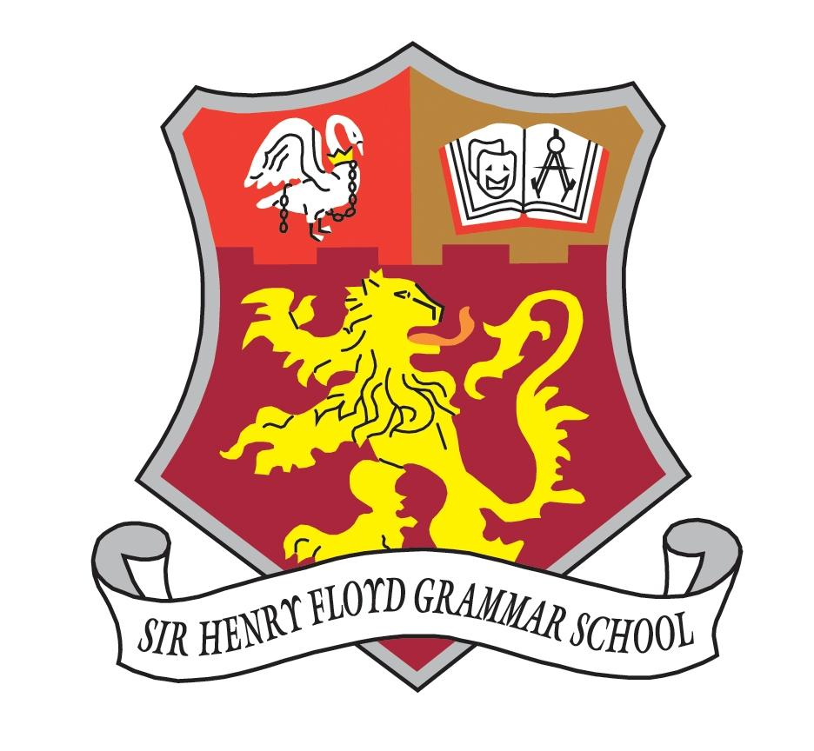

Sir Henry Floyd Grammar School

Teacher of Chemistry

Information for Applicants

Teacher of Chemistry

General Information

We are a mixed grammar school with 1300 students, the overwhelming majority of whom are well motivated, hard working, committed learners. Our examination results as a school have improved steadily over the past five years (from 45% A-A* to 67% at GCSE and from 50% A* -B to 71% at A level). This year, over 30% of students attained eight or more 7-9 grades and over two thirds gained five or more 7-9 grades (A*/A equivalents). We seek an enthusiastic and dynamic person to lead the teaching of physics. In addition to enjoying classroom teaching, the successful candidate will be well organised, enthusiastic and well motivated, as well as able to communicate effectively with others.

Our most recent Ofsted graded as outstanding in every respect – the first time that the school has received this judgement. We were excited by that but are still keen to carry on improving and are building networks with other schools that we feel we can learn from. The school is growing in popularity. This year we are having two building projects to provide extra accommodation and have we are increasing our admission number.

Our focus in recent years has been very much on improving examination results but we are fortunate that large numbers of staff and senior students give up their time to run extra-curricular activities. We run a “Freshers Fair” at the start of each year where all lunchtime and after school activities are promoted to new students. This year we had over eighty clubs and activities represented at the fair.

The appointee will be joining a successful school with a distinctive ethos. Being mixed and selective is relatively unusual in the current climate, and so this post offers a rare opportunity to join a staff team committed to excellence and high academic standards in a supportive environment. Pupils of both sexes work hard and are positive about their studies, while enjoying a natural working atmosphere in which civilised and thoughtful behaviour is the norm.

We are looking for:

- A well-qualified graduate with a love of the subject and a determination to support every student in achieving his/her best.

- A teacher capable of teaching throughout the age range.

- A person with an interest in applications of ICT, target-setting and value-added analysis within the teaching of chemistry

- Someone capable of working effectively within a team, co-operating in the construction and sharing of resources.

The Chemistry Department

There are currently four full time chemistry teachers who promote the subject throughout the school. Chemistry is a taught as stand alone subject at both GCSE and A Level.

This year 69% of students gained a grade 7-9 at GCSE and 59% of students gained A*-B at A Level. Students study the AQA specification for their GCSEs and A Levels. There are 6 classes each year studying chemistry for their GCSEs and typically 5 classes at A Level.

We aim to inspire our pupils with a wide range of strategies and activities, both curricular and extra curricular, to stimulate an interest in chemistry. The successful candidate will have a love of chemistry and an interest in development of the subject. In addition to enjoying classroom teaching, he / she will be well organised, enthusiastic and well motivated, as well as able to communicate effectively.

