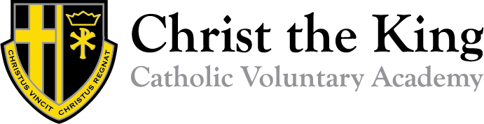

Teacher – Main Professional Grade
JOB DESCRIPTION

The appointment is subject to the current conditions of employment for Pre Threshold teachers contained in the School Teachers' Pay and Conditions Document. This job description may be amended at any time following discussion between the head teacher and member of staff, and will be reviewed annually.

General Description of the Post

The post holder will be accountable to the Principal and will carry out the following professional duties in accordance with the Academy’s policies and procedures under the direction of the Academy’s Principal.
Pupil Progress

- Identifying clear teaching objectives and specifying how they will be taught and assessed
- Setting appropriate and demanding expectations
- Setting clear targets, building on prior attainment
- Assess how well learning objectives have been achieved and use them to improve specific aspects of teaching
- Mark and monitor pupils’ work and set targets for progress
- Assess and record pupils’ progress systematically and keep records to check work is understood and completed, monitor strengths and weaknesses, inform planning and recognise the level at which the pupil is achieving

Professional Practice

- Identifying key groups of students and ensuring an appropriate level of challenge to support progress
- Provide clear structures for lessons maintaining pace, motivation and challenge
- Make effective use of assessment and ensure coverage of programmes of study
- Ensure effective teaching and best use of available time
- Monitor and intervene to ensure sound learning and discipline
- Use a variety of teaching methods to:

- match approach to content, structure information, present a set of key ideas and use appropriate vocabulary
- use effective questioning, listen carefully to pupils, give attention to errors and misconceptions
- select appropriate learning resources and develop study skills through library, ICT and other resources;

- Ensure pupils acquire and consolidate knowledge, skills and understanding appropriate to the subject taught
- Evaluate their own teaching critically to improve effectiveness
- Prepare and present informative reports to parents
- Establish effective working relationships and set a good example through their presentation and personal and professional conduct

Whole Academy Responsibilities

- Be a positive influence on the climate and culture of the Academy and demonstrate a positive professional attitude at all times.
- Support the Catholic ethos of the Academy.
- Be aware of and comply with policies and procedures relating to child protection, equality, health, safety and security, confidentiality and data protection, copyright etc. reporting all concerns to line manager.
- Attend and participate in team meetings, pupil progress meetings, open evenings and pupil performances.
- Be aware of and support difference and ensure equal opportunities for all.
- Contribute to the overall aims of the Academy.
- Appreciate and support the role of other professionals.
- Attend and participate in relevant meetings as required.
- Participate in training and other learning activities and performance development as required.
- Recognise own strengths and areas of expertise and use these to advise and support others.
- The Academy is committed to safeguarding and promoting the welfare of children and young people and we expect all staff to share this commitment.

