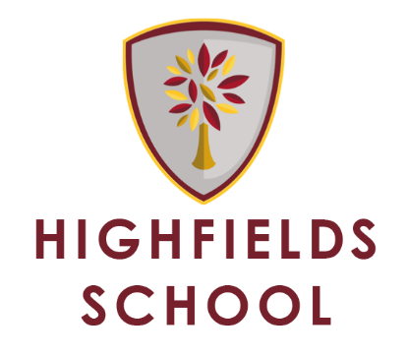

Assistant Headteacher – Head of Middle School

How to apply
Complete a letter of application. This should be word processed using font size 12. In your letter we would like you to address the following:

- How your experiences to date have prepared you for the post of Assistant Headteacher/Head of Middle School?

- How you would develop and sustain outstanding achievement and standards across Middle School?

- What skills and qualities you will bring to the role and how you will personally develop if appointed to the role?

Closing Date: 23rd April 2018
The selection process will be held over two days:
Thursday 26th and Friday 27th April 2018
A presentation on ‘Developing and sustaining outstanding achievement and standards across Middle School’ will be required for Friday 27th April if you successfully progress through the first day of interviews.

Completed applications should be returned:
PRINTED HARD COPY BY EMAIL
Mrs L Bishop, Head’s PA recruitment@hswv.co.uk
Highfields School
Boundary Way
Penn
Wolverhampton
WV4 4NT

