September 2017 Newsletter

Oakdale School
Cheetham Hill Road, Dukinfield
www.oakdale.tameside.sch.uk Tel: 0161 367 9299

Welcome back to the new school year and I hope you have all had a happy, healthy summer break and are ready for a wonderful start to the term.

We know that a strong partnership with you will make a great difference in your child’s education. As partners in your child’s learning and successes it is important that we are able to work together to ensure that your child realises his/her potential to be the best they can be.

It is important that your child attends school daily, arrives on time and is ready for the day’s learning opportunities. Please refer to our attendance policy for further details. This is available on the school website or a paper copy can be requested.

Our school improvement priority this year is “Dealing with Change”. We will be working hard to ensure that we are able to support your child’s learning and ability to deal with changes and transitions in as many contexts as possible.

I anticipate another busy year ahead and I look forward to working with you.

Linda Lester
Headteacher

Key Stage 2 Playground

To ensure the privacy and safety of our pupils in Key Stage 2 we have installed a woodland screen! We think it looks fantastic!
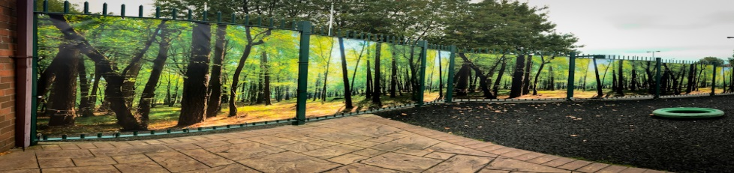
PFTA

Over the coming school year we are hoping to arrange fund raising and social events for our children, families and friends. If you have any ideas or interest in supporting us please contact school.

Medicines

A reminder that all medicines must come to school in the original box, blister packs and bottles with your child’s name clearly visible. If you require a medicine consent form please speak to class - Thank you!

Upcoming Events

Enrichment Topic
This month’s enrichment topic will be based around Islam and special journeys.

Half Term
School will close on Friday 27th October and re-open to pupils on Monday 6th November 2017.

Macmillan Coffee Morning

We will be holding our annual Macmillan coffee morning on Friday 29th September 2017. Please come and join us. It is a very pleasant social occasion where parents, friends and staff can share a coffee and sweet treat.

So that we can raise as much money as possible for MacMillan Nurses we will be asking for donations of biscuits, cakes and raffle prizes. A letter with more information will be sent home via your child’s class

More School News!

Access/Parking to School
Over the summer we have had electronic gates installed. This is to enhance our onsite security and safeguarding of pupils.
We understand that the school grounds are extremely busy both at the beginning and the end of the school day and we appreciate your patience and support. Please read the attached guidance for more information. Together we can make access safer and easier for you and your child. If you have any concerns please contact school.

Pupil Premium
Pupil Premium is funding that comes into school for children who are eligible to receive free school meals. Last school year the funding allowed us to purchase additional resources / activities in school such as Music Therapy, I pads and IT communication resources and additional SPLT and OT support. Please consider applying for free school meals – even if your child would prefer sandwiches etc. as it will bring useful funding into school. If you need more information about free school meals and how to apply, please contact school. The important thing is that you apply even if your child continues to bring their own lunch as the funding is around eligibility.

Dinner & Class Fund Money
Dinner monies are now £2.18 per day = £10.90 per week. Please send the money into school in an envelope every Monday morning, clearly marked DINNER MONEY with your child’s name and class on. Class fund money will remain at £1.50 per week and this should come in a separate envelope clearly marked CLASS FUND MONEY with your child’s name and class on. Alternatively you can pay for school meals online via Tameside Councils Website using a credit/debit card.

Contact Information
Over the year if your phone number or any other personal details change please let us know. This is very important as we will need the most up to date information if we ever have to contact you in an emergency. Following an inquest in London regarding the death of a 4 year old boy, new recommendations for schools have now been made-
- For every child in school we must have the emergency contact telephone numbers of three different adults
- If a pupil unexpectedly fails to attend school and no relevant adult can be contacted via phone, staff do not now wait three to five days to visit but instead must immediately send a member of staff to the family home
- If there is no answer at the family home when staff members attend, they are required to contact the police, who in most cases are likely to force entry

Many pupils attending Oakdale are more vulnerable and have greater needs than the majority of their mainstream peers. This is why these recommendations are vital.

Helpful Information

Radar Key

A radar key enables access to disabled toilets within Tameside and around the country for people with disabilities. The key can be purchased by visiting one of Tameside councils customer service centres, Tameside libraries or online via the council’s website. The key costs £3.50 which is refundable upon the return of the key and production of the receipt. You can keep the key for as long as you require it.

Jeans for Genes Day 2017

Oakdale raised a massive £143.05 for Jeans for Genes! Thank you to everyone who supported us and wore their jeans! Classes visited our tuck shop in the afternoon where cakes made by pupils were available to buy.

Pound Coins

Due to banking restrictions school will no longer be able to accept the old style £1 coins.

ACCESS TO SCHOOL

Dear Parents and Carers,

There are now electronic gates which offer greater security throughout the day. Please use the call points (driver/pedestrian) to request access to school.

At the start and end of the school day access to school is very busy so, as you drive onto school premises I would like to remind you of the following;

- SEN transport has access to school premises from 2:30pm. Parents may access the site from 2:45pm. This is to ensure that children’s learning is not disrupted and we maintain the safety of all site users
- Once SEN transport has left the site there is sufficient access for most parent cars
- Please maintain a 5mph speed limit at all times when on school premises
- Please ensure that your children are well supervised at all times.
- Park safely and with consideration for other road users
- Respect the direction and guidance of the member of staff directing traffic at the front of school (Craig Collins).
- Please do not make a “U” Turns on the school drive. Please use the turning circle at the bottom of the drive.
- Please do not park in spaces which are allocated to St Mary’s School.

Your child’s safety and welfare is our most important consideration.
Please adhere to these guidelines and all road users will be safe.

Thank you for your cooperation.

Yours sincerely
Linda Lester
Headteacher

