Class Teacher Recruitment Pack
Chisenhale Primary School
Learning together for a better future

PLEASE VISIT OUR SCHOOL WEBSITE
chisenhale.towerhamlets.sch.uk

September 2017
Contents

Welcome from the Headteacher 3
Recruitment Process Details 4
About the School 5
School Curriculum 6
Ofsted – June 2015 7
2016 Unvalidated Results 8
School Improvement Priorities 10
Job Description……………………………………………………………………………….………………………………….11
Person Specification 15

Welcome from the Headteacher
May 2018
Dear Candidate,
Thank you for your interest in Chisenhale Primary School. Chisenhale is a much loved, successful, one and a half-form entry school in Bow, Tower Hamlets. Our children come from a wide variety of backgrounds, reflecting the borough’s cultural and economic diversity.
We are proud to be a local authority school, with a roll of 350 children coming from a tight catchment area of less than a mile. We strive to give our children the best possible education and start in life and to inspire in every child a love of learning, which we do through an extremely broad curriculum, with lots of school outings.
Our involvement with our community is key: parents are a huge part of school life; through our active PTA and other contributions they help enrich the curriculum, which in turn gives them the opportunity to grow their skills and confidence. Parents help provide exciting lessons (music, fitness, gardening, cooking) and have been involved in designing our playground equipment, edible garden, outside classroom and numerous events to raise funds (pop-up restaurants, popular summer and winter fetes, parent mornings).
As a member of the Teach East London Teaching Schools Alliance, we are extremely fortunate to have a network of support for teaching and learning, which has become more and more important as fiscal and LA structures have been realigned. The Alliance also enables our teachers and support staff to grow and showcase their skills within a wider teaching environment, as well as providing an opportunity to learn from and reflect on each other’s practice.
If you would like to apply, please do come and visit us. We are within walking distance of Mile End and Bethnal Green tube stations. The current Head will be happy to show you around and answer questions, so please contact Kim Glynn (020 8980 2584) in our school office to arrange a suitable time. We look forward to hearing from you.
Yours sincerely,
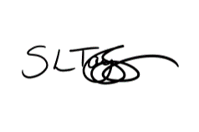
Sharon Taylor-Sezgin
Headteacher

Recruitment Process Details

To start: September 2018

Grade: Mainscale plus Inner London Allowance
Closing date for applications: 21 May 2018

Interview date: 23 May 2018

Visits are strongly encouraged and can be booked through Kim Glynn (020 8980 2584) in our school office.

The Class Teacher Job Description and Person Specification can be found at the back of this pack.
Please use the Tower Hamlets Application form provided and follow the application instructions carefully.

About the School

Chisenhale is proud to be a 3 - 11 community school. Our area is a rich social and ethnic mix and families are welcomed to become an important part of school life. We have a really committed and hard-working staff team, who want children to enjoy learning through a range of interesting experiences.
Our vision is Learning Together for a Better Future and to achieve this vision we aim for all children to be
- Successful learners
- Confident individuals
- Responsible citizens
As a school, we have a strong ethos of inspiring children to enjoy learning. We celebrate the rich diversity within our community and nurture children’s individuality.
Staff’s particular talents are valued and we also recognise the need for consistency and shared standards for school life.
Chisenhale is also marked by the strength of its partnerships with outside organisations, through which we can offer children a range of rich experiences, including the Tower Hamlets Education Partnership; the Worshipful Companies of Weavers, Musicians and Bakers; the Chisenhale Art Studios and Gallery; THAMES and Mini Maestros, through which we offer a wide range of instrumental lessons; Tower Hamlets Youth Sports Trust, which enables children to participate in a large number of different sports, including tournaments across the borough.
Please see the Parent Information Booklet as well as the school website http://www.chisenhale.towerhamlets.sch.uk/ for lots more information about the school.

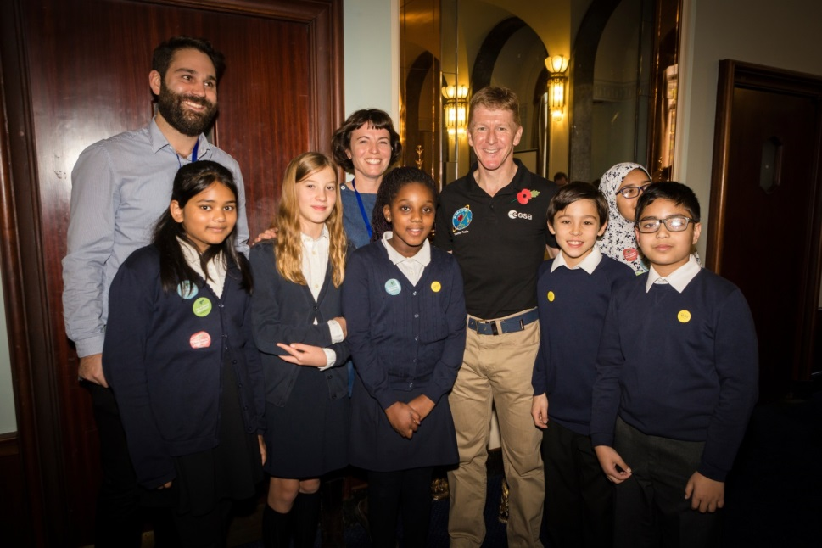

School Curriculum

Our children learn through a creative curriculum, which we have developed over the past few years, in order to make learning more exciting and meaningful. We have high expectations of all children and give lots of praise. We believe our job is to inspire and motivate through the learning experiences we offer children.
The school aims to promote a unified, rights respecting approach, to enable high quality learning. We are currently working towards becoming a UNICEF Rights Respecting School.
Examples of what this looks like in practice are:
- Each topic has a “big bang” to start (such as a trip, or a day in role) and a “grand finale” to finish (such as an opportunity for children to share their work with other classes, or an event where parents are invited in to enjoy the work).
- We try to offer as many real experiences as possible, including visiting experts, trips and enterprise projects.
- We encourage learning in role, such as when Florence Nightingale visited KS1, to help them think about what jobs might need doing at her hospital.
- We work from core texts, which are rich and exciting books that engage and excite children in learning.
- Successes are celebrated in a variety of ways, including displays, assemblies, newsletters and postcards home.
We have planned a 2 year cycle to cover all aspects of the new National Curriculum, as we have mixed age classes. The topics link as many aspects of learning as possible.

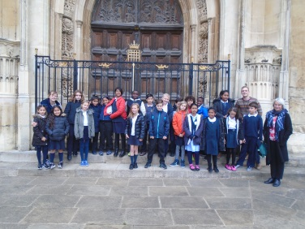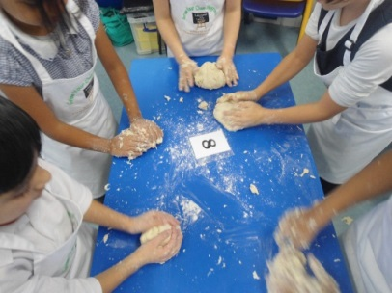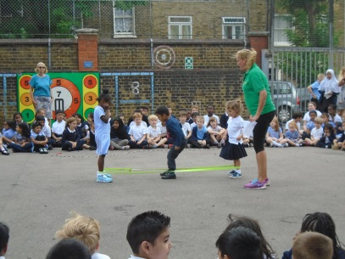

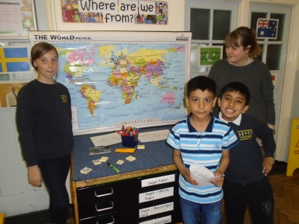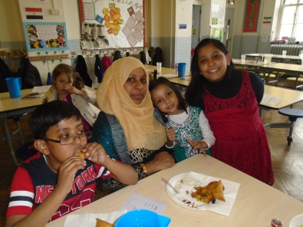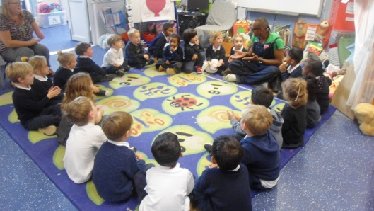

Ofsted – October 2015

Inspection Judgements
Overall effectiveness: how good is the school? 2
The school’s capacity for sustained improvement 2

Key Findings
- Skilled and determined leadership by the Headteacher, senior leaders and governors is leading to sustained improvements in teaching and pupils’ achievement over time.
- Staff share the Headteacher’s drive for success. They feel valued and supported, and are eager to strengthen their practice. As a result, teaching is good.
- Governors are fully committed to the school’s continuing development. They have a good understanding of pupils’ achievement and they challenge leaders effectively.
- Very strong relationships exist with parents who are supportive and engaged in their children’s learning. The school is an integral part of the local community.
- Disadvantaged pupils, pupils who speak English as an additional language and those who are disabled or have special educational needs make good progress from their starting points and achieve well.
- The school provides many interesting and exciting learning opportunities through its creative curriculum. These promote pupils’ spiritual, moral, social and cultural development well. Pupils have a good understanding of the values of respect and tolerance. They are well prepared for the next stage in their education.
- Pupils’ behaviour is good. They are eager to learn and they feel safe. Pupils form excellent relationships with staff based on mutual respect and trust. There is a positive climate for learning. Attendance is good and improving.
- Provision in the early years is good and improving. Children learn in an exciting and stimulating setting and make good progress from their starting points.
What does the school need to do to improve further?
- Improve teaching further in order to continue to raise pupils’ achievement, by ensuring that:
  - teachers provide more opportunities for pupils to develop and practise their skills in tackling investigations and problem solving, especially in mathematics and science;
  - teachers consistently reinforce the school’s handwriting and presentation policy, and so continue to improve pupils’ written work in all subjects.

2017 Unvalidated Results

Phonics screening check provisional outcomes
 | LA | National | Chisenhale
2015 | 78.3% | 76.8% | 77.8%
2016 | 81.0% | 80.6% | 80.0%
2017 | 82.1% | 81.0% | 86.0%

KS1 provisional outcomes (teacher assessment)
Percentage of pupils working at or above the expected standard:
 | LA | National | Chisenhale
Reading | 76.4% | 75.6% | 82%
Writing | 71.6% | 68.2% | 76%
Maths | 77.3% | 75.1% | 79%
Science | 81.3% | 82.6% | 84%
RWM | 66.6% | 63.7% | 67%

Percentage of pupils working above the expected standard (working at greater depth / higher standard):
 | LA | National | Chisenhale
Reading | 24.9% | 25.2% | 32%
Writing | 17.1% | 15.6% | 21%
Maths | 22.7% | 20.5% | 27%
RWM | 12% | 11% | 16%

KS2 provisional outcomes
Percentage of pupils working at or above the expected standard:
 | LA | National | Chisenhale
Reading | 74.2% | 71% | 86%
Writing | 80.8% | 76% | 82%
Maths | 80.7% | 75% | 89%
GPS | 83.1% | 77% | 75%
RWM | 66.6% | 61% | 73%
Average scaled scores for each subject:
 | LA | National | Chisenhale
Reading | 104.4 | 104 | 105
Writing | Not available, as results based on teacher assessment
Maths | 105.4 | 104 | 108
GPS | 107.7 | 106 | 106

Percentage of pupils working above the expected standard (working at greater depth / higher standard):
 | LA | National | Chisenhale
Reading | 24% | 24.5% | 16%
Writing | 20.2% | 17.7% | 20%
Maths | 26.5% | 22.6% | 18%
GPS | 39.3% | 30.9% | 25%
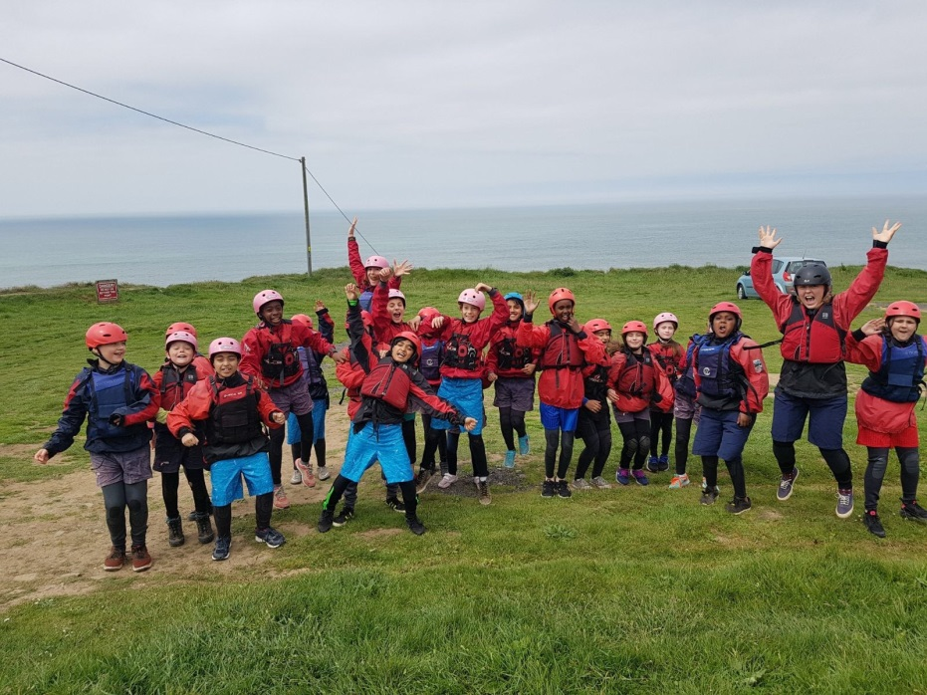
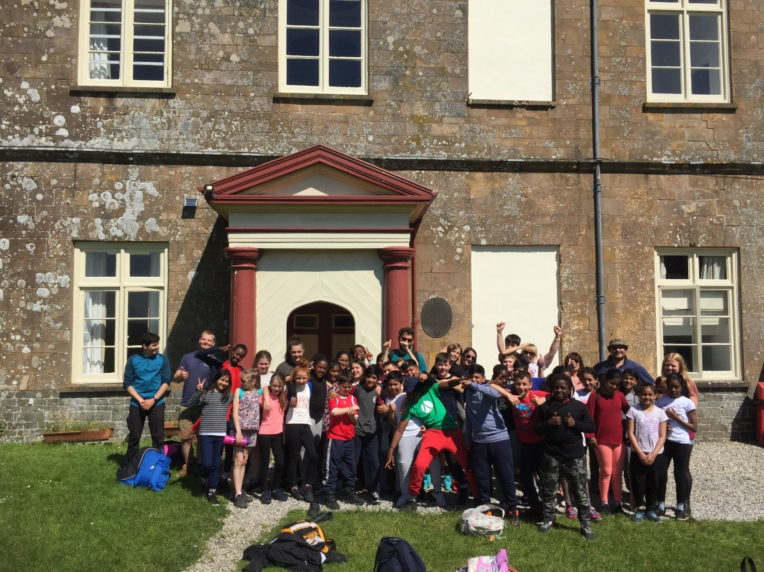

School Improvement Priorities

Our main priorities for 2017-18 are:
- Outcomes for pupils:
Continue to ensure good progress and attainment (at least in line with national averages), by ensuring that all children are challenged in their learning, by all staff working with them. This will include consideration of the balance between independent and guided learning.

- Quality of teaching, learning and assessment:
Continue to ensure that the best practice is shared across the school and more widely, including teaching and support staff.
Continue to develop work to improve children’s independence in learning and to improve the communication environment in school.

- Effectiveness of leadership and management
Embed the good practice in planning, teaching and assessment in order to ensure a good transition for new members of staff and for staff working in different year groups.

- Personal Development, Behaviour and Welfare:
Support children to take greater responsibility for their own behaviour through a revised behaviour policy, which will include the development of emotional literacy and emotional coaching.

The school continues to work towards its vision of Learning Together for a Better Future. We aim to enable children to become successful learners, confident individuals and responsible citizens. We have developed strong partnerships with parents and outside organisations that continue to support children and families on this journey. As a school we have a strong, inclusive teaching and learning ethos. We place a high value on creative cross-curricular learning and on providing the children with a range of rich and varied learning experiences.

This plan was written with input from governors and staff in order to provide a dynamic ongoing plan for the school, based on a clear vision which has measurable impact. It is reviewed every half term with all stakeholders and updated accordingly. It provides a transparent means for the school to move forward. The targets have been arrived at in relation to our OFSTED report in June 2015 and our own school self evaluation.

Alongside the main priorities, we have curriculum action plans, which are written by the curriculum leaders and monitored by the Head and governors. The SIP then details how we intend to achieve these targets, as well as enabling us to keep track on progress towards them over time. As well as the details of the targets, there is also information about staffing and governors and the data which we have used to help us arrive at our next step decisions.

Job Description

Job Title: Class Teacher

Responsible to: Phase leader and Headteacher

TEACHER STANDARDS - PREAMBLE
Teachers make the education of each child their first concern, and are accountable for achieving the highest possible standards in work and conduct. Teachers act with honesty and integrity; have strong subject knowledge, keep their knowledge and skills as teachers up-to-date and are self-critical; forge positive professional relationships; and work with parents in the best interests of their child.

OVERALL RESPONSIBILITY
To maintain and build upon the Teacher Standards (DfE Sept 12) and in particular:
- To work within and support the policies, practices and ethos of the school.
- To demonstrate consistently the positive attitudes, values and behaviour which are expected of children.
- To be accountable for children’s attainment, progress and outcomes
- To take responsibility for improving teaching through appropriate professional development, responding to advice and feedback from colleagues
- To manage behaviour effectively to ensure a good and safe learning environment
- To monitor children’s progress, keeping records that include assessment outcomes and targets set at regular intervals in line with school policies, to enable all children to achieve their full potential.
- Contribute to the safeguarding and promotion of the welfare and personal care of children and follow school Child Protection Procedures.

SECTION 1 - GENERAL TEACHING DUTIES
Teaching and Learning:
- Enable children’s learning through high quality effective teaching, in accordance with the school’s schemes of work and policies.
- Encourage children to be part of a school community which affords equal value to all its members, is seen to be just and encourages mutual respect, concern for others and truthfulness.
- Encourage all children to reach their true potential and become independent learners with a positive attitude to life-long learning, valuing perseverance, initiative and independence of thought and action, as well as co-operative endeavours.
- Develop in children a sense of moral values which can form a framework for a sense of own worth, and relationships with others, so that children become responsible members of society.
- Develop in children a positive attitude towards themselves and others irrespective of gender, race, ethnicity, religion, disability or academic achievement.
- Develop in children an appreciation of human achievements, failures and aspirations, including positive attitudes towards, and concern for, the environment.
- Teach in an inspiring cross-curricular way to the assigned class or classes to facilitate the acquisition of knowledge and skills and to promote enjoyment in learning.
- Support individual learning, including children on gifted and talented registers, by planning work with appropriate challenge and monitoring and reviewing child outcomes regularly.
- Direct the use of support staff (to include prior discussion and joint planning) in order to benefit from their specialist knowledge and to maximise their effectiveness within lessons.
10.Use a variety of differentiated teaching methods which incorporate effective questioning and response, whole class, small group and individual teaching.
11.Plan and provide structured learning opportunities, which engage children’s interest and which take account 1 of their needs - particularly their developing physical, intellectual, emotional and social abilities.
12.Have high expectations of the children’s behaviour, academic and social abilities, and set clear targets that are both realistic and measurable and which build upon prior knowledge or attainment.
13.Set homework regularly (in accordance with the School Homework Policy) to consolidate and extend learning and encourage children to take responsibility for their own learning.
14.Provide a challenging, yet supportive, learning environment which stimulates, maintains and develops, lively enquiring minds.
15.Consider the needs of all children within lessons (and implement specialist advice) especially for those who:
- have SEN;
- are gifted and talented;
- are not yet fluent in English;
- have disabilities.
16.To use Planning, Preparation and Assessment (PPA) time effectively for these purposes. At least 10% of timetabled time will be designated as PPA time, and it will be allocated in blocks of no less than 30 minutes.

Monitoring, Assessment, Recording, Reporting
- Assess children’s work systematically and use the results to inform future planning, teaching and curricular development, giving children both oral and written feedback.
- Make effective use of data to monitor and evaluate child progress across the curriculum and to inform teaching and learning planning.
- Be familiar with statutory assessment and reporting procedures, and to prepare and present informative, helpful and accurate reports to parents.
- Write high quality and informative annual reports to parents and carers
- Discuss children’s progress and welfare with parents and carers - both formally, e.g. at parents’ evenings and also informally at other times.
- Contribute towards the implementation of IPMs (Individual Provision Maps) for children with special needs, as detailed in the current Code of Practice, particularly the planning and recording of appropriate targets, actions and outcomes.

Curricular Knowledge and Understanding
- Have a thorough and up-to-date knowledge and understanding of the National Curriculum, or the Early Years Curriculum, as appropriate.
- Have a good knowledge of any other statutory requirements related to the children’s education or welfare
- Keep up to date with research and developments in pedagogy and curriculum content.
10.Use detailed subject knowledge to deal effectively with subject-related questions raised by children and the common misconceptions that they hold - thereby deepening the children’s knowledge and understanding.
- Lead on an area of the curriculum, as agreed with the Head. This will include keeping up to date with the latest developments in the subject, auditing and ordering resources and supporting the development of the subject across the school.

Professional Standards and Development
- Understand professional responsibilities in relation to school policies and practices and in so doing to actively support and reinforce those policies.
- Set a good example, not only to the children they teach, but also to all other children in the school, in their appearance and their personal conduct.
- Critically evaluate resources and teaching, using this knowledge to improve the quality of teaching and learning.
- Establish effective working relationships with other professional colleagues, not only those within the School, but also those from outside agencies.
- Be aware of the role and functions of the Governing body.
- Assist in the development of the School Curriculum in line with the School Improvement plan.
- Attend and participate in open evenings and children’s performances.
- Attend meetings within the constraints of directed time and contribute to the development of programmes of study, and any other relevant aspects of the life of the School.

Health and Safety

- Be aware of the responsibility for personal Health, Safety and Welfare and that of others who may be affected by your actions or inactions.
- Co-operate with the school on all issues to do with Health, Safety & Welfare.

Continuing Professional Development - Personal
- Take responsibility for personal professional development, keeping up to date with research and developments in teaching pedagogy and changes in the School Curriculum, which may lead to improvements in teaching and learning.
- Undertake any necessary professional development as identified in the School Improvement Plan taking full advantage of any relevant training and development available.
- Implement and develop pedagogic procedures introduced through school, local or government initiatives.
- Implement the use of new technologies that enhance teaching and learning.
- Participate in leadership, peer and self-monitoring and evaluation schemes, responding to, and acting upon, advice and guidance received.
- Carry out reflective practice exercises to improve classroom practice and teaching and learning.
- Up-date Child Protection training every three years.
- Maintain a professional portfolio of evidence to support the appraisal and teaching and learning review process - evaluating and improving own practice.
- Contribute to the professional development of colleagues, especially NQTs.

SECTION 2 – SPECIFIC PASTORAL DUTIES
Support, Guidance, Monitoring and Reporting
- Consider the child’s welfare as paramount, and take action in accordance with the responsibility ‘in loco parentis’.
- Use a counselling approach to help children explore thoughts, feeling and solutions to problems.

Managing Behaviour
- Establish and maintain a high standard of discipline by the use of praise, rewards and sanctions, and thereby create an environment in which children feel safe, secure and confident, in line with the school Behaviour Policy.
- Implement the ‘Rights Respecting School’ guidelines and the Chisenhale Behaviour Policy. Teachers have a central role in clarifying to children the consequences of stepping over the boundaries set by the behaviour guidelines of the School.
- Oversee the collation of records of all rewards and incidents of inappropriate behaviour relating to children in the class, in line with school policy.
- Check daily that correct uniform is worn and to take action when necessary.

Liaising with Others
- Consider carefully issues of confidentiality when dealing with children, teachers, parents and outside agencies.
- Inform Head or SENCO about social or behavioural issues related to children.
- Contact parents, if appropriate, after proper consultation with the SLT or the Headteacher.
- Be able to liaise with agencies responsible for children’s welfare providing the appropriate accurate information.
- Keep up-to-date with Child Protection Procedures and notify the ‘named person’ of any concerns about a child.

Revised 2.17

Name: ________________________________________

Signature: _____________________________________

Date: _________________________________________

Person Specification

In your application, please show evidence that you have:
Qualified teacher status with at least one year’s primary teaching experience, unless you are a Newly Qualified Teacher.
A commitment to the vision and ethos of the school, including a creative, enthusiastic and committed approach to learning together in the best interests of the children.
A good understanding of the Early Years Curriculum and/or National Curriculum.
A commitment to high quality individual lesson planning, high expectations of pupil achievement and a record of pupil success as a result of your teaching.
An awareness of the importance of health & safety at work, safeguarding children and the promotion of child welfare
An awareness of equal opportunities, race equality and inclusion issues, which ensure access to the curriculum for all pupils.
The ability to assess pupils’ learning and take part in tracking their progress through the school.
An ability to work with a range of colleagues in a team and to make a positive contribution to the wider life of the school.
An ability to respond to innovation and adapt your existing practice as a teacher, in the light of experience.
Good classroom organisation skills, including a clear approach to behaviour management.
An ability to use ICT to support your work as a class teacher.
An ability to liaise constructively with parents and outside agencies.

2.17

Review
This job description will be reviewed annually and may be amended to ensure that the needs of the pupils in school are being met or to reflect any changes in the role.

