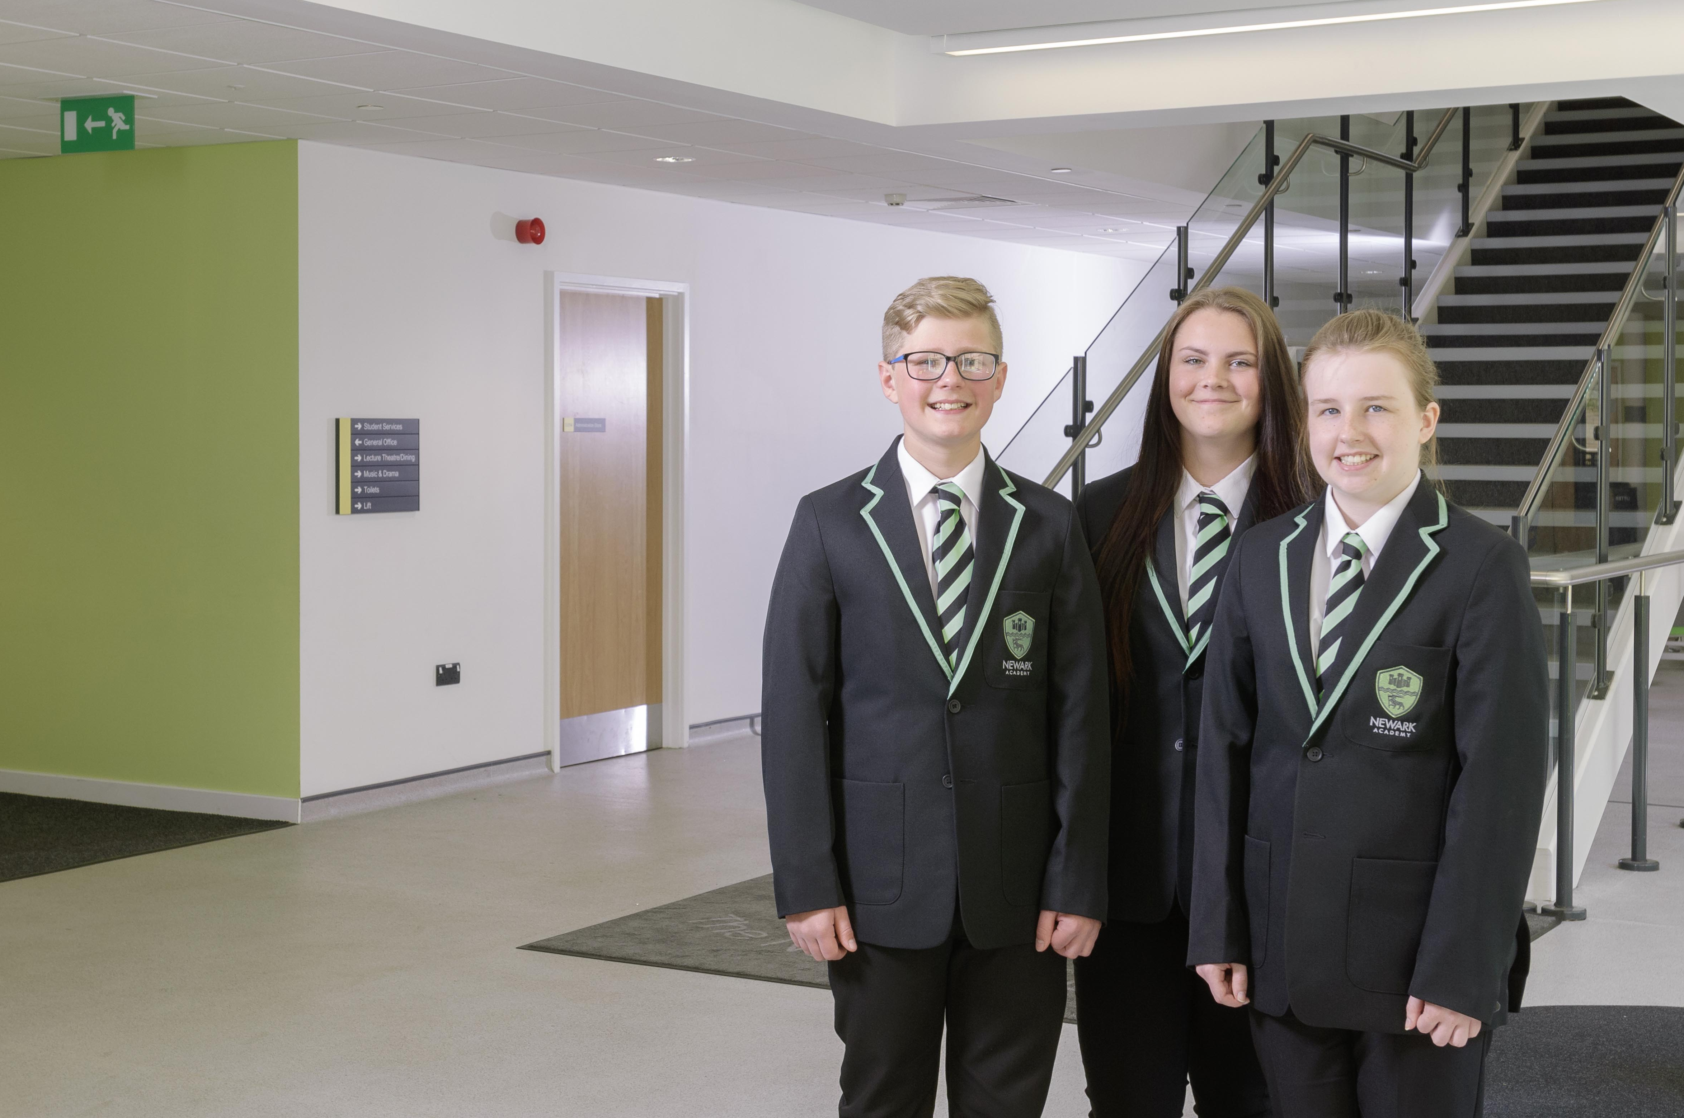

Job Application Pack

Lead Teacher of Mathematics

MPS/UPS plus TLR 2a
Full Time, Permanent
Closing Date: 9.00 am Wednesday 31st January 2018

Letter from the Head of School
Welcome.
Thank you for expressing an interest in a vacancy here. On behalf of everyone here at Newark Academy, I extend you a very warm welcome.
I am enormously proud to be the Head of a vibrant and dynamic community school which has undergone a period of significant change during the past 12 months and is now rapidly emerging as a ‘great’ local school; a school with exceedingly high standards and expectations and one which demands nothing but the best from evert member of school community.
We are committed to providing stimulating, challenging and engaging learning experiences for our students and invest heavily in professional development. Our staff and students work exceptionally hard to secure strong academic achievement but are equally passionate about their development outside the classroom as life long leaners and take part in a range of enriching experiences that compliment academic studies.
The transformational changes that have been secured over the past 12 months now mean that the local community see Newark Academy as the school of choice for their children and the school is growing at an exciting rate.
With a refreshed vision, brand new school building and a dedicated and committed staff team, the future is extremely bright for Newark Academy. If you are encouraged to apply for this position, you will join our school at a very exciting stage of its development and will be provided a range of opportunities to make a significant difference to the lives of our students and indeed our entire school community.
I do hope that this information encourages you to apply to join a talented team committed to success and look forward to receiving your application.
Andy Seymour
Headteacher

Letter from the CEO
Dear Candidate,
I am delighted to be able to introduce you to Newark Academy and the tremendous opportunities this school offers the young people of Newark.
We aim to be a ‘great’ school with recognition both nationally and internationally for the standard of education that we secure.
Critical to this, is the appointment of dynamic and innovative staff who can bring energy and initiative to the work of the school.
This is a tremendous opportunity to make a difference to the lives of young people, and will suit an ambitious professional looking to make their mark.
Thank you for showing an interest in working at Newark Academy, and we look forward to receiving your application.
John Tomasevic
CEO Nova Education Trust

Application Details
Thank you for your interest in the Lead Teacher of Mathematics vacancy at Newark Academy. Further details of this post, the school and the Trust are included in this pack and details of how to apply can be found below.
How to Apply
The online application form for this role is located on the current vacancies page of the school website www.newarkacademy.co.uk. Wherever possible, please provide email addresses for your referees.
Closing Date
Please ensure your application arrives by 9am on the closing date of Wednesday 31 January 2018.
Interview
Interviews will be held week commencing 5th February 2018. If you have not heard from us within 2 weeks of the closing date, please assume that unfortunately, on this occasion, your application has not been successful.
Safeguarding
Newark Academy is committed to safeguarding and promoting the welfare of children and young people and we expect all staff and volunteers to share this commitment.

Job Description – Lead Teacher

Reports to: Head of Department, Senior Leadership Team and Head of School

Key purpose of the job

To provide assistance in the leadership and management of the department.

In addition to the requirements of a class teacher, areas of responsibility and key tasks include supporting the Head of Department in the following areas:

Strategic direction and development of the department

- Develop and implement policies and practices which reflect the school’s commitment to high achievement through effective teaching and learning
- To have an enthusiasm for the subject which motivates and supports other staff and encourages a shared understanding of the contribution the subject can make to all aspects of pupils’ lives
- Use relevant school, local and national data to inform targets for development and further improvement for individuals and groups of pupils
- Develop plans for the subject which identify clear targets, time-scales and success criteria for its development and/or maintenance in line with the school development plan
- Monitor progress and evaluate the effects on teaching and learning by working alongside colleagues, analysing work and outcomes
- Chair meetings of subject staff (including provision of agenda and minutes) and provide other briefings as necessary.

Teaching and learning

- Use your own class as an example of high quality teaching and learning in the subject;
- Ensure continuity and progression in the subject by supporting colleagues in choosing the appropriate sequence of teaching and teaching methods and setting clear learning objectives through an agreed scheme of work, developed in line with the school development plan;
- Establish clear targets for achievement in the subject and evaluate progress through the use of appropriate assessments and records and regular yearly analysis of this data;
- Evaluate the teaching and learning of the subject by the monitoring of teachers’ plans and through work analysis, identify effective practice and areas for improvement, and take appropriate action to improve further the quality of teaching;
- Develop effective links with the local community including parents, business and industry;
- Ensure that teachers are aware of the implications of equality of opportunity which the subject raises;
- Assist in the efficient organisation of internal assessments ensuring that assessments are started, changed and finished in accordance with the schools assessment policy;
- Ensure that entries for all external examinations are submitted to the examinations officer by specified deadlines.

Leading and managing staff

- Enable all teachers to achieve expertise in planning for and teaching the subject through example, support and by leading or providing high quality professional development opportunities;
- Ensure that the Head of School, S.L.T. and governors are well informed about policies, plans, priorities and targets for the subject and that these are properly incorporated into the school development plan.

Effective deployment of resources

- Support the Head of School by maintaining efficient and effective management and organisation of learning resources, by developing or identifying new resources including ICT applications to the subject;
- To be aware of and respond appropriately to any Health and Safety issues raised by materials, practice or accommodation related to the subject;
- Support the Head of School by maintaining efficient and effective management of the expenditure for the subject;
- Help colleagues to create a stimulating learning environment for the teaching and learning of the subject;
- Take on any additional responsibilities, which might from time to time be determined.

Requirements of a classroom teacher

- Teach pupils within allocated classes, enhancing their learning and providing the opportunity for achievement for all pupils
- Planning and preparing tasks which challenge pupils and ensure high levels of interest during lessons
- Monitor the academic progress of pupils within allocated classes and implement appropriate strategies to address underachievement
- To assess, record and report on the progress and attainment of all pupils within allocated classes
- To register the attendance of pupils in class
- To set appropriate homework
- To mark pupil’s work and give appropriate and constructive feedback
- To research new topic areas, maintain up-to-date subject knowledge, and devise and write new curriculum materials
- Manage pupil behaviour in the classroom and on school premises, and apply appropriate and effective measures in cases of misbehaviour
- Communicate with parents and carers over pupils' progress and participate in departmental meetings, parents' evenings and whole school training events
- Undergoing regular observations and participating in regular in-service training (INSET) as part of continuing professional development (CPD)
- Undertake critical self-evaluation and then participate in continuous professional development designed to enhance the quality of teaching or other working practices.

Responsibilities of a form tutor

- To address any issues concerned with the wellbeing, personal development and academic progress of pupils within the tutor group
- To check uniform and general appearance on a daily basis
- To monitor the behaviour of pupils in the tutor group.

Performance Management responsibilities

- All members of staff are required to participate fully in the school’s performance management system.

Other professional requirements

- Have a working knowledge of teachers’ professional duties and legal liabilities
- Operate at all times within the stated policies and practices of the school
- Establish effective working relationships and set a good example through their presentation and personal and professional conduct
- Contribute to the corporate life of the school through effective participation in meetings and management systems necessary to coordinate the management of the school.

Person Specification: Lead Teacher

Factors | Essential | Desirable
Qualifications | - Qualified Teacher Status (PGCE or equivalent qualification)  - Good Honours degree (First or Second Class) | - Higher professional qualification.
Experience | - Successful experience of teaching in the subject across the full age range of a secondary school  - Experience of teaching a wide range of abilities  - Proven record as a teacher whose pupils reach high standards of learning and achievement. | - Current/recent responsibility post within a department  - Experience of pastoral/tutor role
Skills/  Knowledge | - Excellent teaching skills, including effective communication skills, ability to motivate students and staff and the capacity to create good learning environments.  - A clear understanding of the characteristics of high quality teaching and learning and achievement for all pupils.  - Knowledge of current issues and recent developments in the curriculum area.  - Capacity to use ICT as integral part of teaching.  - Knowledge and understanding of the value added agenda, including levels of progress.  - Ability to lead initiatives, support the process of change and work effectively in a team.  - Ability to prioritise, plan and organise.  - Secure commitment to a clear aim and direction for the subject  - Understanding of safeguarding and promoting of welfare of children issues.  - Understanding of equal opportunities issues and their application to work. | - Understanding of particular needs of pupils with SEN  - Awareness of factors affecting language and learning across the curriculum  - Knowledge/involvement in other cross curricular initiatives/projects or whole school developments
Personal Qualities | - Enthusiasm for the subject  - Ability to use own initiative  - A commitment to the vision of the school  - A commitment to inclusive education.  - Ability to form good working relationships with pupils and staff  - High standards and expectations  - Ability to use pupil assessment data to raise standards  - Outstanding communication skills  - Reliability and integrity  - A commitment to safeguarding and promoting the welfare of young people | - A willingness to contribute to extra-curricular activities  - A vision for the development of the department.  - A commitment to personal and professional development.

Overview of the Trust
The Nova Education Trust is a dynamic and growing Multi Academy Trust Group based in the East Midlands. Our Trust Group is committed to providing high quality education to all of our students, regardless of their backgrounds.

With a range of schools in the trust serving a variety of different communities, opportunities for career progression and wider professional experiences are extensive. We have outstanding CPD provision across our schools, supported by our Teaching School Alliance, which links 23 schools together, sharing effective practice and developing new models for staff development. We also have a unique programme designed to provide middle and senior leaders with all the skills required to develop their careers.

As an employer we offer an enhanced benefit package to all staff that includes help with healthcare and a fully-funded MA programme for all teaching staff. We can also offer help with relocation in certain circumstances. The Trust also has a policy of wider engagement for main-scale, middle and senior staff. In recent years, employees have visited schools in America, Canada, Finland, Singapore and South Africa as part of their professional development.

Overview of the School
Ethos
Newark Academy has a very clear ethos focused on the achievement and well being of our students. We believe that a school should be at the very heart of the community and place great value on collaboration, partnership and service alongside a range of core values that compliment academic success.
We encourage staff to be creative, independent and ambitious. We expect them to challenge and inspire our students, providing them with the motivation and support necessary to achieve their full potential.
To Summarise
- We have high expectations of students and staff;
- We believe every student can succeed;
- We ensure barriers to learning are challenged and overcome;
- We expect teaching to be well planned, varied and stimulating;
- We expect learning to be active, focused, social and engaging; and
- We insist on high standards of behaviour at all times.
Achievement
At Newark Academy we believe that examination success allows our students to make the very most of their lives and student achievement is at the very heart of everything we do.
We have developed a curriculum designed to challenge and engage students, offering them the very best preparation for examination success and the skills and confidence required to make full use of those qualifications.
Exciting, engaging and inspiring lessons lie at the centre of our curriculum and as a school we constantly strive to provide students with the very best educational experiences possible.
Should a student require additional support, Newark Academy provides a range of support services that will ensure every student’s success, whatever their individual educational needs.
Pastoral
At Newark Academy we pride ourselves on the quality of care, guidance and support given to individual pupils. At the core of this provision is a year system led by a Head of Year and supported by the Pastoral Leaders, Tutors and Learning Support teams.
This system provides students with the care they need whilst allowing them to nurture friendships and develop a strong sense of community.
Tutors play an active role in ensuring that students are happy, well supported and fully engaged in school life and serve as the first point of contact between school and home. There are regular updates of pupils’ progress through termly reports, online data and twice yearly Achievement events
Newark Academy is a very caring community and the health, happiness and well-being of students underpins our overall ethos and philosophy.
Curriculum
Our curriculum follows National Curriculum guidelines and aims to provide a broad and balanced learning experience for all.
At Key Stage 3 our two-year programme covers all the National Curriculum subjects. Students are taught in ability groups in the majority of subjects.
During our three year Key Stage 4 programme all students study the English Baccalaureate core subjects of English, Mathematics, Science, a Modern Foreign language and a humanities subject such as Geography or History.
A wide range of option subjects including visual and performing arts, technology, sports and computing courses supplement the core curriculum. We expect all our students to achieve their full potential in all their chosen qualifications and work hard to support them to do so.
Extra-Curricular
Extra-curricular opportunities are an essential part of providing a balanced and exciting range of experiences in school. At Newark Academy our after-school ‘’enrichment’ programme provides students with an impressive range of courses and sessions across the week.
Opportunities include Photography club, Science, Journalism, Canoeing, Debating, and a comprehensive range of sporting activities including football, Cricket, Netball, Rugby, Basketball, Tennis and Athletics are also available. Newark Academy students regularly compete at county level and our sports teams have a strong tradition of success.
The Performing Arts also take a leading role in school life with regular Drama productions allowing all students to fully explore their creativity. In 2017 our students performed Little Shop of Horrors to a packed audience in our Lecture Theatre. We are very much looking forward to this year’s performance of Sister Act in Feb 2018.
In addition, there are regular opportunities to travel including a Year 7 Netball trip to Disney Land Paris and a Football tournament at Borussia Dortmund In Germany. There is a ski trip planned for 2019 which will be open to all students from across the school.
Student Voice
Student voice is active within the school with each year group choosing student representatives that meet through our student council.
There are additional opportunities for students to be leaders through our Prefect system which encourages students to apply for both junior and senior prefect roles.
Students are involved in all aspects of school life and contribute to the interview process for new staff and assist at school open evenings and events. They have also delivered feedback to staff on aspects of teaching and learning, such as marking.
Safeguarding and Child Protection
The Trust and all its schools are committed to safeguarding and promoting the welfare of children and expects all staff to share this commitment. All new staff within the Trust will be subject to an enhanced DBS check.
Each school in the Trust has a designated senior member of the leadership team who is responsible for referring and monitoring any suspected case of abuse. All members of staff will receive training in line with our child protection policy.

