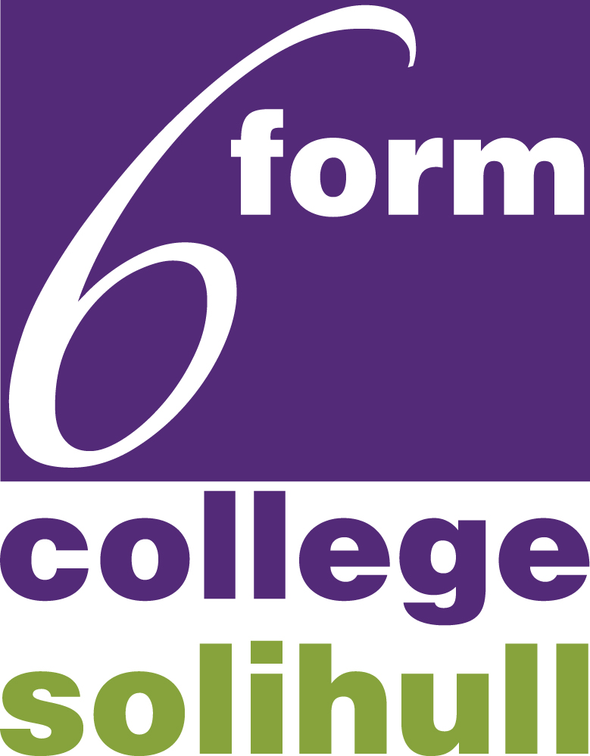 DBS ONLINE DISCLOSURE GUIDE

APPLICANT GUIDANCE NOTES
An online DBS check can be completed by accessing the Internet from any PC/Laptop that has this facility. If you do not own your own computer you can go to any internet café or local library. Please be aware that you must complete your application form in full as part completed application forms cannot be saved.
LOGGING ONTO THE SYSTEM
Please enter the following address in the web browser:
https://disclosure.capitarvs.co.uk/solihull
If you are not taken directly to the ‘Start New Application’ page, please click on ‘Start Application’ in the orange box entitled ‘DISCLOSURE AND BARRING SERVICE (DBS) APPLICATION’ to enter the system and start your application.
Please note at this stage of the process your login details are case sensitive.
- Enter the Organisation Reference – SIXTHF
- Enter the Password – please leave this blank
Once you have completed your application form you will be given a submission reference number. Please make a note of this number for reference purposes. If you entered an email address onto your application form you will receive a confirmation email.
Your application form will be processed by your employer once they have verified your identity. Please see below for guidance on identity verification.
Next step – identity verification
In line with the DBS code of practice all applicants requiring a DBS check must have their identity verified.
How do I have my identity verified?
Please provide original identification to HR at The Sixth Form College, Solihull as listed in the acceptable ID table attached. Your application form will be processed by your employer once they have verified your identity and then sent onto the DBS.
Tracking the progress of your application with the DBS
If you supplied an email address whilst entering your application, as soon as your application has been received at the DBS and is assigned a DBS Application Reference number you will receive a second email detailing this information. This email will also include details and links to the DBS website to enable you to track the progress of your application from the moment the disclosure process commences.

Please contact the HR Team at The Sixth Form College, Solihull if you encounter any problems.

DBS List of Acceptable Identification
Three documents in total must be seen; one document must come from Group 1 and a further two documents from Group 1, 2a or 2b
Group 1 – Primary Trusted Identity Credentials
- Current valid Passport – UK
- Biometric Residence Permit (UK)
- Current Driving Licence Photocard (UK) (Full or provisional) Isle of Man/Channel Islands and EU
- Birth Certificate UK and Channel Islands – including those issued by UK authorities overseas, eg embassies, High Commissions and HM Forces – issued at the time of birth
- Adoption Certificate (UK & Channel Islands
Group 2a – Trusted Government/State Issued Documents
- Current driving licence – photocard. All countries (full or provisional)
- Current driving licence – paper version. UK, Isle of Man, Channel Islands and EU (full or provisional)
- Birth certificate (UK and Channel Islands) – issued after the time of birth by the General Register Office/relevant authority ie Registrars – photocopies are not acceptable
- Marriage/Civil Partnership Certificate (UK and Channel Islands).
- HM Forces ID Card (UK)
- Fire Arms Licence (UK and Channel Islands)

Group 2b – Financial/Social History Documents
- Mortgage Statement (UK or EEA)** Non EEA statements must not be accepted
- Bank/Building Society Statement (UK and Channel Islands or EA)*
- Bank/Building Society Account Opening Confirmation Letter (UK)
- Credit Card Statement (UK or EEA)*(Non EEA statements must not be accepted)
- Financial Statement** eg.pension,endowment, ISA(UK)
- P45/P60 Statement** (UK & Channel Islands)
- Council Tax Statement (UK & Channel Islands)**
- Work Permit/Visa (UK) (UK Residence Permit) **(valid up to expiry date)
- Letter of Sponsorship from future employment provider (Non-UK/Non-EEA only – valid only for applicants residing outside of the UK at time of application.
- Utility Bill (UK)* - not mobile telephone
- Benefit Statement* eg. Child Allowance, Pension
- A document from Central/Local Government/Government Agency/Local Authority giving entitlement (UK & Channel Islands)* eg. from the Department for Work and Pensions, the Employment Service, Customs & Revenue, Job Centre, Job Centre Plus, Social Security
- EU National ID Card
- Cards carrying the PASS accreditation logo (UK)
- Letter from Head Teacher or College Principal (16-19yr olds in full time education (only in exceptional circumstances when all other documents have been exhausted) (UK)

Please note If a document in the List of valid Identity documents is:
- denoted with * - should be less than three months old
- denoted with ** - it should be issued within the past 12 months
- not denoted – it can be more than 12 months old

