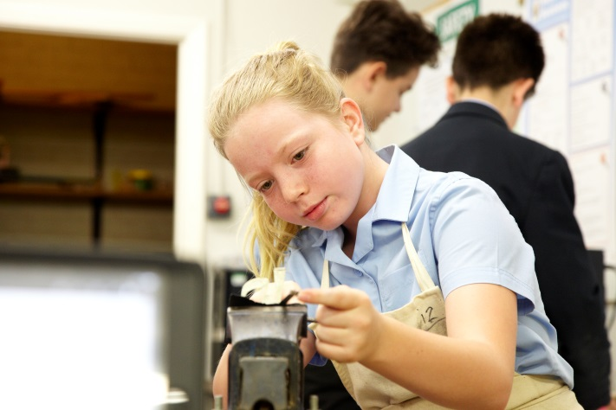

Information for Prospective Candidates

For the post of

T E C H N O L O G Y T E A C H E R

(SEPTEMBER 2017)

Dear Potential Candidates June 2017

Thank you for your interest in this teaching vacancy. We are at an exciting point of Warden Park’s development! I have been in post since January 2014 as Headteacher of the Secondary Academy and Chief Executive Officer of Sussex Learning Trust which includes Warden Park Primary Academy in Haywards Heath and is due to expand in the next few years welcoming more schools into the Trust. This job relates to the Secondary Academy, however there are always the opportunities for shared and collaborative working across the phases.

Warden Park Secondary Academy is a significantly over-subscribed school demonstrating the high regard with which it is held in the local community. The students are generally above average ability on intake although the school incorporates an SSC with capacity for 18 young people with statements of SEN. The vast, vast majority of students are committed and hard-working and it is in no doubt that this is a very enjoyable place to teach!

Of course, the demographics mean that parents have appropriately high aspirations for their children. This year our students achieved 78% 5 A*-C grades including English and Maths making us the highest attaining school in Mid-Sussex. However, we expect even better results this year as our strategies for improving teaching and learning embed themselves throughout the school.
The Technology Department - the following is indicative rather than exhaustive
If you have the ability to teach Food & Nutrition at KS3 and Product Design at KS3 and KS4 this would be advantageous.

We are seeking an innovative and enthusiastic Technology teacher. The Design and Technology department (Child Development, Product Design and Food & Nutrition) consists of seven experienced members of staff all of whom teach at least one specialist area of our curriculum. We also have two full time and experienced technicians. All our staff in D&T have a passion for delivering high quality, creative lessons. The team takes pride in the products it produces. Lessons are dynamic and engaging and our subject at GCSE is over subscribed. Design and Technology students at Warden Park frequently leave the academy with a real passion for the subject, with many choosing to study it post-16.

The department has had a very successful record in recent examinations, with results in D&T being consistently above 80% A*-C with some areas achieving 90% plus A*-C. It is well-resourced, being accommodated in a self-contained ‘Technology Wing’ consisting of 3 mixed media workshops, a graphics suite and two fully equipped food rooms. We also have our own dedicated ICT suite with 22 computers. Digital learning is central to our teaching. The department is well resourced with 3 laser cutters and 3 fully equipped workshops. The Food & Nutrition department enjoys the use of two fully equipped and well maintained cooking and food preparation suites which include the recent addition of a blast chiller in each room. Students in all years have mini-iPads, and wi-fi access is available in all teaching rooms. The department is a leader in developing digital learning strategies and we are committed to using the iPads to maximise student progress. The successful candidate will be responsible for teaching Child Development to GCSE. It is also likely that the successful candidate will be required to teach Food & Nutrition and/or Product Design therefore some experience of at least one of these areas would be desirable.

The Design and Technology department (Product Design and Food & Nutrition) consists of seven experienced members of staff all of whom teach at least one specialist area of our curriculum to maximise student progress.

Students are taught in mixed ability groups in Years 7 and 8 on a carousel. (⅔ Product Design, ⅓ Food & Nutrition) These students are taught an exciting and varied curriculum that has been designed to prepare them for the new GCSE specifications.

Warden Park operates a three-year KS4, with students selecting their options in year 8. In year 9 students are placed into their GCSE classes. They will begin studying the GCSE course in the summer term of year 9 to help cover the increased content of the new GCSE specifications.

From September 2017 we begin delivering the Edexcel GCSE specification for Design and Technology and already deliver the new AQA specification for Food & Nutrition. Child Development will follow the new OCR specification from September 2017.

The successful candidate will be joining a high-performing, passionate department who aim to instil a love of Design & Technology with all its individual strands. It is a very supportive environment, with best-practice being constantly shared between staff. Students are ambitious, polite and have an extremely positive attitude to learning. It is an excellent place to develop as a practitioner. We are developing a vision of sustainability and would welcome candidates who share this passion.

Mr J Hensler
Director of Design & Technology

The Position – Technology Teacher - the following is indicative rather than exhaustive.
Core purpose:
To be an outstanding classroom teacher and an effective member of the subject team.

- To take responsibility for professional development to develop teaching and enhance pupils’ learning;
- To make an active contribution to the policies and aspirations of the school in and beyond lessons;
- To challenge and support all pupils and work collaboratively with colleagues in pursuit of shared objectives.
Principal Tasks:
- Planning, organising and delivering lessons consistent with departmental, whole school and national policies;
- Marking, assessing and recording pupil attainment;
- Monitoring and recording pupil progress against departmental, school and national criteria;
- Managing in-class and outside classroom discipline;
- Completing planned monitoring and evaluation tasks (e.g. monitoring, academic tracking, annual reports);
- Communicating with parents and/or other professionals as indicated in the school’s policies;
- Attending and contributing to departmental and whole school meetings/events.
Essential Criteria:
- Qualified Teacher Status
- Relevant Degree
Personal qualities:
- Show drive, energy and commitment to the Mission Statement and the outcomes of the School Improvement Plan;
- Work to develop a positive culture in lessons and in tutor periods/activities and around the school;
- Support whole school values, departmental ethos and form/year group identity;
- Act as a positive role model in all aspects of school life;
- Be well organised and conscientious, meeting professional expectations expressed in national and school publications;
- Be committed to and participate fully in self-evaluation;
- Be optimistic and enthusiastic about education in general;
- Have a sense of team!

Safer Recruitment:
Warden Park Academy is committed to safeguarding and promoting the welfare of children and young people and expects all staff and volunteers to share this commitment. We will ensure that all our recruitment and selection practices reflect this commitment. All successful candidates will be subject to DBS checks along with other relevant employment checks
In Conclusion
I have set out my vision for Warden Park. It is for the school to be “World Class”. The students deserve us to be more than outstanding in every aspect of school life. You will possess the energy, drive and passion to add significantly to this, our determined outcome for this special school. Visits from prospective candidates are encouraged. We look forward to meeting you!
Jonathan Morris
Headteacher/CEO

Candidate information

Individual visits:

We would be delighted to organise individual visits with any potential candidate who wishes to visit or find out more detail about a particular area of the Academy. Please contact our Reception staff on 01444 457881 to arrange a tour.

Submitting your application:

Applications should comprise of an Academy Trust application form (available on the Warden Park website) and a letter of application. Where possible, these should be emailed to jobs@wardenpark.co.uk our HR Manager, Roseanne Gainsford ( rgainsford@wardenpark.co.uk ) will be happy to answer any questions you may have about this process or vacancy.

Short listing:

The selection panel with undertake short listing wherever possible on the same day as the vacancy closing date, however if there is no closing date we will contact successfully shortlisted candidates as soon as possible. Shortlisted candidates will be notified by telephone and/or email giving them as much notice of the date of interview as possible.

IMPORTANT INFORMATION FOR SHORTLISTED CANDIDATES

Please bring with you your passport, driving licence and a recent bill or bank/credit/store card statement less than 3 months old along with your degree/educational certificates (for teaching vacancies) when you attend for interview. This is for DBS purposes and will save time later should you be appointed.

Parking:

There is onsite parking, please park in marked bays.

Local information

Location:

The school is ideally situated in the lovely Sussex village of Cuckfield, in a rural location, yet within easy reach of excellent facilities and communications. There are a good range of local amenities, including restaurants, boutiques and pubs found in Cuckfield and the nearby town of Haywards Heath. Haywards Heath lies in the centre of the Mid Sussex District of West Sussex, surrounded on all sides by stunning countryside, which is less than a five-minute drive in any direction from the town centre.

The vibrant seaside city of Brighton (15 miles) offers first-rate shopping, restaurants and cultural facilities.

Transport:

There are regular trains from Haywards Heath to London and the South East (London Bridge/Victoria from 42 minutes). Gatwick airport (14 miles) has a fast rail connection to London (Victoria 30 minutes).

www.southernrailway.com

There is very easy access to the A23/M23 and in turn the M25 and national motorway network.

Schools:

There are a number of highly regarded schools and nurseries in the area:

www.wardenparkprimary.co.uk www.harlandsprimaryschool.org

www.holytrinity-cuckfield.w-sussex.sch.uk www.bolnorevillage.w-sussex.sch.uk

www.roundabouthouse.co.uk www.robins-nest-nursery.co.uk

Leisure:

The area is well served for sporting and recreational facilities including show jumping at Hickstead, racing at Goodwood as well as golf at Haywards Heath and West Sussex Golf Clubs. The Olympos leisure centre is situated in Haywards Heath and there are also excellent sporting facilities at The Olympos in Burgess Hill and the K2 centre in Crawley. There are local rugby, football cricket and athletics clubs for boys, girls and adults.

The theatres in Brighton, Crawley and Horsham attract a wide variety of performers from the worlds of music, comedy, dance and drama. Crawley and Brighton also boast large multi-screen cinema complexes.

Places of interest:

There are numerous places of interest within a short distance of the town, including the famous Bluebell Railway, Wakehurst Place, Ardingly Reservoir, Devil’s Dyke, the Royal Pavilion and the South of England Showground, where various and varied events take place throughout the year.

Estate Agents:

www.mansellmctaggart.co.uk Tel: 01444 704144 www.fox-and-sons.co.uk Tel: 01444 450105

www.connells.co.uk Tel: 01444 441441 www.huntersnet.co.uk Tel: 01444 440400

www.holroydhomes.co.uk Tel: 01444 440035 www.savills.co.uk Tel: 01444 446000

www.marcusgrimes.co.uk Tel: 01444 476200

Broad Street, Cuckfield, Haywards Heath, West Sussex RH17 5DP
Tel: 01444 457881 Fax: 01444 417024
Email: admin@wardenpark.co.uk www.wardenpark.co.uk

