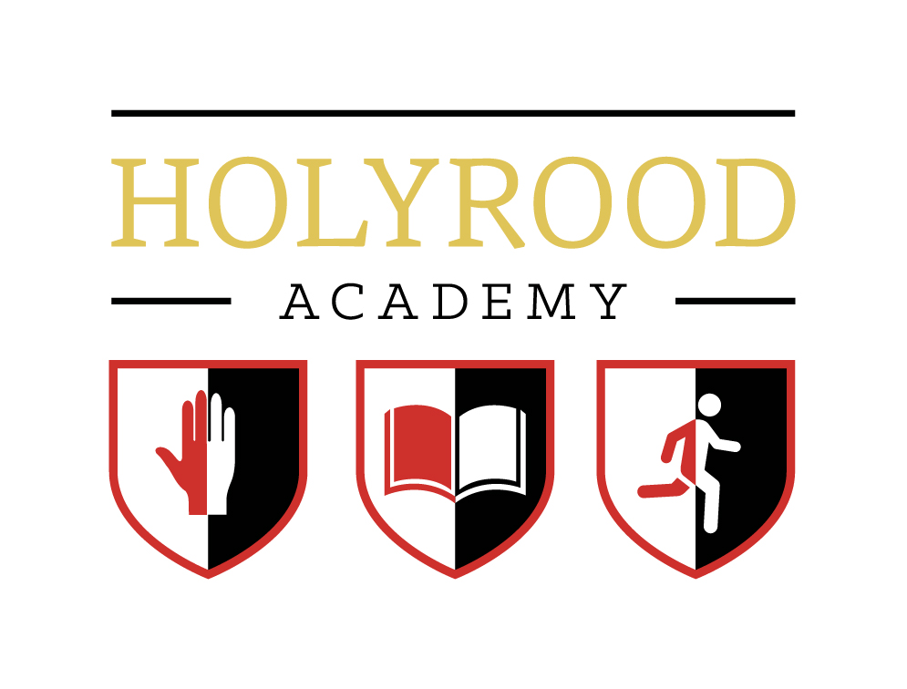
Holyrood Academy Maths Team – 2017-18
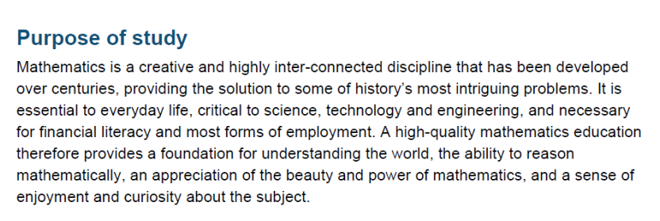
The above opening paragraph from the new programme of study for Key Stage 3 Mathematics sums up the purpose of all mathematics teaching today. The new curriculum has three aims:
- Build fluency in mathematics
- Enable students to reason mathematically
- Develop the ability to solve problems using mathematics
These aims therefore build the basis of what we do day-to-day in the Mathematics classrooms of Holyrood Academy.
The Maths Team is made up of eleven full time members of staff: seven teaching mathematics full time, four teaching maths on reduced timetables to accommodate their roles as Academy STEM Coordinator, Academy Lead Practitioner, Year Leader, and Academy Head of School. The department is line managed by one of the Academy Vice Principals.
The Maths Team is accommodated in six dedicated maths classrooms in L block, one dedicated classroom in M block and two dedicated maths classrooms in S block. The Team also makes use of rooms on Upper Site. All classrooms are equipped with projectors and whiteboards, the majority of classrooms have interactive whiteboards. We are subscribers to a number of online resources that aid learning and revision. These include: www.vle.mathswatch.com, www.supermathsworld.com , www.mrcartermaths.com . All teachers are provided with a Hudl to allow them to access data, emails and other services. As an Academy we use the online ShowMyHomework service to set homework and the online ClassCharts service for our seating plans. We are moving towards using Google Classrooms as our online presence and as a way of interacting with our students.
As mathematicians, the team is dedicated to developing a love of mathematics in all students. We aim to deliver interactive and stimulating lessons that encourage students to think for themselves. We have strong links with the local primary schools and take part in the UKMT Maths Challenges at all levels.
Our students are organised into teaching sets based on ability. We have developed a mastery scheme of work for our Academy wide two year Key Stage 3. At GCSE we follow a scheme of work that covers the key objectives of the 9 – 1 GCSE. All students are entered for GCSE at the end of Year 11. At Key Stage 5 we offer both AQA A Level in Mathematics and in Further Mathematics. Students study a mixture of core mathematics and applied content. We also offer the Core Maths AS at Key Stage 5.

