# Contact Details AND MAP

**Tele:** 020 8570 1079

**Fax:** 020 8577 0621

**Email:** office@springwell.hounslow.sch.uk

**Website:** http://www.springwelljunior.co.uk

**Address:**

Springwell Junior School

Vicarage Farm Road

Heston, Hounslow

TW5 0AG

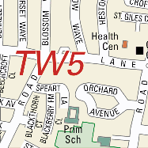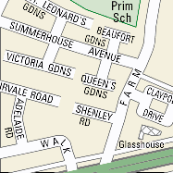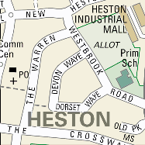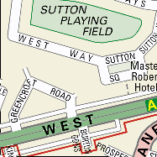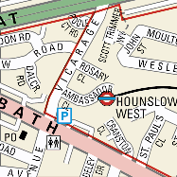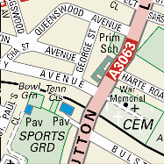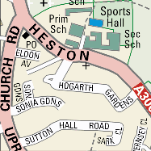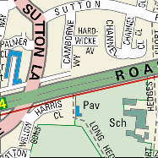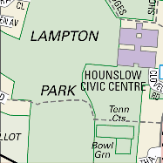

10 minute walk from Hounslow West tube station (Piccadilly Line)

Bus Routes: H91, H32, H28, 482